**BUSINESS INTELLIGENCE**

**Software Installation:**

STEP1: To install Power Bi desktop go to <https://powerbi.microsoft.com/en-us/> and then click on products from drop down click on Power Bi Desktop.

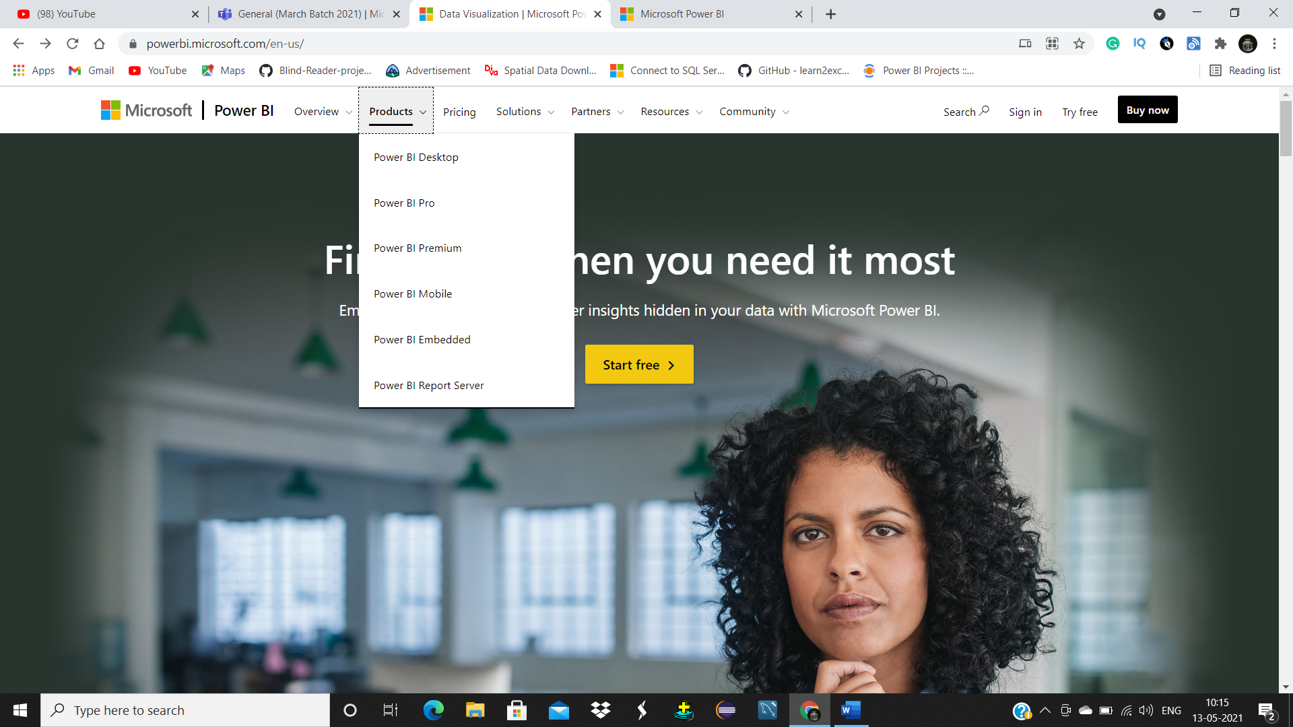

STEP2: If you want to download the software with default language options click on Download free button. If you want to change the language click on “see download or language options”

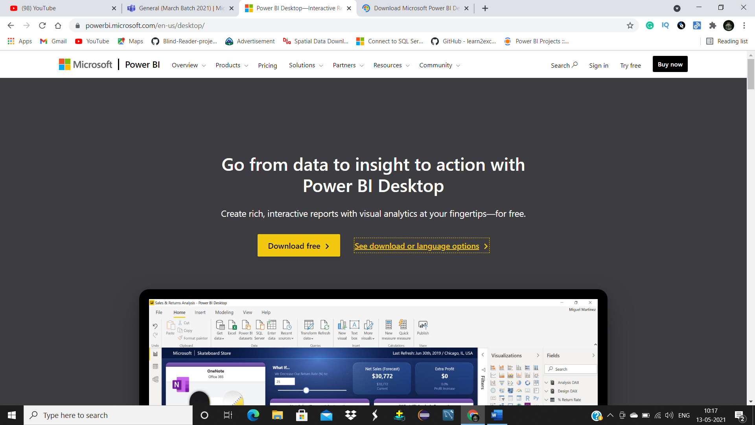

STEP3: Select your preferred language and then click on download button.

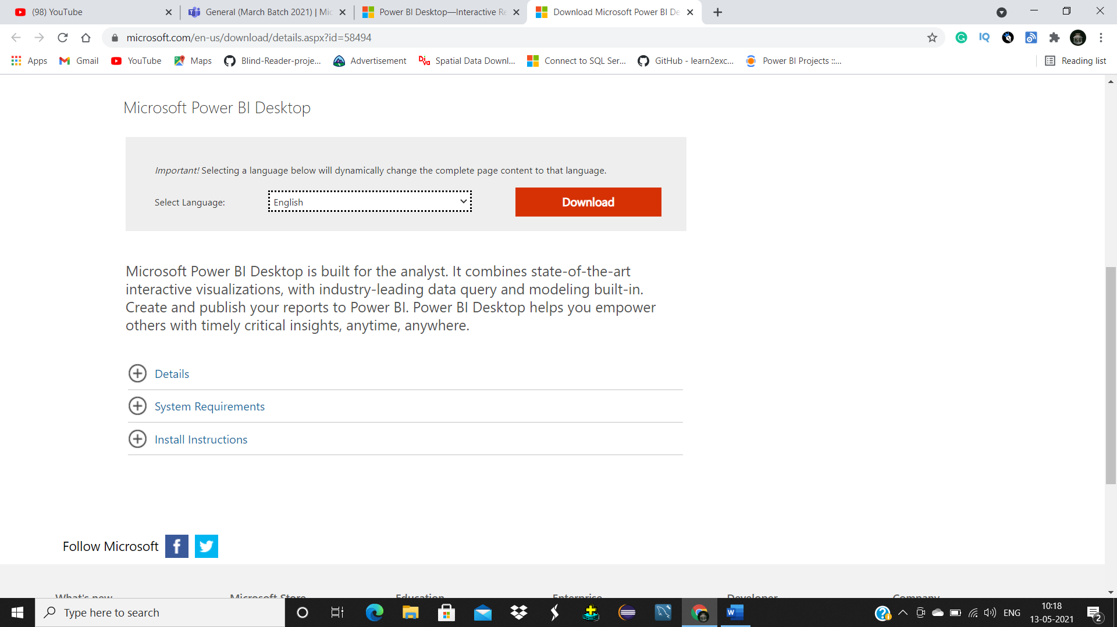

STEP4: Choose the software you want to install by clicking on check box and then click on next button.

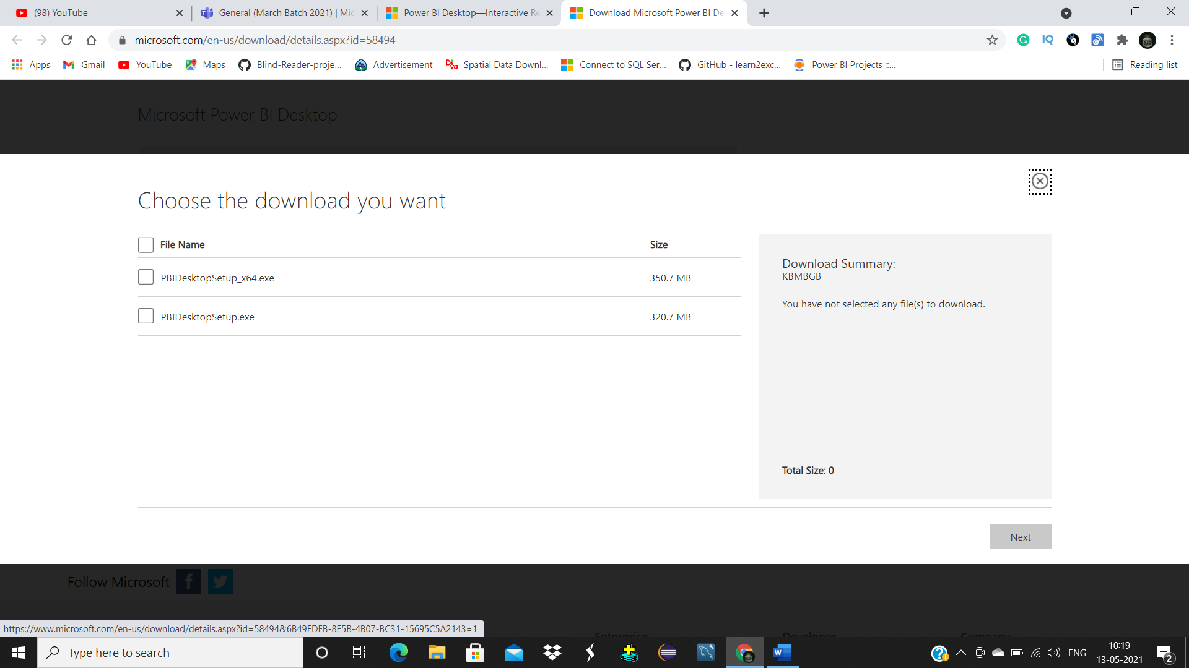

STEP5: Double click on downloaded software to start installation process. Click on next.

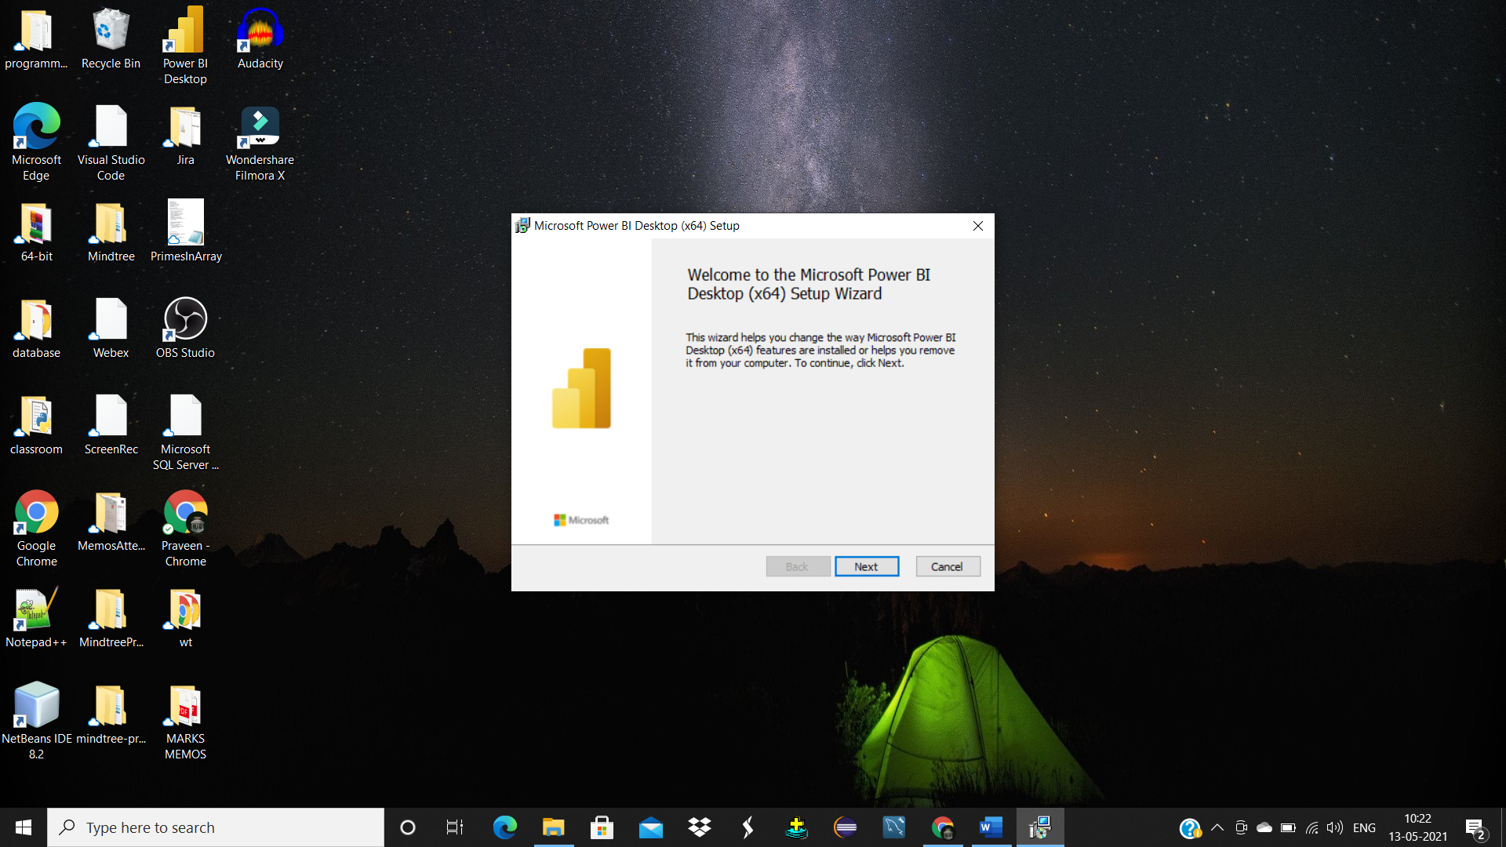

Power Bi will be installed into your pc

STEP6: Click on finish.

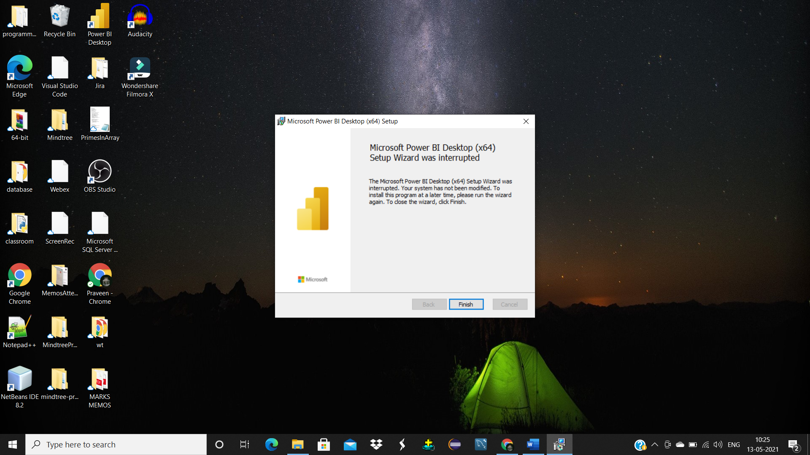

STEP7: To start working with Power Bi desktop double click on power bi icon.

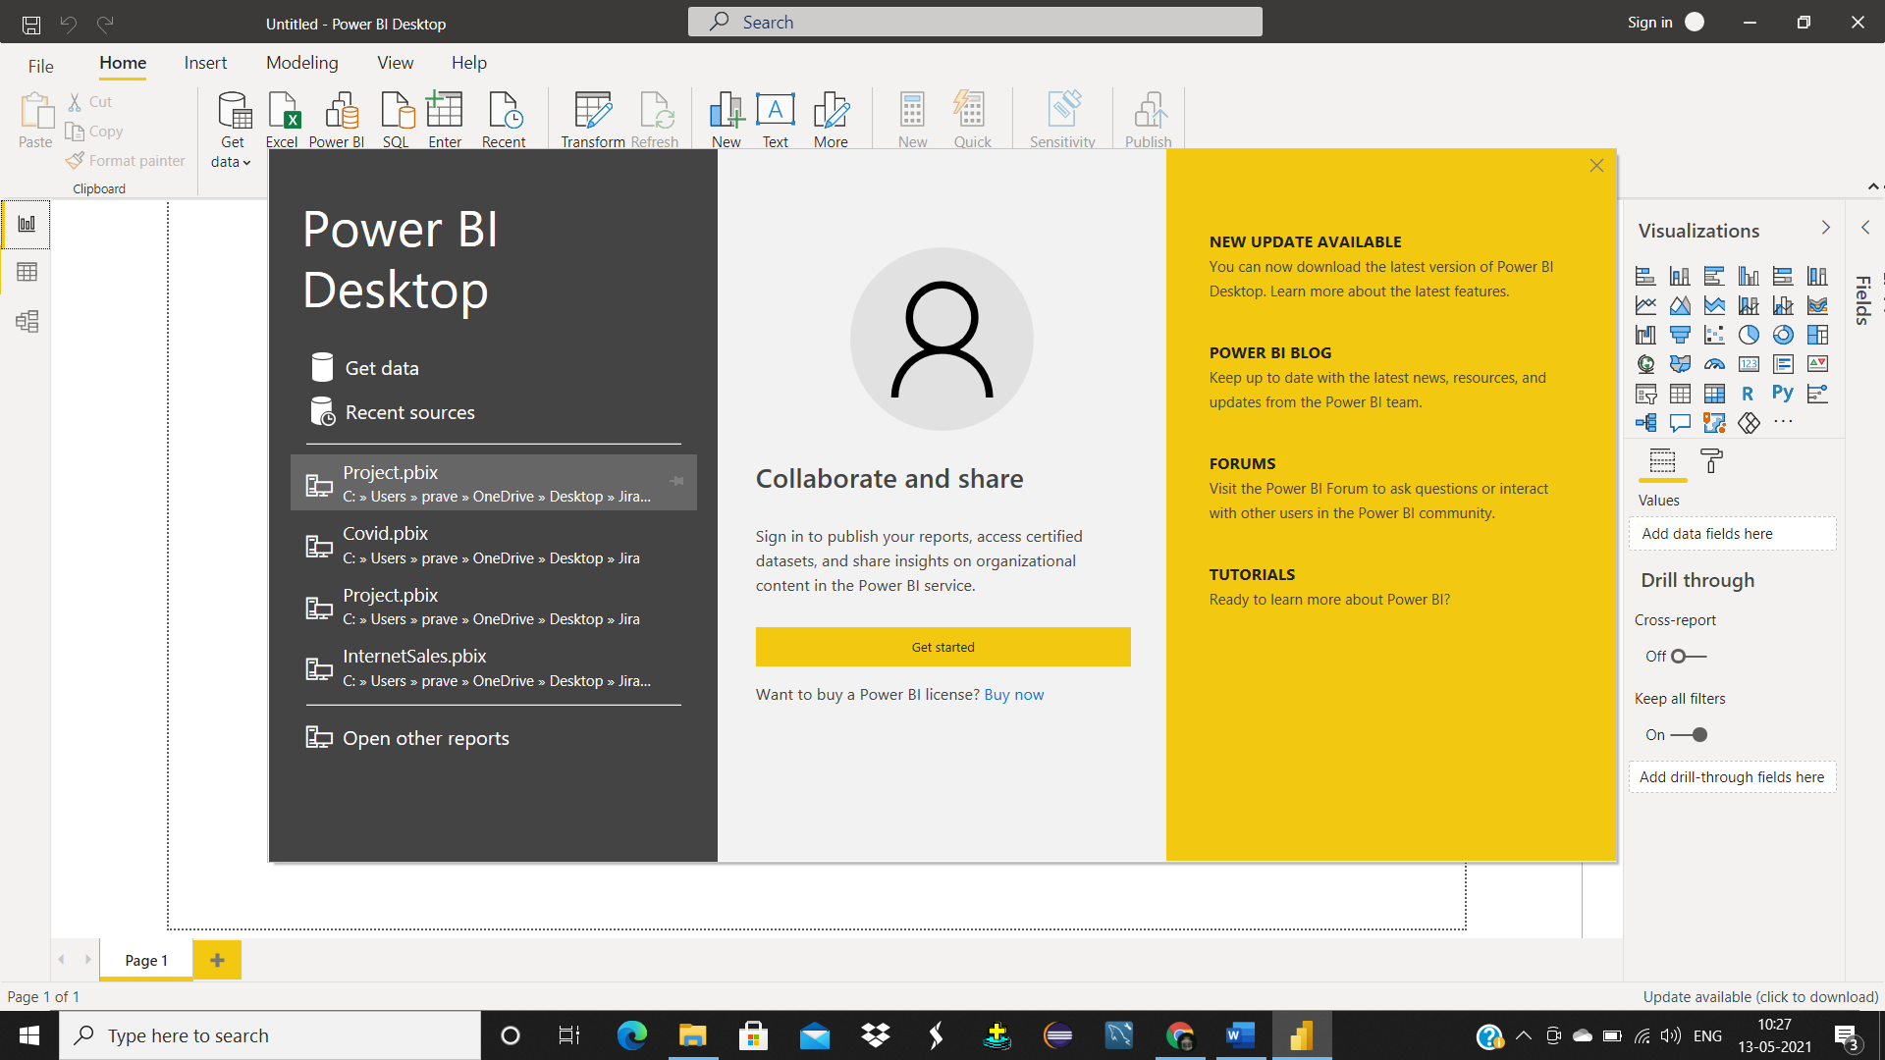

**POWER BI**

**Power BI** is a collection of software services, apps, and connectors that work together to turn your unrelated sources of data into coherent, visually immersive, and interactive insights. With the help of Power BI we can work on an Excel spreadsheet, or a collection of cloud-based and on-premises hybrid data warehouses.

**Power BI Desktop**

The Windows-desktop-based application for PCs and desktops, primarily for designing and publishing reports to the Service.

# Capability 1 : Ability to work with Basic Data Preparation Tasks

# If we open Power BI Desktop this is how the screen looks

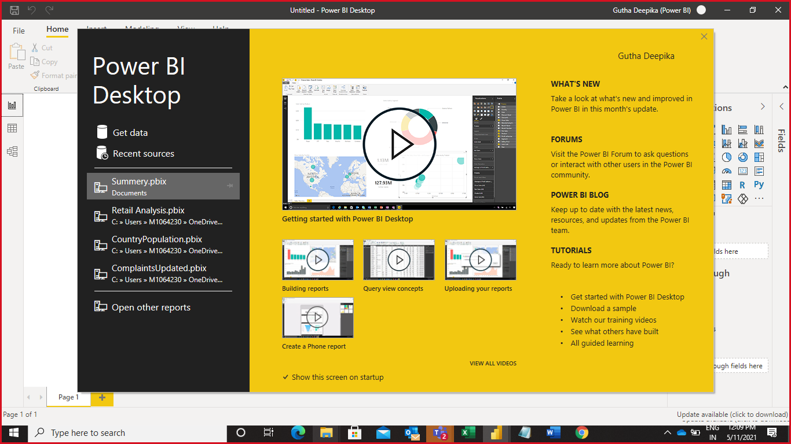

**Able to get Data from Databases Using Power BI Desktop**

Step 1 : Click on Get data and it shows the various data sources from where we can get data

Step 2 : Click on more option

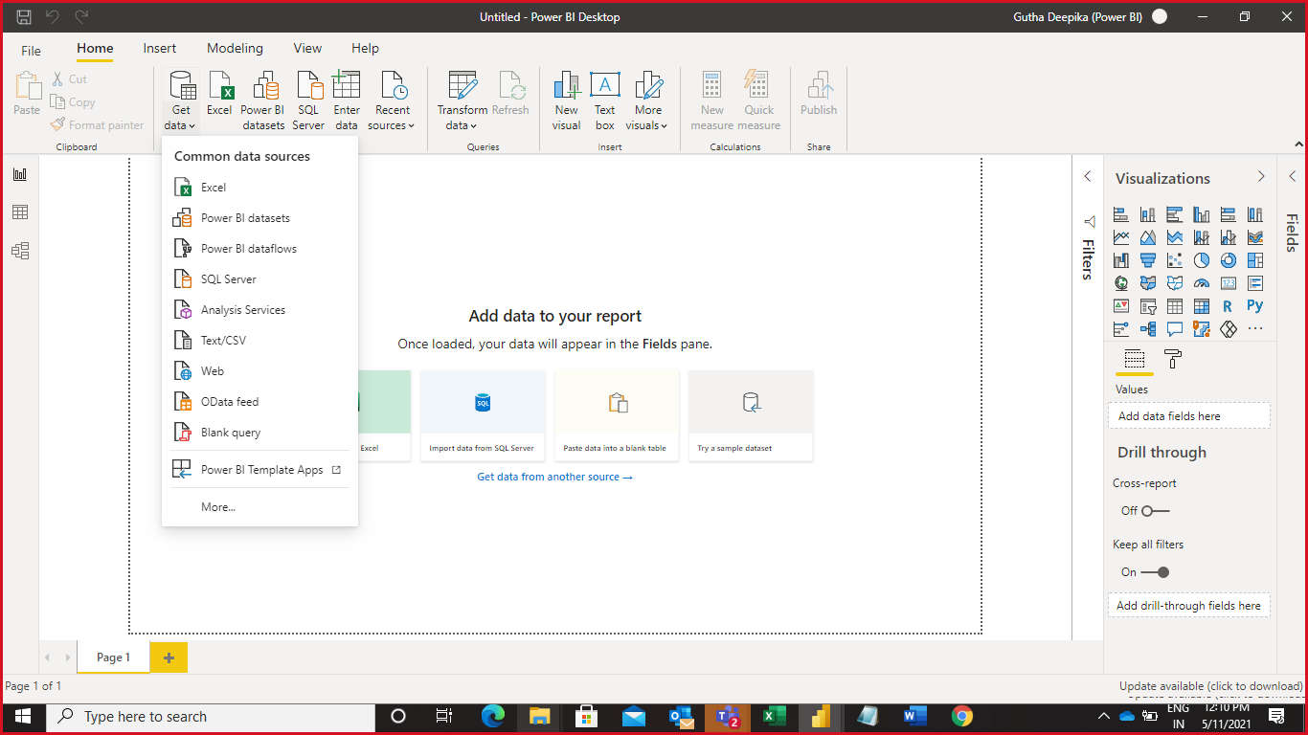

Step 3 : Click on database and it shows various database sources

The picture shows how to connect to database, select the database of your choice and click on connect button. Here we are connecting to MySQL Database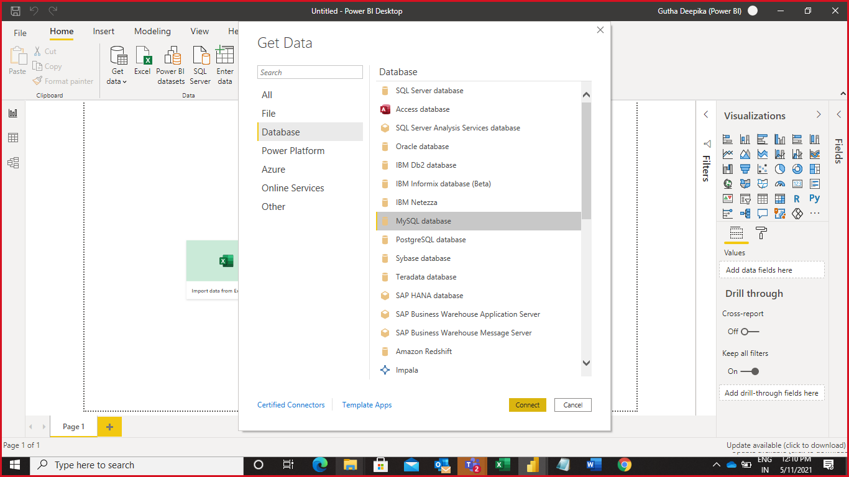

Now we need to give the name of the Server and Database and click OK

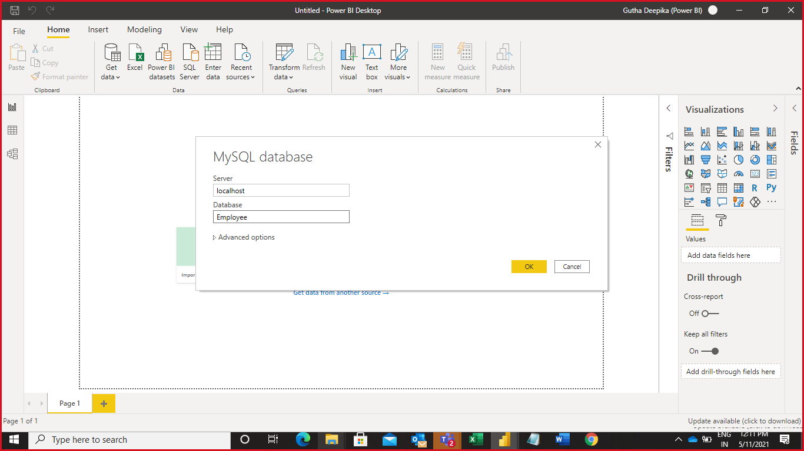

Step 4 : Select the table and load the table to Power BI desktop

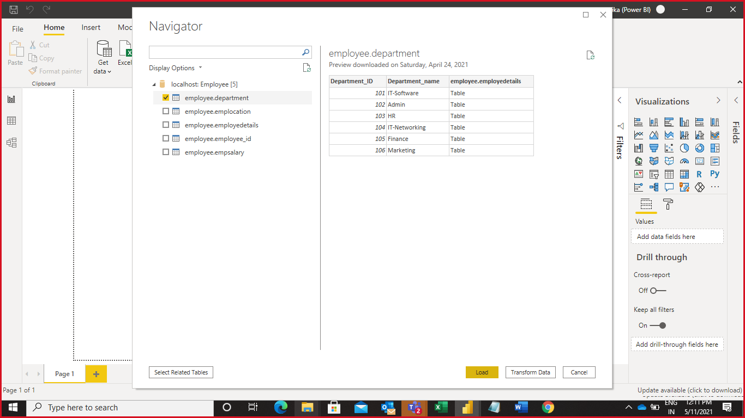

This is how the desktop looks like after loading the database

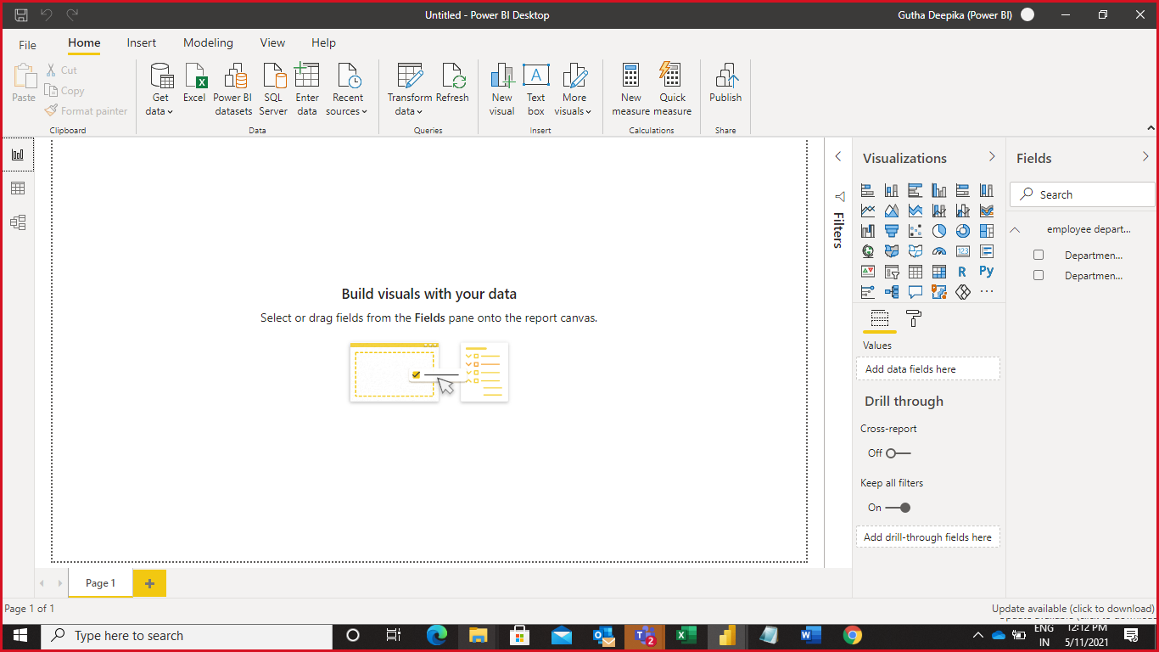

**Able to get Data from Files Using Excel**

Step 1 : Click on Get data and Select Excel or else you can directly select the Excel from Home

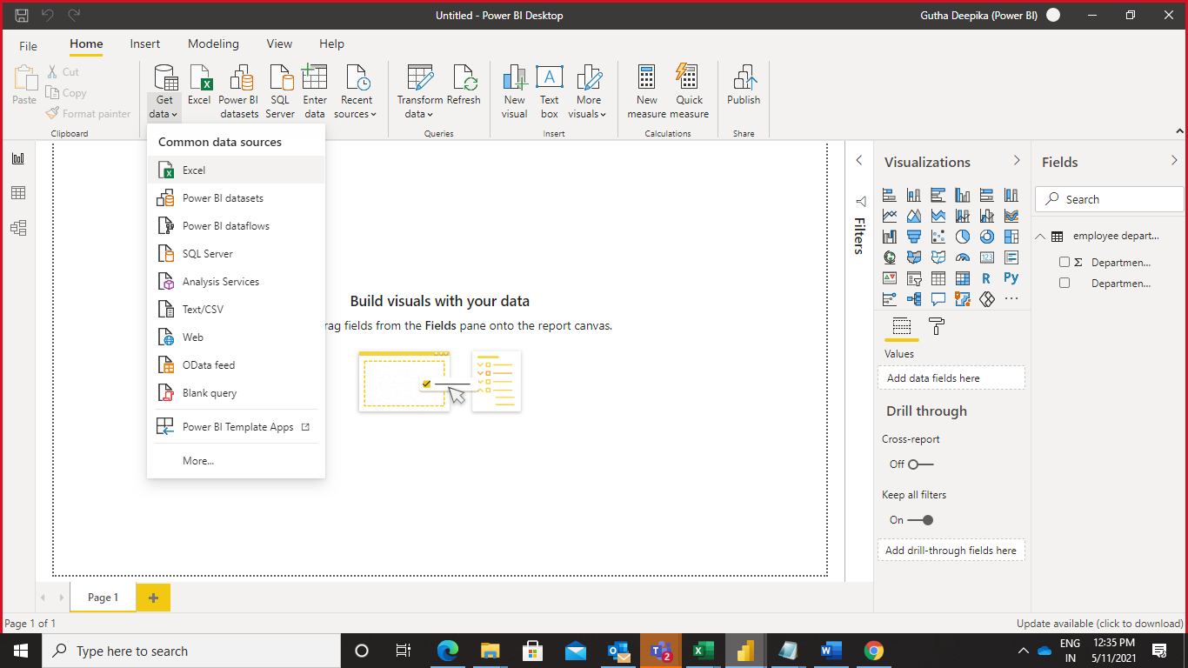

Step 2 : Select the Excel sheet which we need to load to Power BI desktop and click on Open

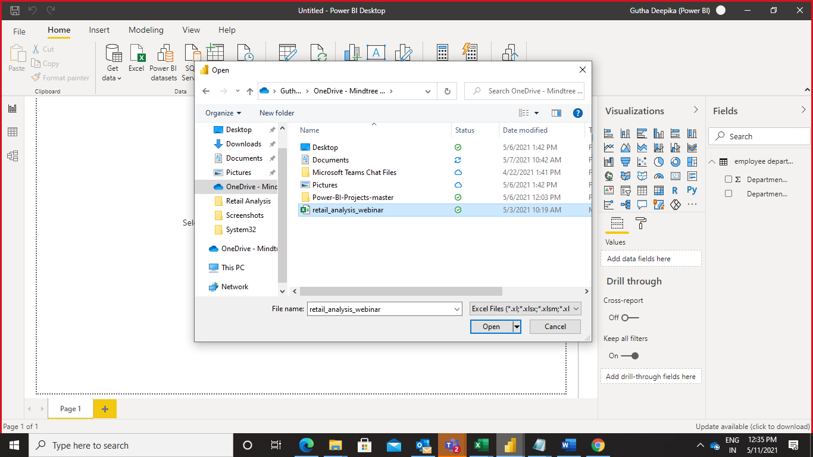

Step 3 : Select the table and click load button

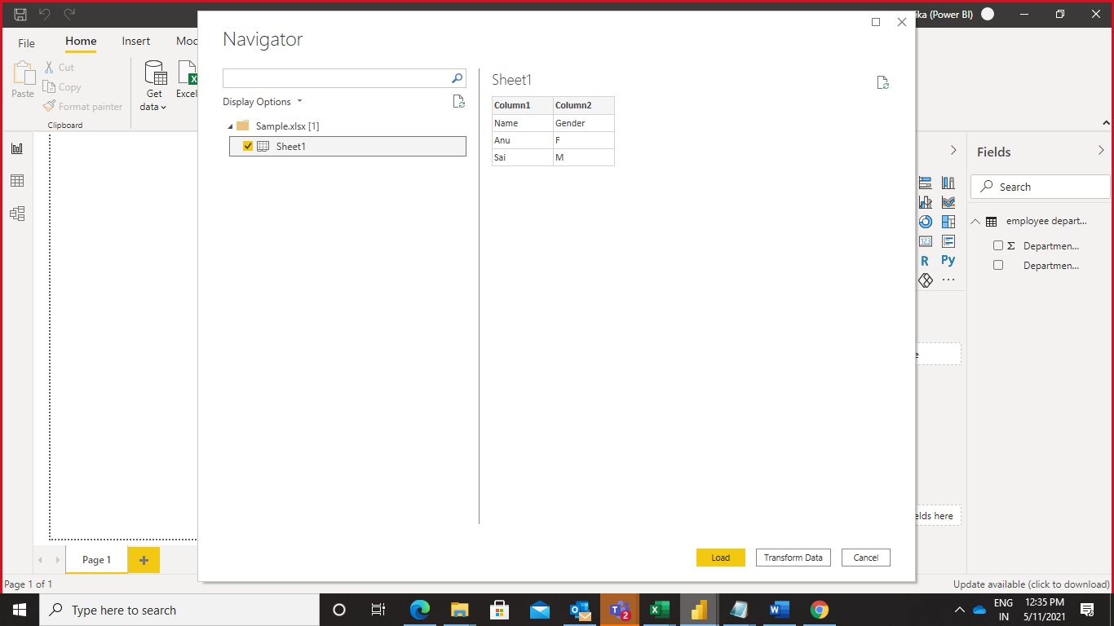

Step 4 : This is how the Power BI desktop looks like after loading the Excel Sheet

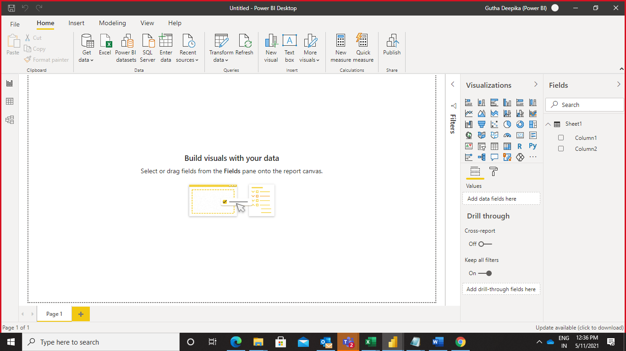

**Able to get Data from the Web**

Step 1 : Click on Get data and select Web to get data from web services

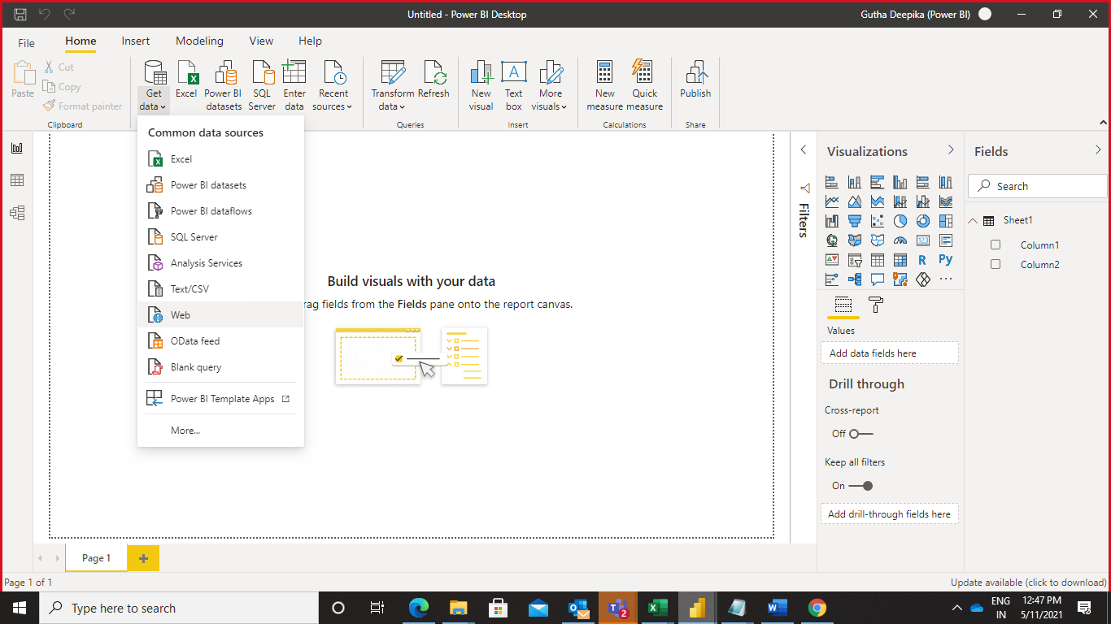

Step 2 : Give the URL of the data

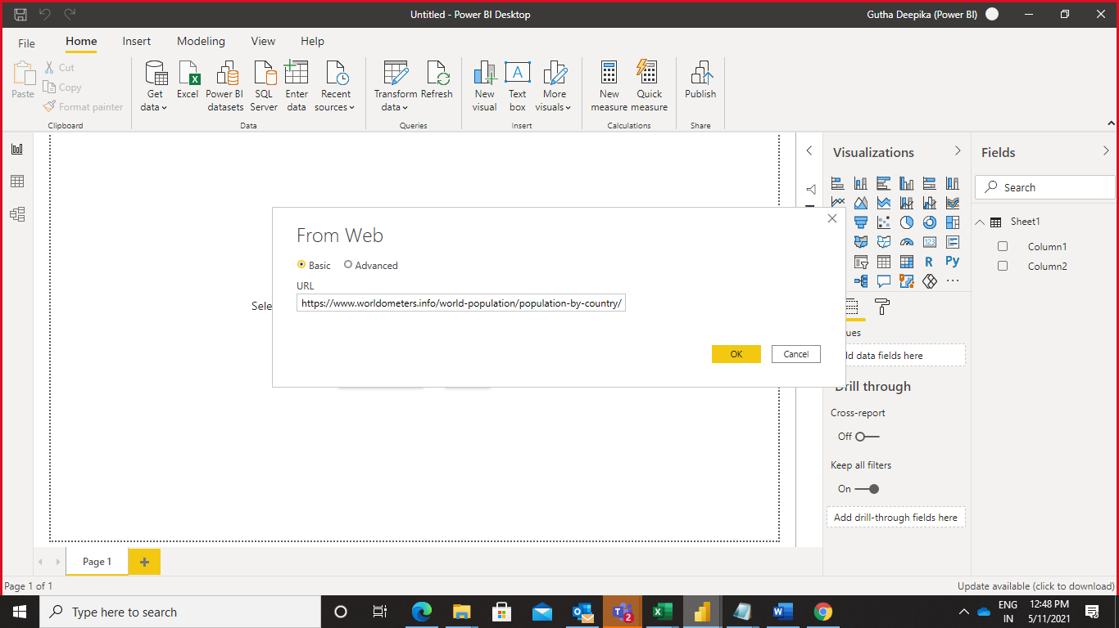

Step 3 : Click on connect button to connect to the Web services

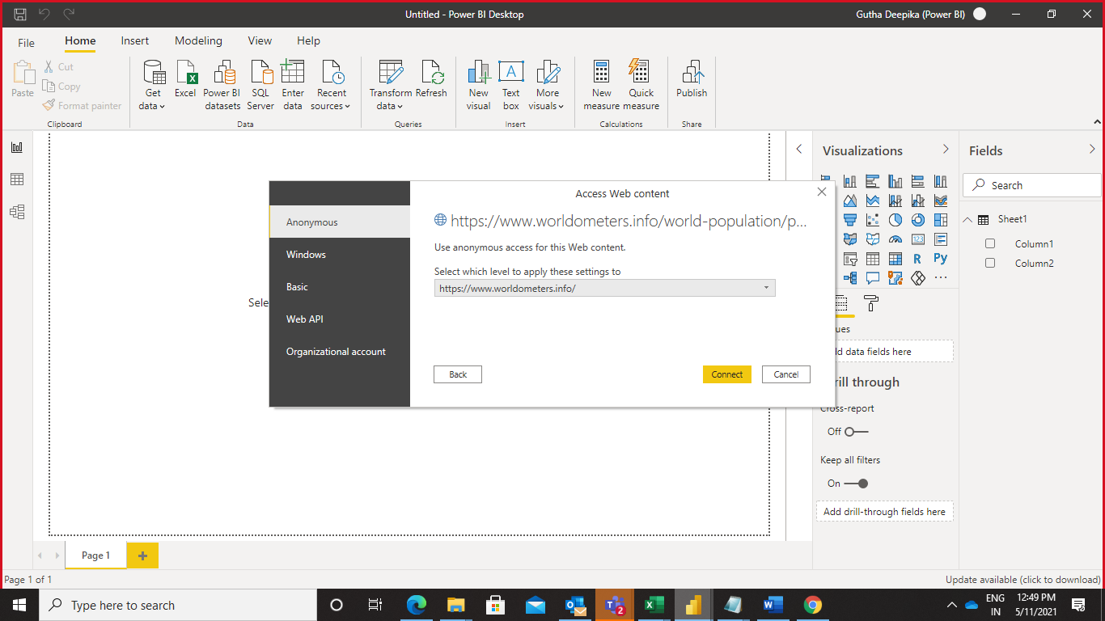

Step 4 : Select the table from the database and click on load button.

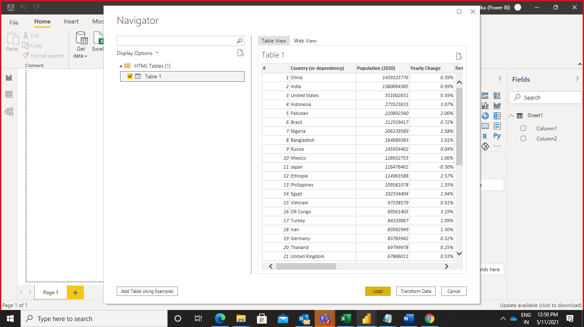

After loading the table we can see them on the right side on Power BI desktop.

**Able to add Data Manually Using Power BI**

Step 1 : Click on Enter data on the home

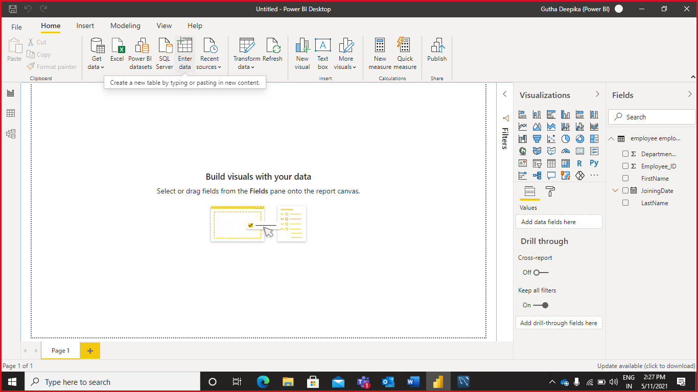

Step 2 : Give the table name and enter the data into columns which you need

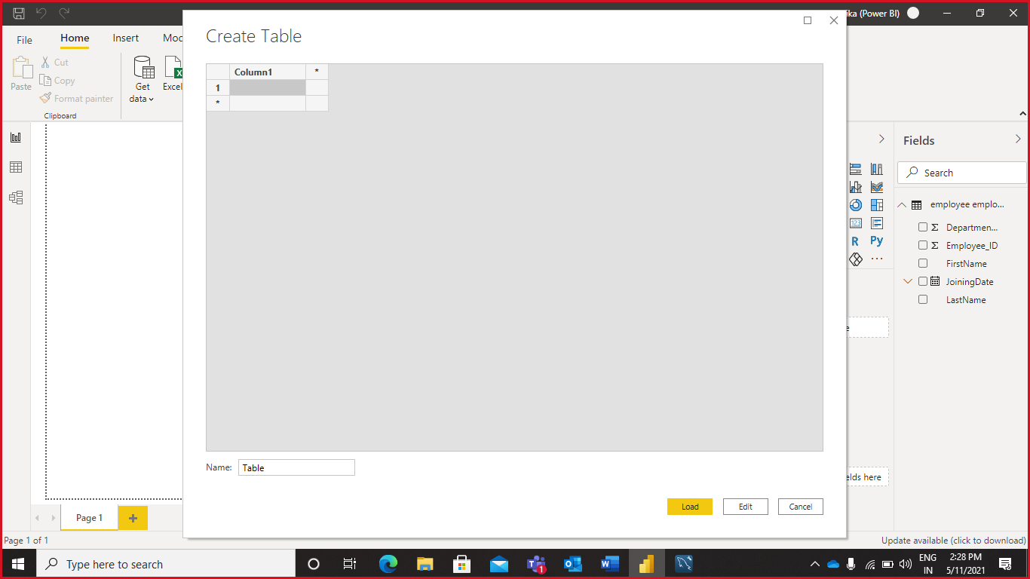

Step 4 : After entering the data, click on the load button to load data manually to Power BI Desktop

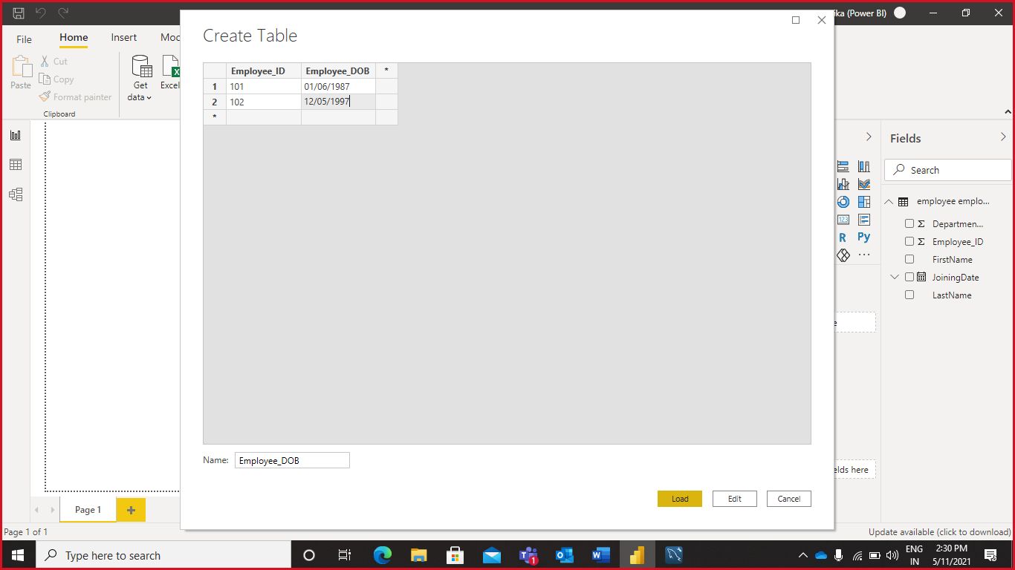

Step 5 : This is how the Power BI Desktop appears after loading the data, We can see the loaded data on the right hand side

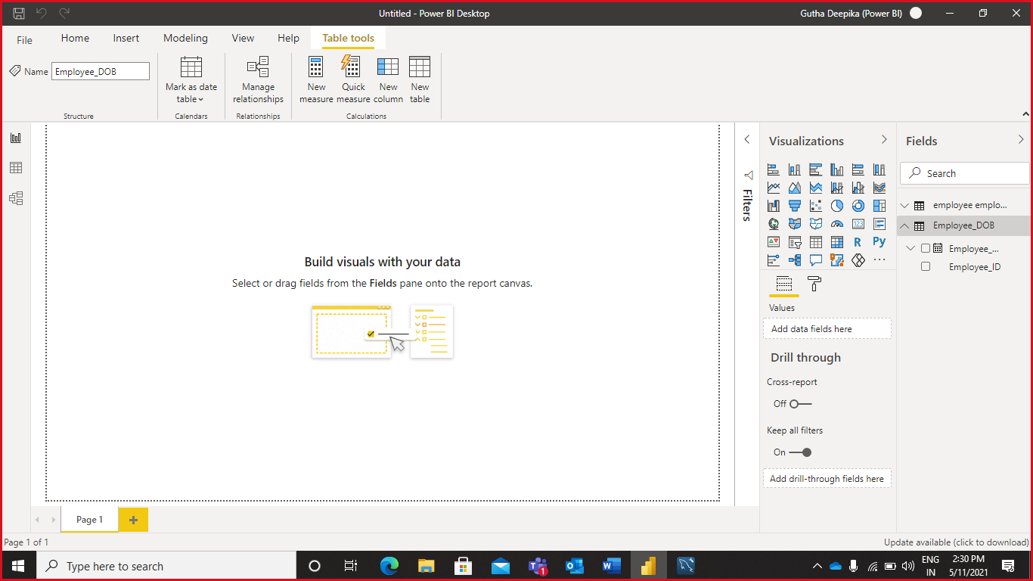

**Able to add Data Manually Using Excel**

Step 1 : Open Excel sheet and select new sheet

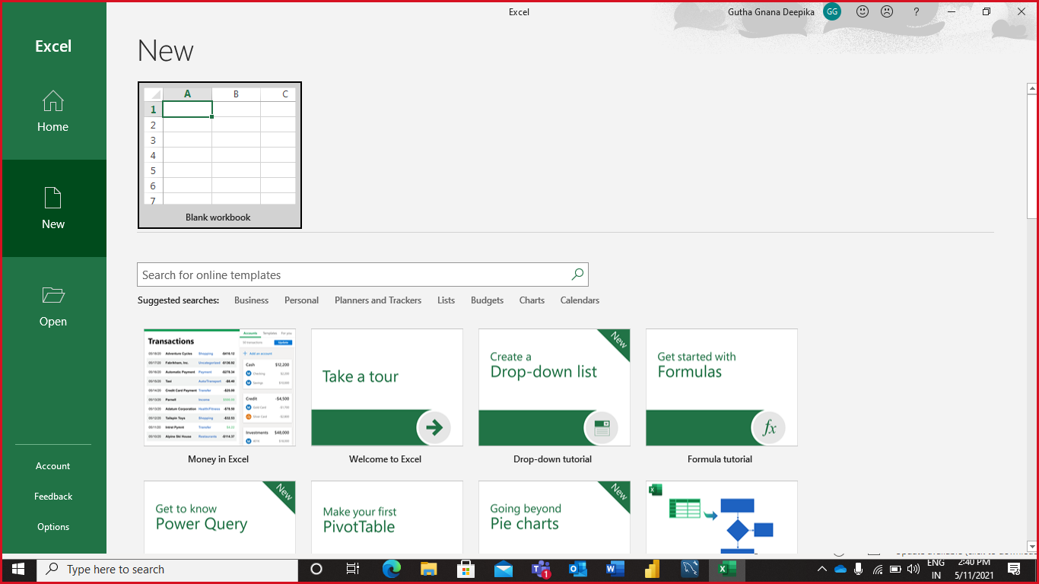

Step 2 : This is how the Excel sheet appears

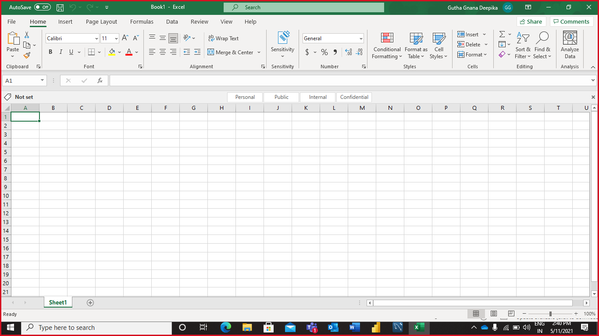

Step 3 : Enter the data into Excel sheet manually

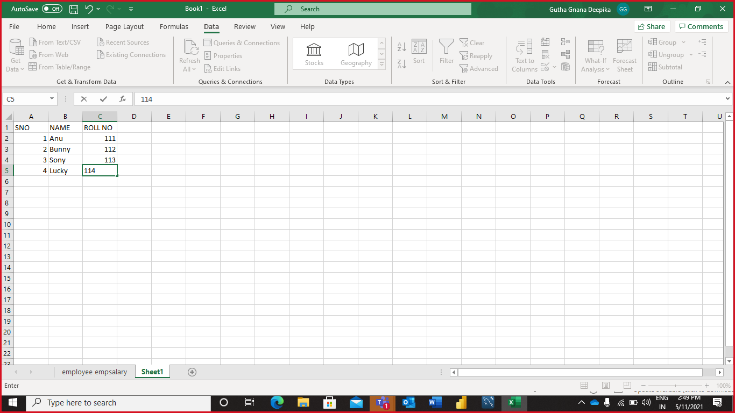

Step 4 : Click on From Table from the Data option to change the Excel sheet to Table format, There you can see a pop up window and click Ok.

After that the Power Query Editor appears there click on the Keep changes option and save the changes

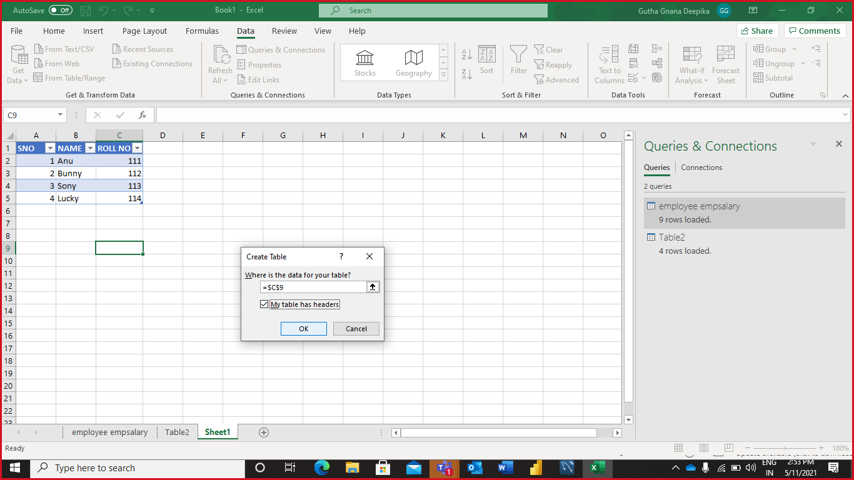

After applying all the changes manually this is how the Excel appears

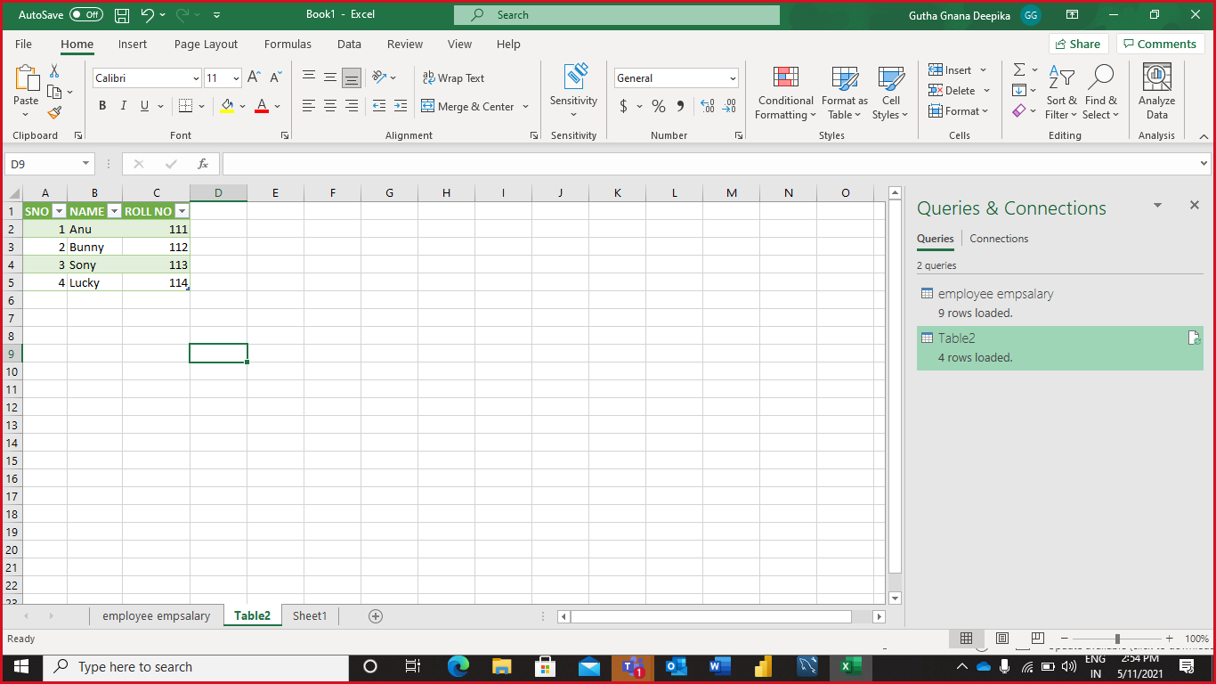

**Capability 2 : Ability to apply Basic Data Transformations**

**Able to Rename Queries, Combine Queries, Append Queries**

**Renaming Query**

Right click on the table which we need to Rename, It shows the rename option click on that and enter the name to be replaced

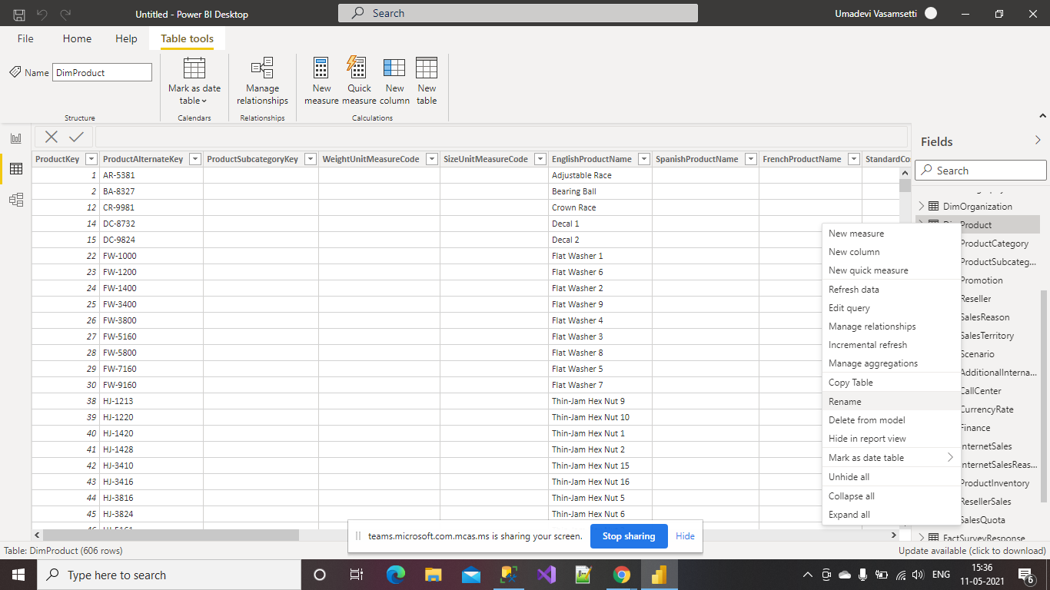

We can the in the below picture after renaming the table name

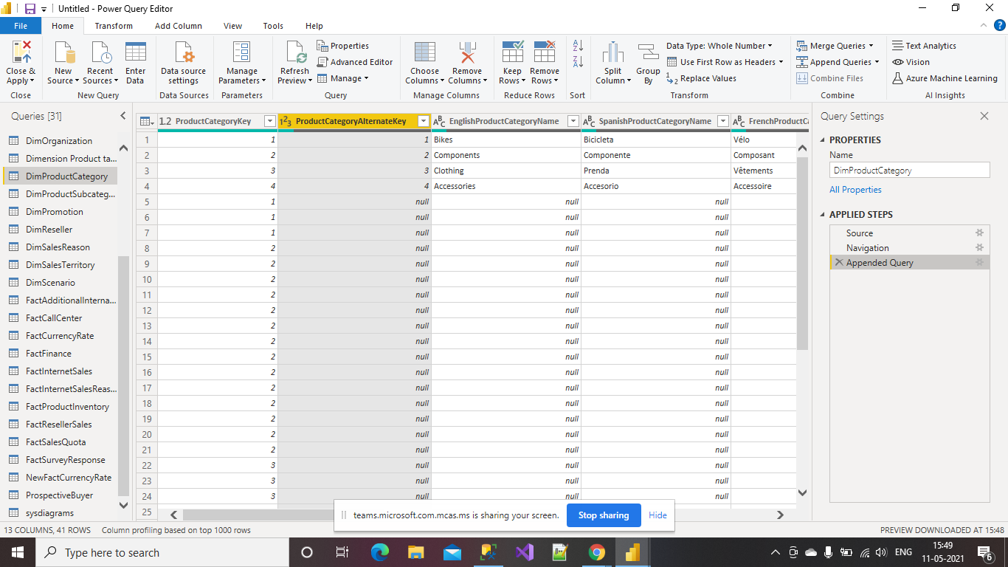

**Appending**

Click on transform data option in the home, it opens the power Query Editor there you select Append Query option

Now we need to select number of tables to Append, select the option and click Ok

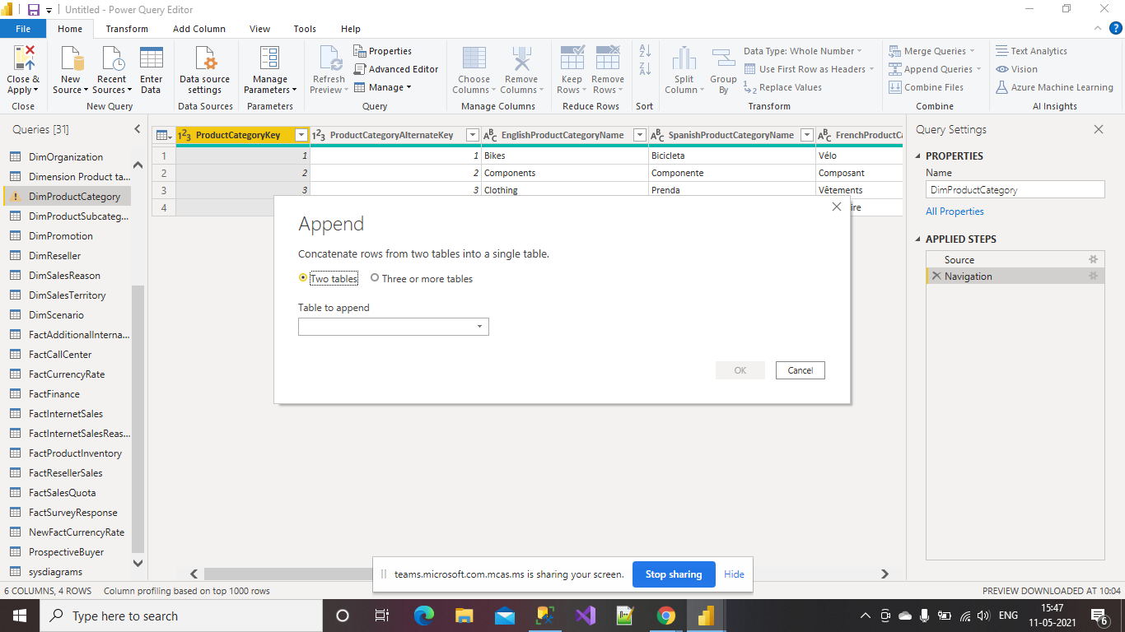

Now we need to select the tables which we need to Append, in the picture it shows two boxes one to Available data and the other is Tables to append.

Select tables in Available table, click on Add then we can see the tables on the next table, final click ok

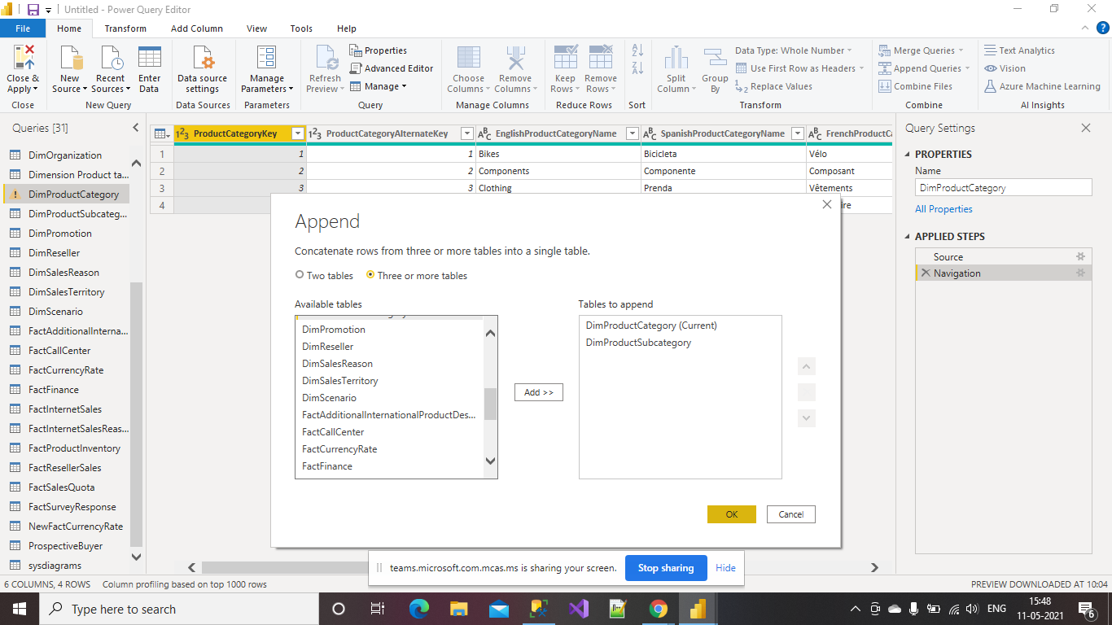

This is how the Power BI Desktop appers after appending the values

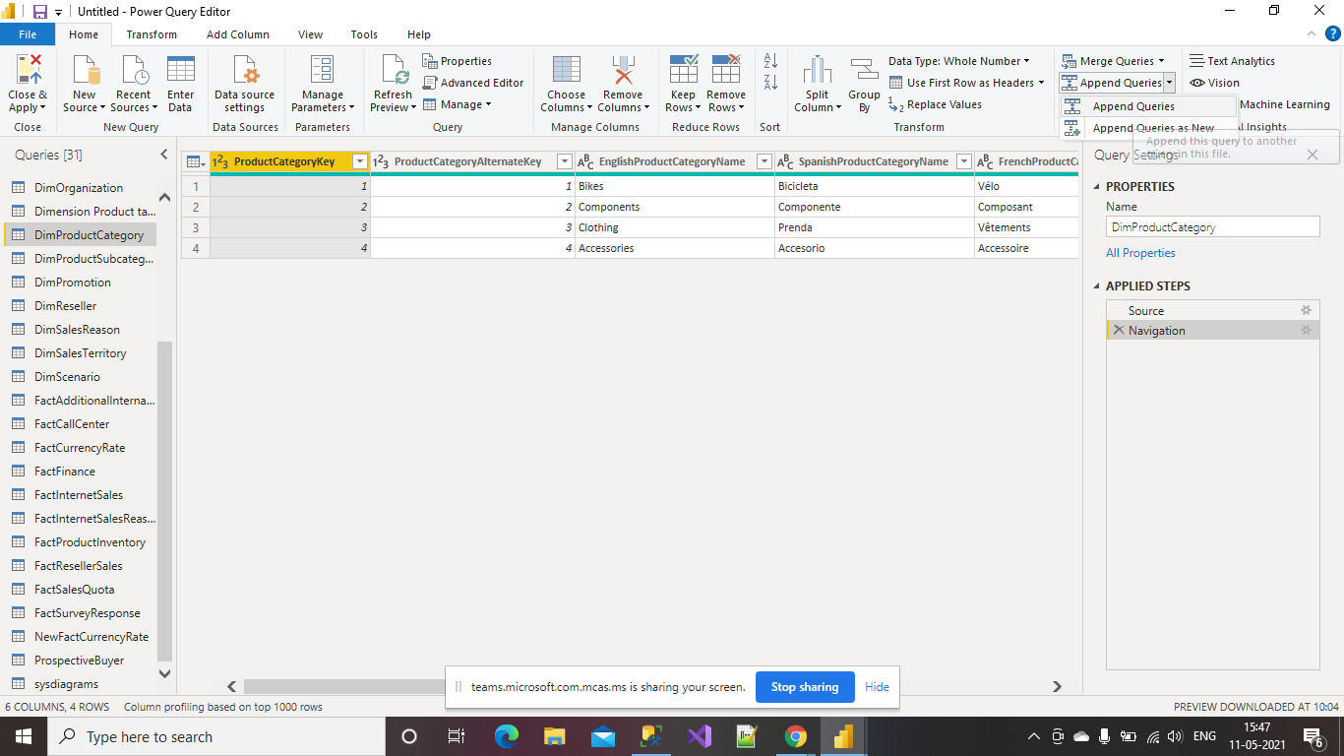

**Combining Queries**

For combining queries select Transform Queries option there we can select Merge queries option

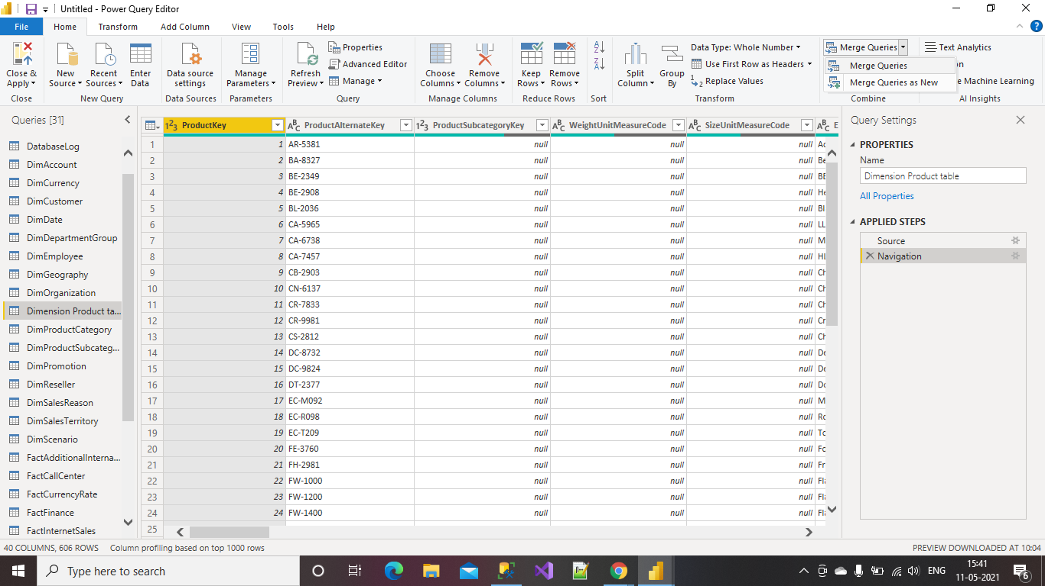

Now select the tables which we need to Merge and click Ok

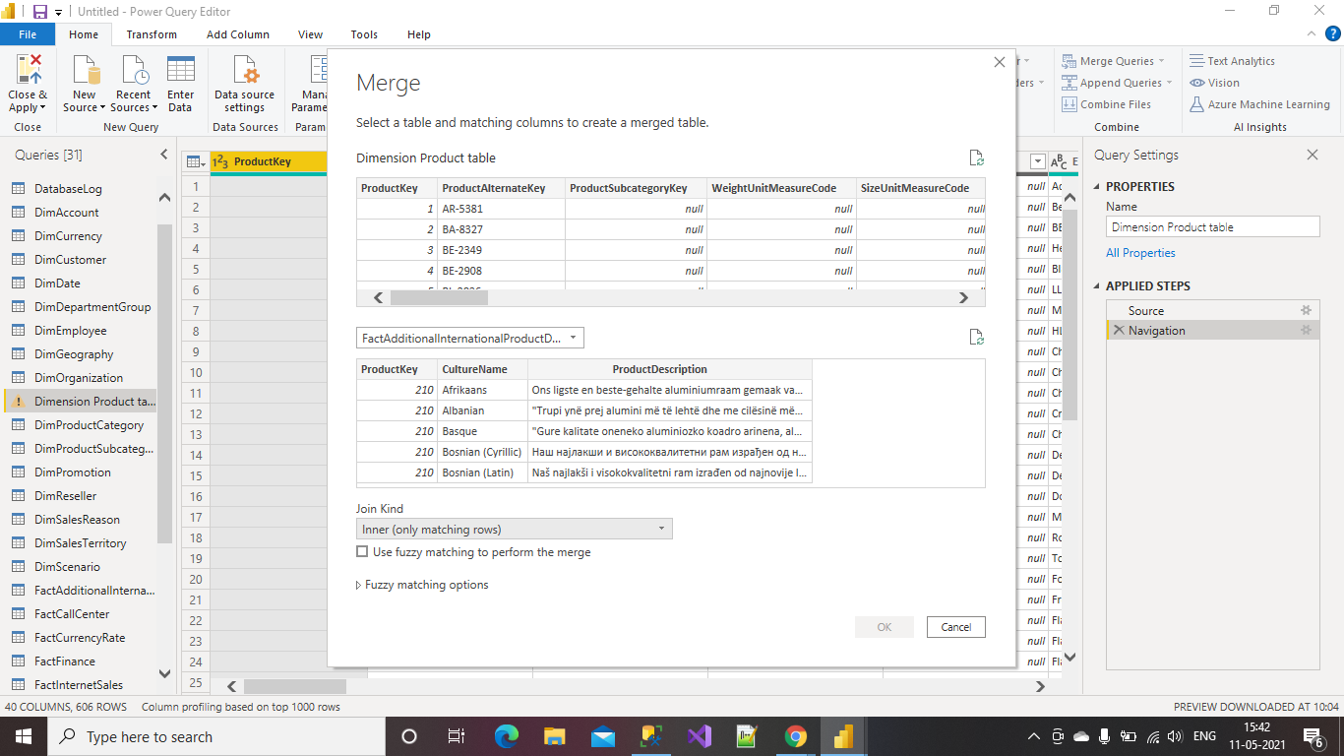

**Able to Fix Metadata Using Power BI**

Select any row which you want to manipulate by setting the selected row as a header.

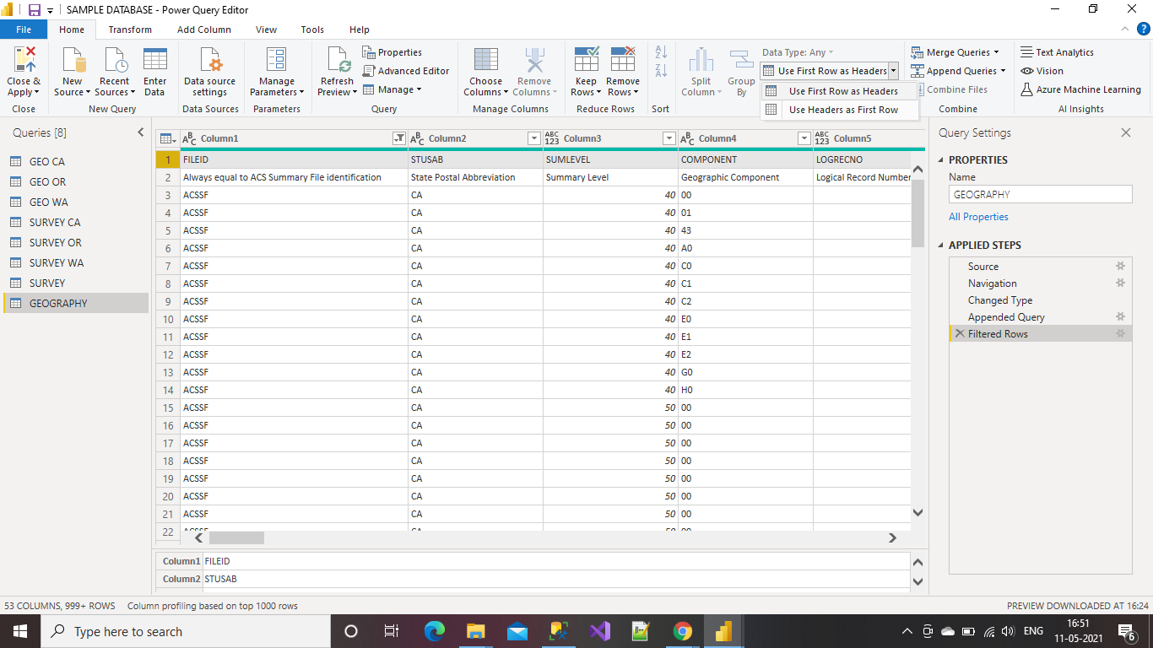

Select the row which you want to remove, Click on the Remove Row on the home and select the option of your choice

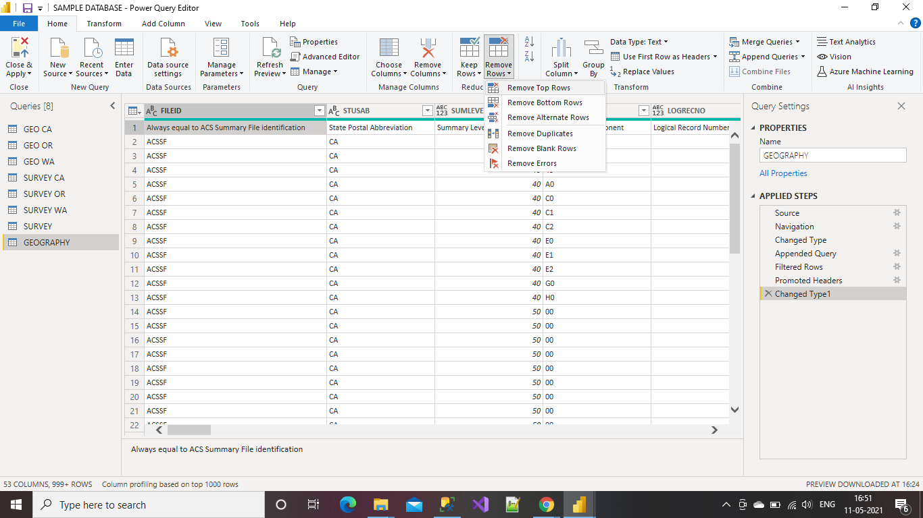

Given the number of rows to be removed and click Ok.

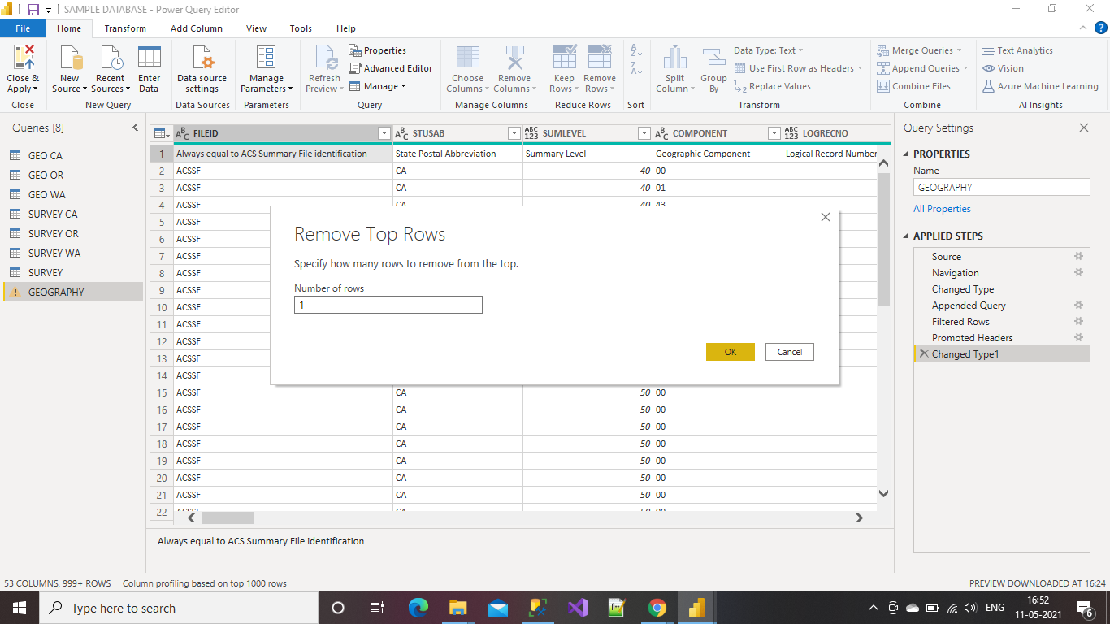

This is how the Editor appears after removing the rows

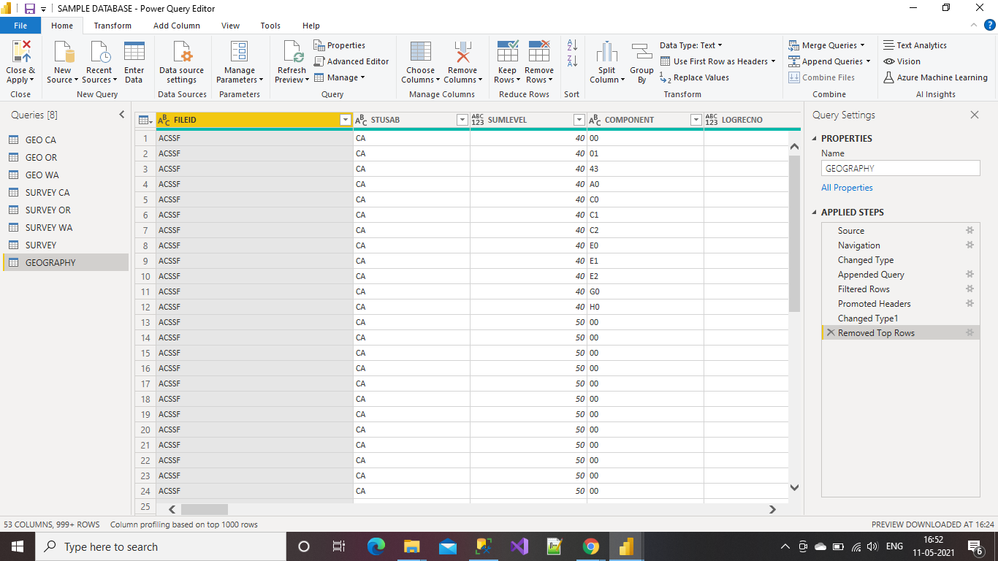

**Able to Filter Rows and Eliminate Columns**

Select the row which we need to filter

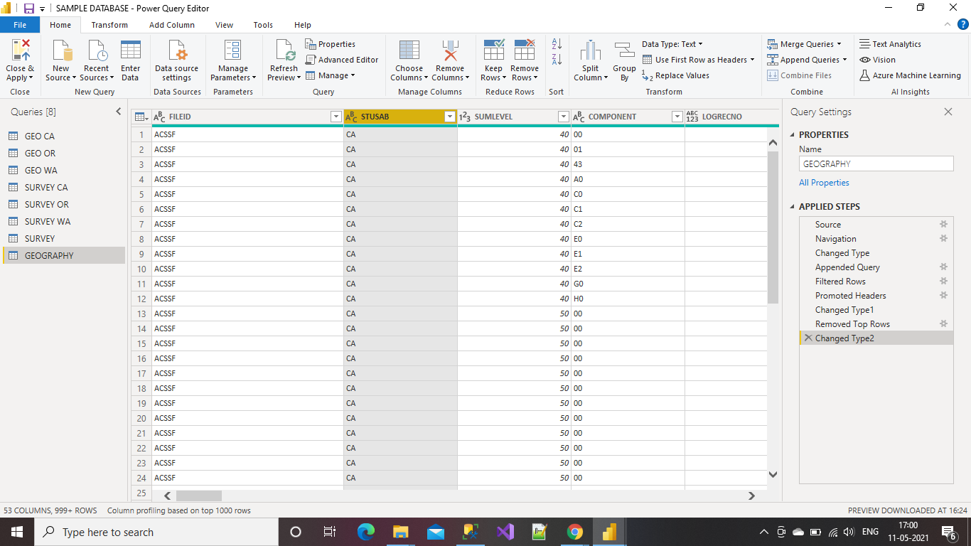

Click on the down arrow and select the values which you need to display and click Ok.

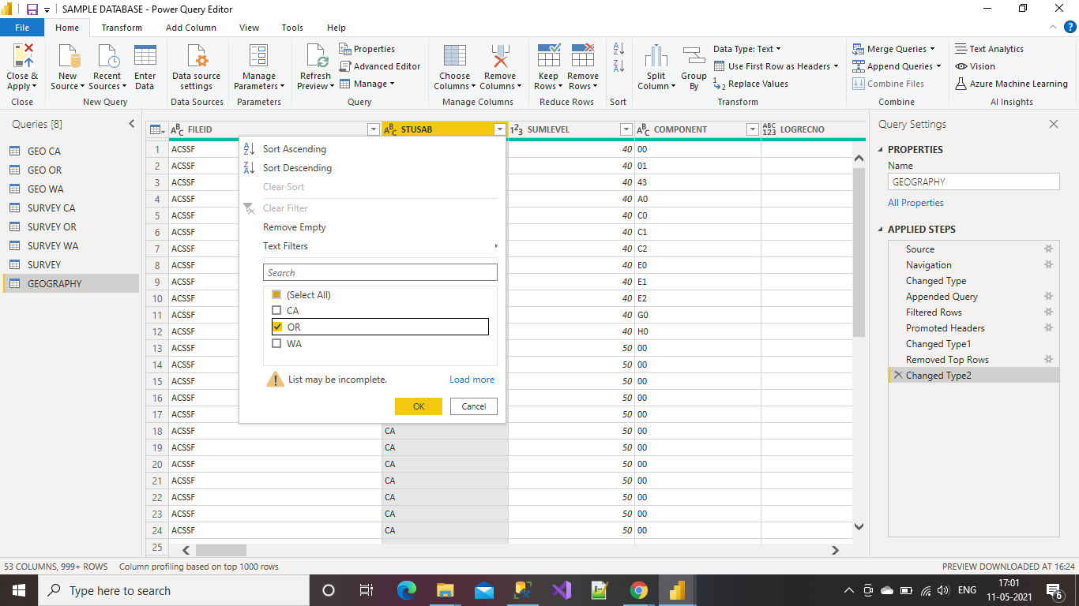

This is how the Editor appears after applying the filtering.

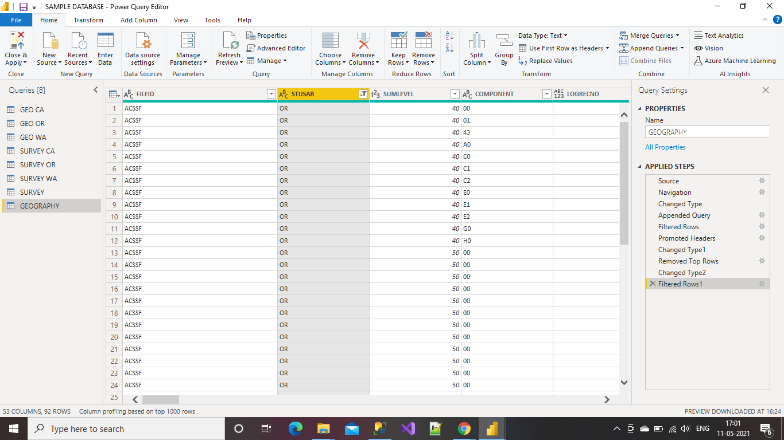

**Removing Columns**

Select Remove Columns option and Click Remove columns then the columns will get removed

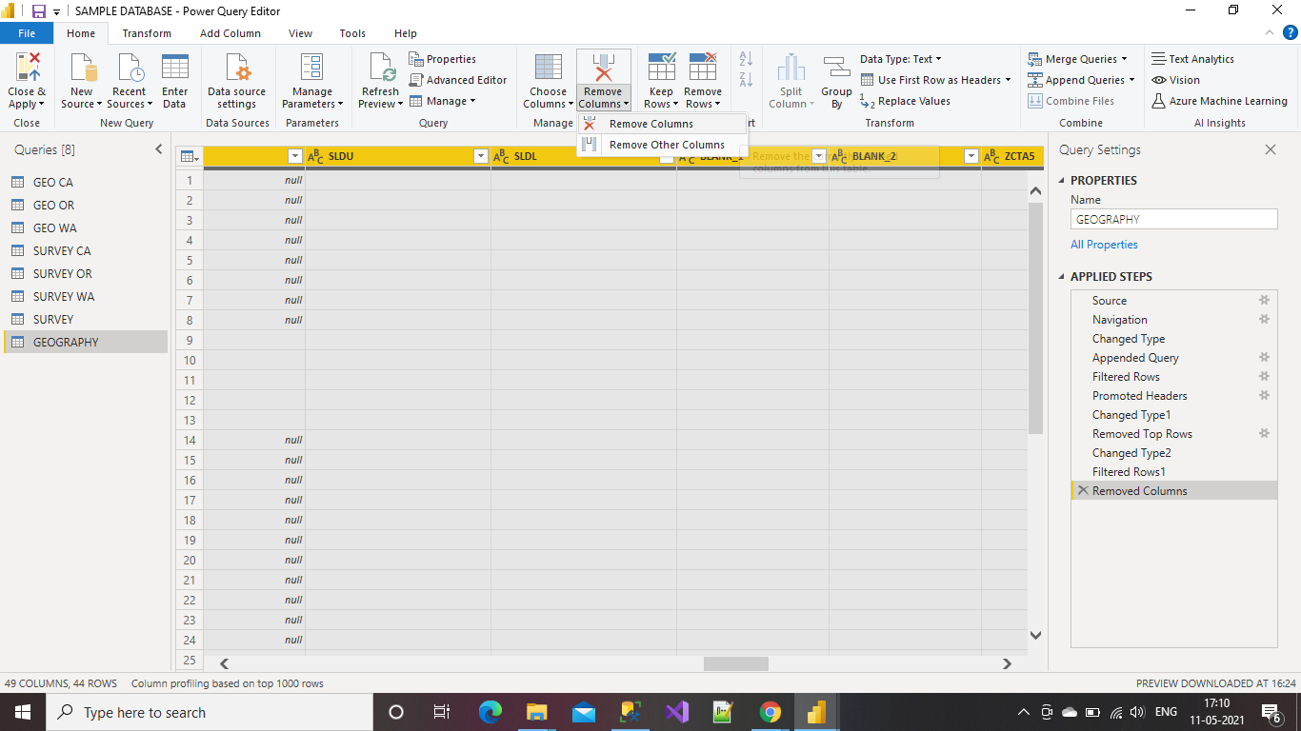

This is how the Power Query Editor appears after removing the columns

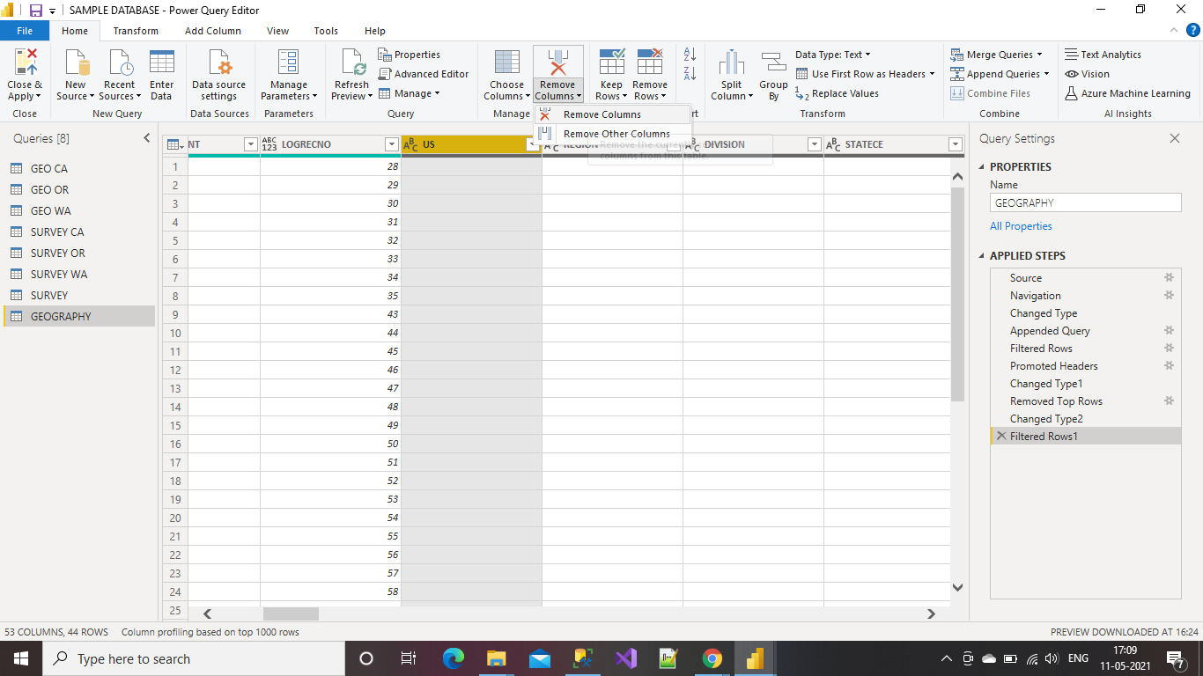

**Able to Merge Queries and Add Columns by Splitting Text**

Select the tables which we need to Merge and Click on Merge queries in the Home

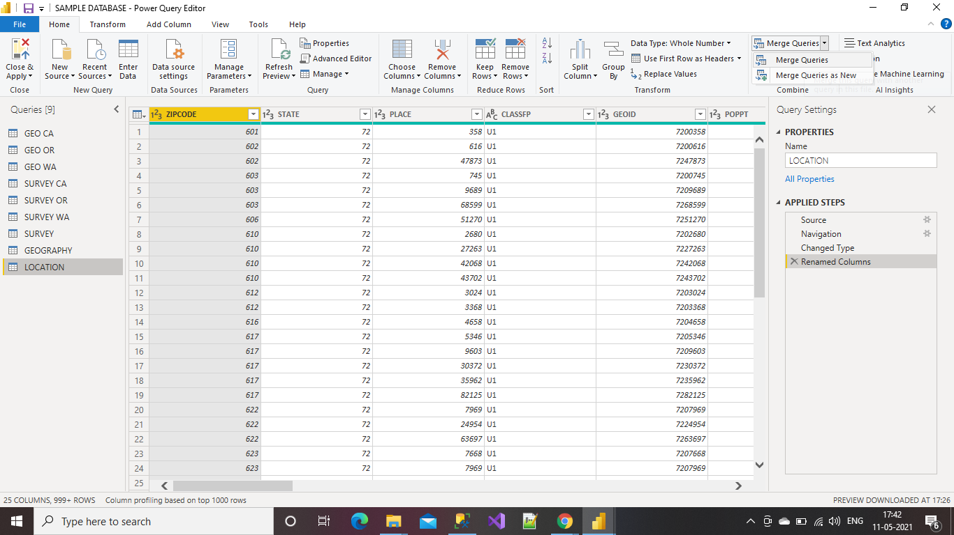

This is how the editor appears after clicking on the Merge option.

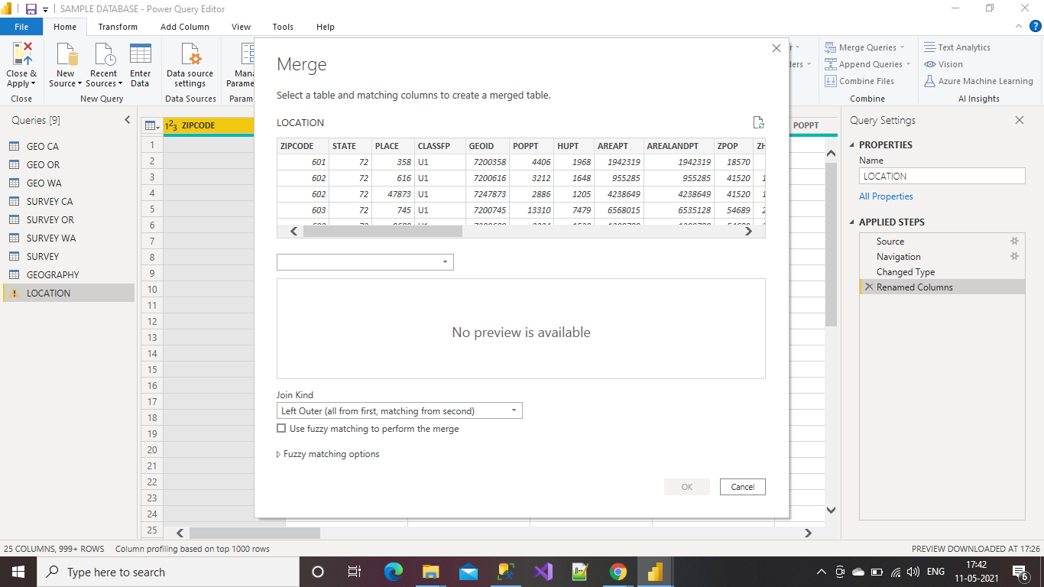

Select the table and matching columns to create a merge table and Click Ok.

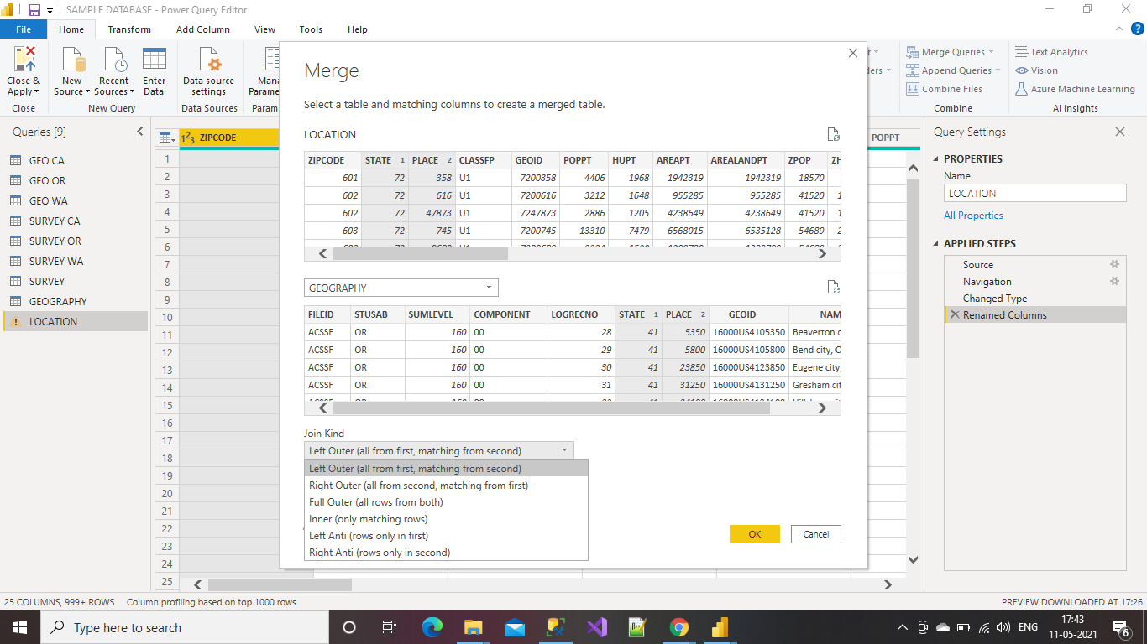

After applying merge option we can see the column added at the end of the table.

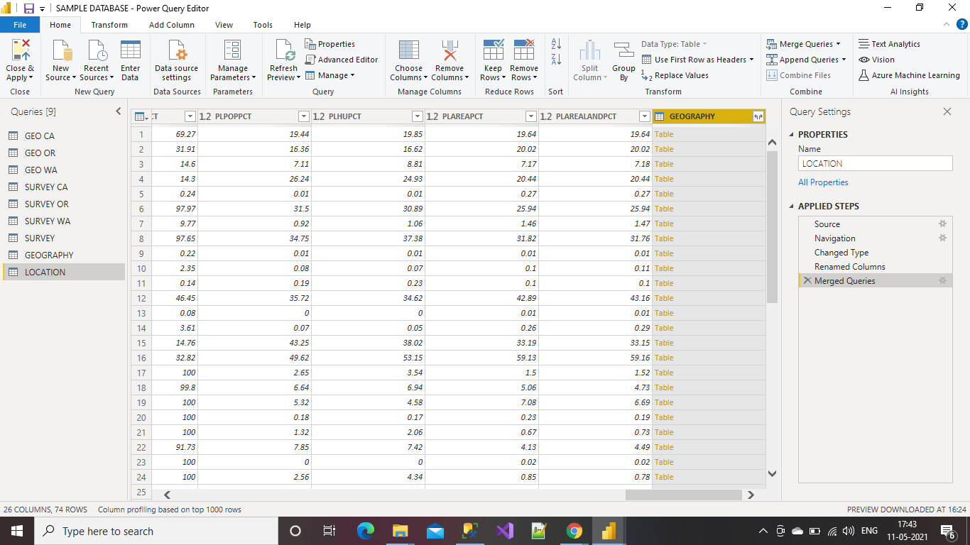

Select a column which we need to Split by selecting the Split Column option on home and select the Delimiter or any of the following options of your choice.

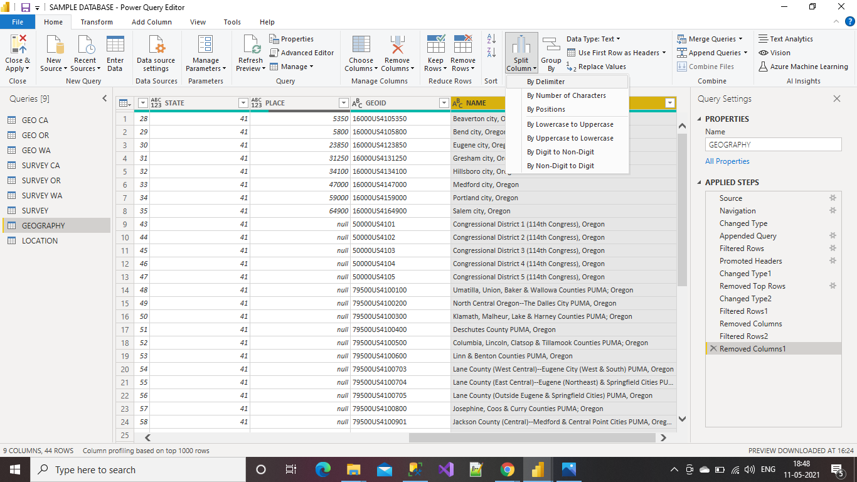

Select the type of delimiter provided in the box and Click Ok.

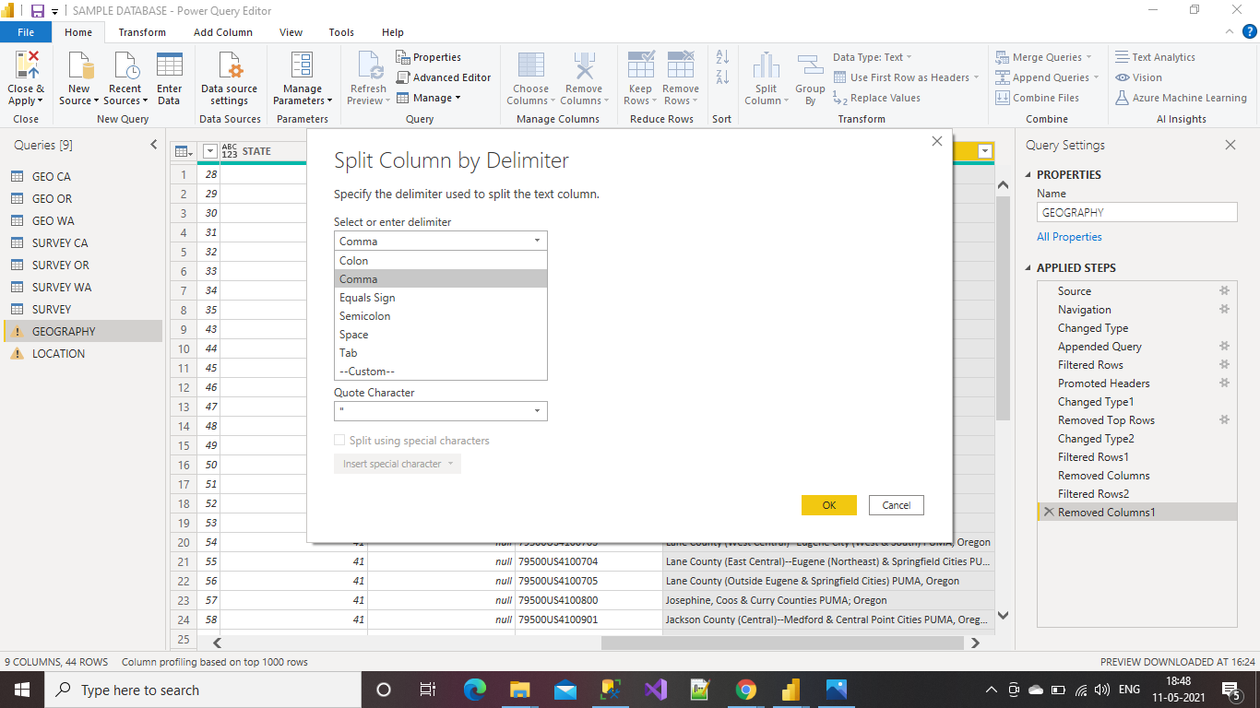

This is how the editor appears after applying the Delimiter to the column.

After applying all the changes Click on Close & Apply option to save the changes.

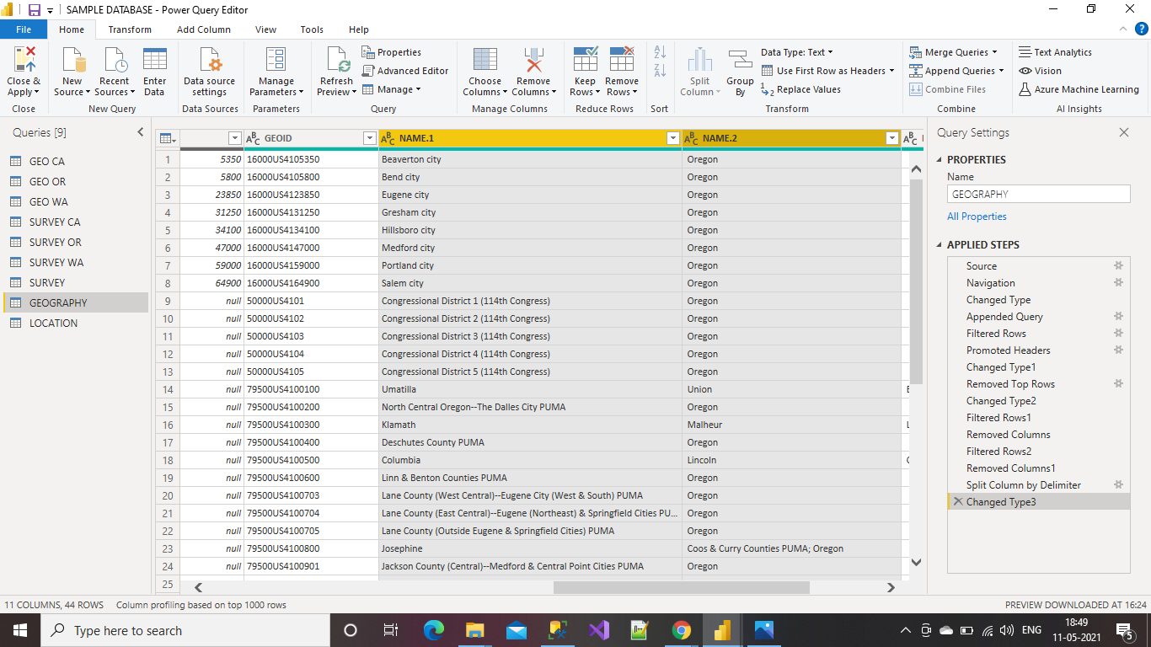

**Able to Add Columns by Splitting XML**

Select the column in which we need to perform splitting function

Now right click on the selected column and select Split Column and then select delimiter

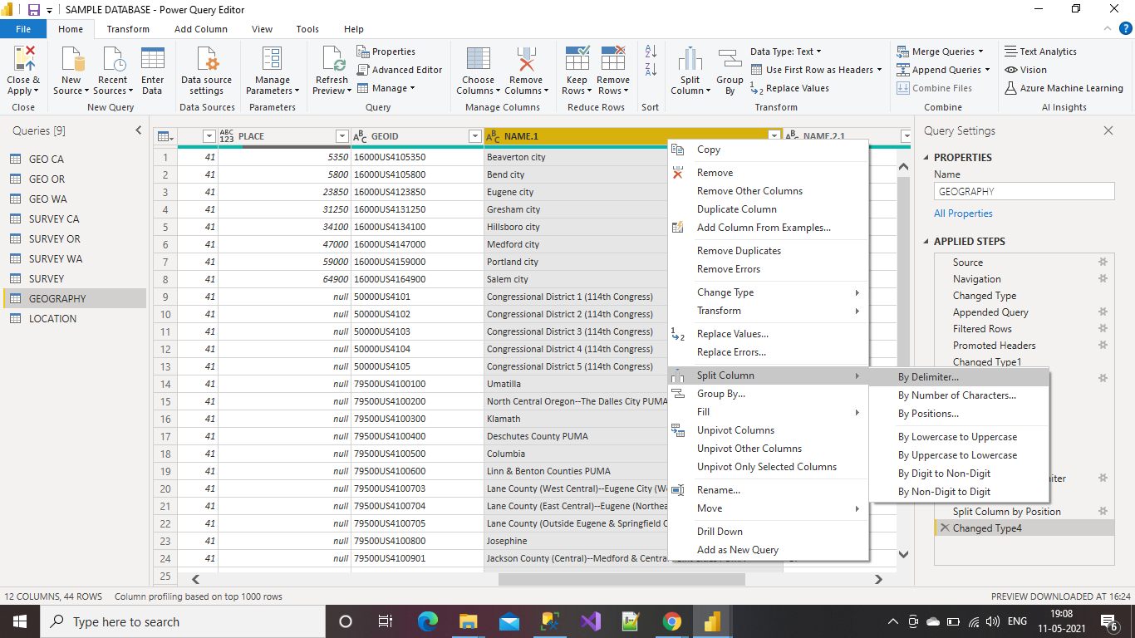

Select the type of delimiter and split at option and then click on Ok

If delimiter was not present then take custom as the type of delimiter and enter delimiter which you want to enter to split the column

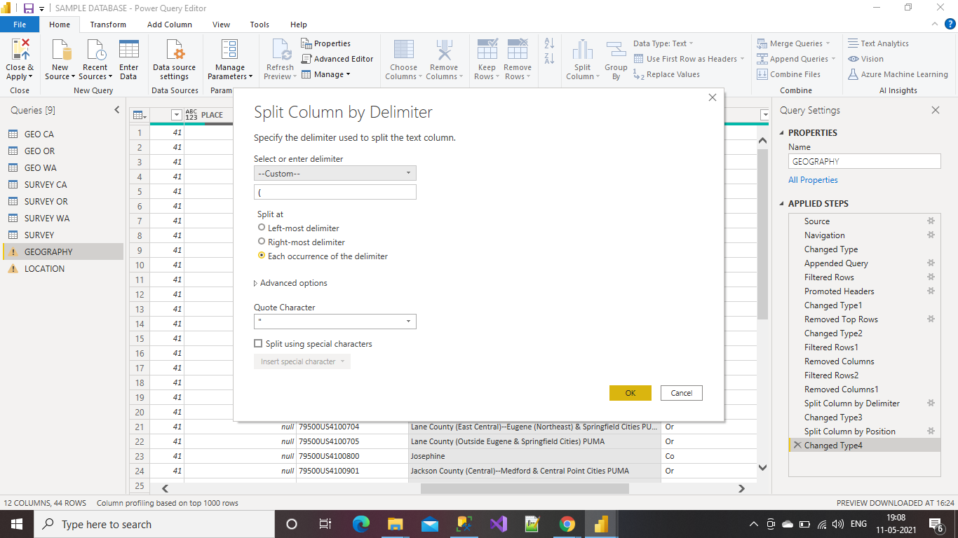

If the column contains any null value, we can Replace them with Empty string

Right click on the column and select Replace values

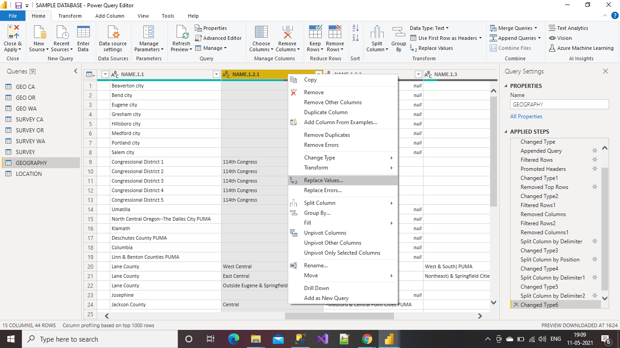

In place of value to find give “null” or the which we want to replace and in the Replace with box give value to be replaced

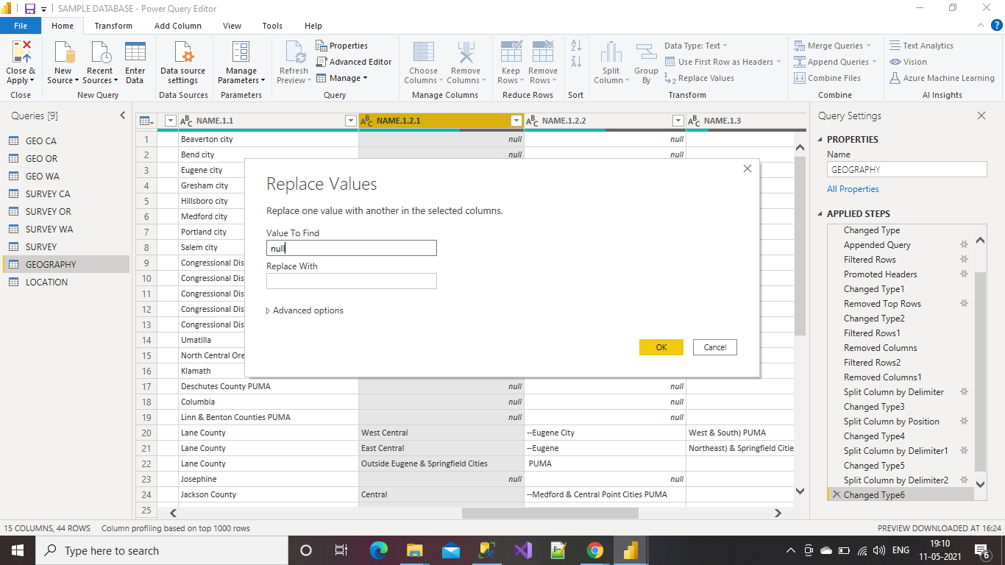

**Able to Add Columns for Sorting**

Select column to perform sorting

Now right click on the selected column and select Split Column and then select delimiter

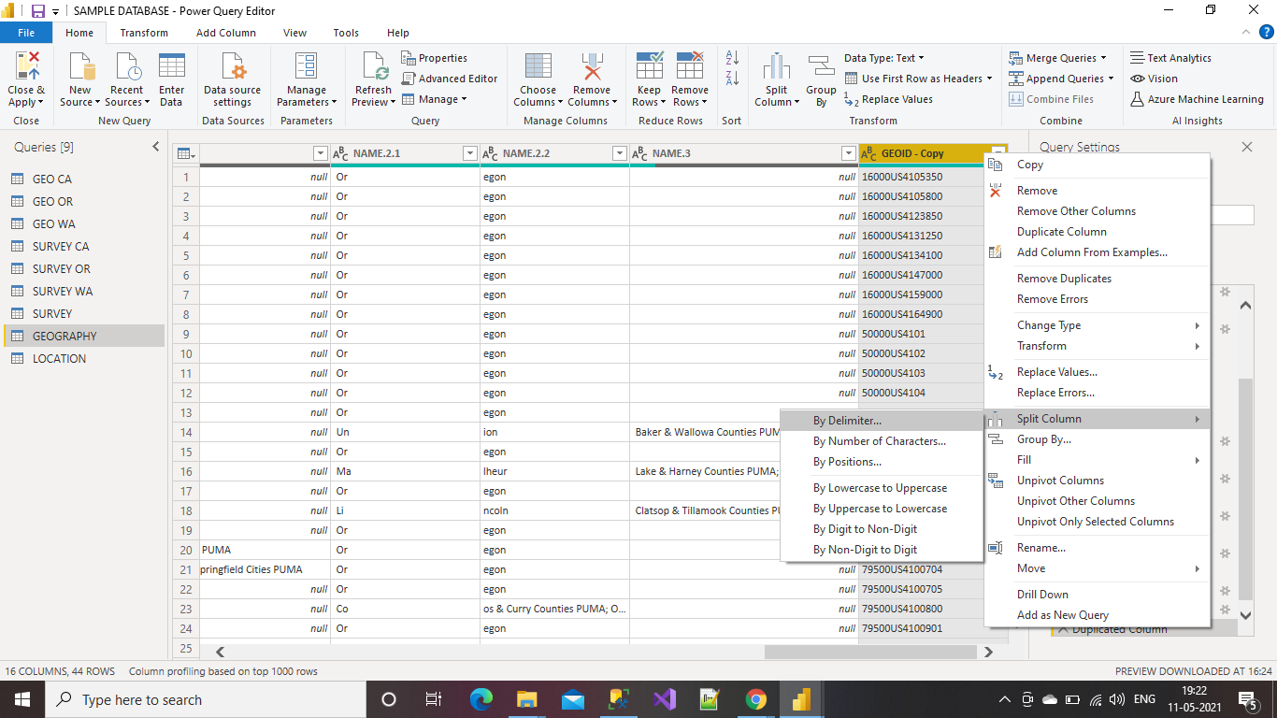

Select the type of delimiter and split at option and then click on Ok

If delimiter was not present then take custom as the type of delimiter and enter delimiter which you want to enter to split the column

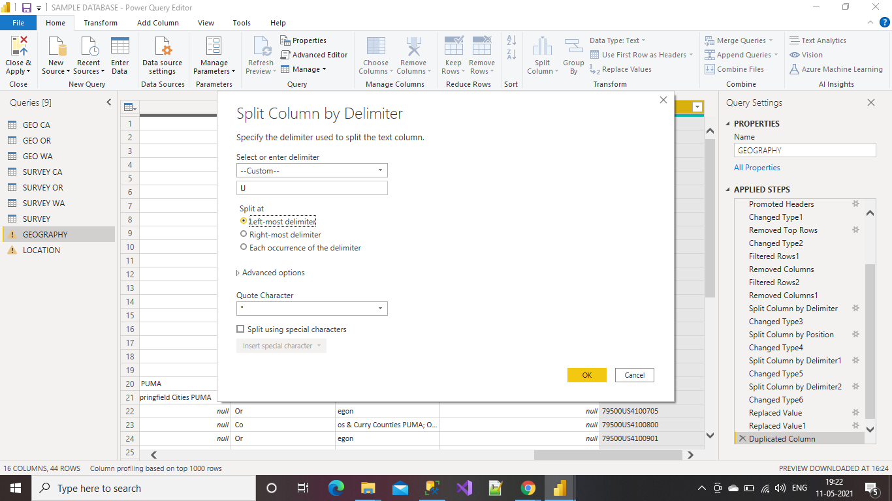

The below picture show the columns after splitting

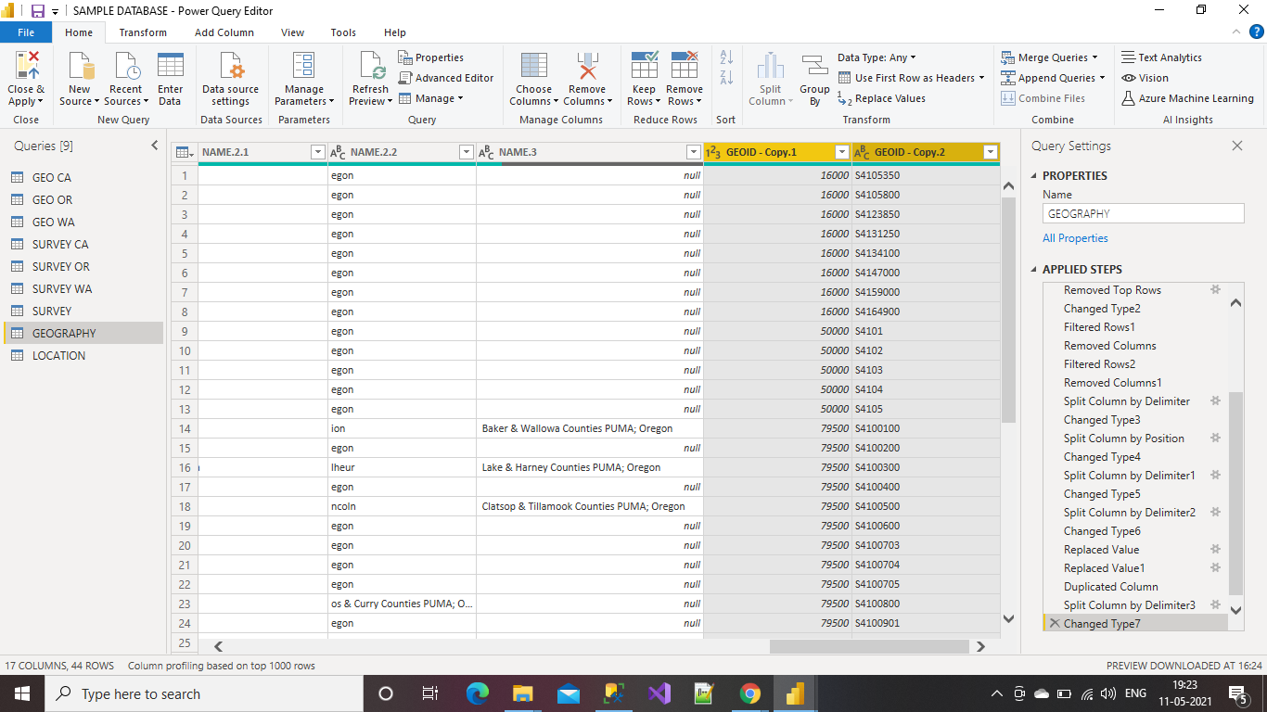

**Capability 3: Ability to understand Data Modeling**

**Able to Create Relationships Using Power BI Desktop**

Click on model it will take you to this page and shows the relationship between the tables.

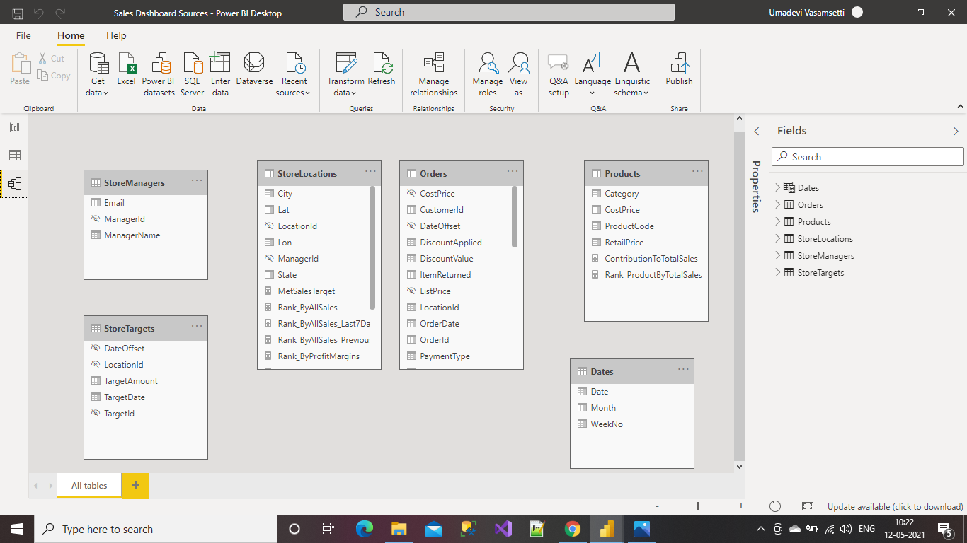

Select the columns which are identical in two tables and drag & drop them to create a relationship.

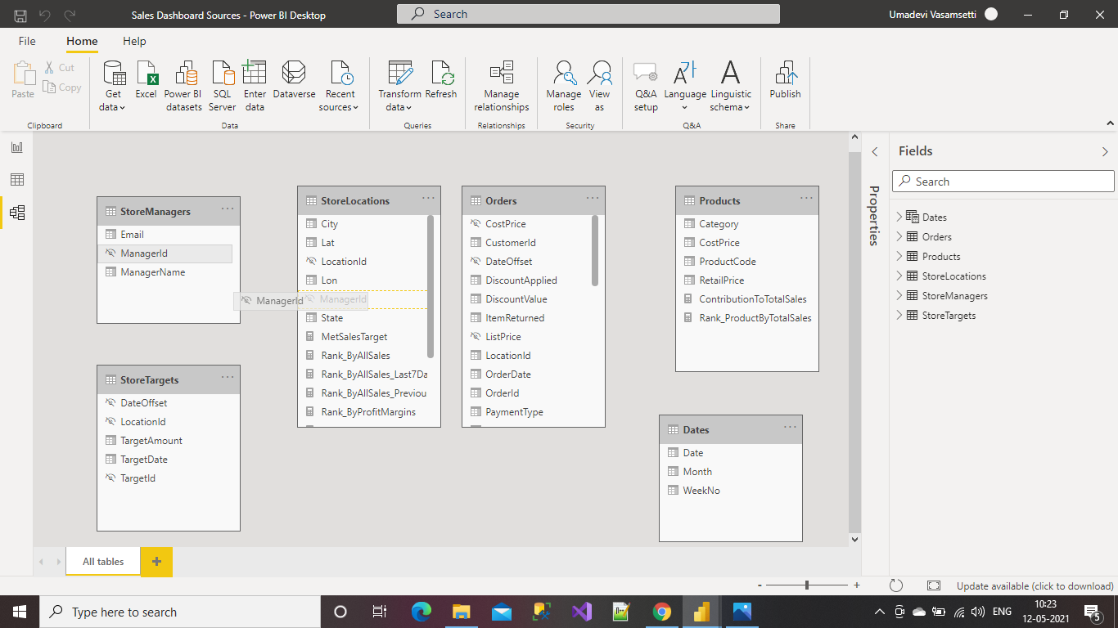

After drag and drop apply relationship between the columns can be seen with the help of the link.

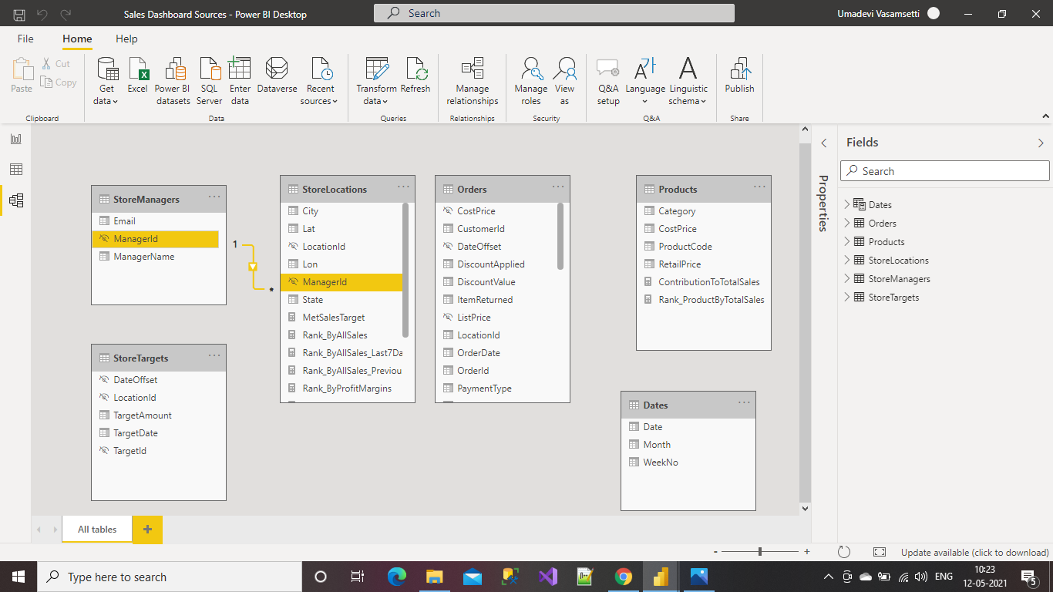

In the same way apply relationships among all the tables.

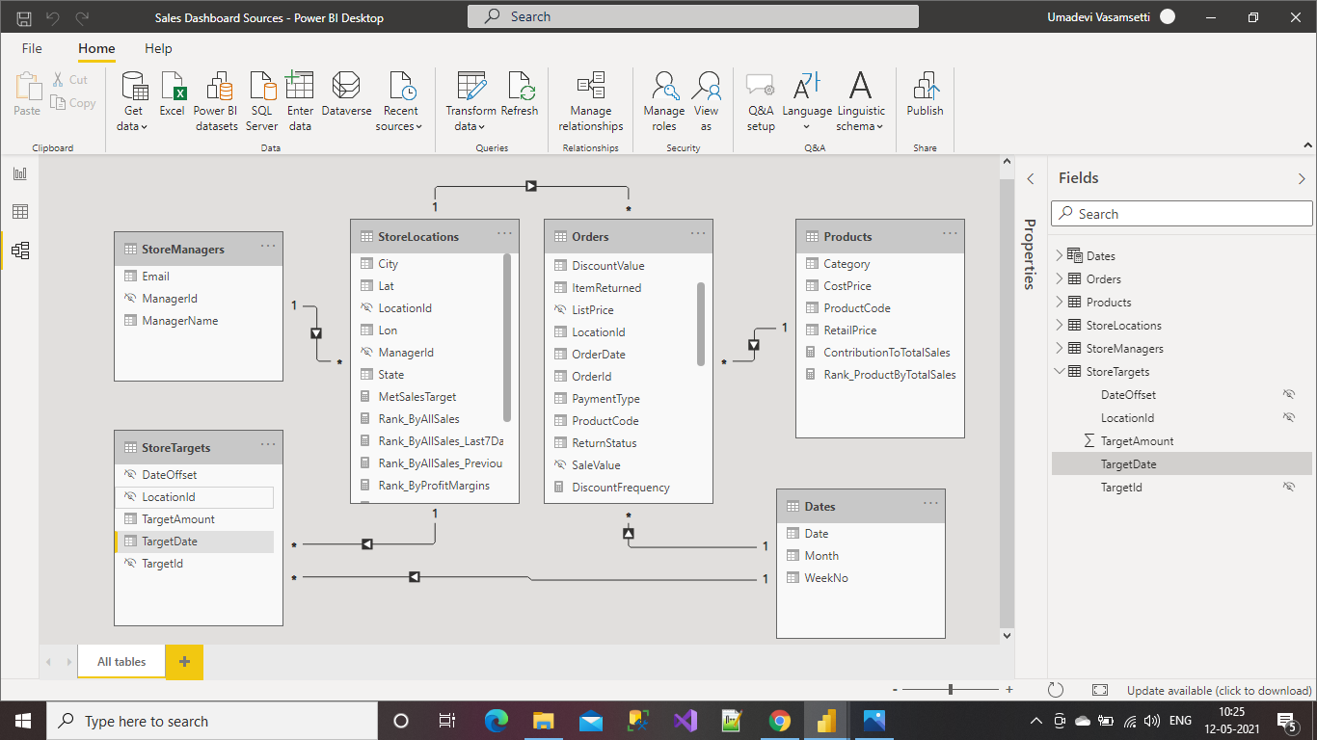

By selecting the Manage Relationships we can edit or delete the relationships among the tables.

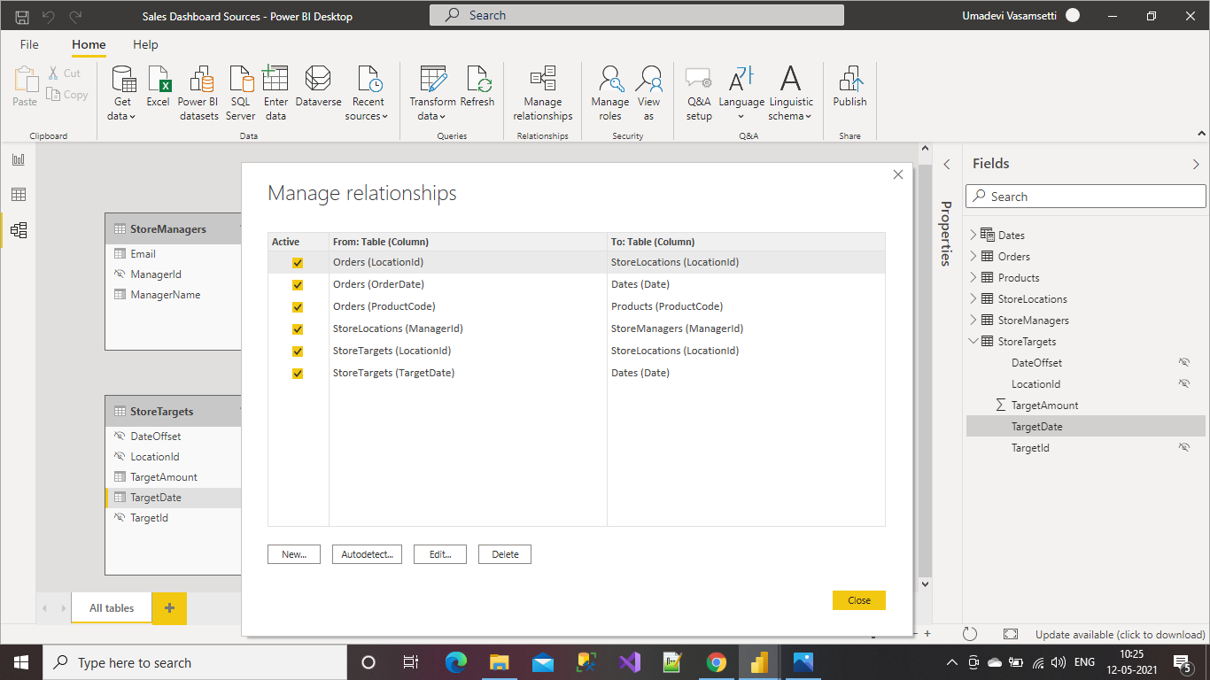

Able to Define New Columns and Able to Concatenate Columns Using Power BI Desktop

Select the data and then select the table for which you need to add the column.

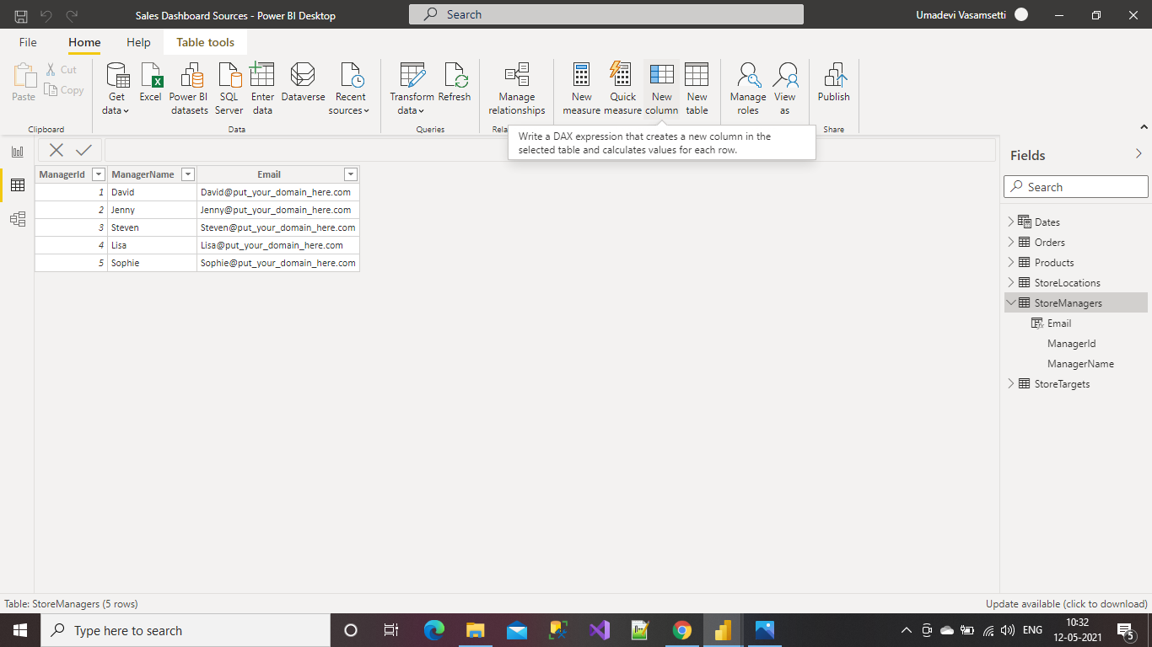

Now click on new column, it automatically adds the column to your table.

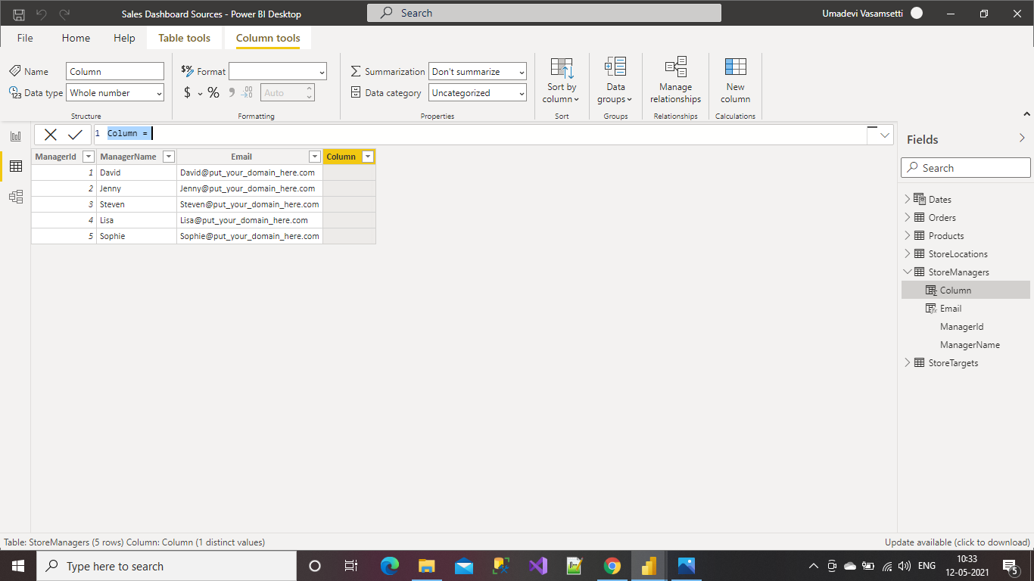

By DAX we enter the data to be there in the new column, after entering the DAX expression, and then click on Enter or simply click on the tick mark, the values will be added to the table.

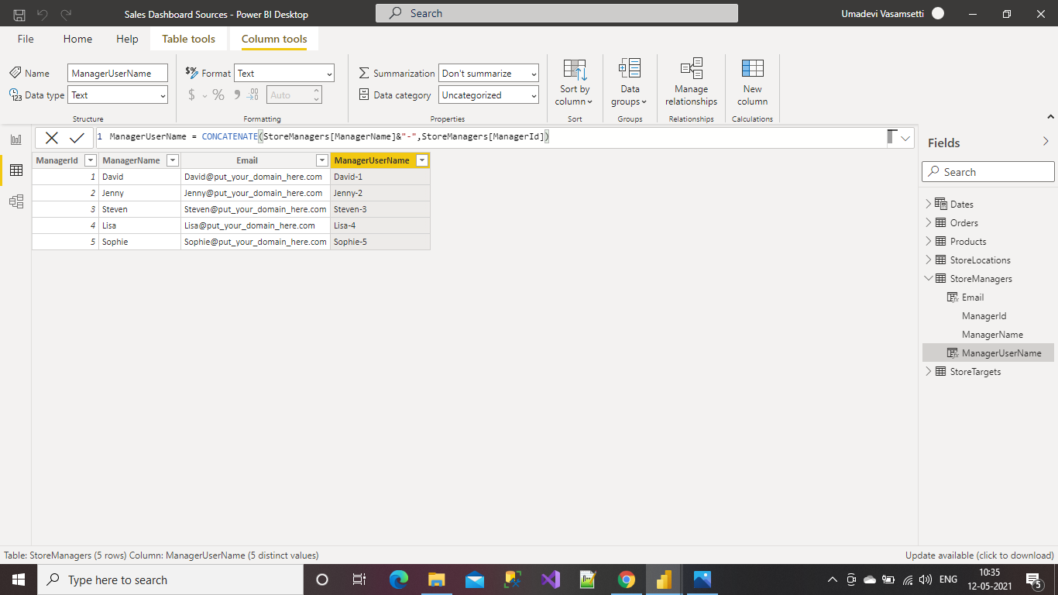

**Able to Perform a Lookup to a Related Table**

Select the table and click on the New column.

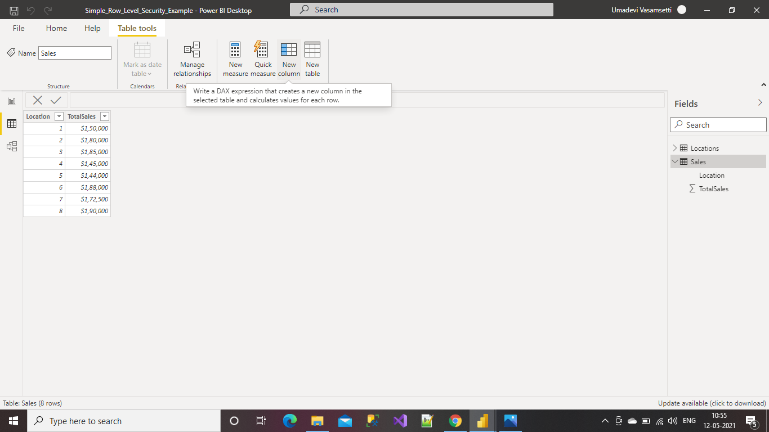

By using DAX expression give the values which you need to perform look up.

Here we have used RELATED function so it returns the related values from another table.

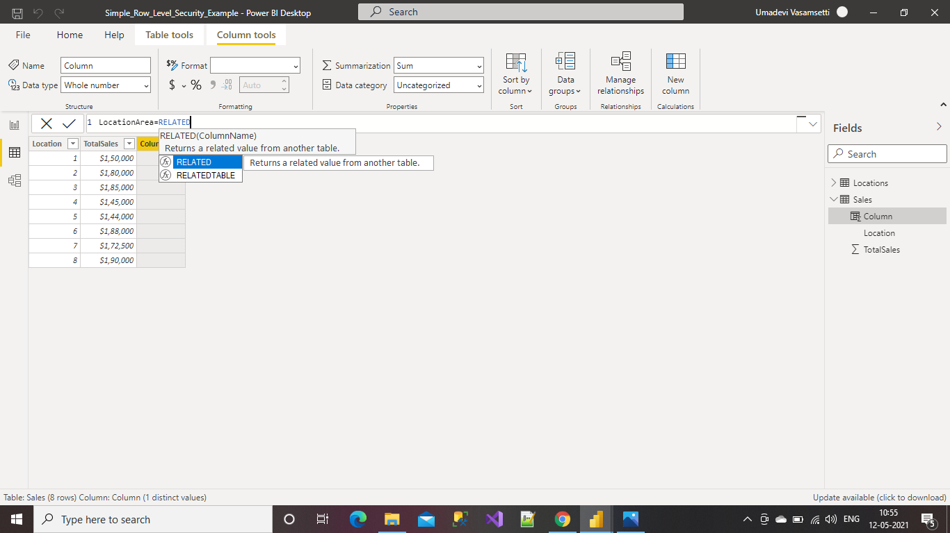

This is the result for the look up operation.

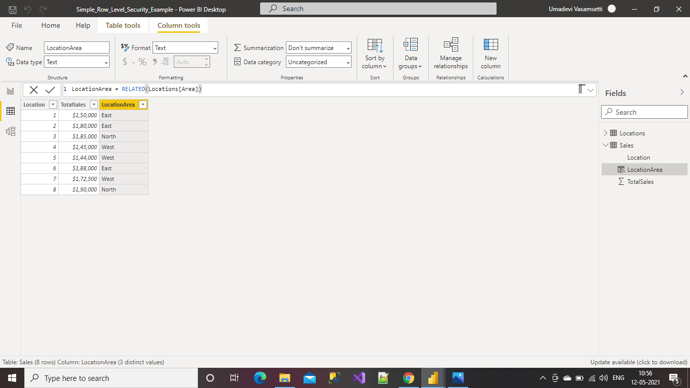

**Able to Translate a Value using IF function**

Select the table and click on New column.

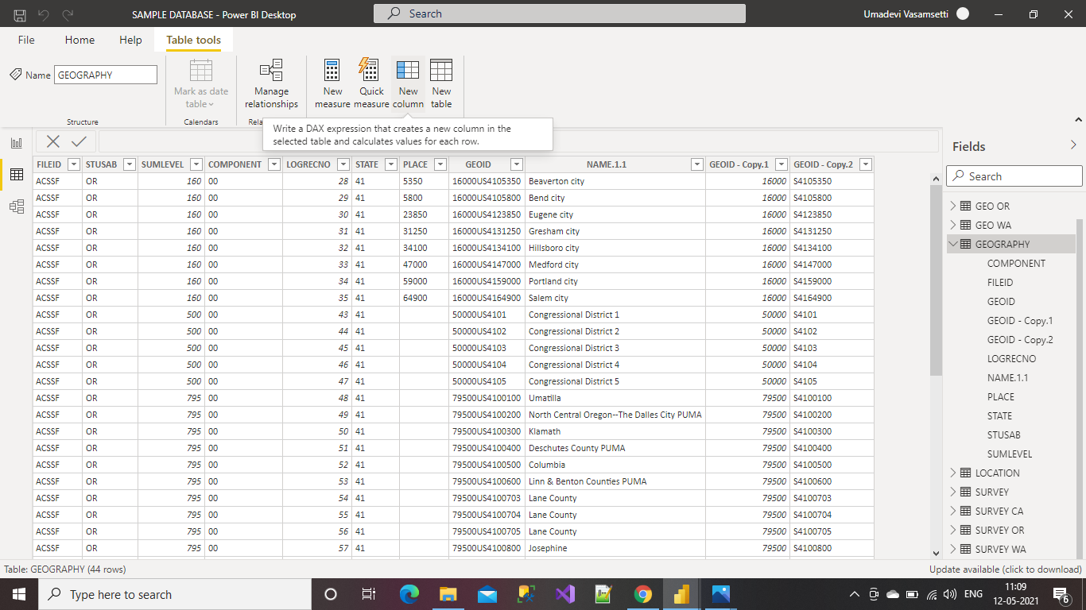

Now select any column you want to perform IF condition and provide the values.

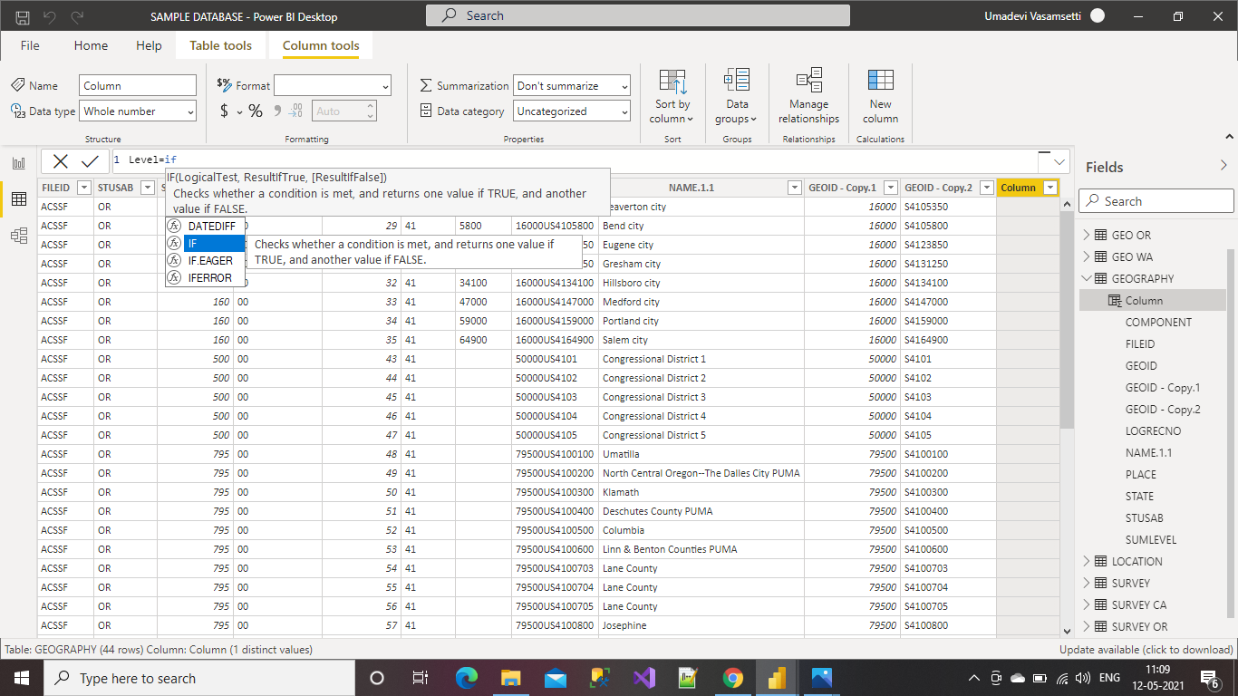

After applying IF condition this how the result is formed.

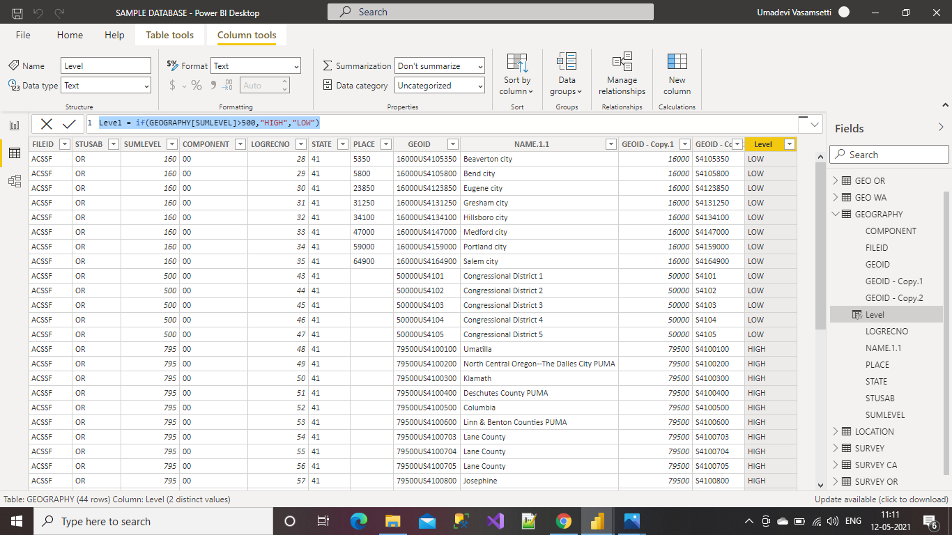

**Able to Add a Date Table in Power BI Desktop**

Go to table tools and Click on New Table option.

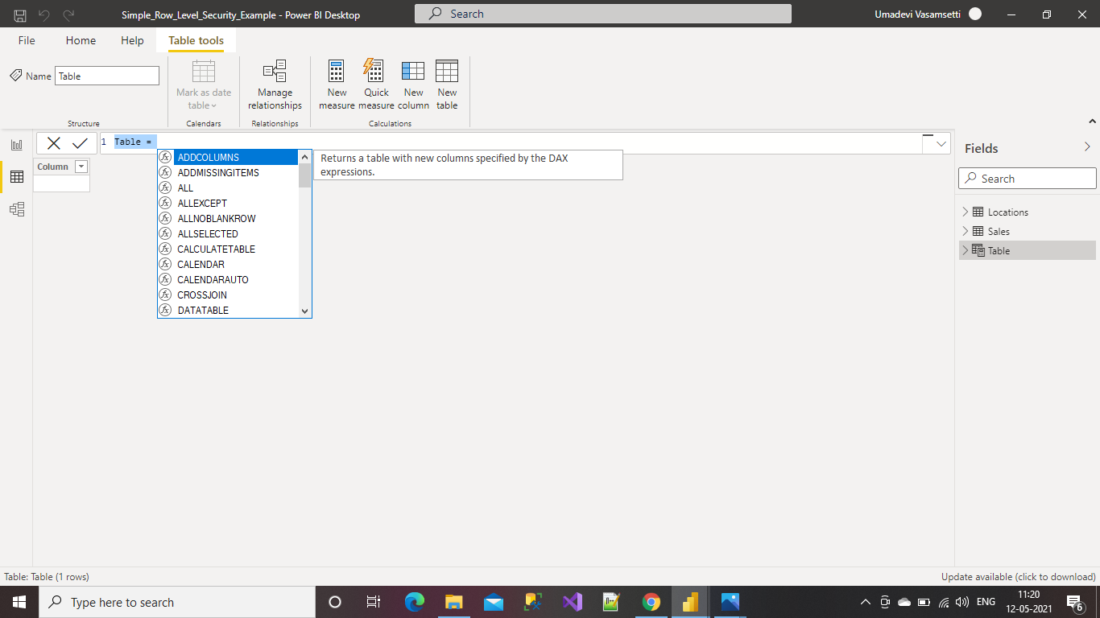

Name the table and use the CALENDAR AUTO function which returns a table with one column which contains Time, Day, Date, Month and Year.

From the Model automatically.

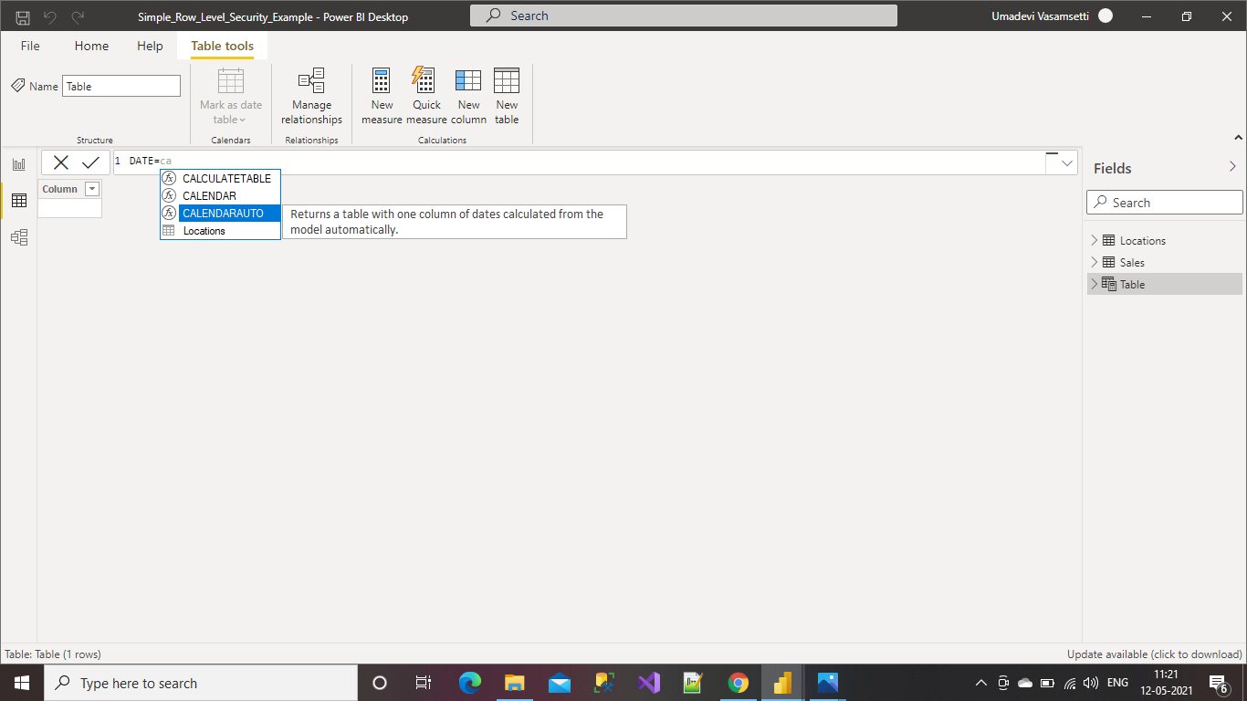

If you want to delete the Time from the above table we need to perform Format and select type of your choice.

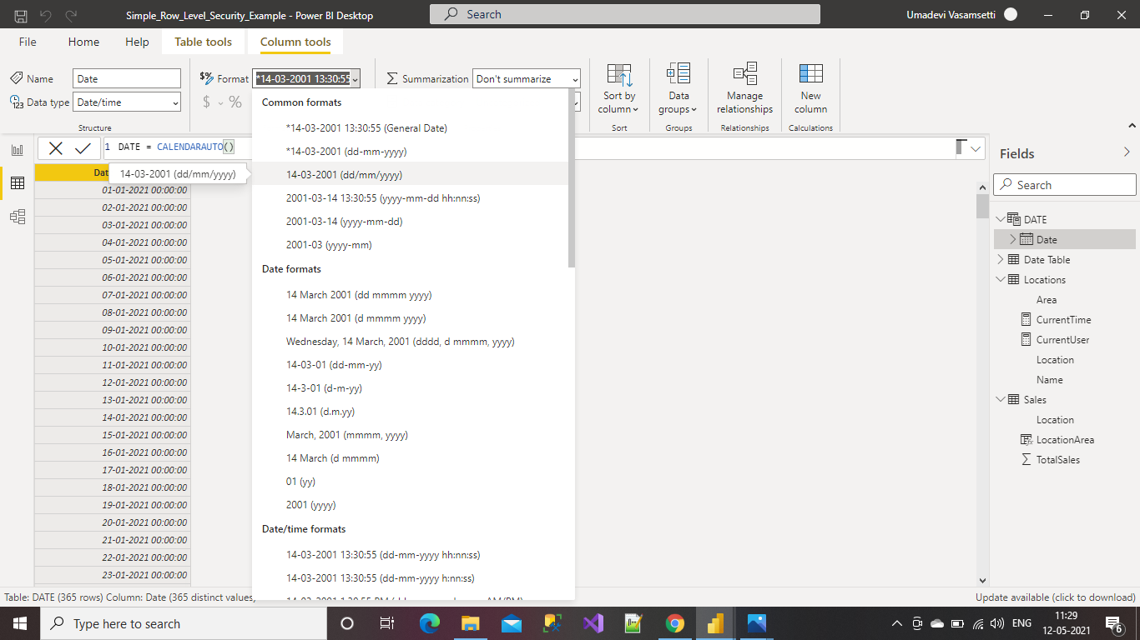

After Formatting the column this is how the Desktop looks.

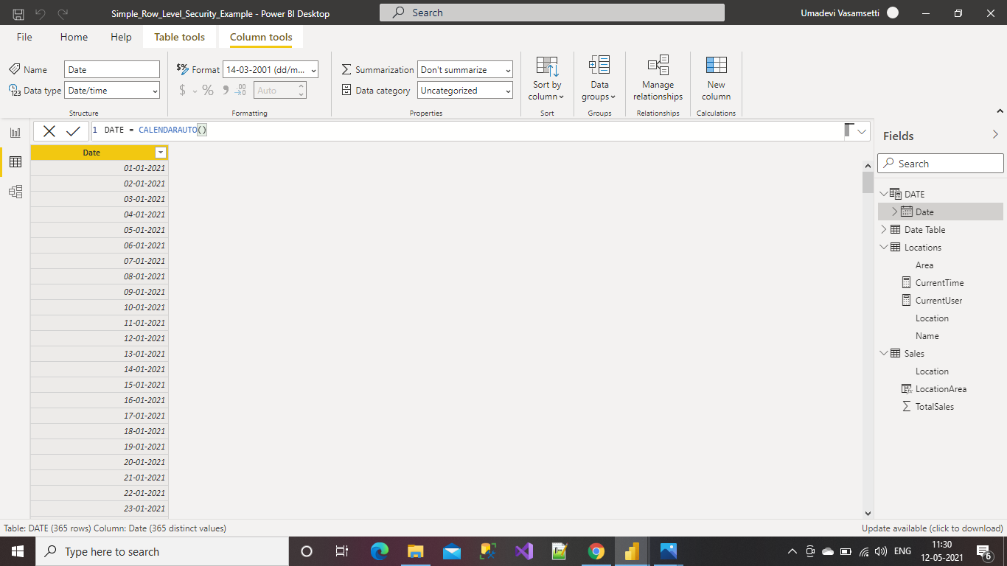

**Capability 4: Ability to Enhance the Data Model**

**Able to Define Hierarchies in Power BI Desktop**

Select any column from the Table to Create Hierarchy.

Right Click on the column and select Create Hierarchy option.

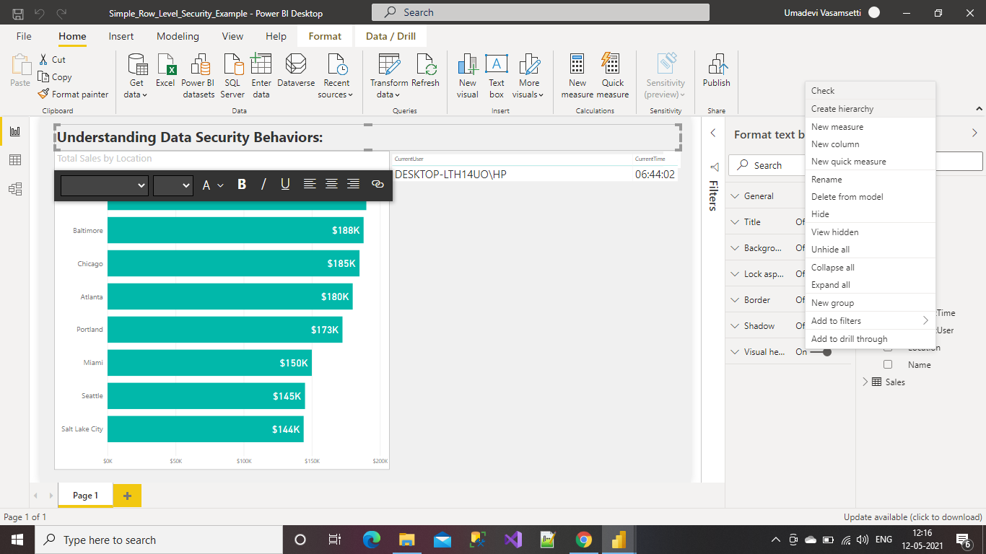

It will create the Hierarchy with same Column name, to change the name of the Hierarchy Right click and select Rename option.

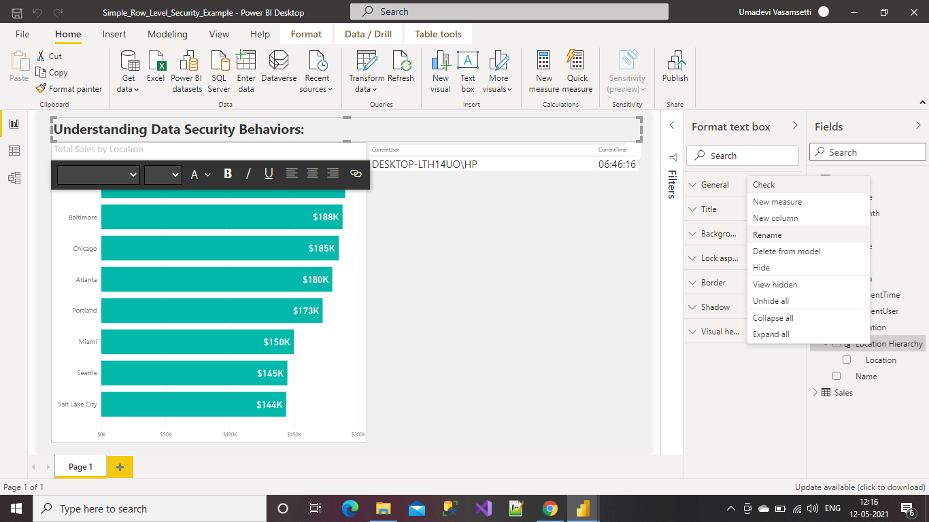

Select another column to add to the Created Hierarchy.

Right click on the column and select Add to Hierarchy option, select the created Hierarchy.

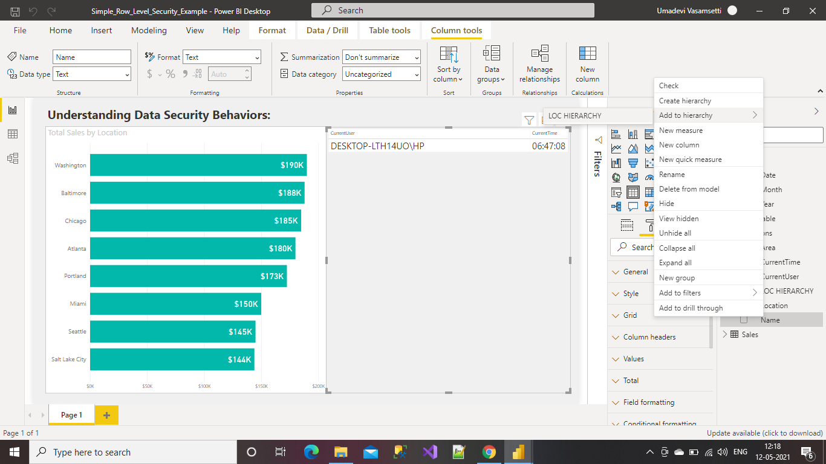

Now we can see the Result of the added Hierarchy on the right side.

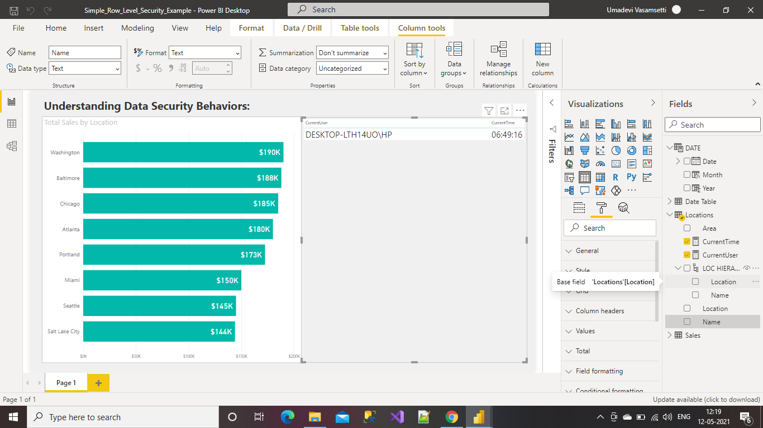

**Able to Define Hierarchies in Excel and Configuring Properties**

Select the Column and Right click on the column and Select Hide in report view option to Configure the properties.

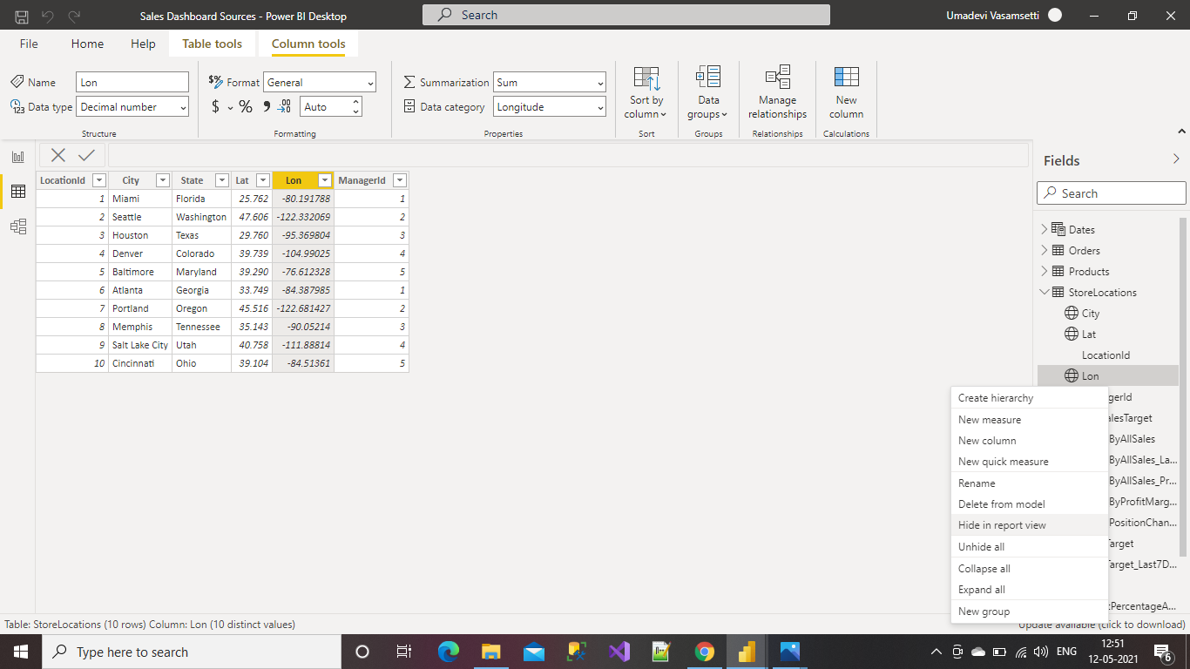

Here you can see the configured column hidden.

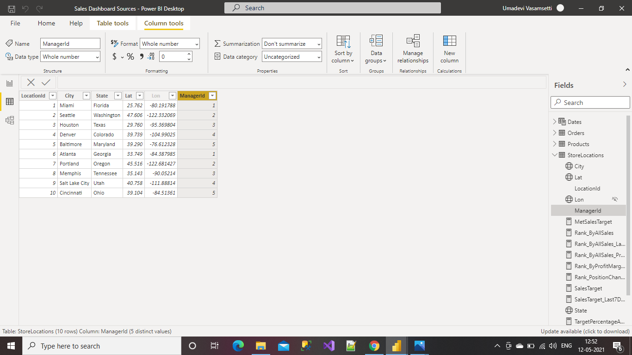

To change the data category of any column, which will configure the properties of that column.

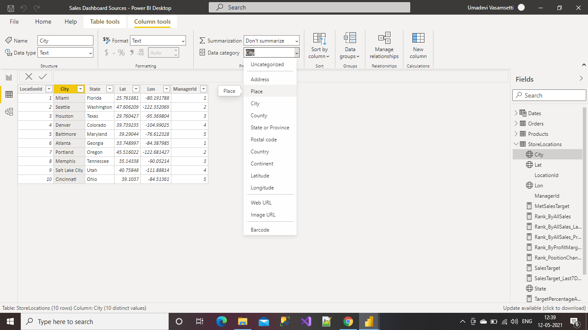

**Able to Configure Properties: Formatting & Default Summarization**

Select any column to be formatted and click on Format option.

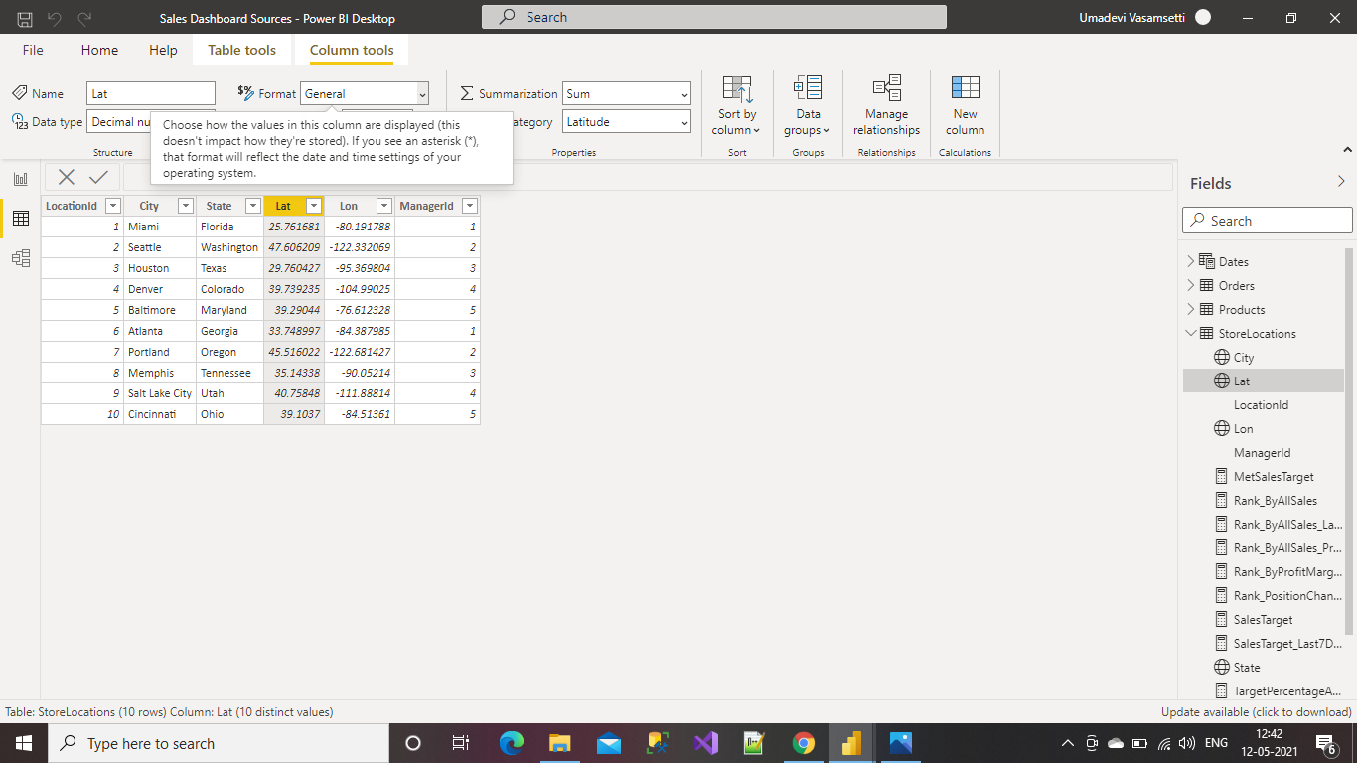

Select any option from the drop down list of your choice to perform format.

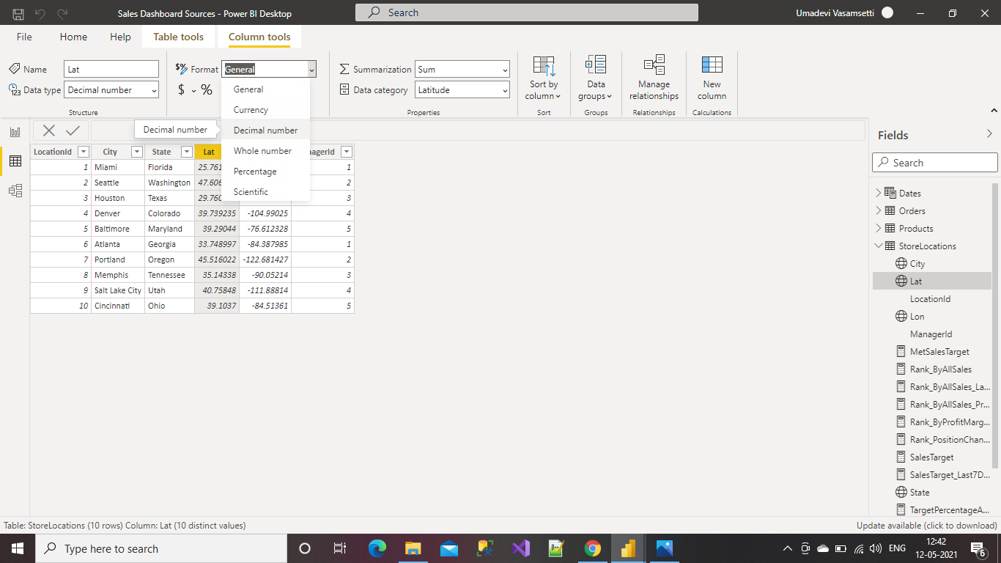

We can give the number of Decimal points to be needed to display the value.

Here we have selected 3 decimal points and this is the result.

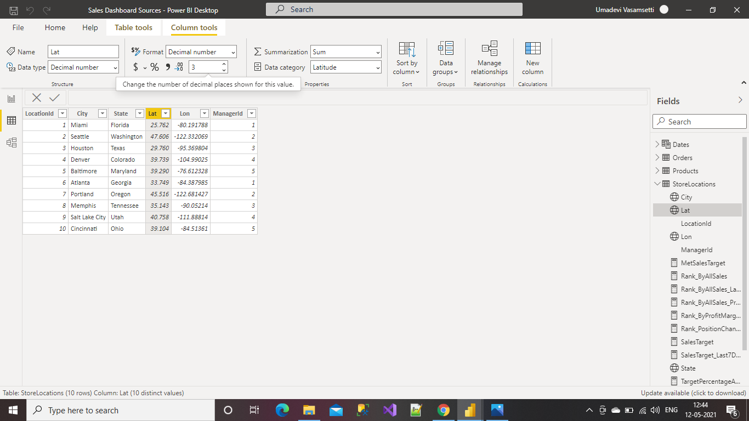

Select column and Click on the Summarization, Select any aggregate function from the drop down list.

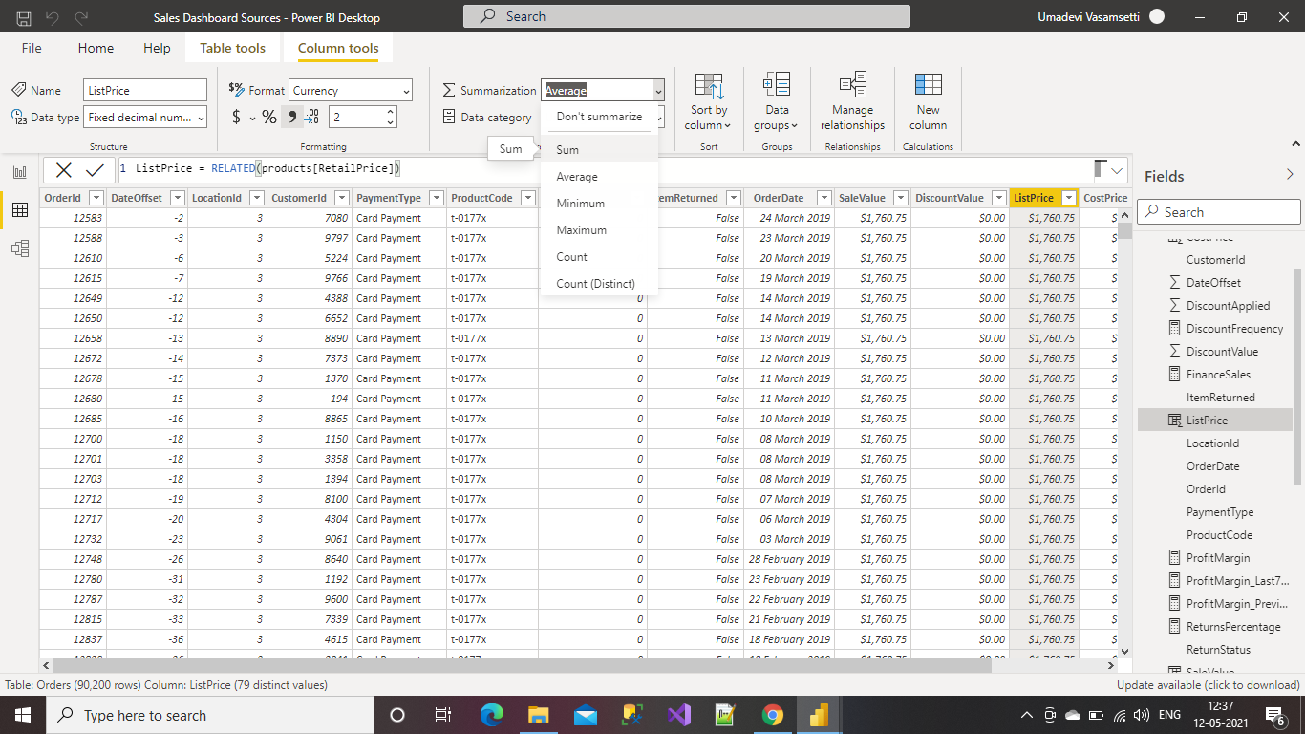

**Capability 5: Ability to Visualize data using various Visualization options in Power BI**

**Able to Add a Table, Clustered Column Chart & Bar Chart**

**Adding Table Visual to the Power BI Desktop**

Go to visualizations and select Table option and click on that.

This is how the Power BI Desktop appears after adding the Table.

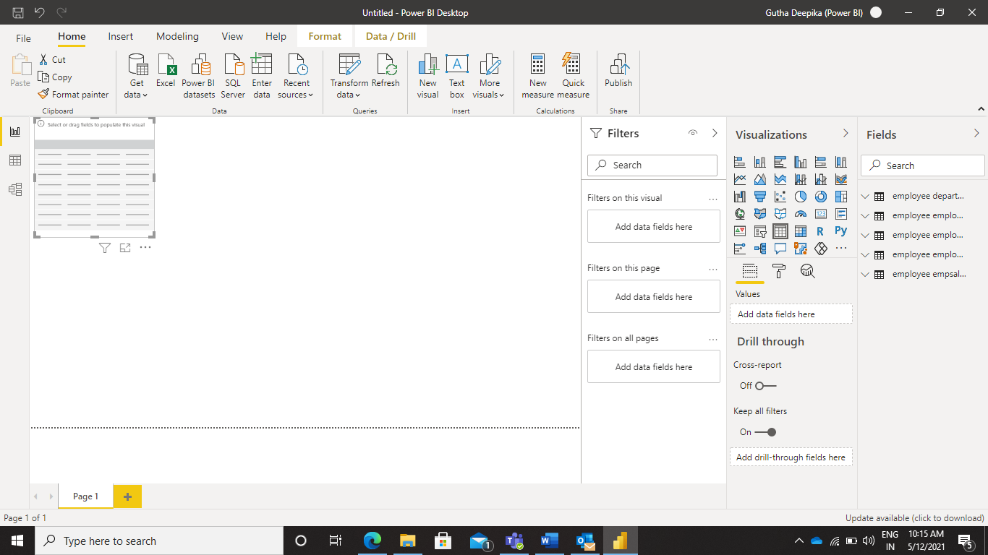

Add the columns which you want to display in the Table.

You can select columns from different tables and add them to single table.

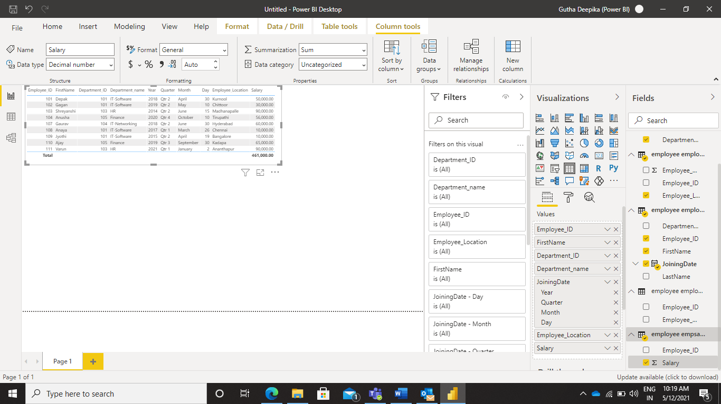

This is how the Power BI Desktop appears after adding the values.

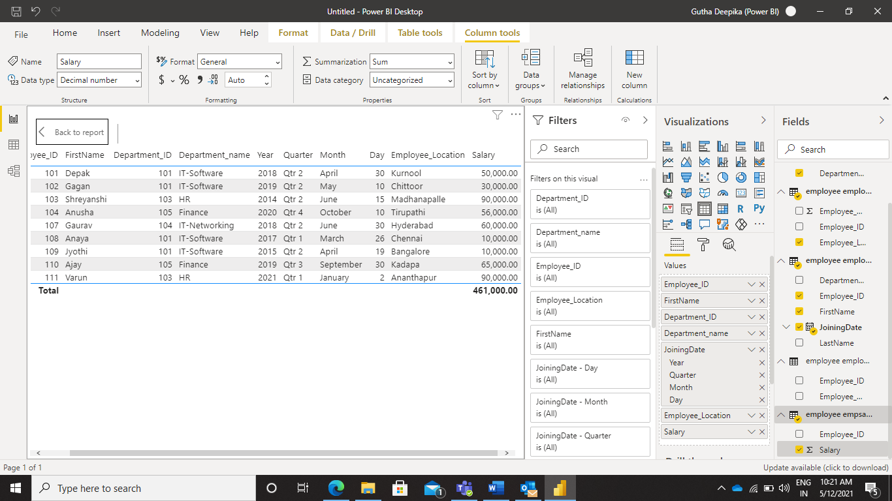

**Adding Cluster Columns chart**

Go to visualizations and Select Clustered Columns Chart and add the Chart to the Power BI Desktop.

This is how the Power BI desktop appears after adding the Clustered Columns Chart.

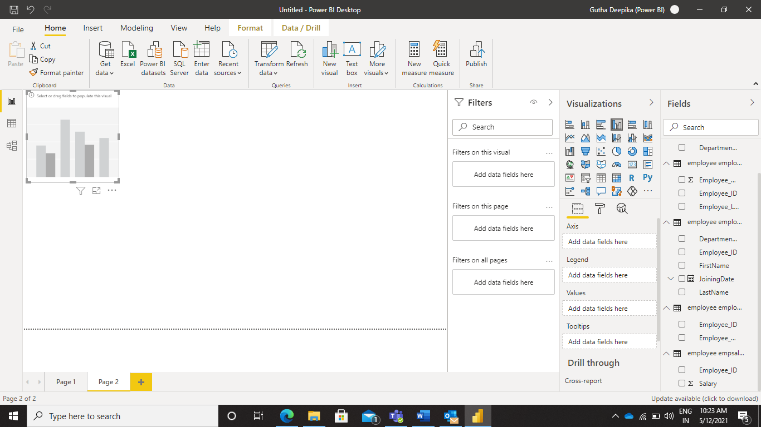

Add the values which we need to compare on the chart.

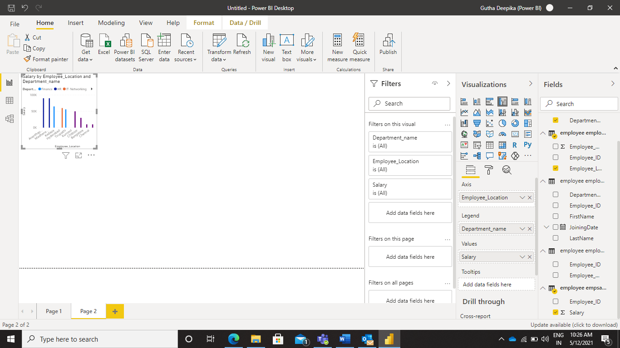

This is how the Clustered Column Chart appears after adding all the values.

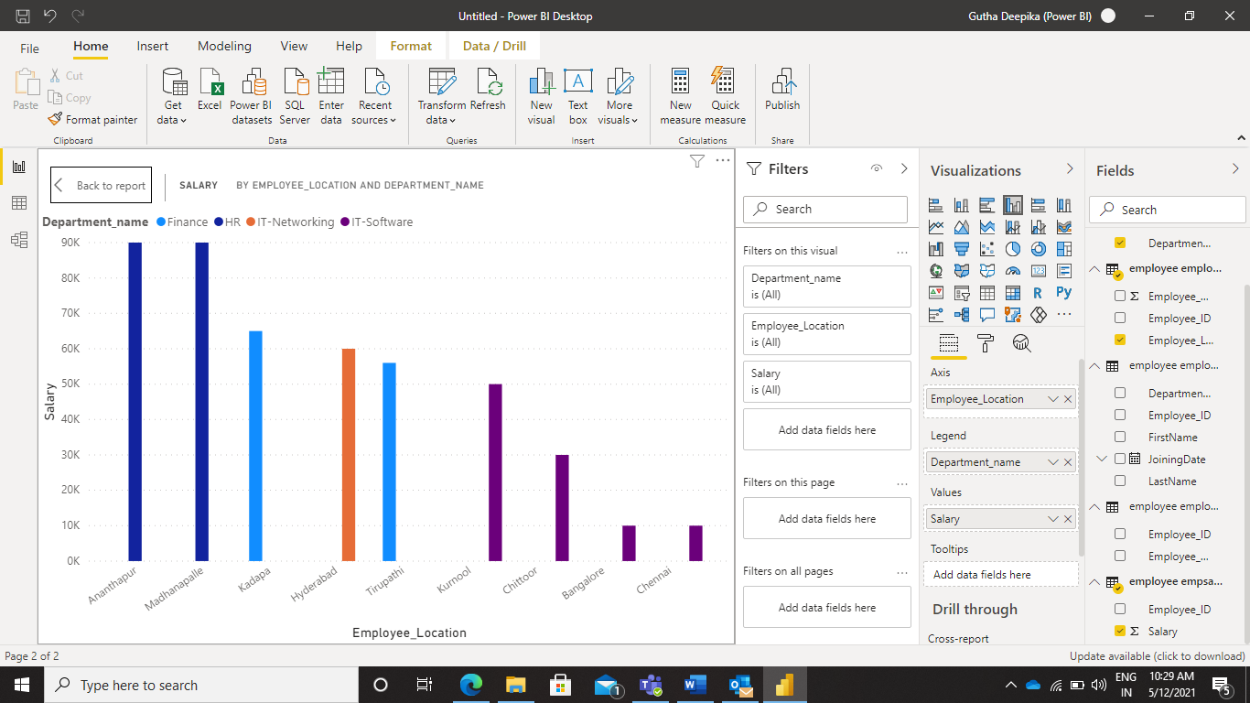

**Adding Bar Chart**

Go to Visualizations and Select any of the Bar charts. Here I am selecting 100% stacked bar chart.

This is how the Desktop appears after adding the bar chart.

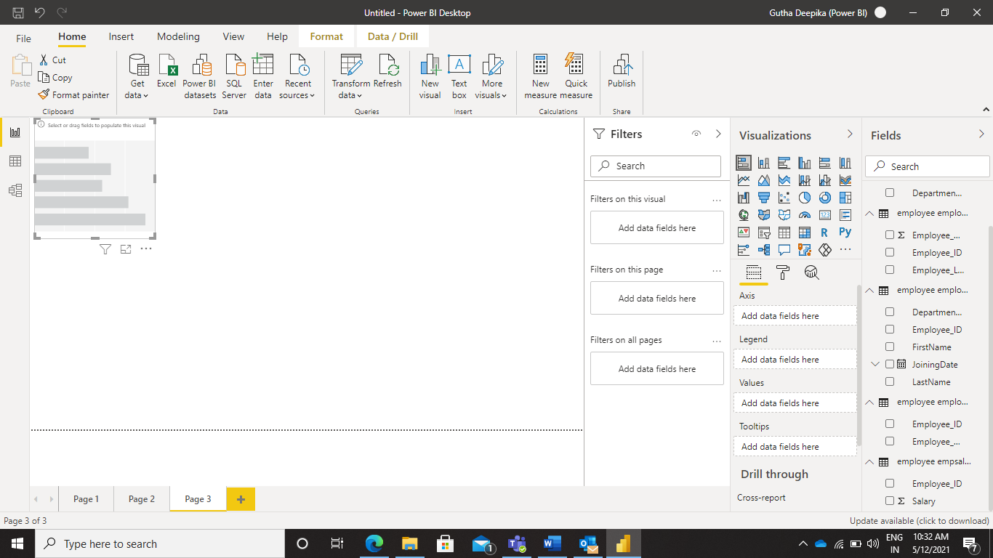

Add the values which we need to compare on the bar chart.

This is how the chart appears after adding the values.

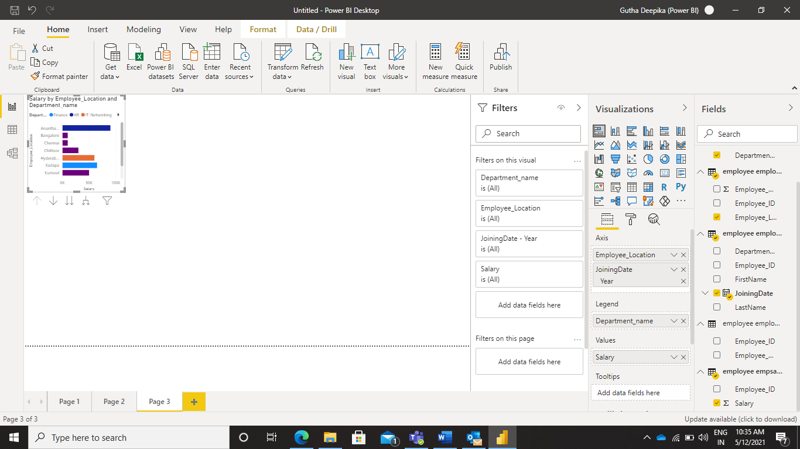

This is how the values compared on the bar chart and final look of the chart.

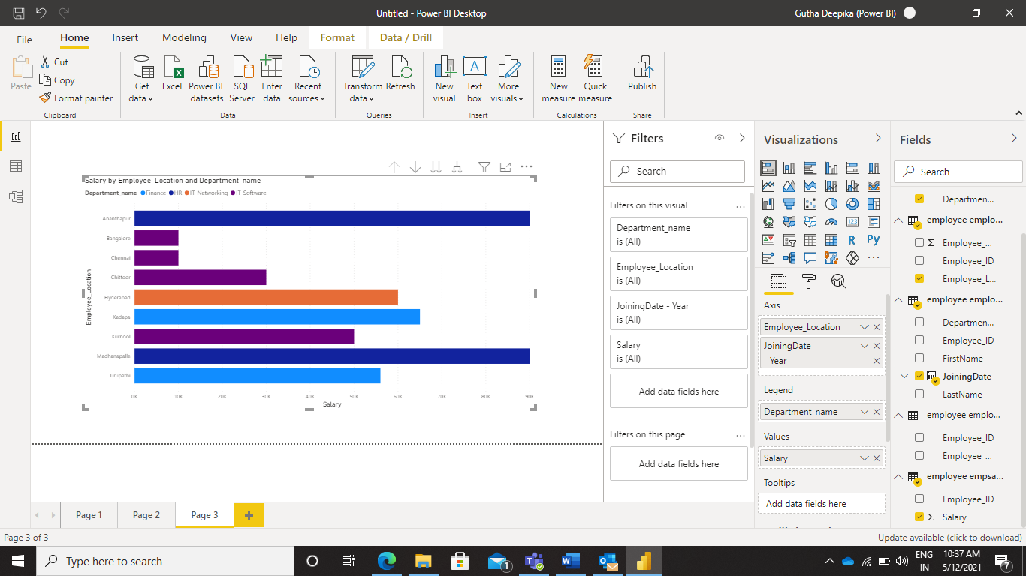

**Able to Add a Map, Card, and Matrix**

**Adding Map to the Power BI Desktop**

Go to visualizations and select the Map visual and add the visual to the Desktop.

This is how the desktop appears after adding the values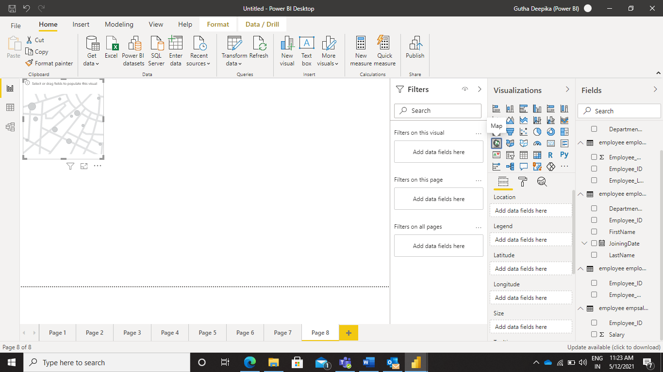

After adding the values to the Map, this is how the Map appears on the Power BI Desktop.

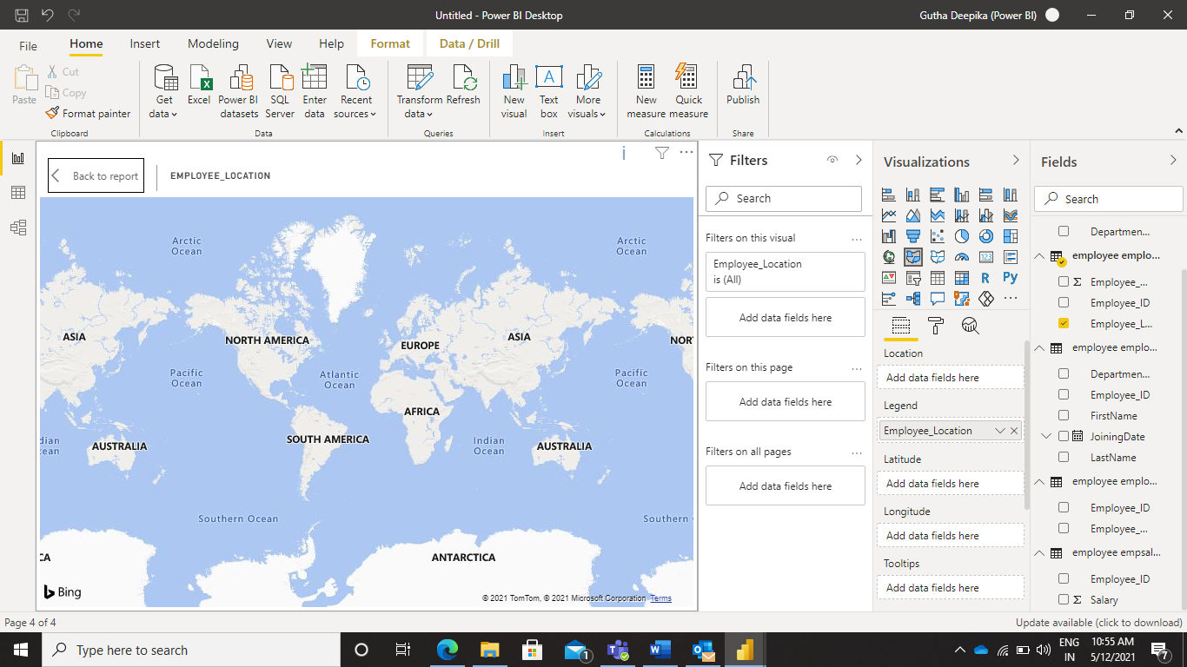

**Adding Card to Power BI Desktop**

Go to visualizations and Select the Card option.

Add the Card to the Desktop, now add the values to the Desktop.

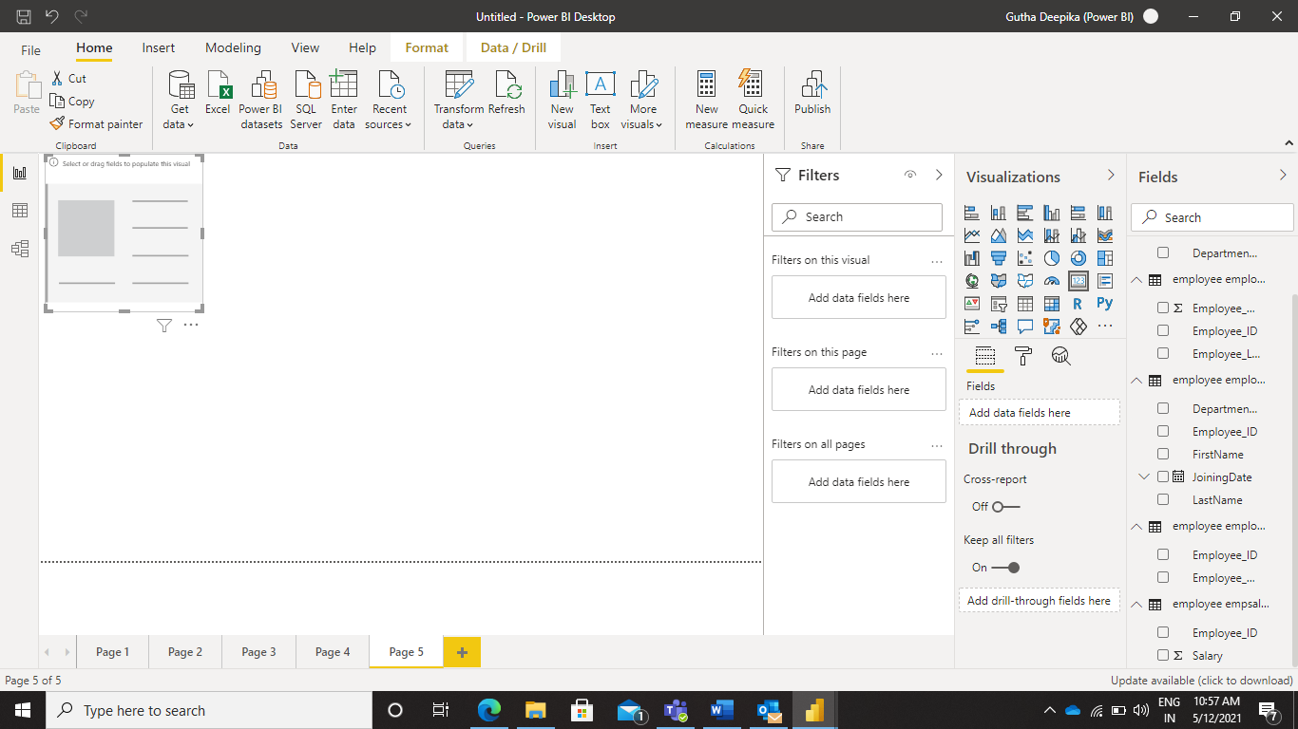

After adding value to the Card, the Power BI Desktop appears as shown in the below picture.

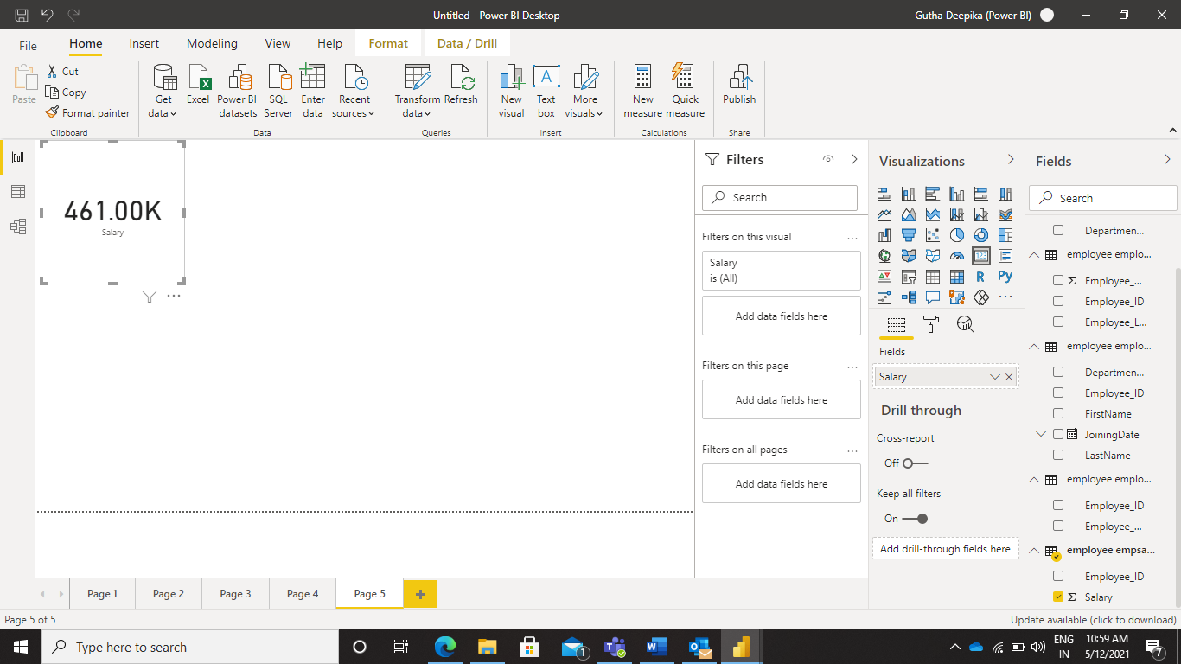

**Adding Matrix to Power BI Desktop**

Go to visualizations and select the Matrix option.

Now add the Matrix to the Desktop. This is how desktop appears after adding the Matrix.

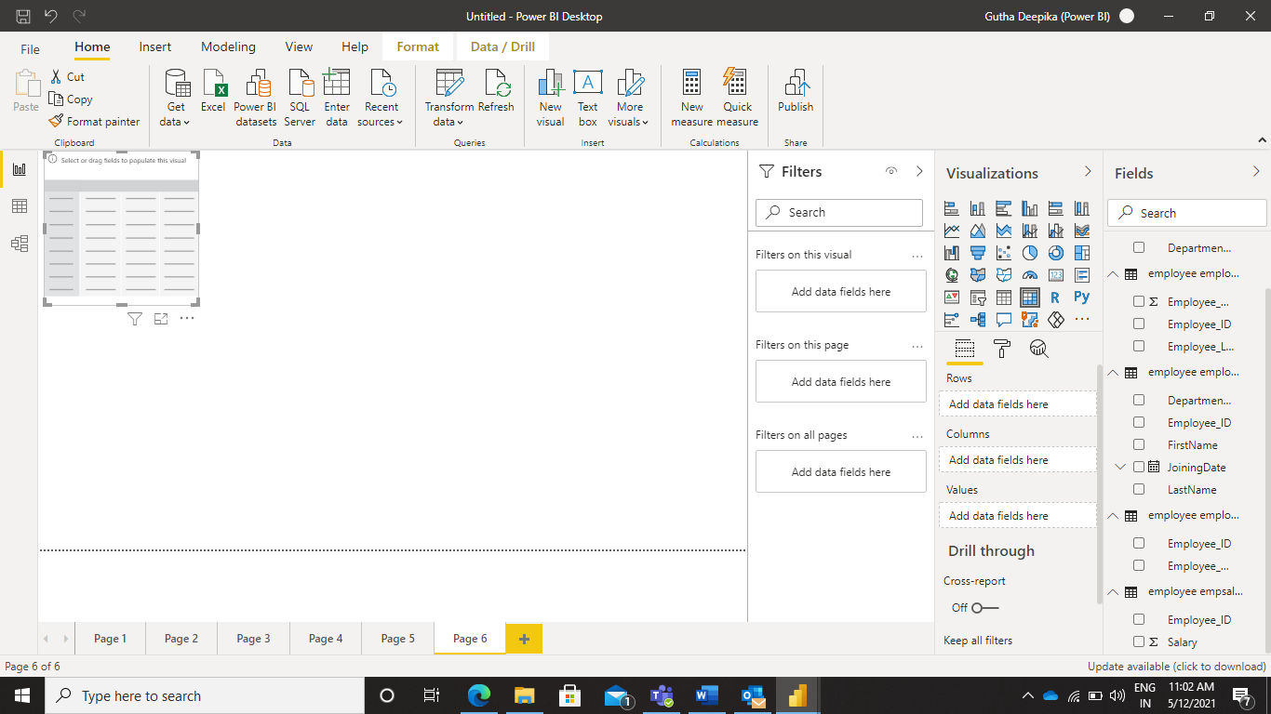

After adding values to the Matrix, this is how the Power BI desktop appears.

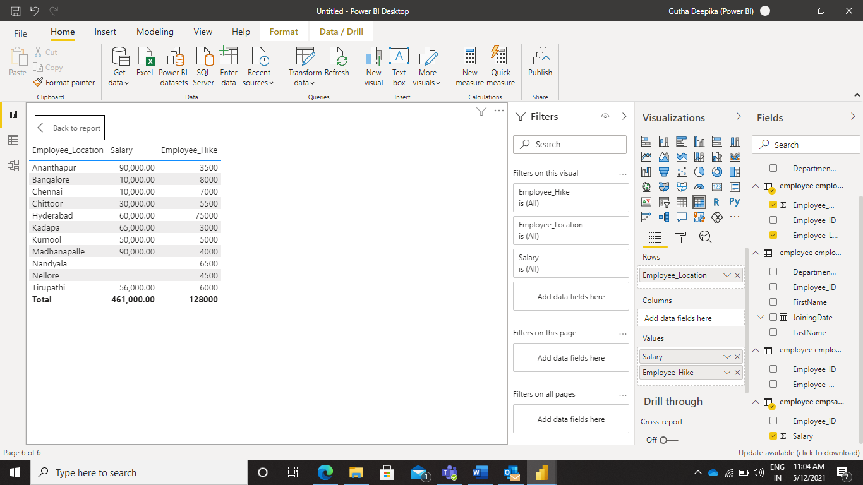

**Able to add a New Page, Column Chart, Filled Map**

**Adding New Page in Power BI Desktop**

At the end of the portal we can see page, if click on the plus it automatically takes us to the new page. In the below picture the bottom we can see the plus(+) option which is highlighted with yellow color.

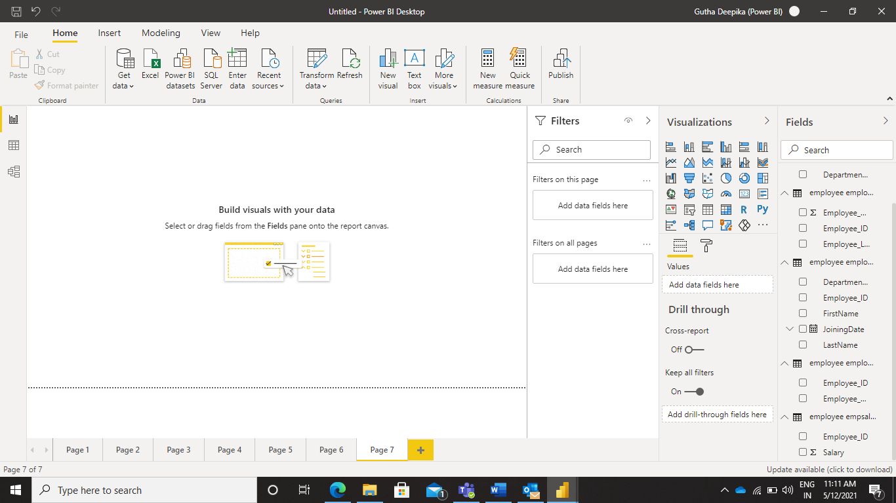

**Adding Column Chart to Power BI Desktop**

Go to Visualizations and select the Column Chart visual. Add the selected visual to the Power BI Desktop

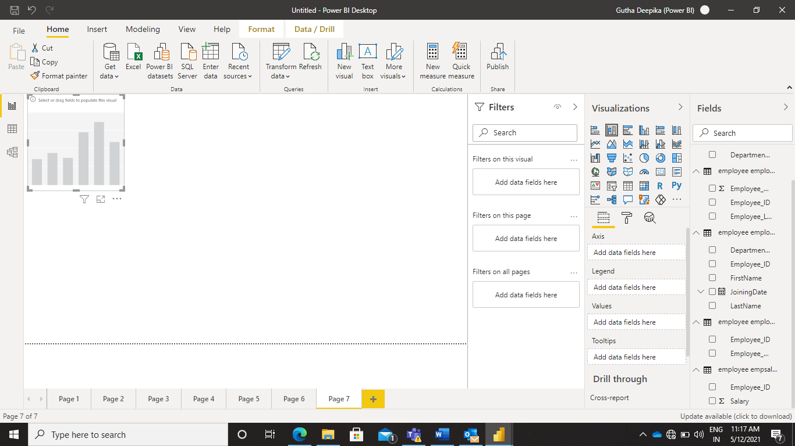

**Adding Filled Map to Power BI Desktop**

Go to Visualizations and select the Filled Map option. Now add the select Map to the Desktop and Add values to it.

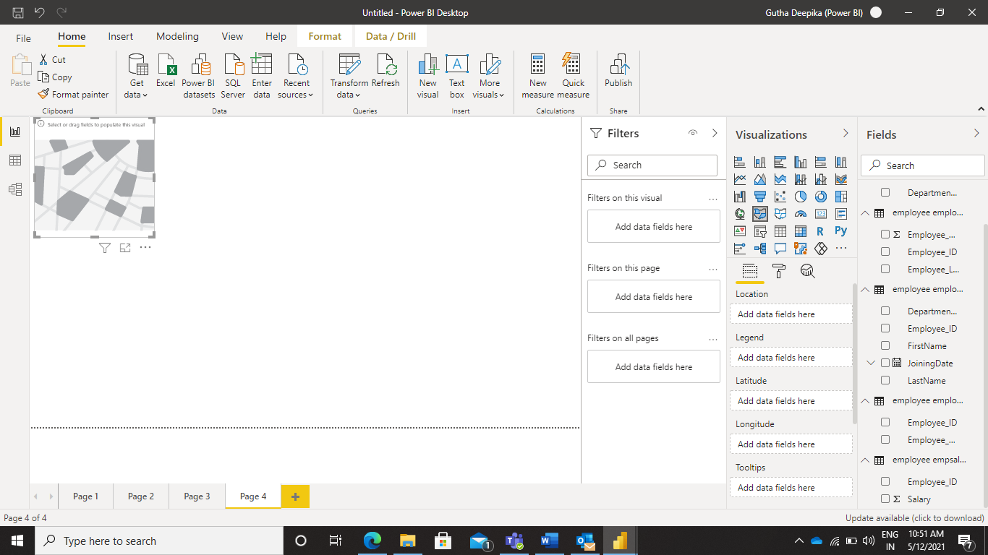

After adding values to the Map this is how it appears.

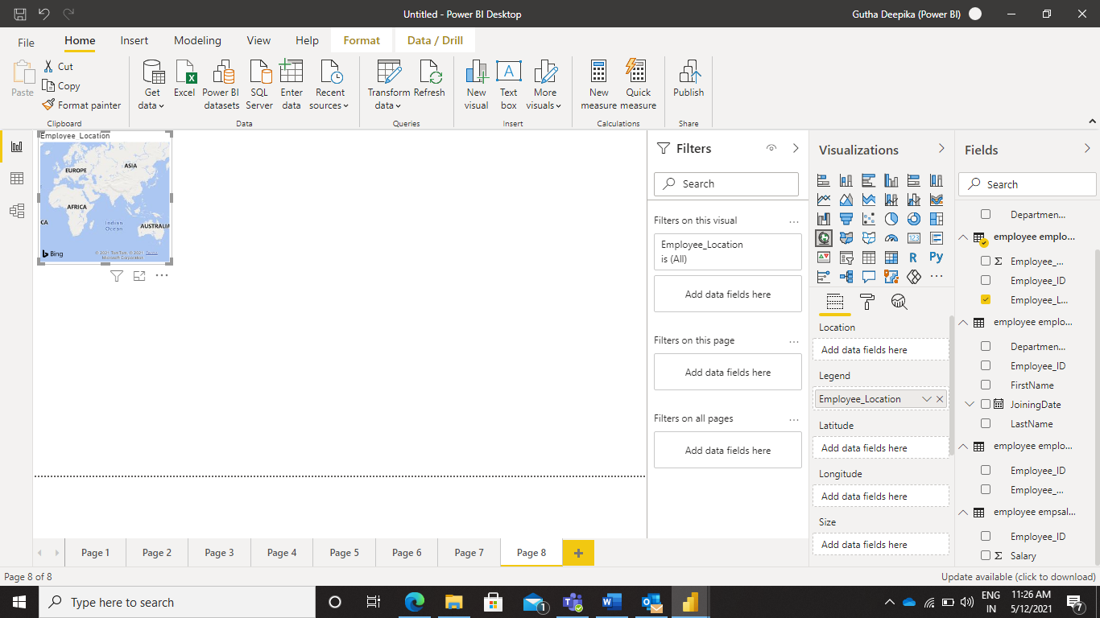

**Able to Filter In Power BI Desktop**

For applying any Filters we need to select the any one of the visuals.

After adding values to the visuals, we need to select the columns to be applied to make the changes.

Here I am using Funnel option to make the changes.

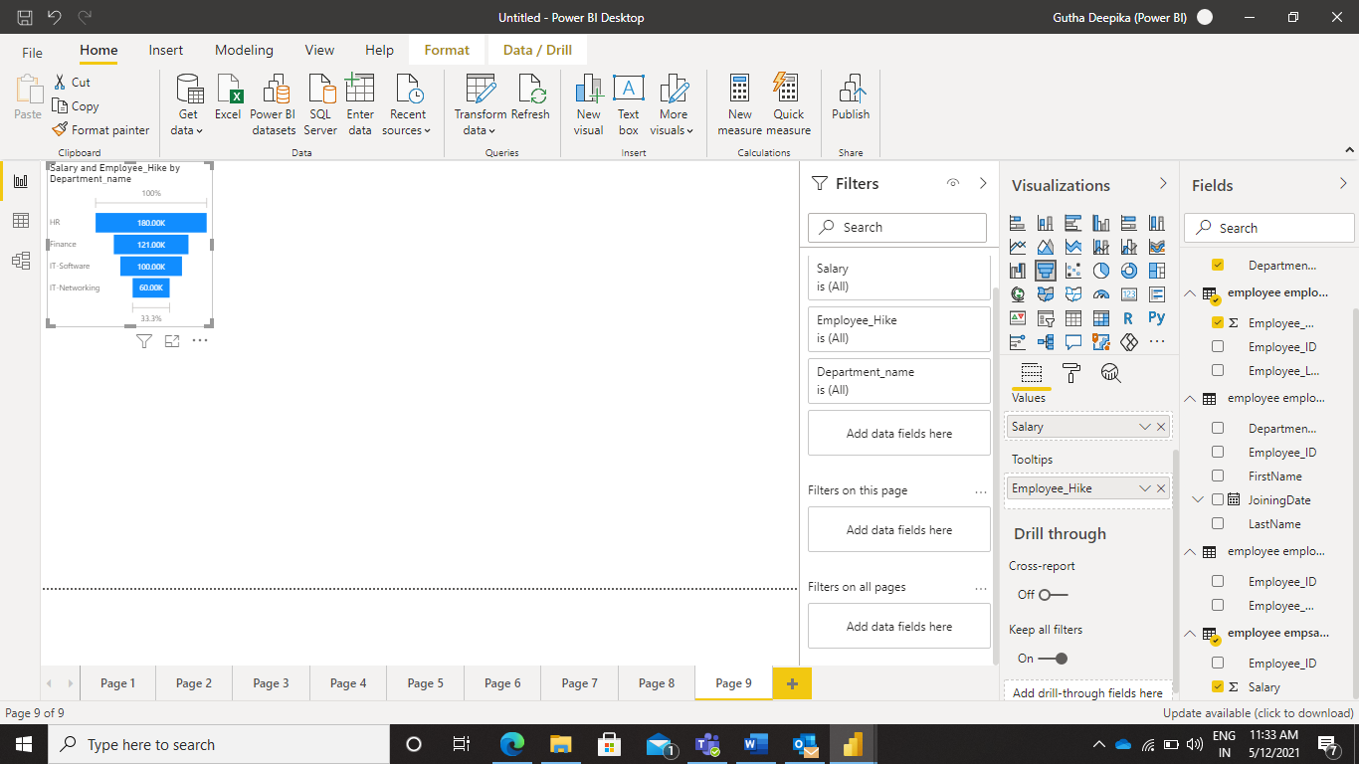

After applying Filter option, this is how the desktop appears.

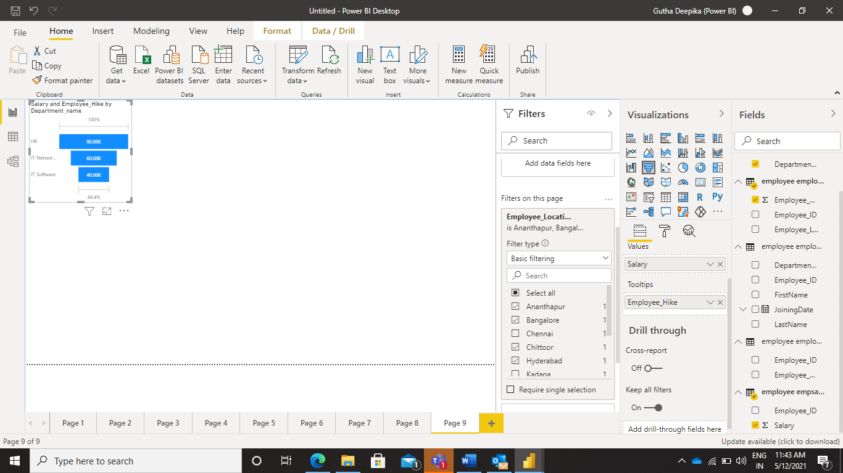

**Able to use Slicer Filtering in Power BI Desktop**

Go to visualizations and select Slicer Filter, Add the Slicer to the Desktop.

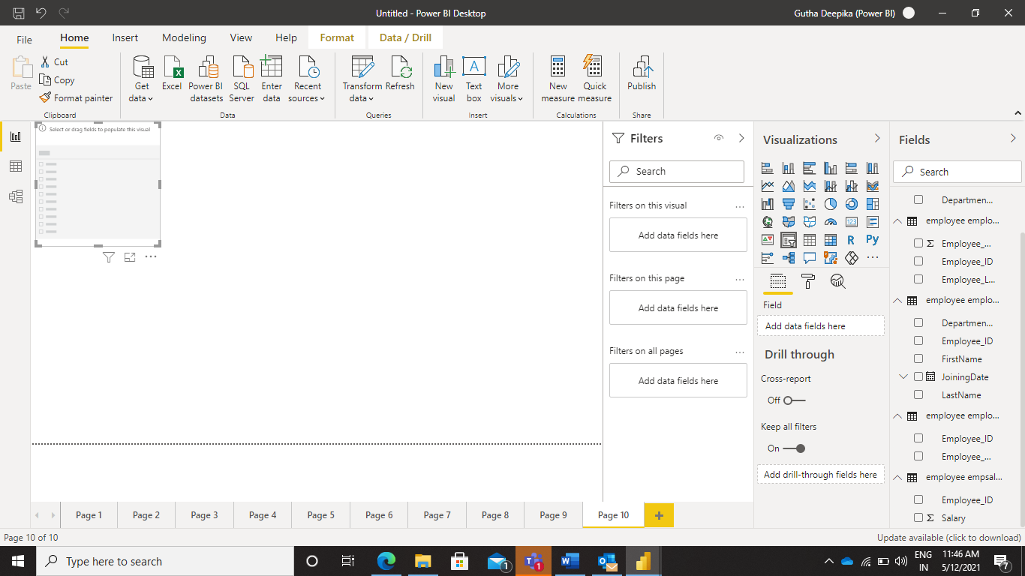

Add values to the Slicer. After adding values to the slicer we can move to slicer in any direction.

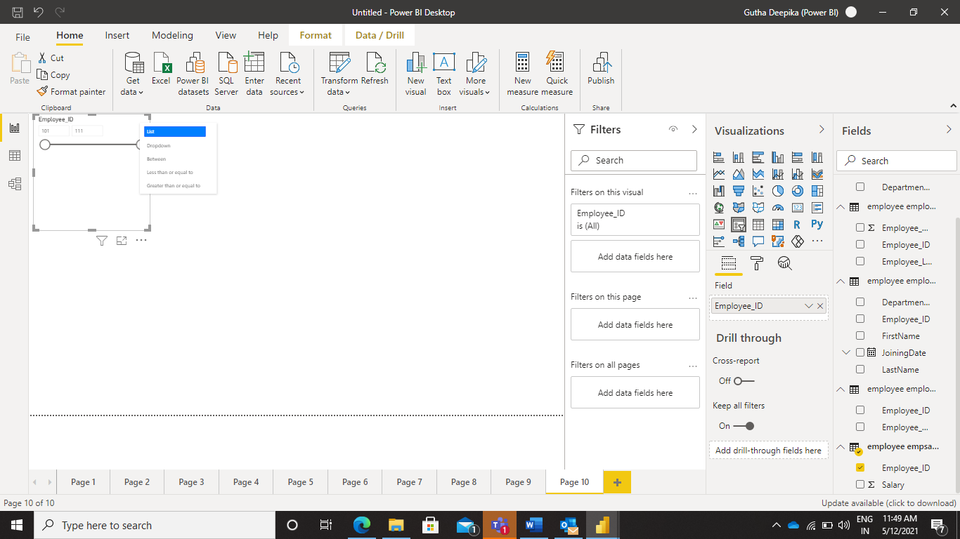

After applying changes to the slicer, This is how the Desktop appears.

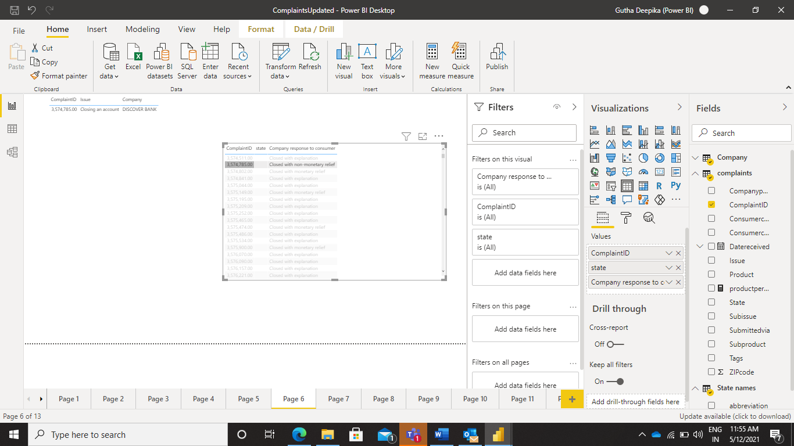

**Able to Set Properties in Power BI Desktop**

Select any visualization and add values to it. Here we have selected bar chart.

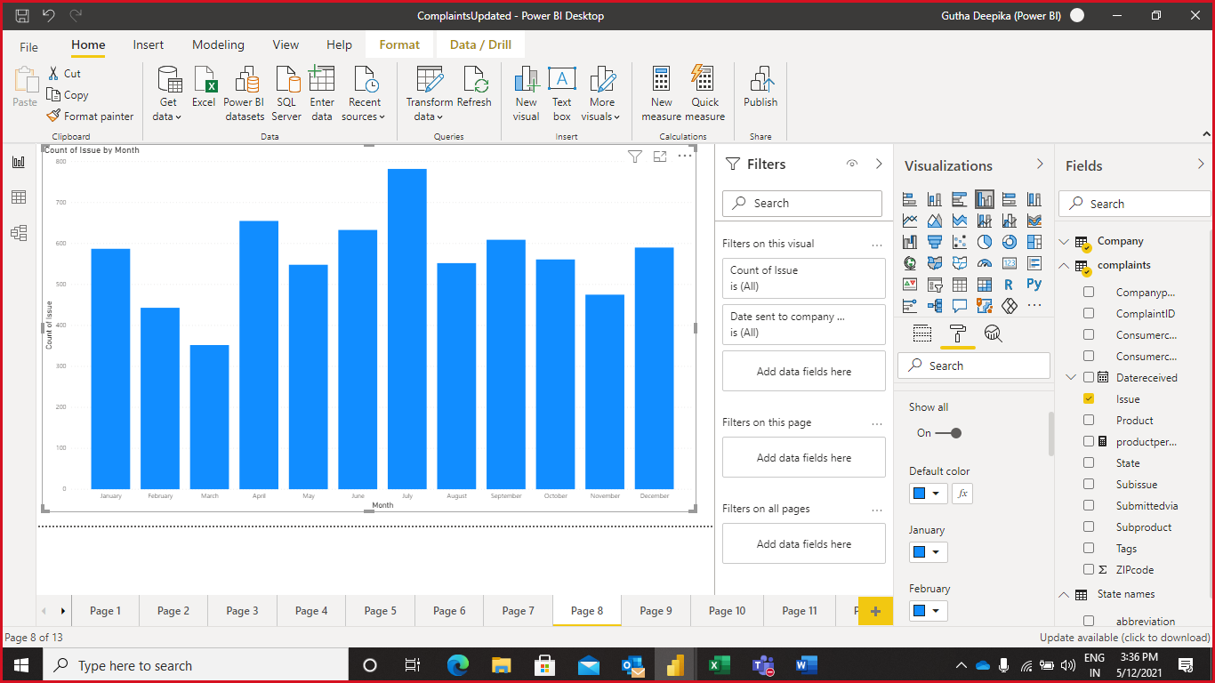

To set the color properties select the Format option below the Visualization and apply the data colors of your choice.

After setting color properties the visualizations appears in this manner.

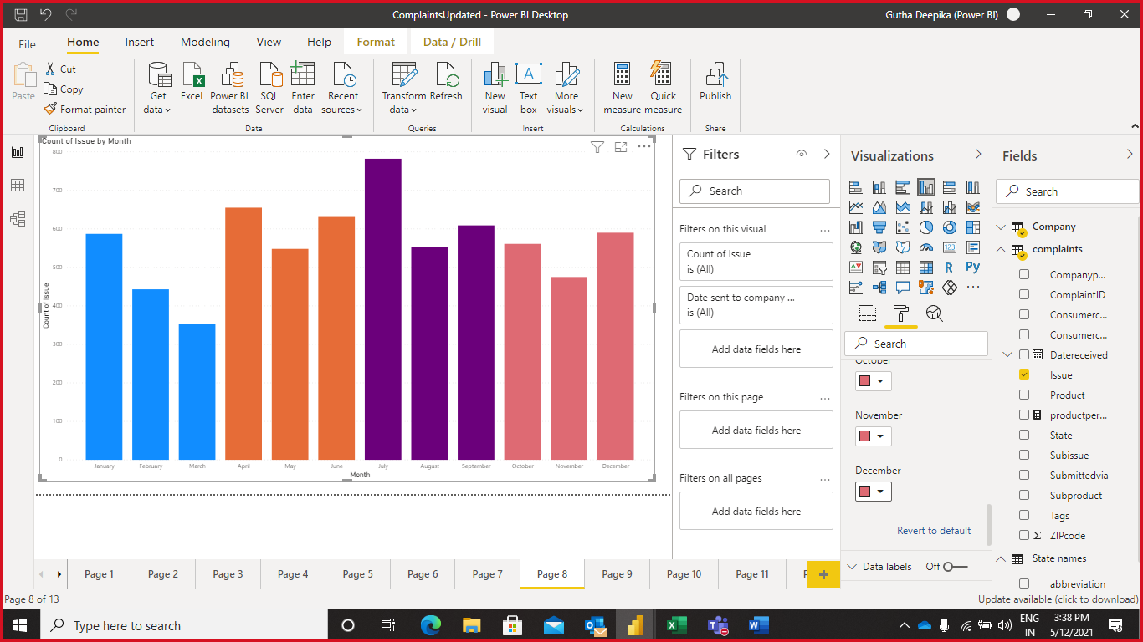

To change the Properties of the Title

Before changing the properties the column chart looks like this.

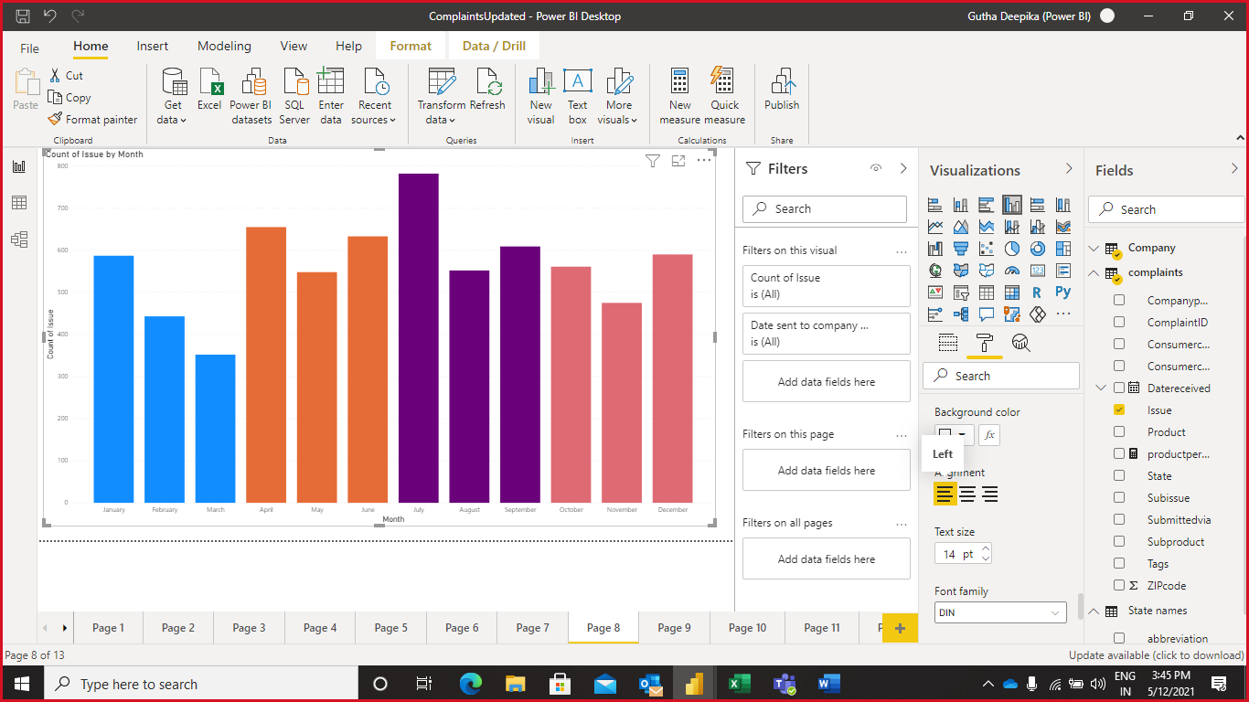

Here we are changing the color, alignment and font size of the Title.

To set the Title properties select the Format option below the Visualization and apply the changes of your choice.

After applying all the changes this how the column chart looks like.

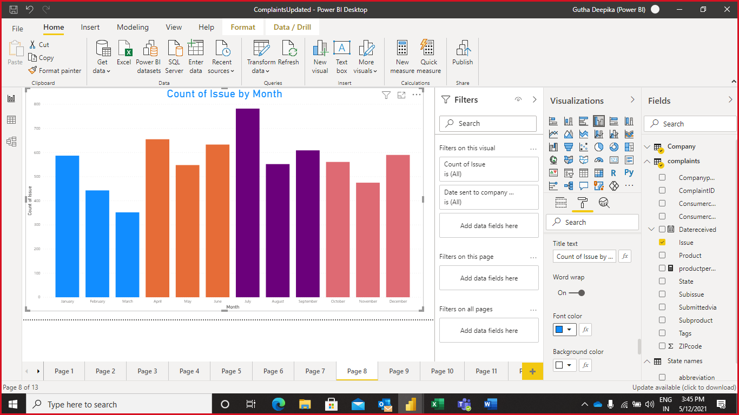

**Able to Drill Within a Hierarchy in Power BI Desktop**

Select the visualization of your choice and add values to the visualization.Here we are selecting bar chart.

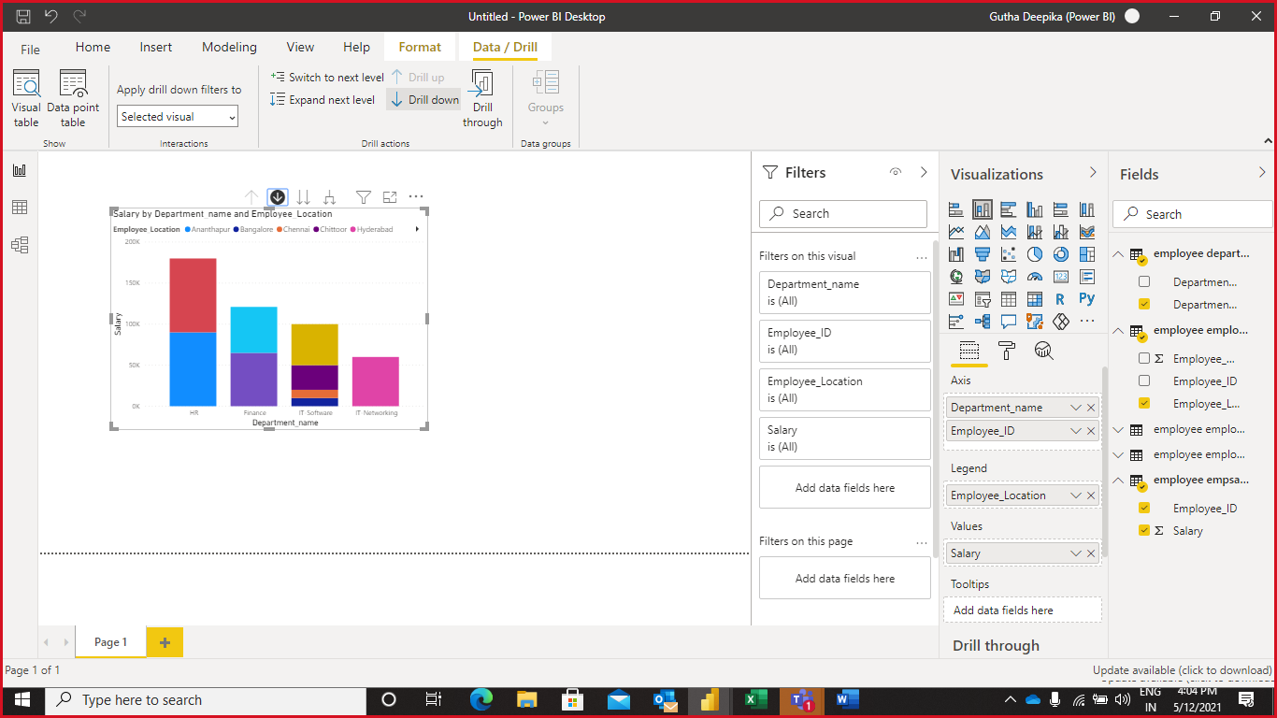

Click Drill and select any drill option of your choice.Here we are selecting drill down and it allows us to perform drill on the visualization.

Select the bar of your choice and click drill down option, it will drill the bar and shows two bars as the result.

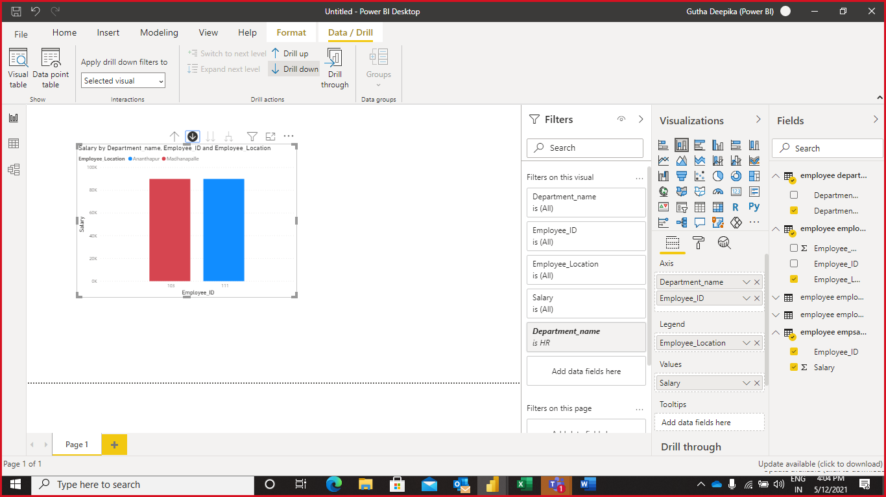

# Capability 6: Ability to create Power BI reports.

# Ko 1: Able to Import Data from Various sources

# Step 1: Firstly, click on Get Data.

# 

# Step 2: Click on more option

# 

# Step 3: Click on Database, then select appropriate database source. Click to Connect option.

# 

# Step 4: Write server name and database name, then click on OK option.

# 

# Step 5: Now, select tables, then click on load option.

# 

# After loading data in power BI, how your data is look likes as shown below.

# 

**Ko 2: Able to Define Table Relationships, Configure Model Properties**

# Step 1: Firstly, click on Get Data.

# Step 2: Click on more option

# Step 3: Click on Database, then select appropriate database source. Click to Connect option.

# Step 4: Write server name and database name, then click on OK option.

# Step 5: Now, select tables, then click on load option.

# Step 6: After load data, the data is show in field section. Then click on model which is show in figure below.

# 

# Step 7: In this figure, we clearly see that relationship. If not just drag out the similar column to another table of column, then it will create a relation.

# 

# Now step to configure the model properties.

# Step 1: Right click on relation, then click on Properties.

# 

**Step 2:** select appropriate tables, make a relation between them. Then click on **OK** option.

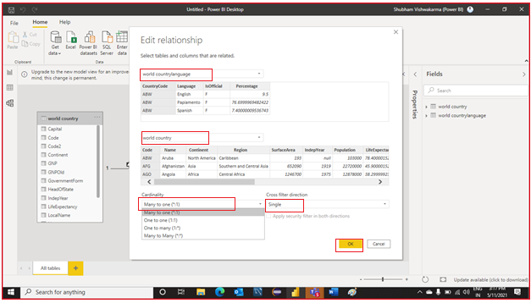

**Ko 3: Able to Review and Change the Demonstration Model's Properties**

Basic Operation that we will perform

* Add a Description to the table

**Step 1:** To **load** data in Power BI. Then click on the **model**.

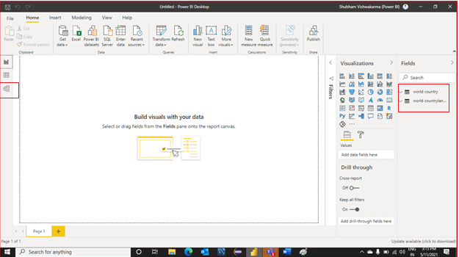

**Step 2:** Click on **Properties** Option.

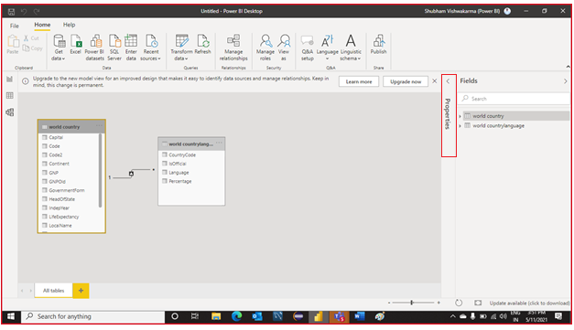

**Step 3:** And provide description about the table.

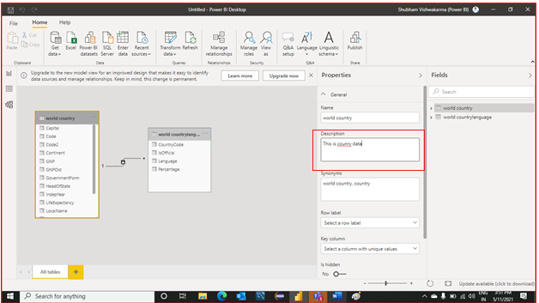

Now, you can see the description about the table.

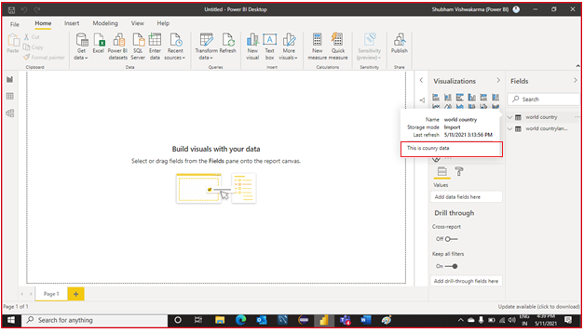

* **Hide identifiers column.**

**Step 1:** To **load** data in Power BI. .

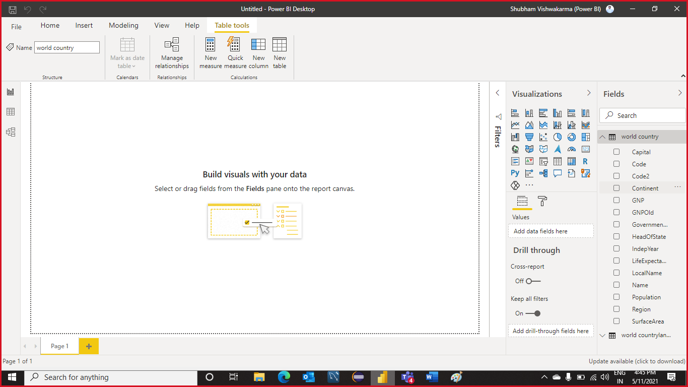

**Step 2:** Then right click on any column which you want to hide. Then Select **hide** option.

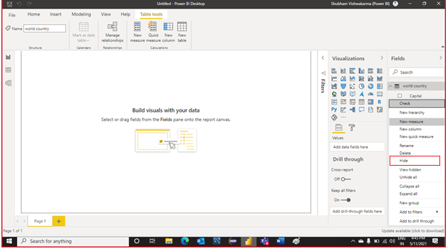

* **Review datatypes and Configure Formatting**

**Step 1:** Firstly, **Load** data in Power BI. Then Click on the **data** option which is shown in figure.

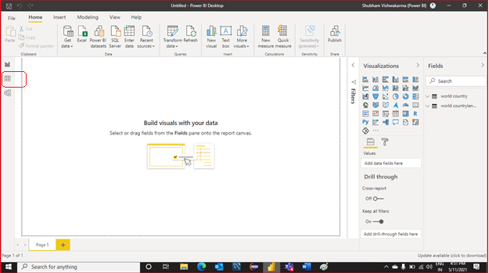

**Step 2:** Select a column and then click on the **format** option which is shown in figure.

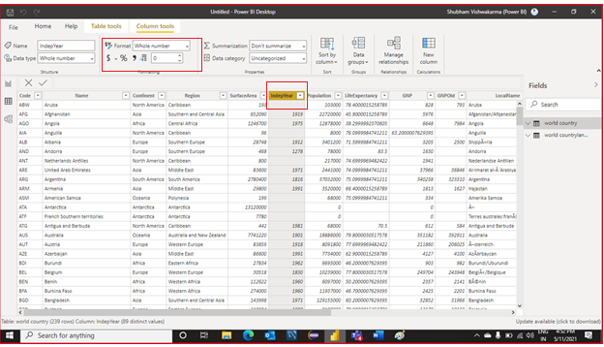

**Step 3:** After click, select appropriate option.

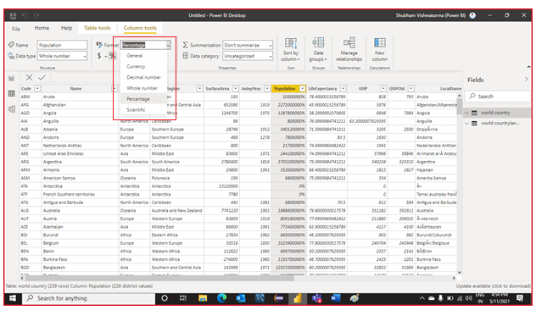

**Set default summarization**.

**Step 1:** Firstly, **Load** data in Power BI. Then Click on the **data** option which is shown in figure.



**Step 2:** Select a column and then click on the **summarization** option which is shown in figure.

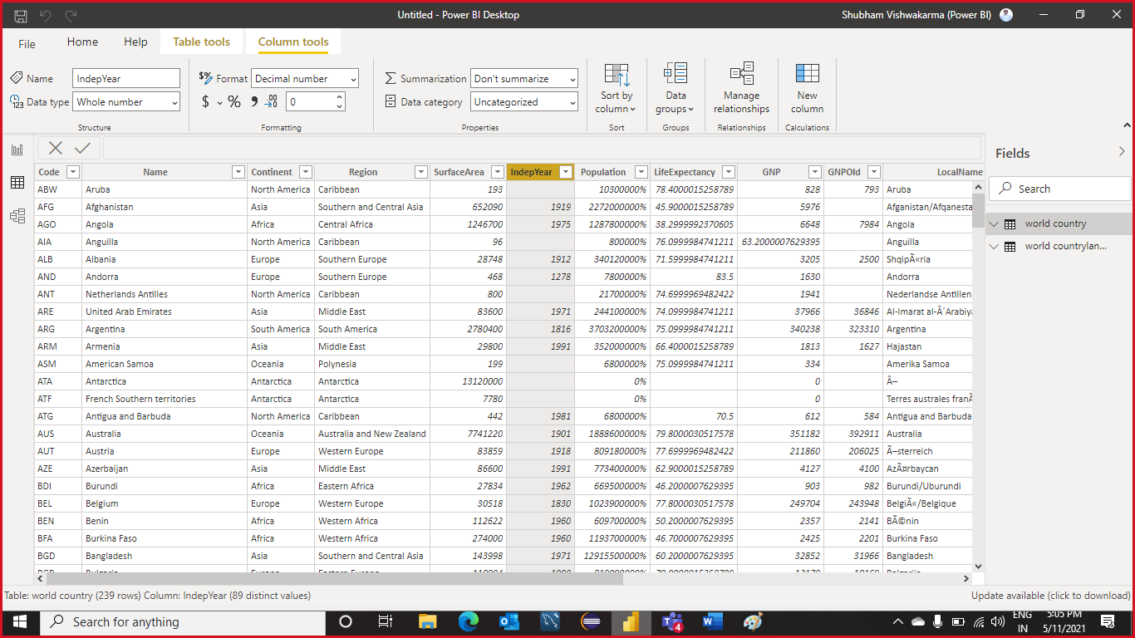

**Step 3:** After click, select appropriate option.

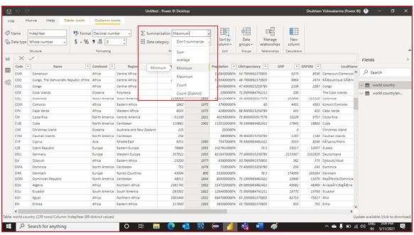

**Step 4:** See the result is sown in the figure.

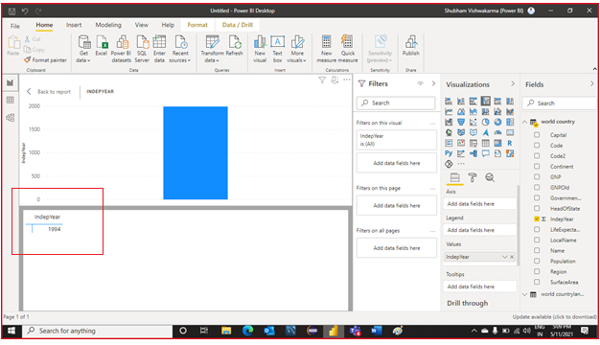

# Ko 4: Able to Create and Publishing Report and Creating a Dashboard

# Step 1: Create a report using visuals.

# Step 2: Click on Publish option. Then click on the save option.

# Step 3: Select On the workspace option and then click on the select option.

# 

# Step 4: Click on the URL to show publish report.

# Finally, this is how our dashboard looks like.

# Capability 7: Ability to connect to a wide range of data sources from Power BI.

# KO 1: Able to Connect to Databases, Data Warehouses, and Power BI Data Models Using Power BI

# Connect to Database

# 

# Step 1: Click on the Get Data. In the Get data, select database and corresponding appropriate data source

# 

# Step 2: Write server name and database name and then click on the ok.

# 

# Step 3: Select tables and click Load

# 

# You can see the data is loaded.

# 

# Connect to Data Warehouse

# Step 1: Click on the get data and Search warehouse. Then select appropriate data warehouse.

# 

# Step 2: Click on the Connect.

# 

# Step 3: Click on the sign in. After signing in, click on the connect.

# 

# Step 4: Select tables and click on the load. After that data will load in Power Bi.

# 

# KO 2: Able to Connect to Databases through Direct Query

# Step 1: Click on the Get Data option, select on more option.

# 

# Step 2: Click on database and select on any of database source and click on connect which is shown as figure.

# 

# Step 3: Now, write server name and database. Then write your statement query and then click OK.

# 

# Step 4: Click on the load.

# 

# Once after loading data in the power Bi and looks likes which is shown in figure.

## **KO 3: Able to Configure Privacy Levels for Data Sources**

**Step 1:** Click on the **File**.

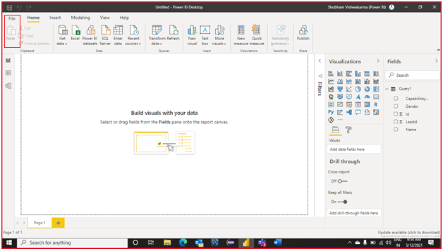

**Step 2:** Go to the **Option and Settings** and then click on the **options**.

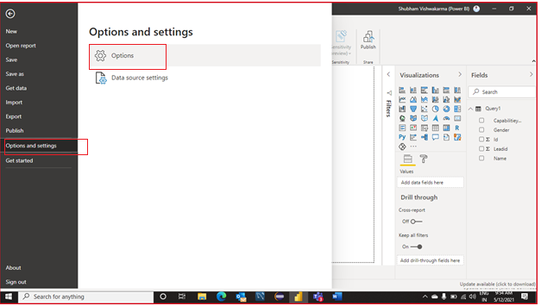

**Step 3:** Click on the **privacy** and select any of **privacy levels**.

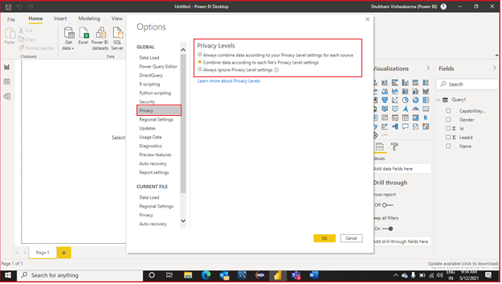

**Step 4:** Set another **Privacy** levels is shown in figure.

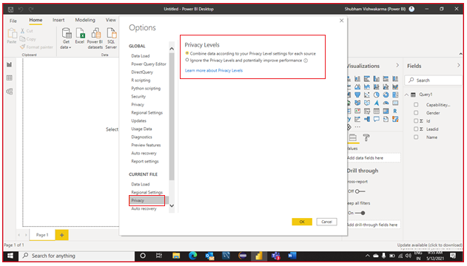

**Another Way to set Privacy settings.**

**Step 1:** Select the **Data** option and then click on the **Transform** data. Then select Data source settings.

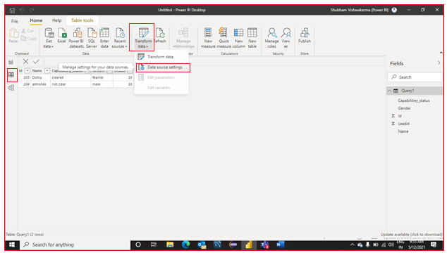

**Step 2:** select the **data** **source** and click on the **edit** permission.

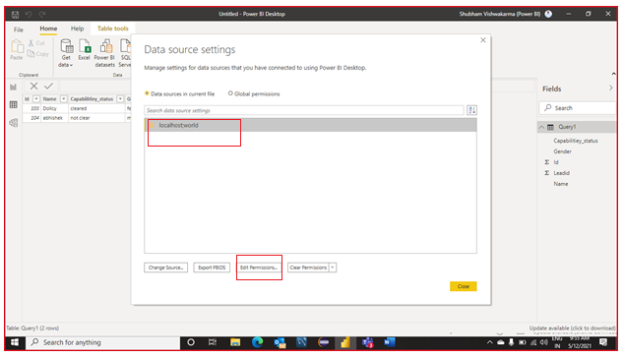

**Step 3:** Now, Set the **privacy** levels and then click on **OK**.

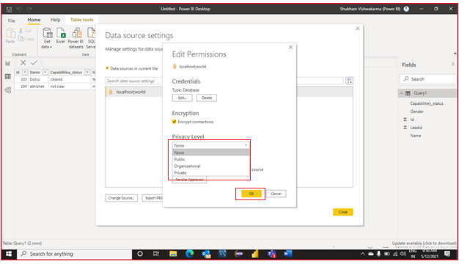

## **KO 4: Able to Connect to Online Sources, SharePoint Data Using Power BI**

**Step 1:** Click on the **Get data** and select the **more** option.

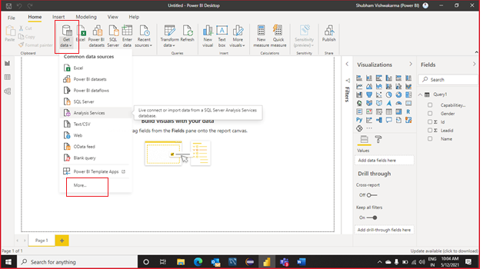

**Step 2:** Click on the **Online Services** and select **SharePoint Online list** and connect it.

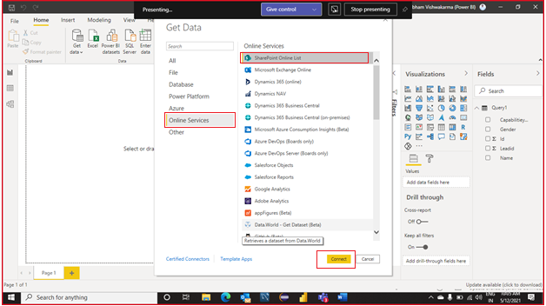

**Step 3:** Now, write the **URL** and click on the **OK**.

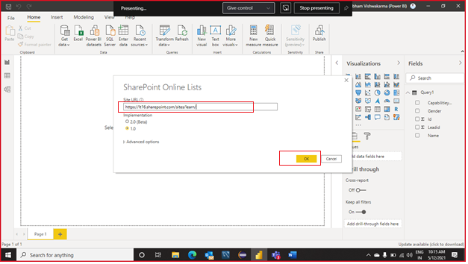

**Step 4:** Click on the **Anonymous** and click on the **connect**.

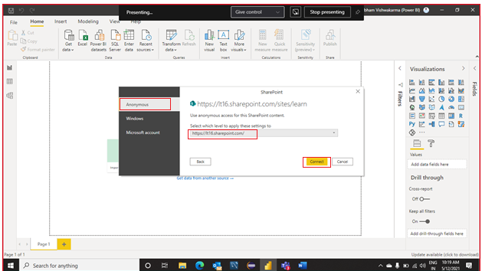

Finally, your data will load in Power BI.

## **KO 5: Able to Connect to Text and CSV Data Sources from Power BI**

**Step 1**: Select the Get Data and Click on the Text and CSV Data Sources.

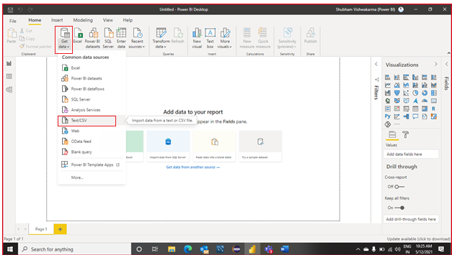

**Step 2:** Select Particular CSV file and **open** it.

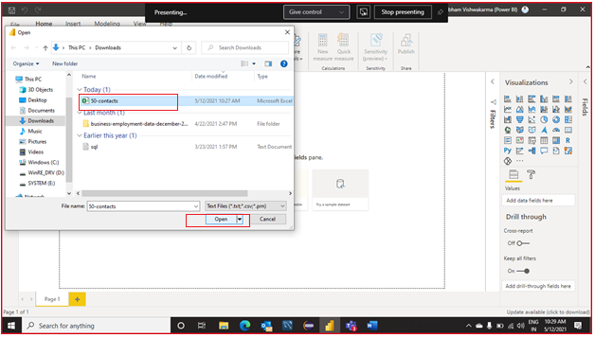

**Step 3:** The data is present in the csv file is now showing and then click on the **load**.

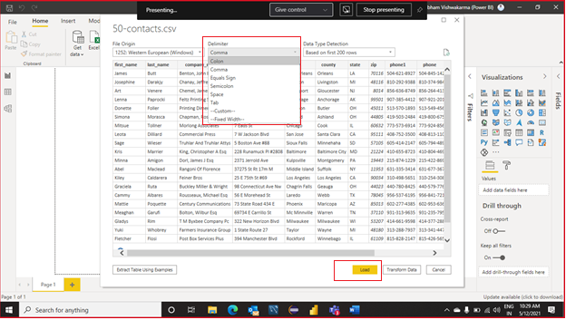

Finally, how your data is looks like which is shown in figure.

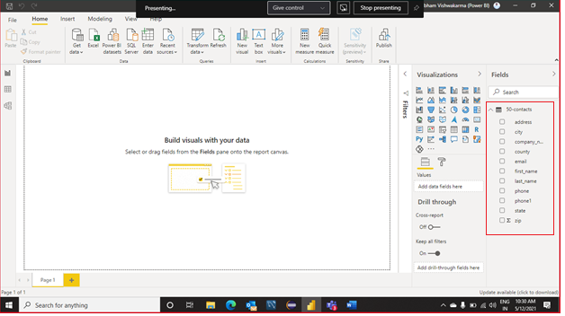

## **KO 6: Able to Import Excel Data and Workbooks to Power BI**

**Step 1:** Click on the **Get Data** and select the **EXCEL source**.

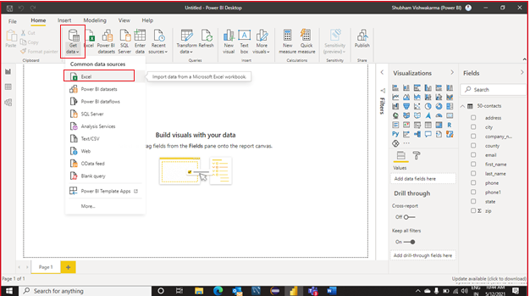

**Step 2:** Select the data file and click on the **open**.

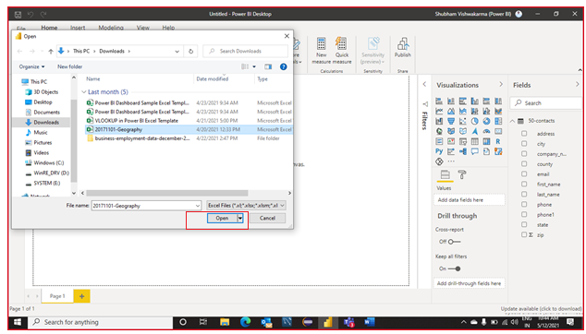

**Step 3:** Select the tables and **Load** the data in the Power BI.

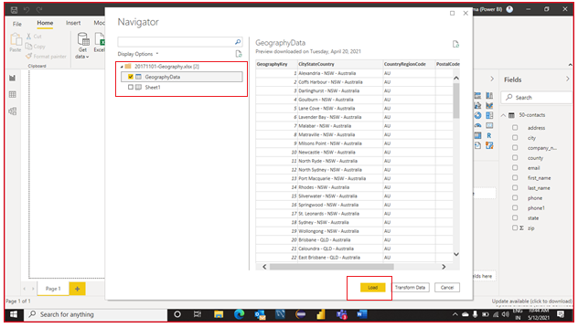

Finally, how your data is looks like which is shown in figure.

## 

## **KO 7: Able to Connect to Web Data Sources from Power BI**

**Step 1:** Select the **Get data** and click on the **web source.**

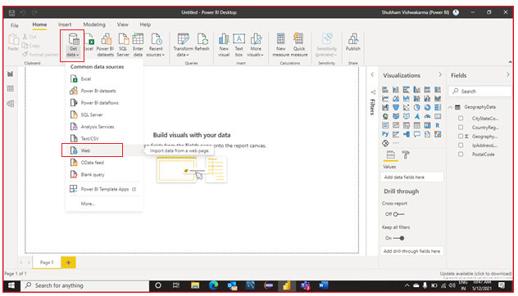

**Step 2:** Now, write the **URL** and click on the **OK**.

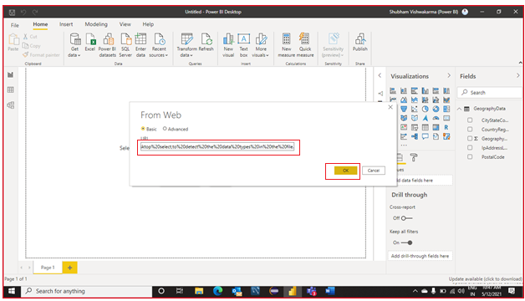

**Step 3:** Select **Anonymous** option and click on the **connect.**

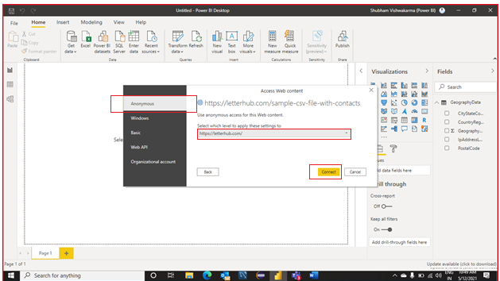

**Step 4:** After connecting to web data, all the table present in a website is now showing. Click on the **load**.

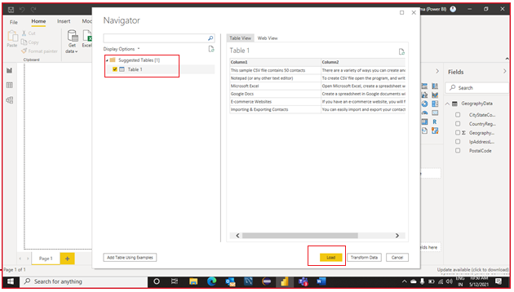

Finally, how your data is looks like which is shown in figure.

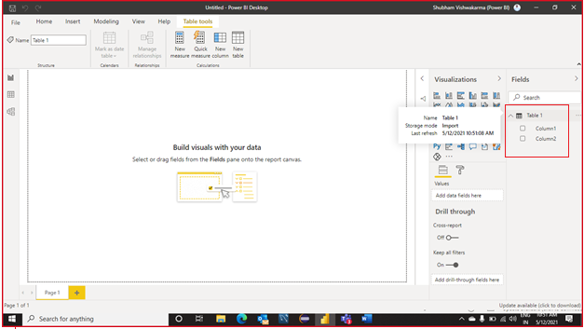

## **KO 8: Able to Use Blank Queries to Create Data Tables**

## **Step 1**: Click on the **Get data** and Select the **blank query**.

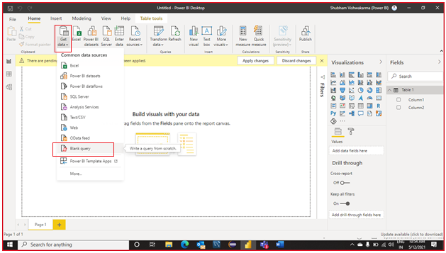

**Step 2:** Select the **Advance Editor**.

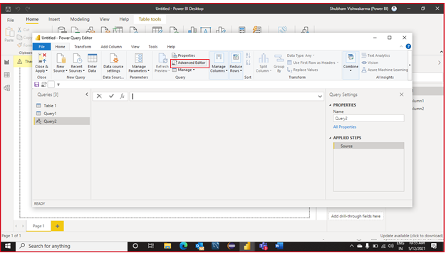

**Step 3:** Now, write Query to create table. Then click on **OK**.

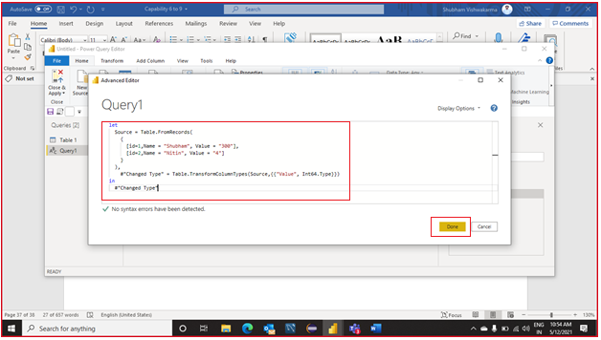

**Step 4:** After applying query, the table is created. And click on **close & apply.**

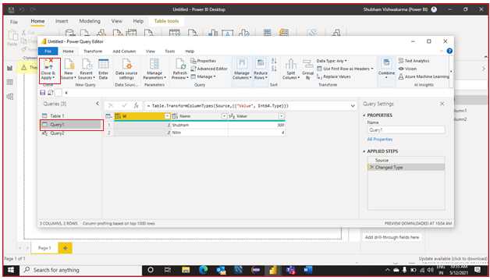

Finally, how your data is looks like which is shown in figure.

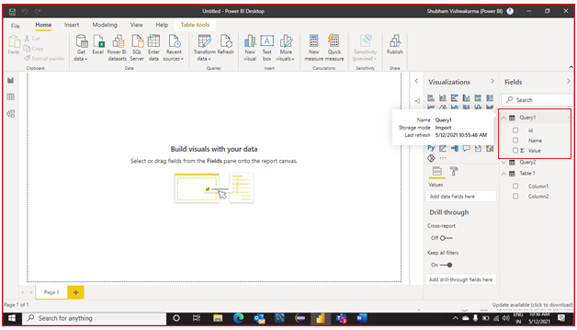

# Capability 8: Ability to use Power Query, Power Query editor, add data transformation steps, fix errors, and make advanced changes.

## **KO 1 Able to access query editor in power BI, Excel**

**Query Editor in Power BI**

**Step 1**: Click on the **Get Data** and select appropriate data sources.

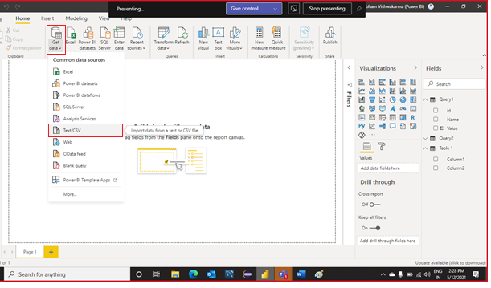

**Step 2:** Select data file and click on the **open** option.

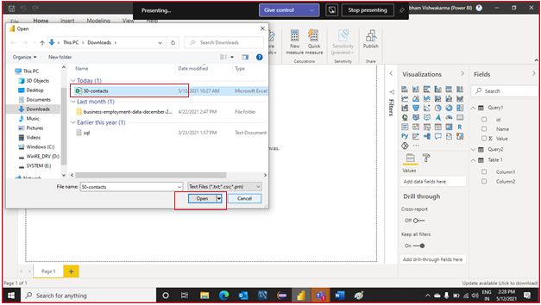

**Step 3:** Now, **Load** the data in the power BI.

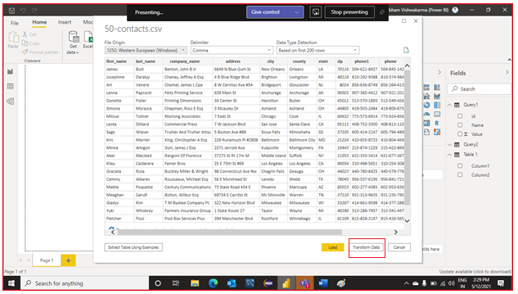

**Step 4:** After clicking transform data, query editor is open. Do the task and close & apply.

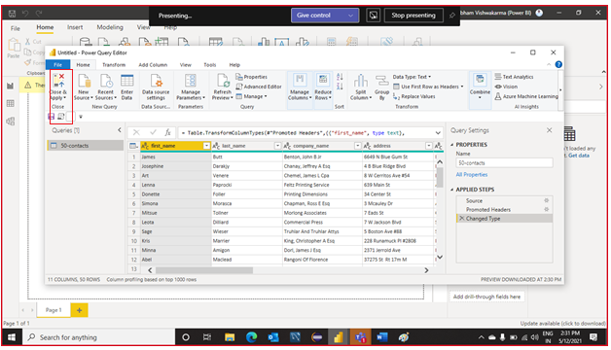

**Query Editor in Excel**

**Step 1:** Click on the **Data option**.

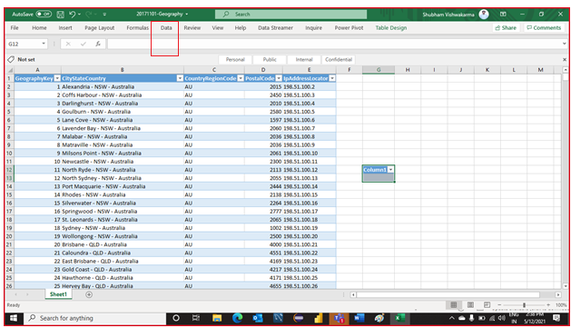

**Step 2:** Click on the **Get Data** and select the **Launch power query editor** option.

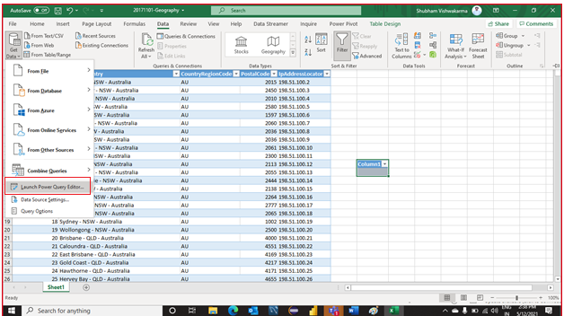

**Step 3:** After clicking Launch power query editor option, query editor is open. Do the task and **close & apply.**

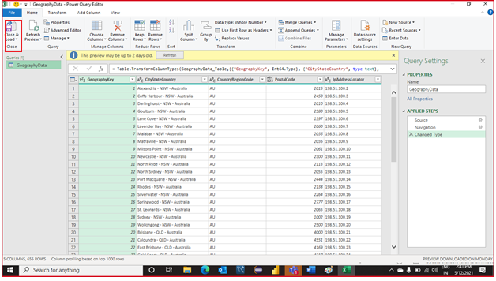

## **KO 2: Able to add and remove steps**

**Step 1:** Click on the **Get Data** and select appropriate data sources.



**Step 2:** Select data file and click on the **open** option.



**Step 3:** Now, **Load** the data in the Power BI.



**Step 4:** For adding, right click on any column and then select **replace values** option.

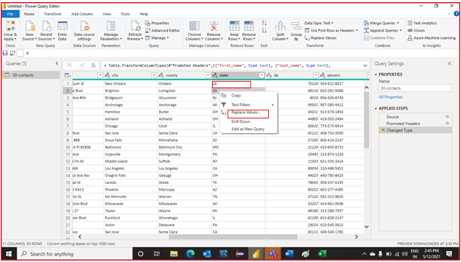

Step 5: Enter value find and replace with and click on the OK.

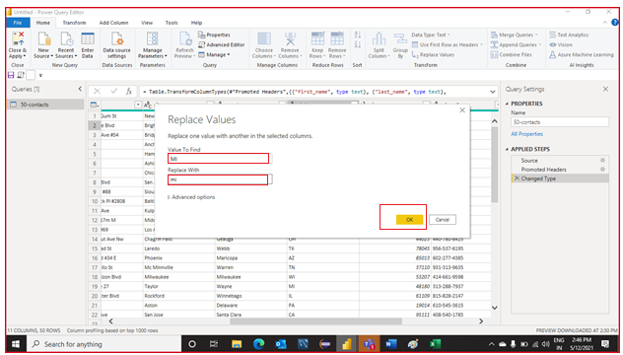

**Step 6:** Now, you can see the replaced value which is shown in figure.

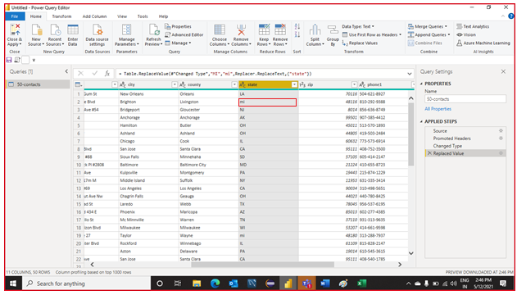

**Step 7**: For the remove column, right click on the particular column and select **remove** option.

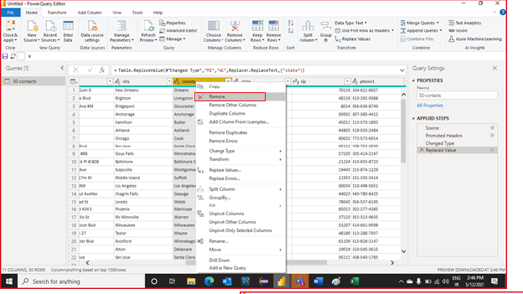

**Step 8:** For the remove specify row, click on **Remove** Rows and select any of the appropriate option.

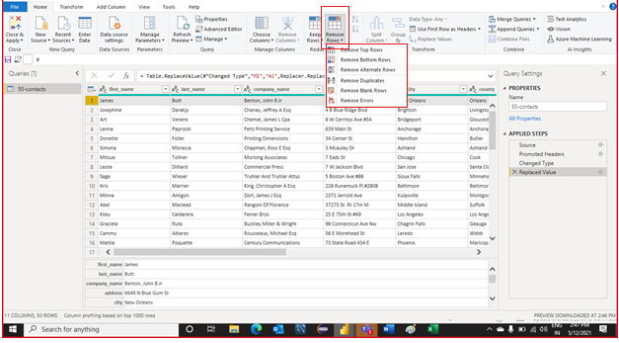

## **KO 3: Able to work with data types**

**Step 1:** **Load** the data and Open **transform** data option.

**Step 2:** Click on the **data type** option or right click on the any particular column.

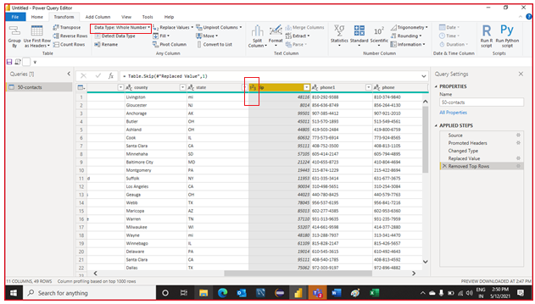

**Step 3:** Select appropriate data type.

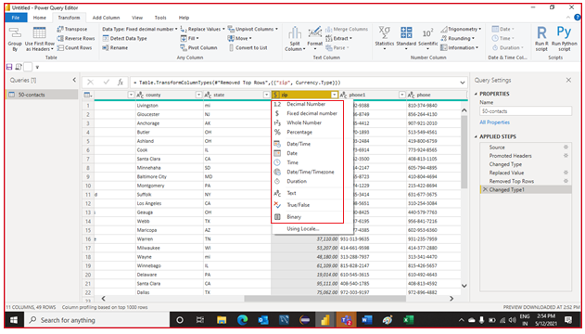

Finally, you can see the modify the data according to the data type.

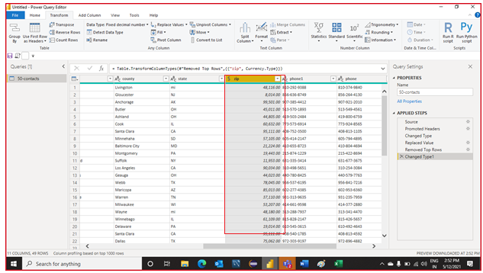

## **KO 4: Able to access advanced query editor**

**Step 1**: Click on the **Get Data** and select appropriate data sources



**Step 2:** Select data file and click on the **open** option.



**Step 3:** **Load** the data in the power BI.



**Step 4:** Click on the **Advanced Editor** option.

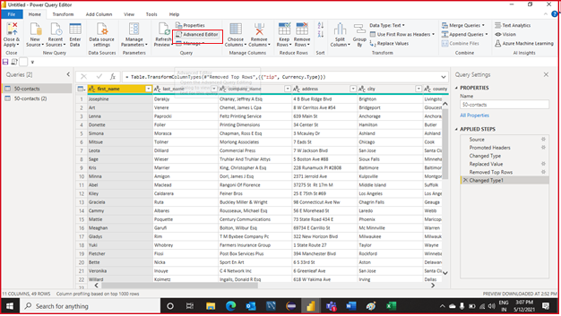

**Step 5**: Now, write a query according to your needs and click on the **Done**.

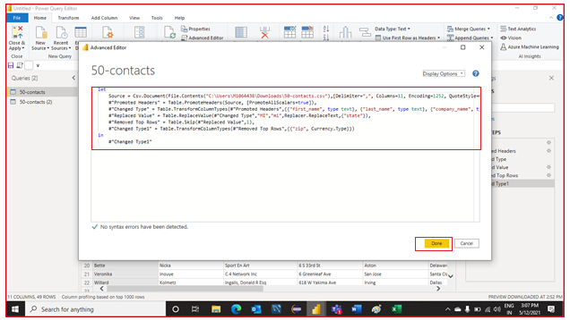

Finally, you can see the changes. And for the save the changes, click on the close and apply option.

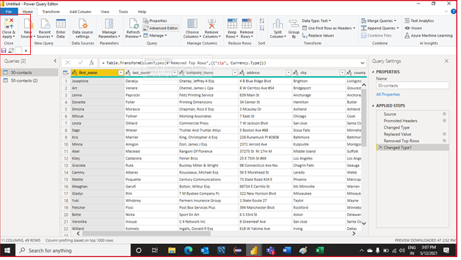

## **KO 5 Able to create Power Bi Data flow**

**Step 1:** Open **PowerBI.com.**

**Step 2:** Click on the **workspace** option and create a **workspace**

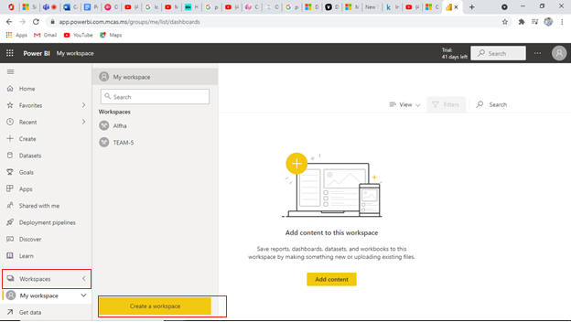

**Step 3:** Write a workspace name and description. Then **Save** it

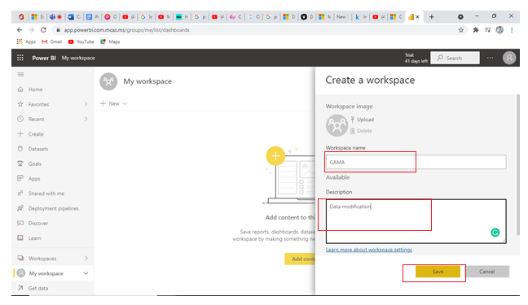

**Step 4:** Click on the **new** Option and select **data flow**.

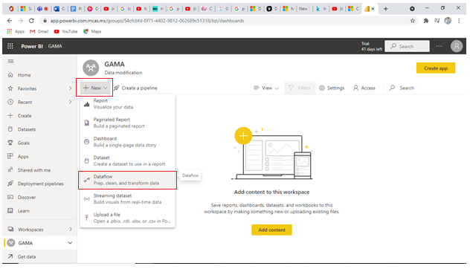

**Step 5:** **Add** a table in the workspace.

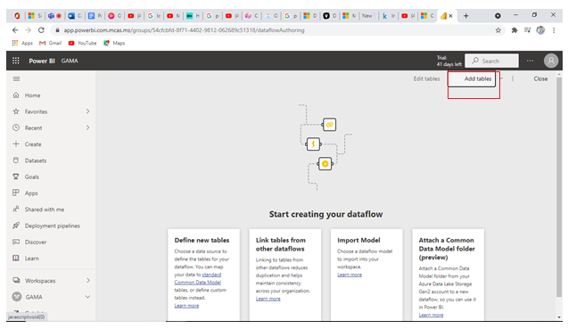

**Step 6:** Select any of data source.

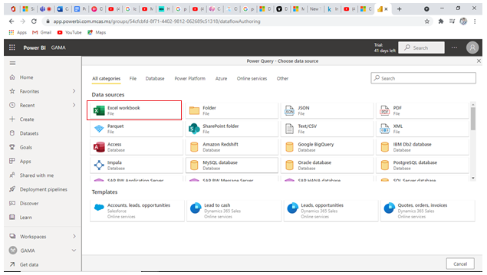

**Step 7:** Select tables and **open** it.

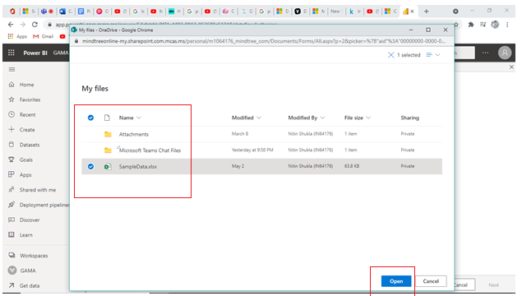

**Step 8**: Now, your file location is showing in file path. Click on the **next**.

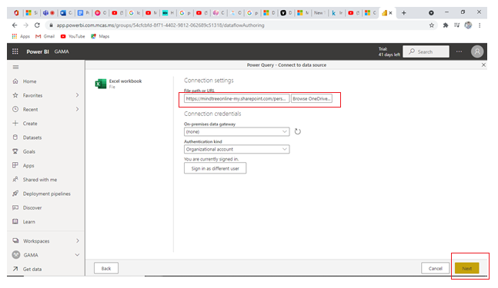

**Step 9:** Click on the **Save & Close**

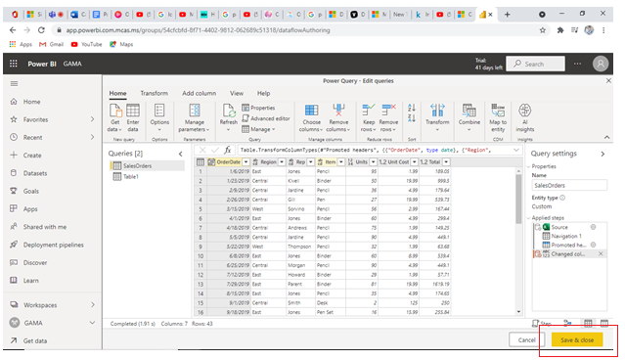

**Step 10:** Select tables and click on the **Transform** the data.

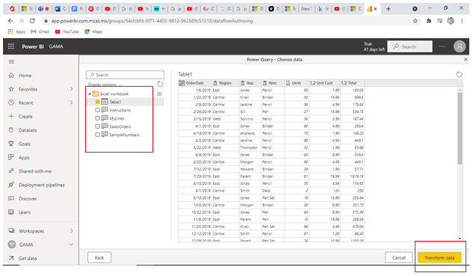

**Step 11:** Give name to the dataflow and click on the save it.

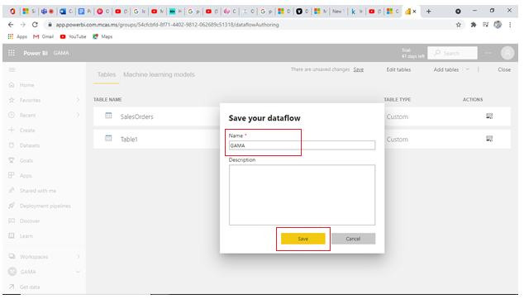

Finally, data is in the dataflow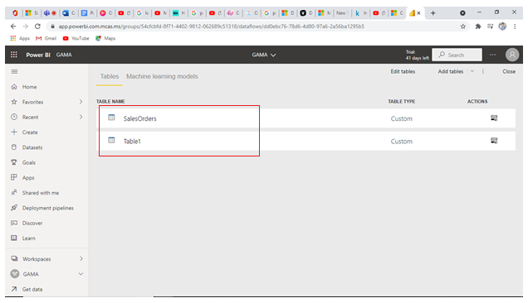

Now, go to the Power BI software. Follow the Step

**Step 1:** Click on the **Get data** and select the **Power Bi Data Flow**

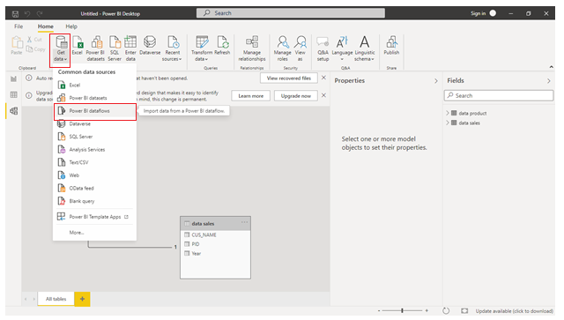

**Step 2:** Select dataflow. In the dataflow, select tables.

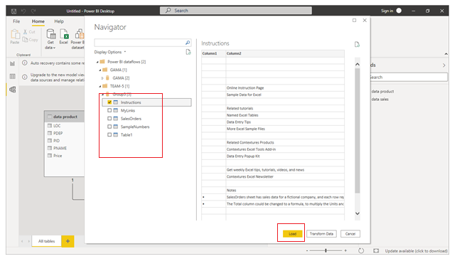

Finally, the data is loaded in the Power BI.

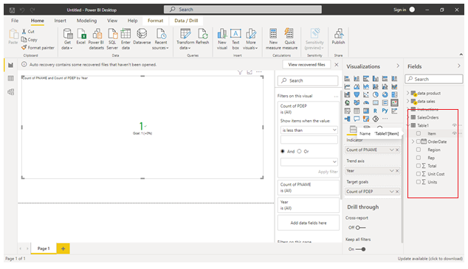

## **KO 6 Able to fix errors in data and replace error values**

**Step 1:** **Load** the data.

**Step 2:** Click on the **transform data** option.

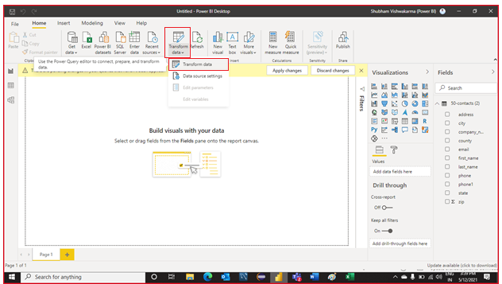

For the Purpose of **Replace Error**.

**Step 3:** Right click on the any specify column, select **replace error** option.

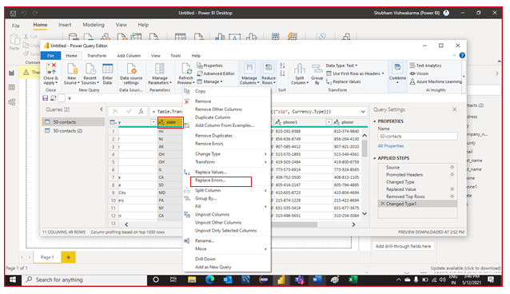

**Step 4:** Now, write **replace error** value and click on the **OK**.

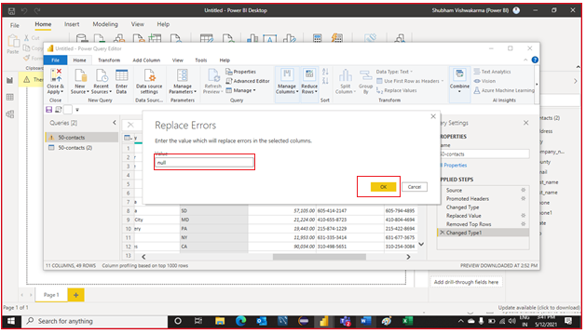

For the Purpose of **replace values.**

**Step 1:** Right click on the specific column, select the **Replace values** option.

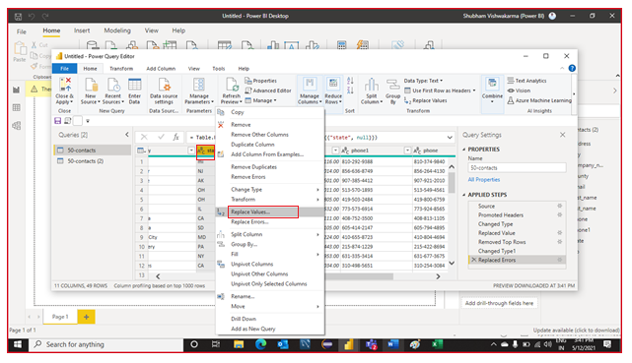

**Step 2:** Now, write value to find and the value to replace with. Click **OK**

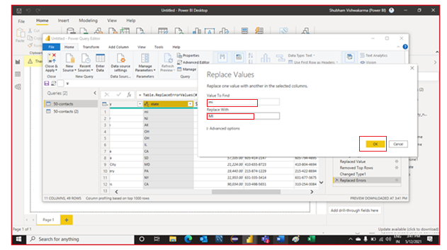

Finally, you can see the changes after modification.

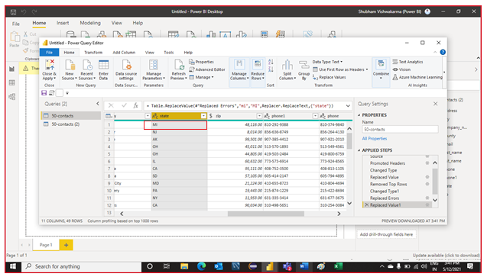

# Capability 9: Ability to combine, reshape, cleanse, and enhance data to create a model that supports reporting and analytics in Power BI.

## **KO 1: Able to explore Power Bi data sources**

# Step 1: Firstly, click on Get Data.

# Step 2: Click on more option

# Step 3: Click on Database, then select appropriate database source. Click to Connect option.

# Step 4: Write server name and database name, then click on OK option.

# Step 5: Now, select tables, then click on load option.

# After loading data in Power BI, how your data is look likes as shown below.

## **KO 2: Able to filter rows in query and eliminate columns in query**

**Step 1:** Click on the **Get Data** and select appropriate data sources.

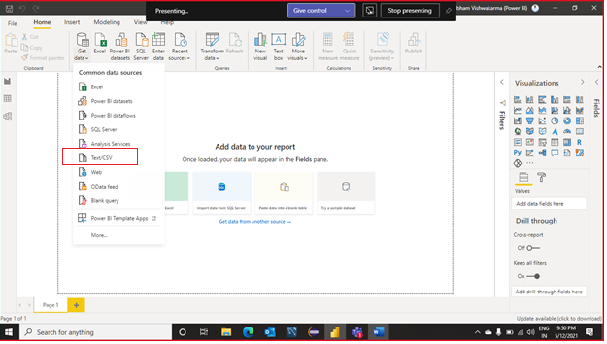

**Step 2:** click on the **load** and load the data

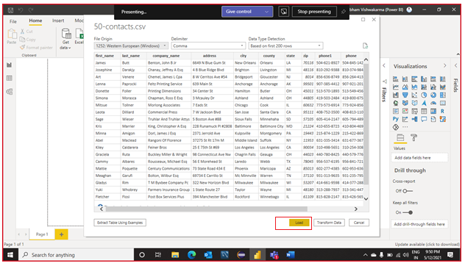

**Step 3:** Click on the **Transform data.**

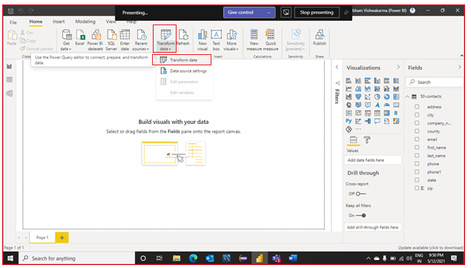

**For the purpose of eliminate columns**

**Step 4:** Select column which you want to remove. And **Right click** on that column and select **remove column** option.

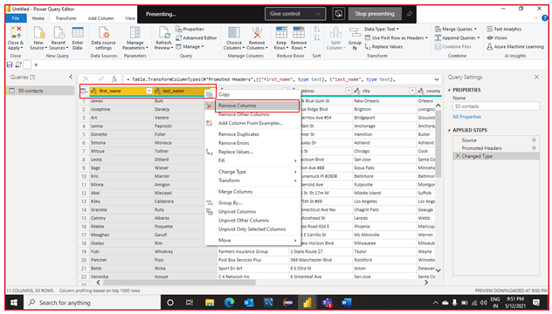

**For the purpose of Filter Rows**

**Step 5:** Click on the **arrow** which is shown in the figure.

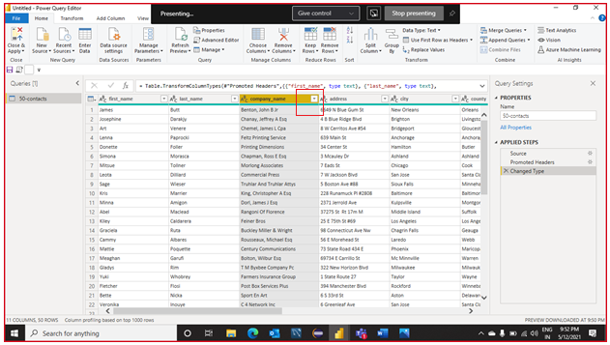

**Step 6:** Click on the **filter row** and select appropriate operation.

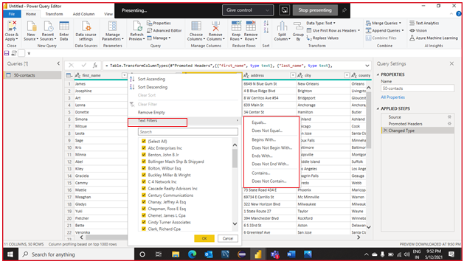

**Step 7:** Write filtering values and click on the **ok**.

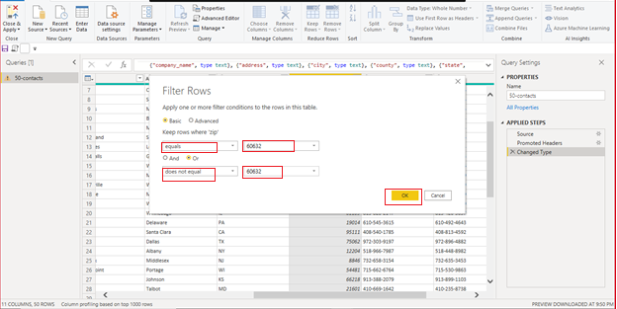

We can see the modification on the data after filtering rows.

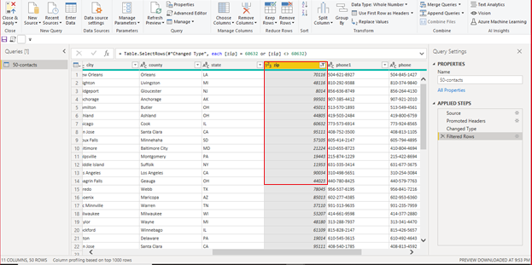

## **KO 3: Able to combine queries**

**Step 1**: **Load** the data in the Power BI.

**Step 2:** Click on the **Transform data** and select Transform data.

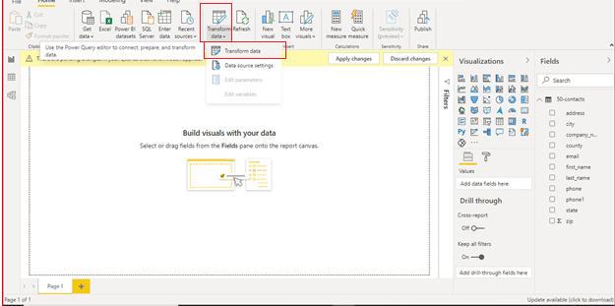

**Step 3**: Click on the **Merge Query** and select merge queries.

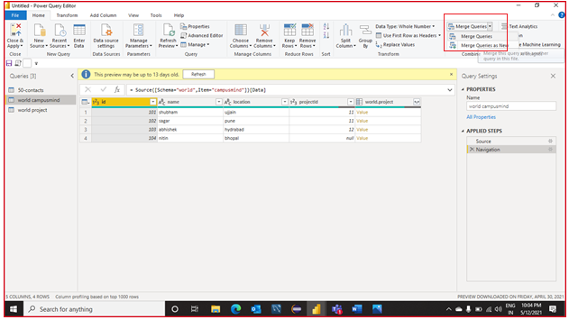

**Step 4:** select the table which you want to merge and select **join** condition. Click on the **OK**

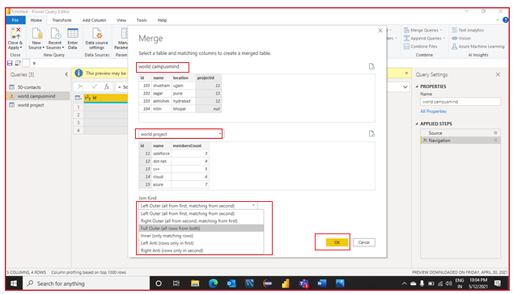

You can see the merge table.

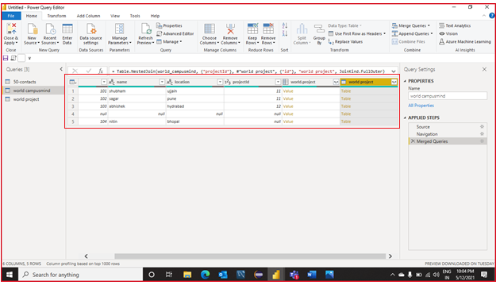

## **KO 4: Able to load and save demonstration data**

# Step 1: Firstly, click on Get Data.

# Step 2: Click on more option

# Step 3: Click on Database, then select appropriate database source. Click to Connect option.

# Step 4: Write server name and database name, then click on OK option.

# Step 5: Now, select tables, then click on load option.

# 

# Step 6: Create any visual and Click on the file.

# 

# Step 7: Click on the save option and save the file.

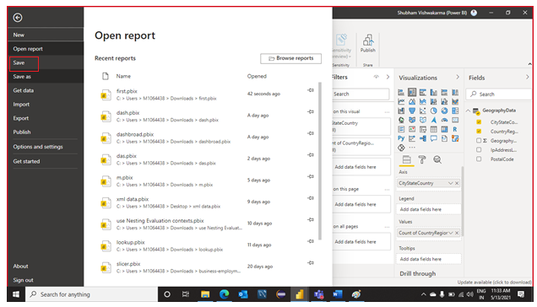

## **KO 5: Able to add columns by Expanding XML, Splitting delimiter**

**Step 1:** **Load** the data in the Power BI.

**Step 2:** Click on the **transform data** and select the transform data.

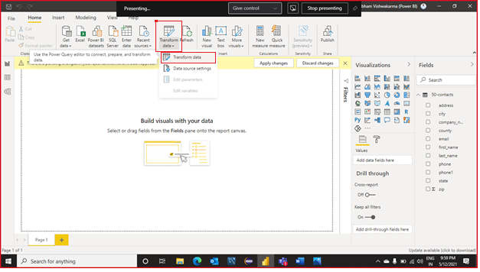

**Step 3:** Click on the **Split** column and select **delimiter** option

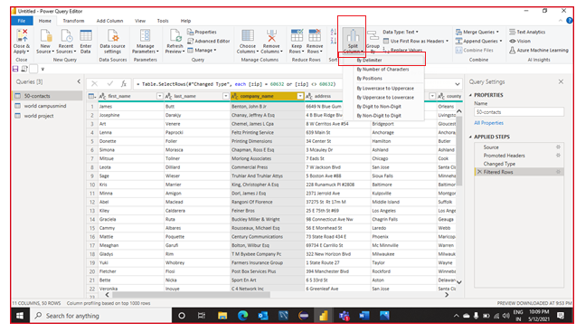

**Step 4:** Select delimiter and click on the **ok**.

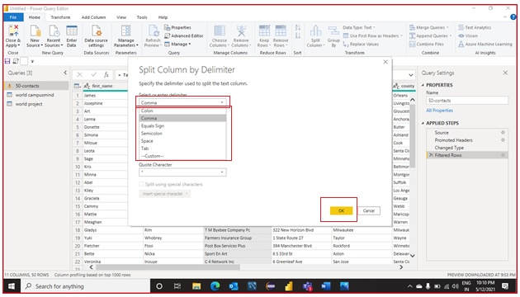

You can see the result.

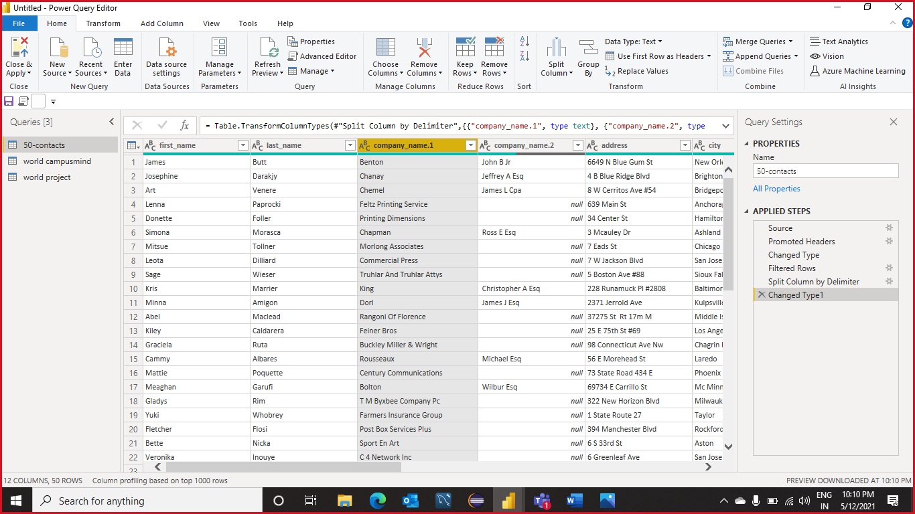

## **KO 6: Able to add custom columns**

**Step 1:** **Load** the data in the Power BI.

**Step 2:** Click on the **transform data** and select the transform data.



**Step 3:** Click on the **custom column** option.

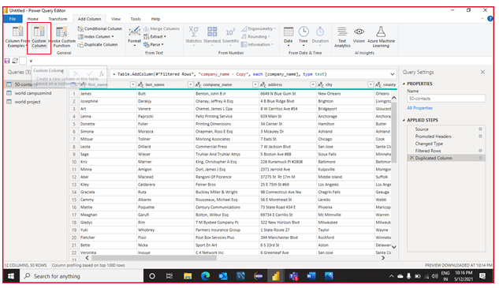

**Step 4:** Write custom formula and click on the **Ok**

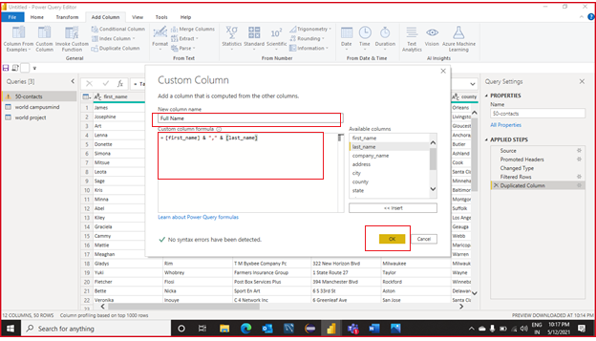

You can see the result after add custom column.

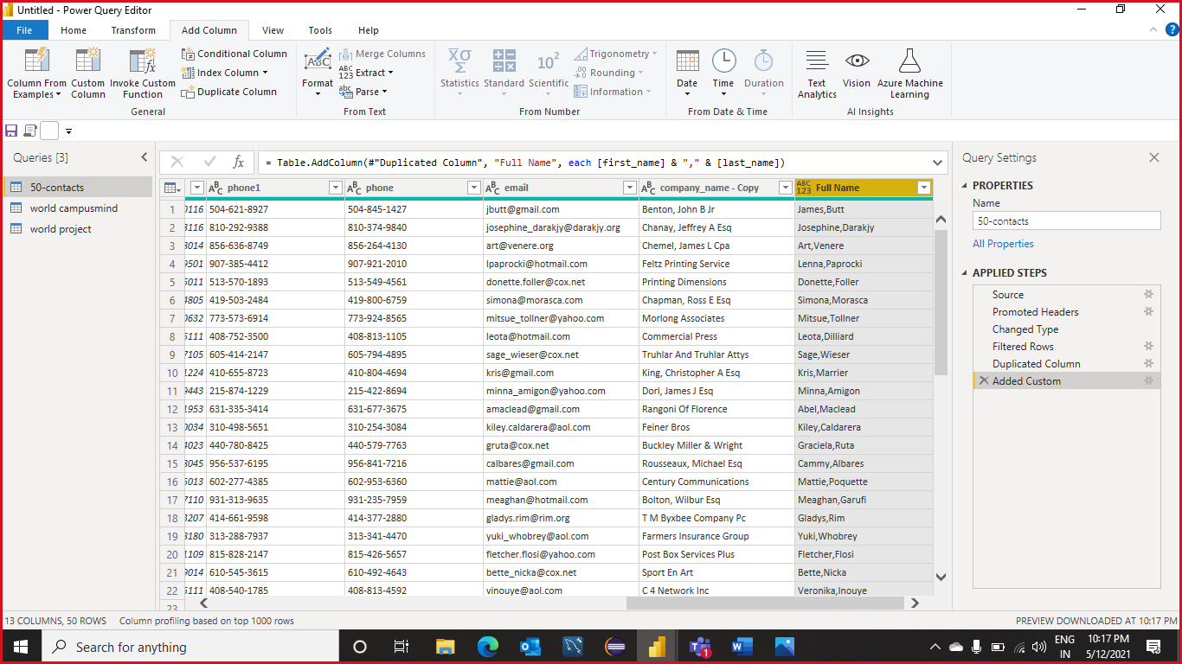

**KO 7: Able to review and create relationships in the Model**

**Step 1:** **Load** the data in the Power BI.

**Step 2:** Click on the **model**. And For the creation of relation, just drag out the column which is common in the other table.

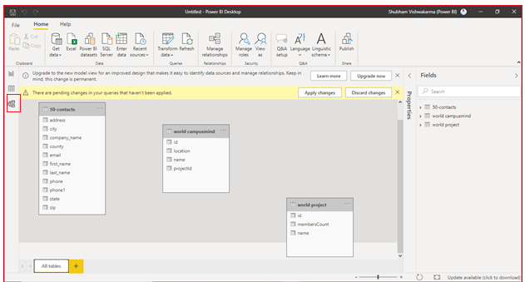

**Step 3:** Select tables which we make a relation and click on the **ok**

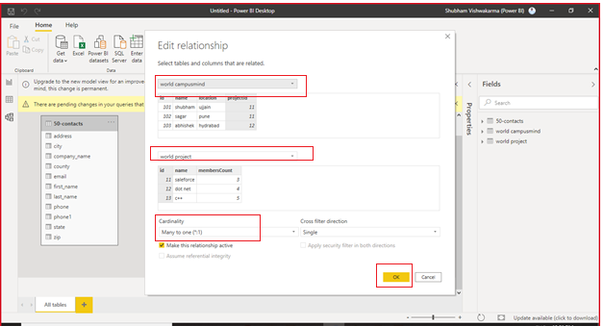

You can see the relationship.

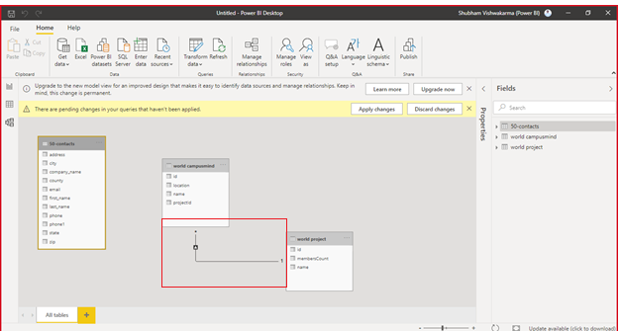

## **KO 8: Able to use Relationship editor**

**Step 1:** **Load** the data in the Power BI.

**Step 2:** Click on the **model**. Right click on the table and select the **manage relationship.**

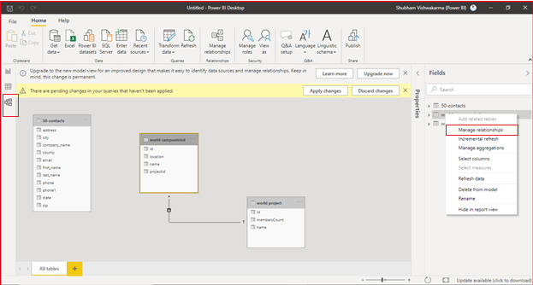

**Step 3:** Select relation and click on the **edit**.

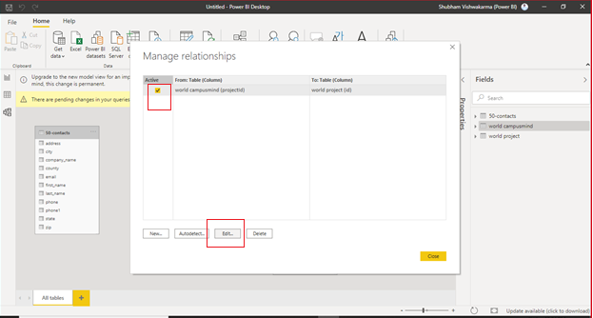

**Step 4:** Select appropriate tables and click on the **ok**.

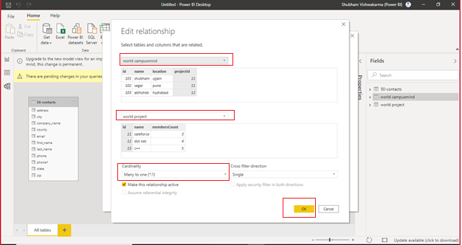

**Step 5:** **Close** it for apply

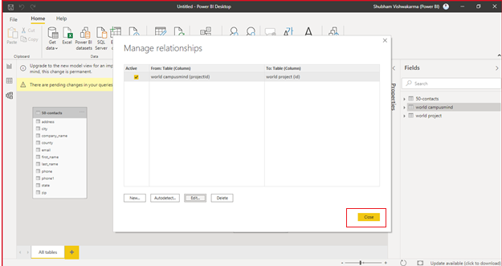

## **KO 9: Able to Resolve relationship issues by Fixing data quality, with a bridge table**

**Step 1:** **Load** the data in the Power BI.

**Step 2:** Click on the **transform data** and select the transform data.



**Step 3:** Click on the **Remove rows** and select the appropriate option.

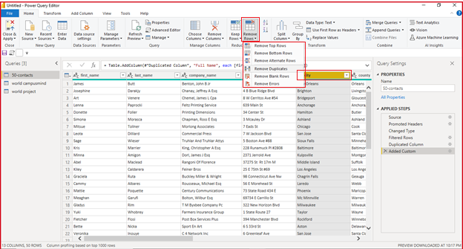

You can see the result after modification.

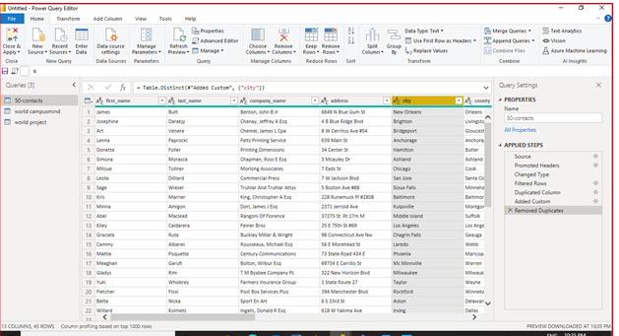

## **KO 10: Able to Add permanent hierarchy to model**

**Step 1**: **Load** the data in the Power BI

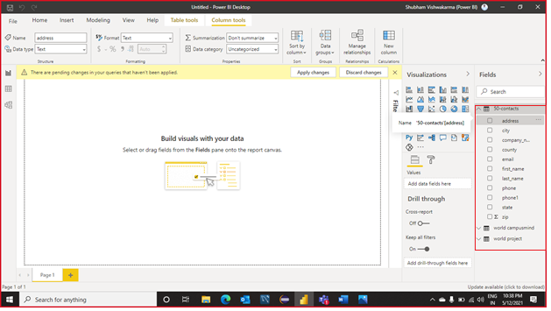

**Step 2:** Right click on the any column and select **new hierarchy** option.

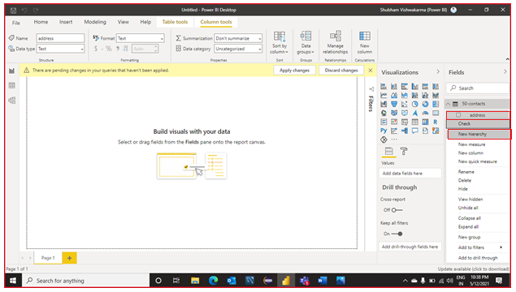

You can see the hierarchy is created.

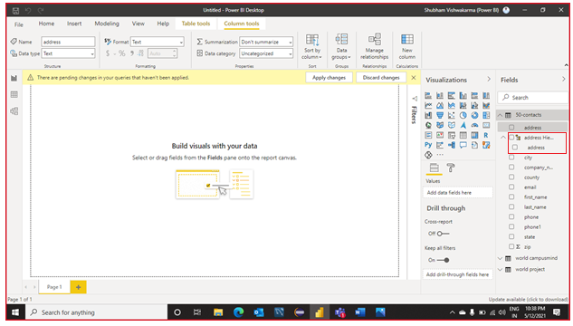

**Step 3**: Right click on the any column and select **add hierarchy** option.

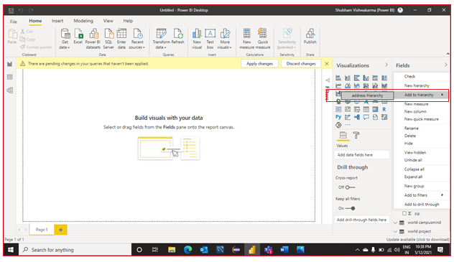

You can see result after creation of hierarchy, and it contain many column.

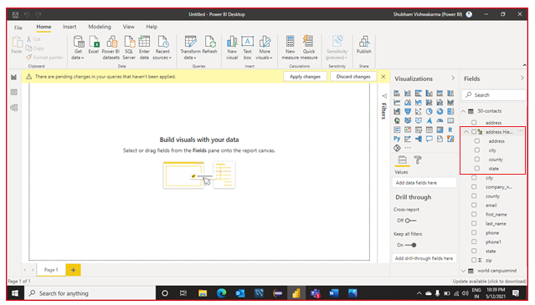

**Capability : Ability to write DAX Formulas in Power BI, Power Pivot**

**Able to understand DAX**

Data Analysis Expressions (DAX) is the native formula and query language for Microsoft power pivot, Power BI Desktop and SQL Server Analysis (SSAS) Tabular models. DAX includes some of the functions that are used in Excel formulas with additional functions that are designed to work with relational data and perform dynamic aggregation.

You can use DAX to define custom calculations for Calculated Columns, Measures, Calculated Tables, Calculation Groups, Custom Format Strings, and filter expressions in role-based security in Tabular models. The same Analysis Services engine for Tabular models is also used in Power BI and Power Pivot for Excel. Power BI also uses DAX for conditional formatting expressions and other dynamic properties of visual components.

**Able to add business logic with calculated column and measures**

**Calculated Columns**

With calculated columns, you can add new data to a table already in your model. But instead of querying and loading values into your new column from a data source, you create a Data Analysis Expressions (DAX) formula that defines the column's values. In Power BI Desktop, calculated columns are created by using the new column feature in report view.

Step 1 – Add new column in data model which is shown in Table tools bar as shown below.

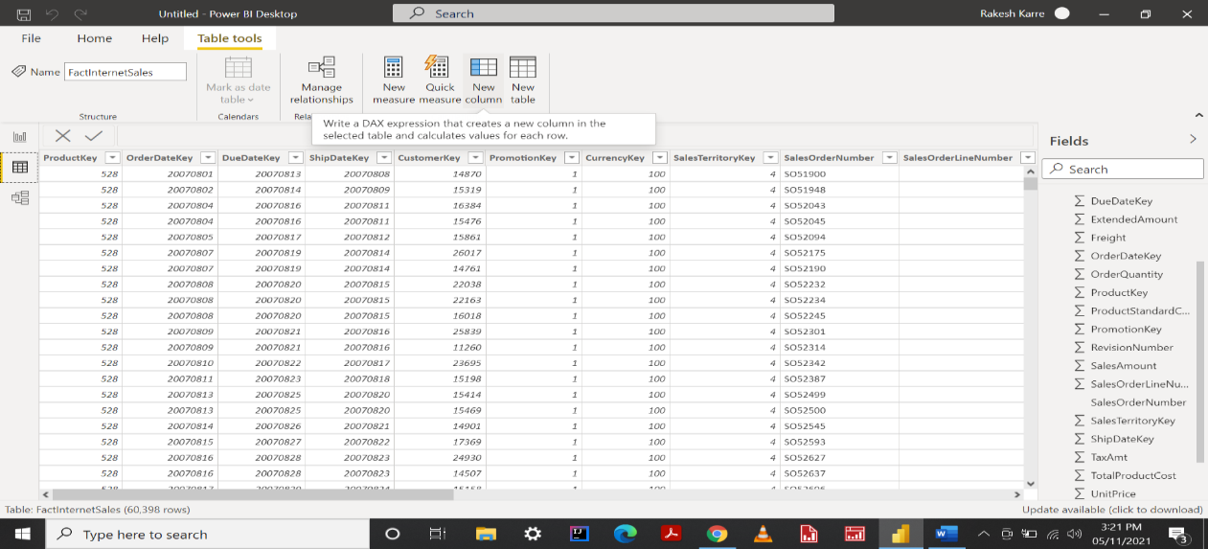

Step 2 – After clicking on new column image will be shown as below, we need to type DAX formula in column box.

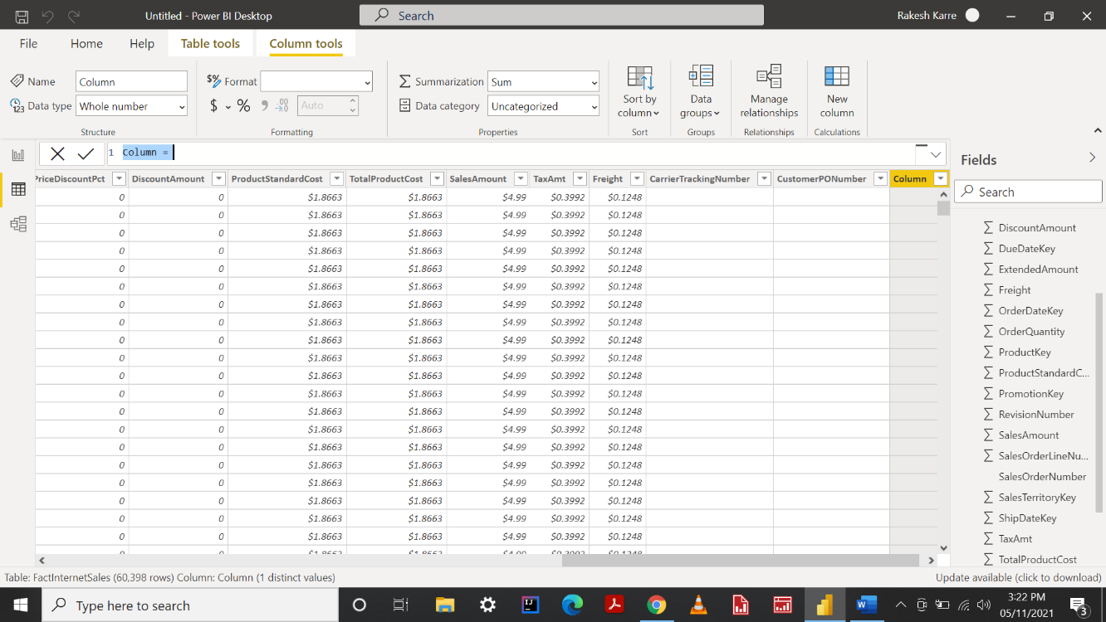

Step 3 – Here, I am creating a calculated column naming it as Line Total as shown below.

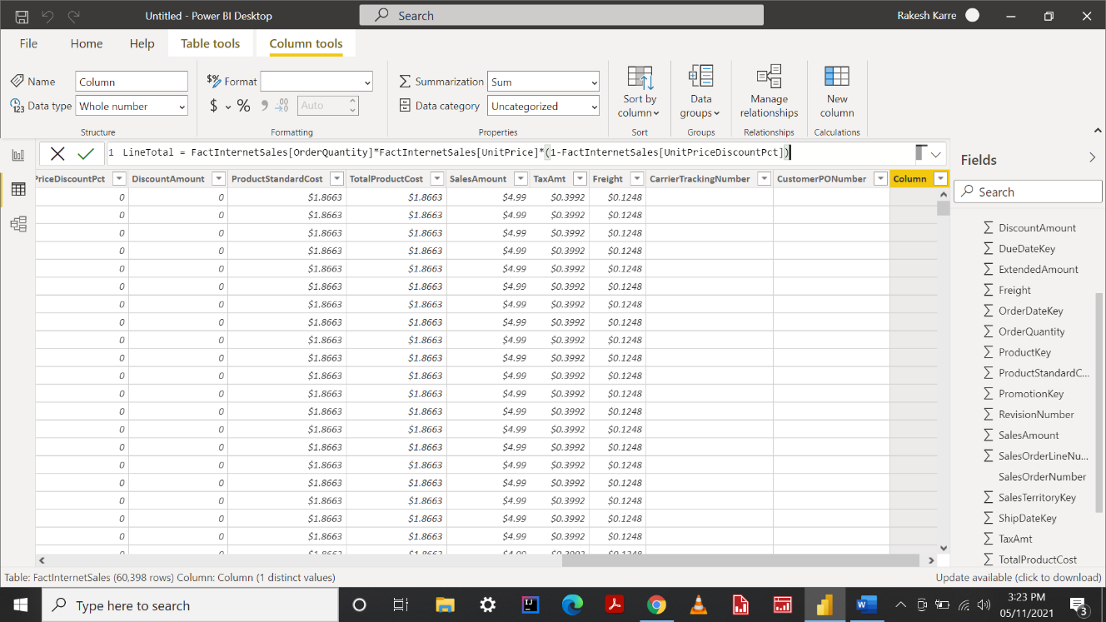

Step 4 – This is how it looks after adding a new calculated column which is shown below in data model.

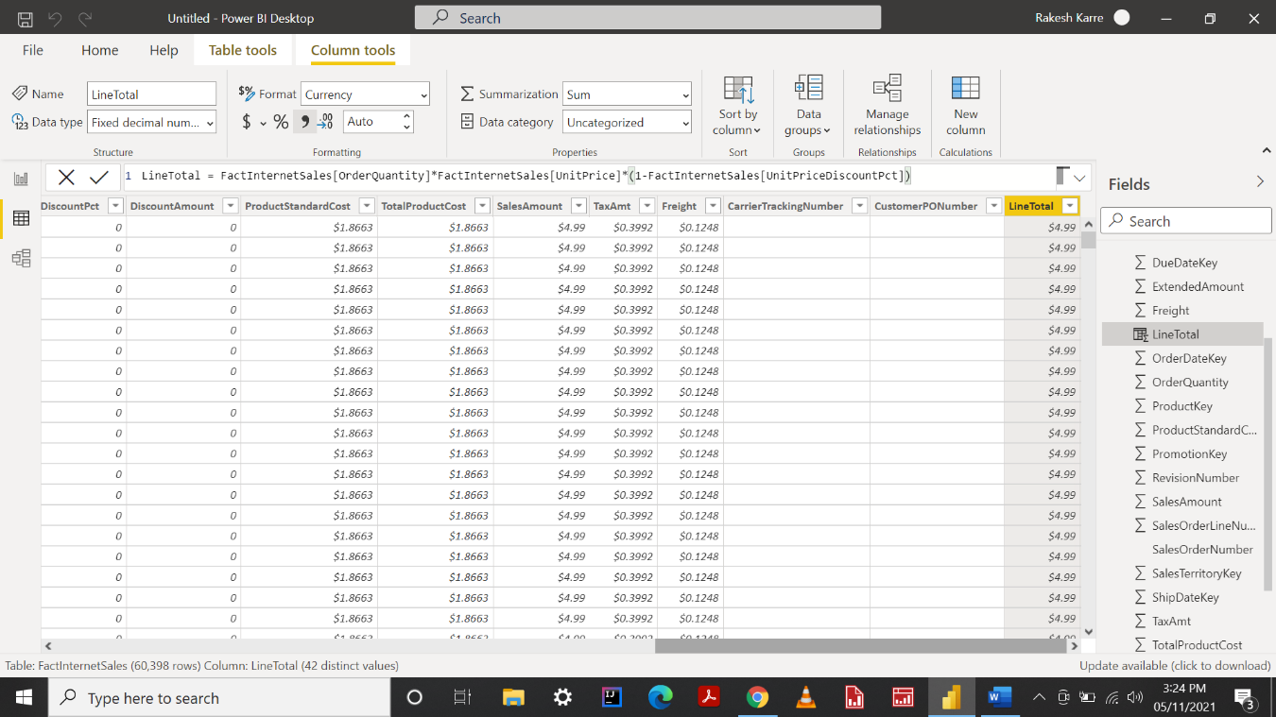

**Measures**

Measures are used in some of the most common data analyses. Simple summarizations such as sums, averages, minimum, maximum and counts can be set through the fields well. The calculated results of measures are always changing in response to your interaction with your reports, allowing for fast and dynamic ad-hoc data exploration.

In Power BI Desktop, measures are created and displayed in Report view or Data view. Measures you create yourself appear in the fields list with a calculator icon. You can name measures whatever you want, and add them to a new or existing visualization just like any other field.

Step 1 – Add new measure to any of the table. Here I am creating a measure to fact internet sales table by just right clicking on Fact Internet Sales table as shown in next page.

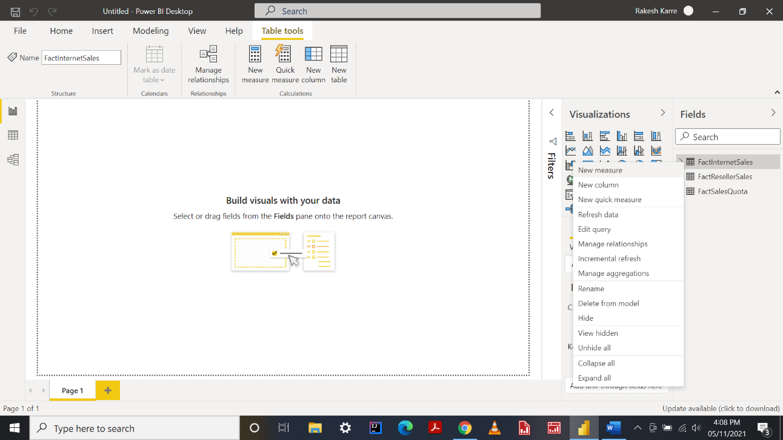

Step 2 – After creating a measure, dialog box will look like below with measures column box .

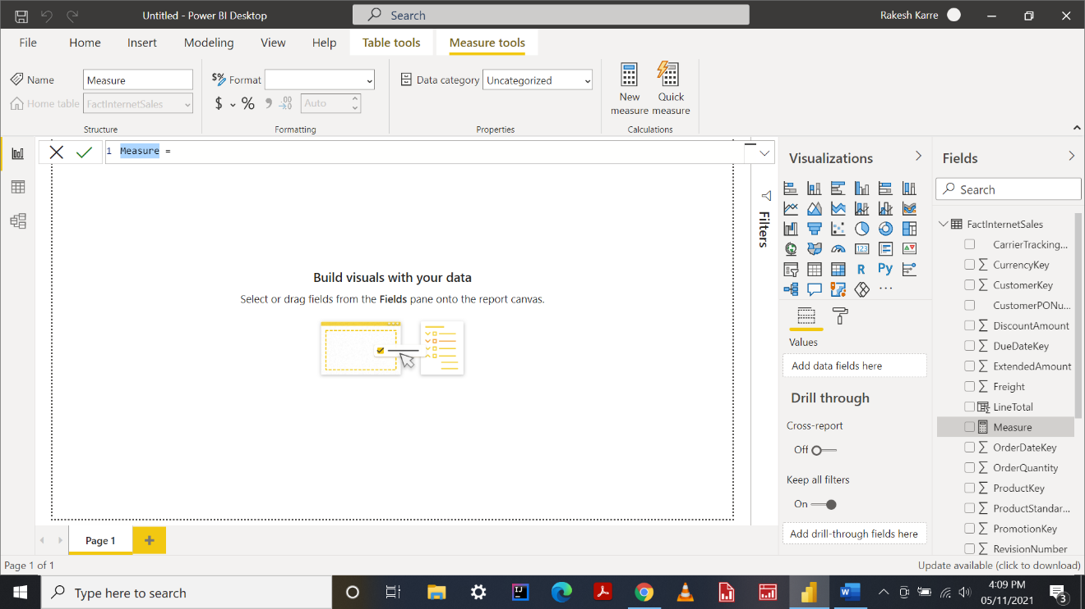

Step 3 – Here I am writing a DAX formula for measures naming it as Minimum price using MIN aggregation as shown below.

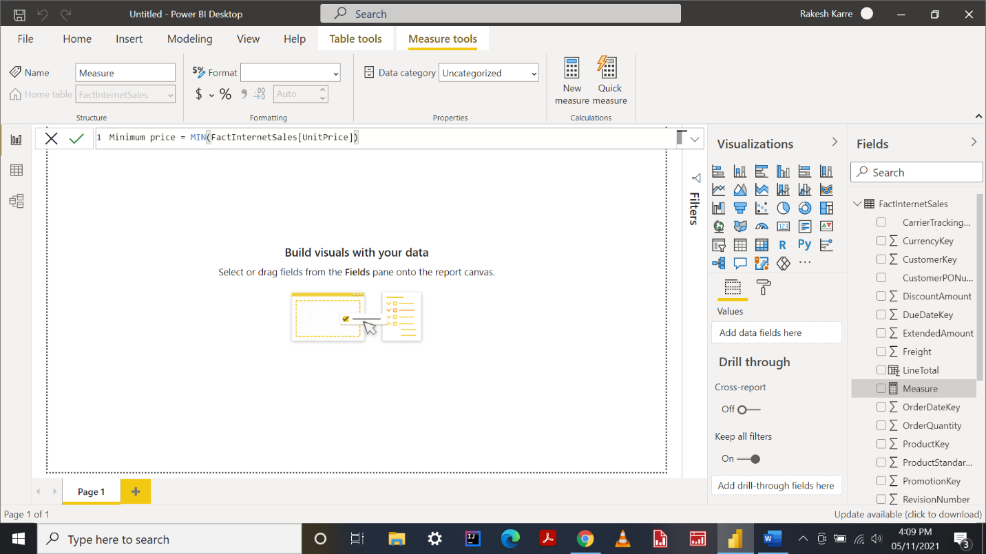

Step 4 – After creating a DAX formula for measure it displays in fact internet sales table with a calculator icon beside Minimum Price field as shown below.

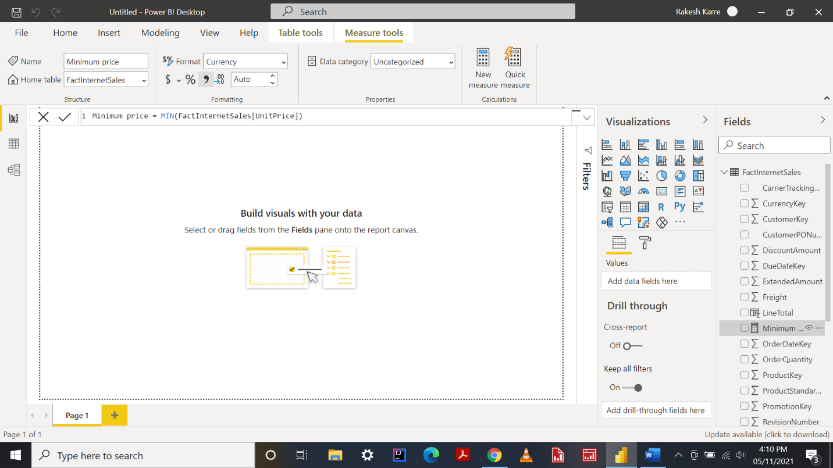

**Able to Filtering Data Using CALCULATE**

**Filter data**

You can create filters within formulas, to restrict the values from the source data that are used in calculations. You do this by specifying a table as an input to the formula, and then defining a filter expression. The filter expression you provide is used to query the data and return only a subset of the source data. The filter is applied dynamically each time that you update the results of the formula, depending on the current context of your data.

Step 1 – In Layout view, I have created a grid with two fields from different tables as shown below here I am going to filter data of average of line total field with using calculate function by creating a new measure.

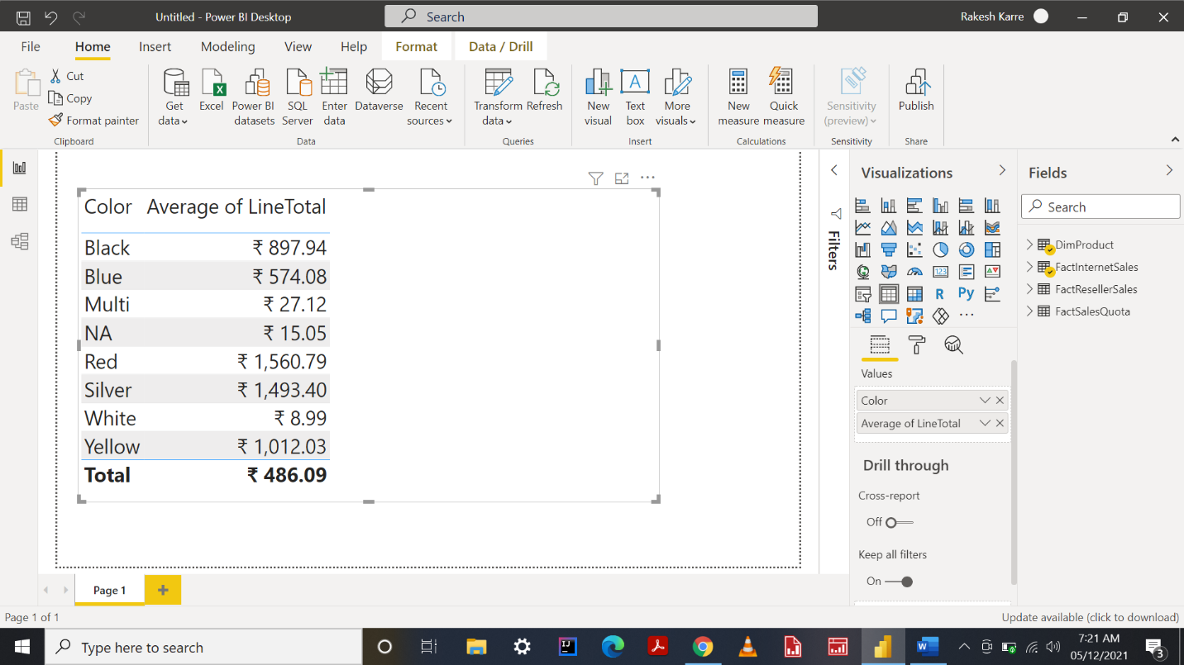

Step 2 – Here I created a new measure by right clicking on table naming it as Filter With Calculate in measures dialog box . What exactly it does means it filter the data according to the expression we have mentioned.

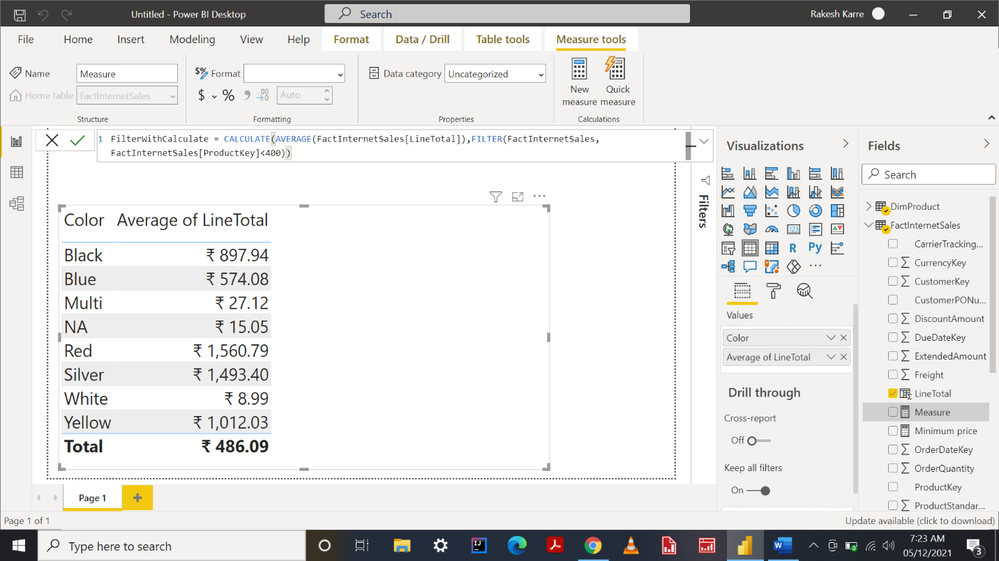

Step 3 – This is how it looks after filtering data with calculate as shown below .

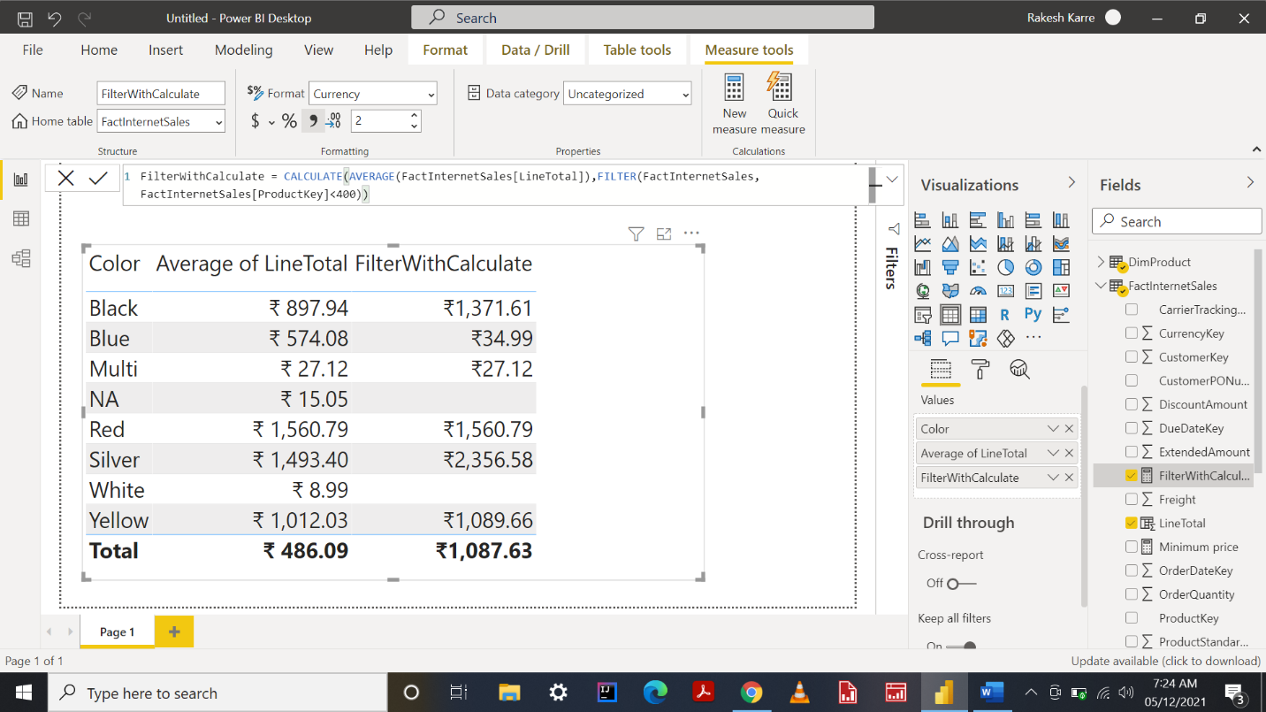

**Able to use Iterators**

Iterators in DAX are functions that iterate through all rows of the given table, apply the expression, and then aggregate the result. Some of the functions in this category are sumx, averagex, concatenatex etc., because an iterator function goes through every row and apply the transformation, then the result is materialized (temporary) before aggregating it, and that causes the totals to be actual sum (or other aggregations) of values in a column.

The main difference between sum(Aggregation) and sumx(Iterator) is that, sum is used for only single column whereas sumx is used for multiple columns.

Step 1 – In layout view, I selected a grid for one field and now I am going to use one of the iterator function ie., Averagex which is going to be shown in step 2.

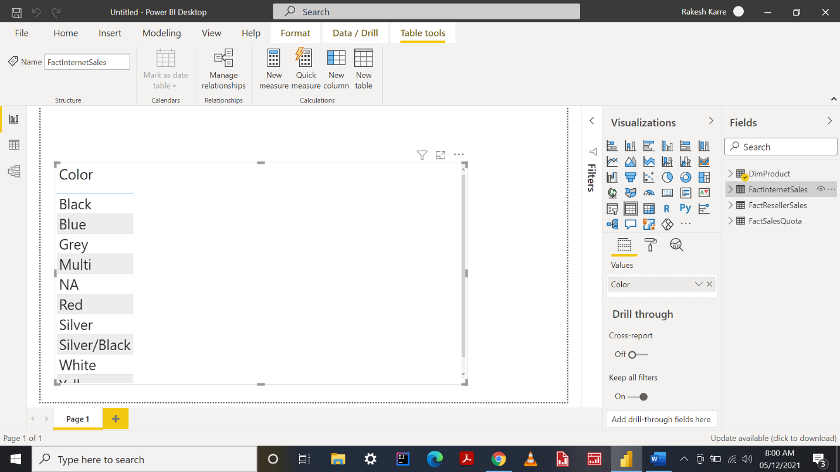

Step 2 – Here, I created a measure naming it as average gross sales using an iterator function of Averagex with expression in measure dialog box as shown below.

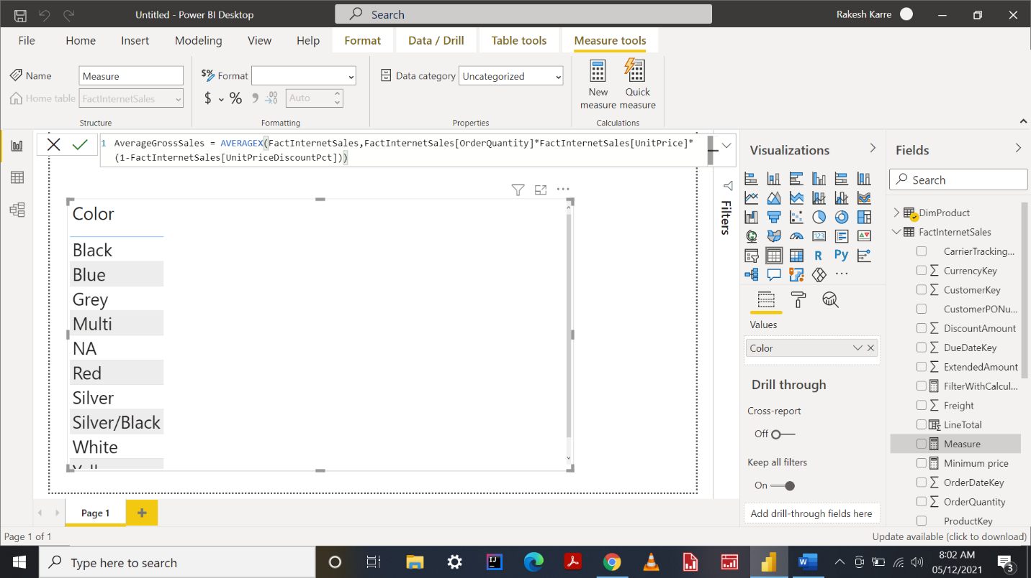

Step 3 – After creating a measure, I am going to add that measure to layout view to view the result of averagex iterator function as show below.

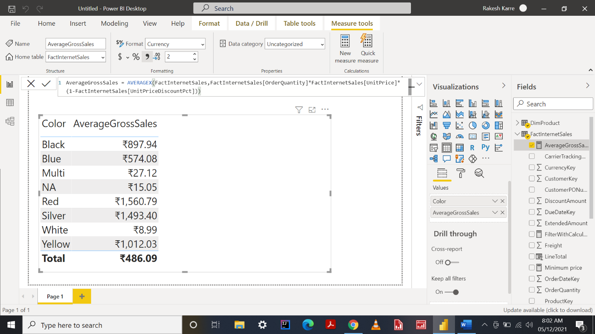

**Able to use Nested Evaluation contexts**

**Evaluation contexts**

The environment in which a DAX formula is evaluated in. So, when we write a DAX formula it gets evaluated within an environment. The DAX formula evaluated will be directly dependent on the Evaluation Context. This means the result returned can be different depending on the context, even if the DAX formula used is the same.

Step 1 – Here I am going to create a calculated column naming it as total sales as shown below. So when we apply DAX formula it gives result for every single row as same value Since filters do not propagate whenever we have row context Even though DAX formula is correct. Reference is shown below.

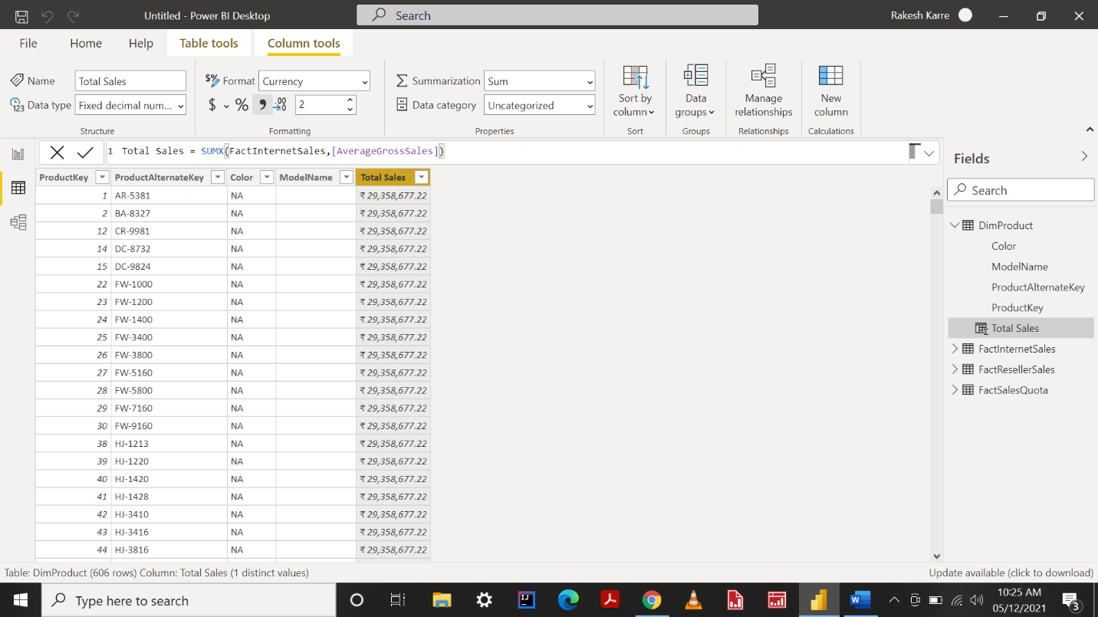

Step 2 - Here I wrap it up with related table function in dialog box as shown below.

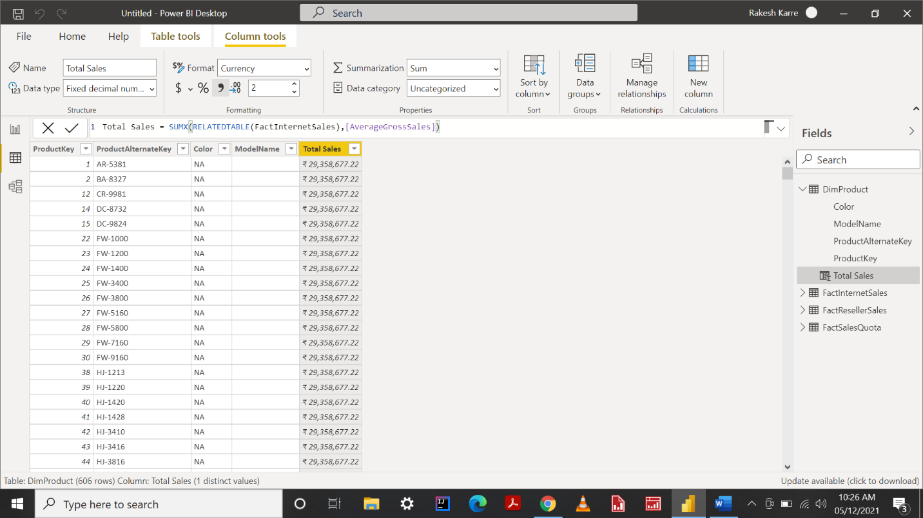

Step 3 – This is how it looks after applying related table as we can see we will get the value specific to each product.

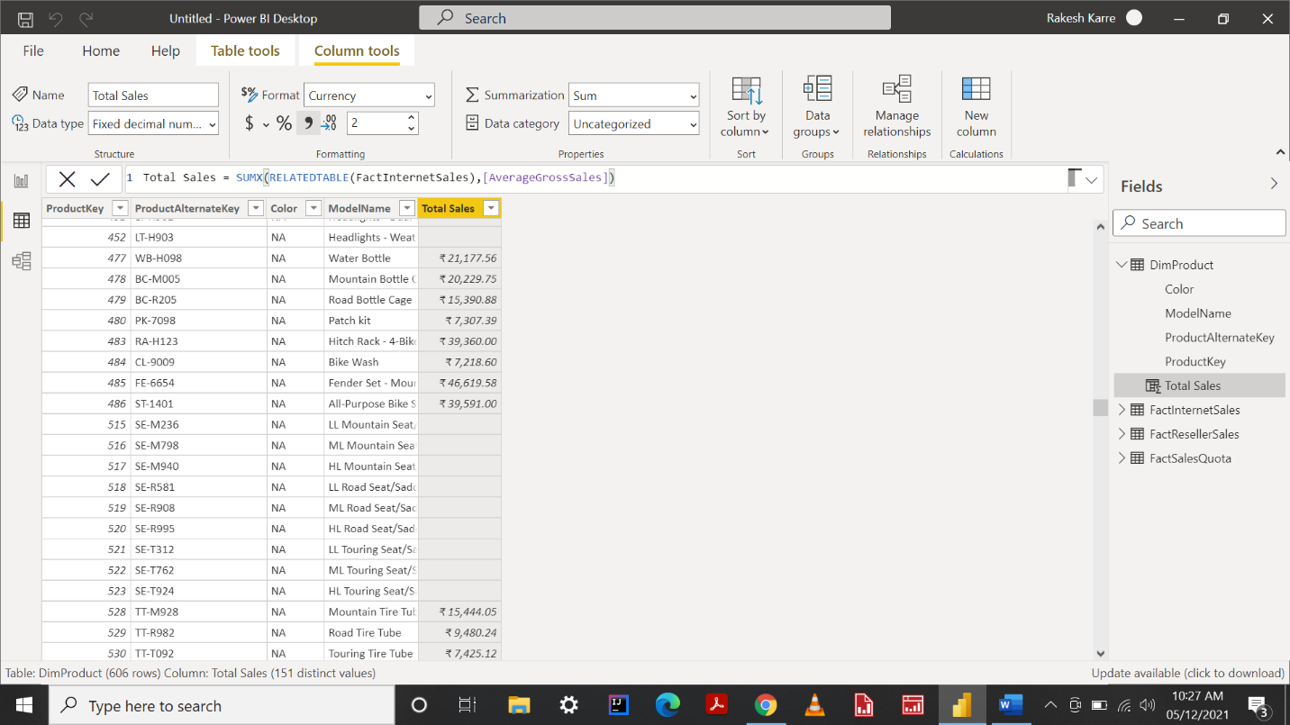

**Able to use Date table and Time intelligence**

Data Analytics Expression (DAX) includes time intelligence functions to support the needs of Business Intelligence analysis by enabling you to manipulate data using time periods, including days, months, quarters, and years, and then build and compare calculations over those periods.

The time intelligence functions are sometimes categorized with the Date and Time functions.

In Power Bi Desktop you can use all the Time Intelligence functions available in DAX when the Calendar table has relationships with other tables using a column of Date data type.

**Date Table**

Step 1 – Click on new table in data model which is in home bar as shown below

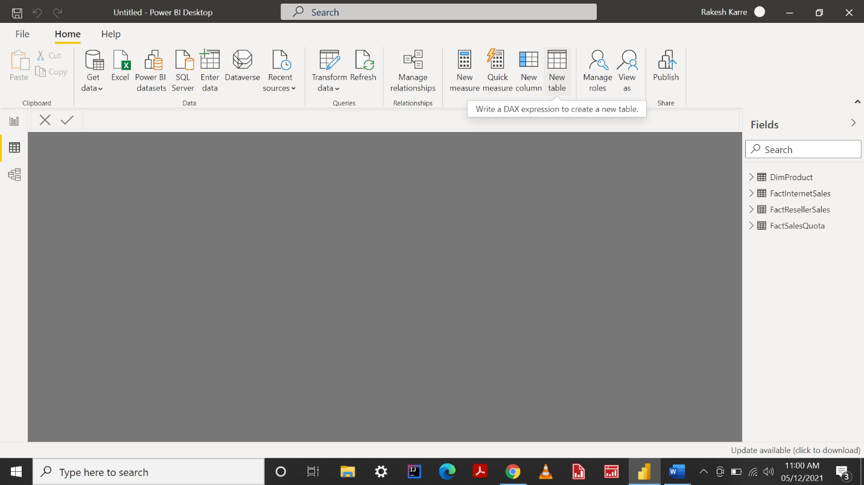

Step 2 – Here I created a date column by using calendar function in DAX dialog box as shown below.

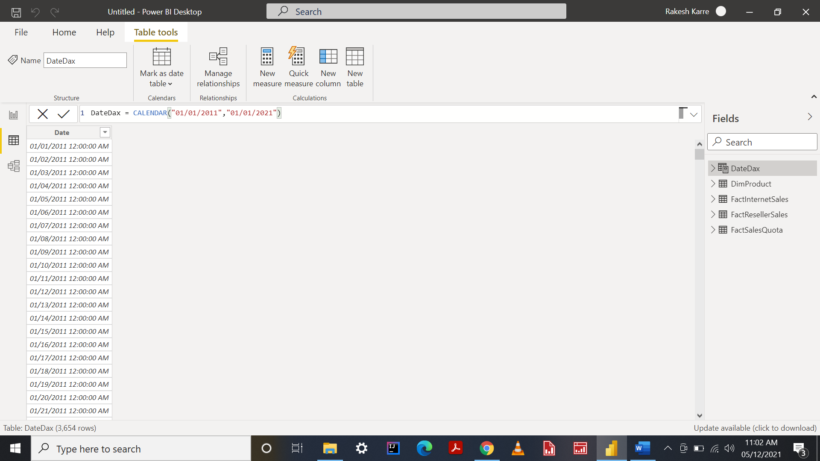

Step 3 – I am adding a new column name YEAR to the date table by using ADDCOLUMNS function which is shown below in dialog box.

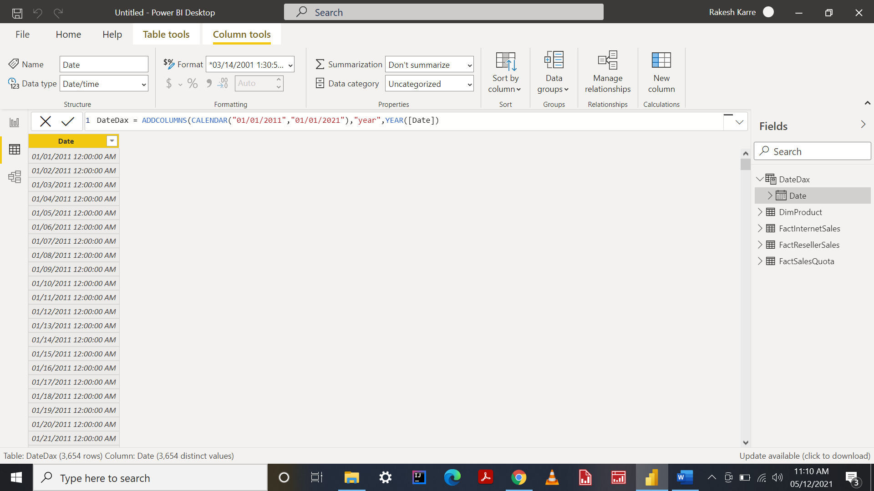

Step 4 – This is how it looks after applying DAX formula .

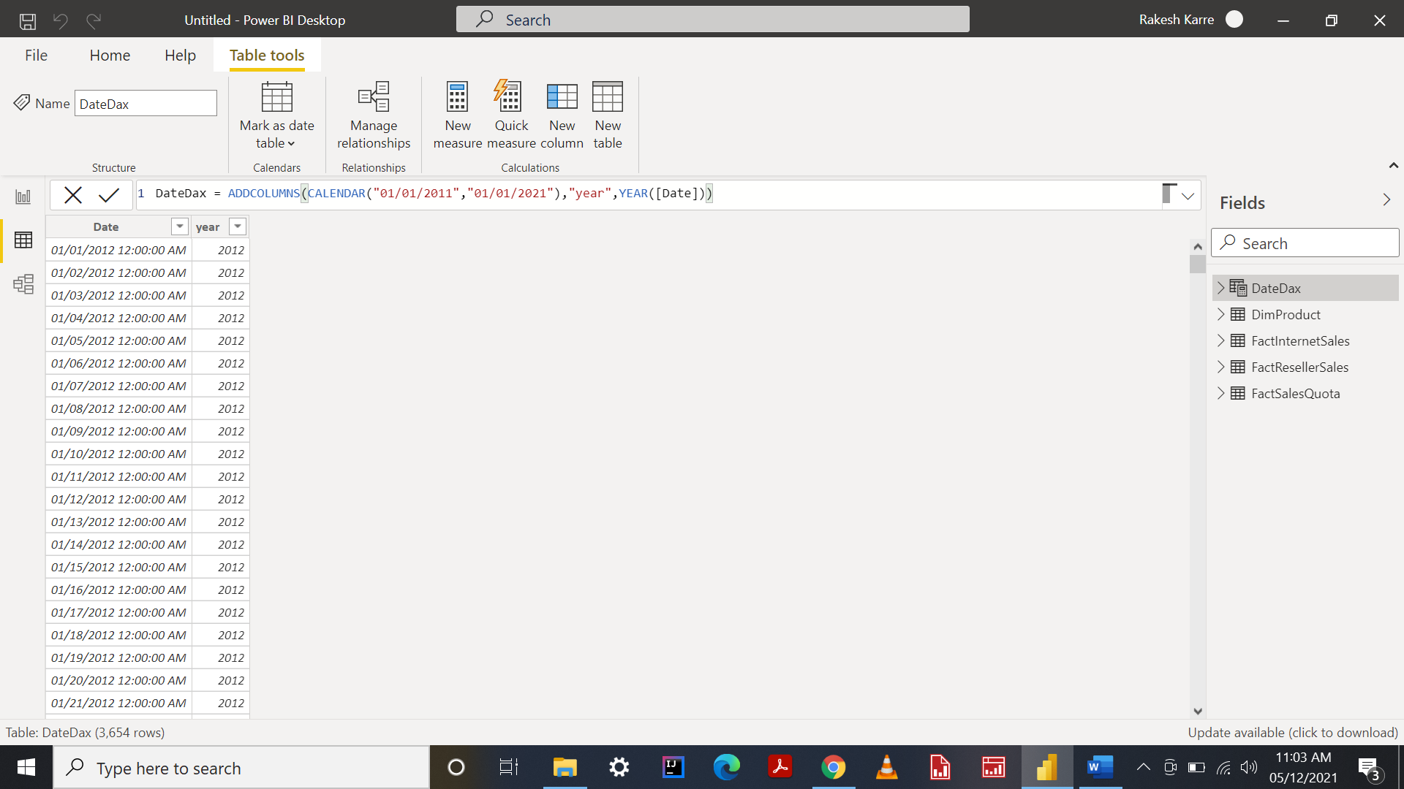

**Time Intelligence**   
Step 1 – Here, creating a new measure using time intelligence function DATESYTD

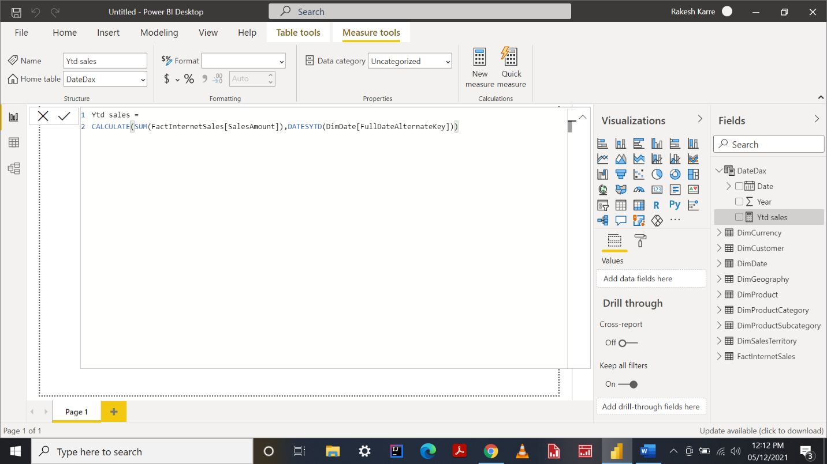

Step 2 – Creating a new measure using time intelligence function SAMPLEPERIODLASTYEAR.

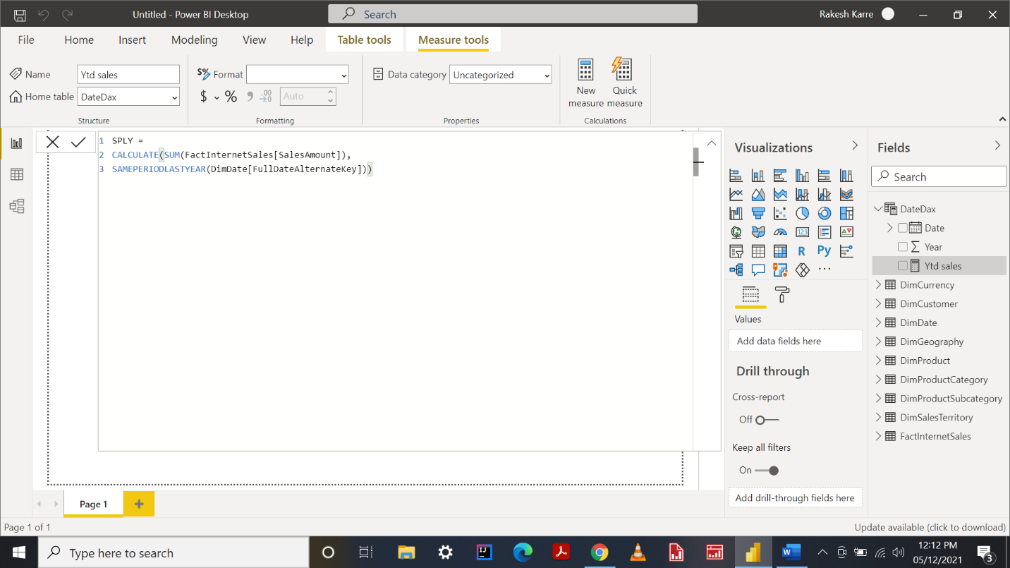

# Capability : Ability to communicate data stories through clear and compelling reports

**Able to create reports to show relationships**

100 Percent Stacked Chart

100% Stacked Bar Chart displays the metric information in percentages. Let me show you Example of creating a stacked bar chart.

Step 1 – First we need to select stacked charts from visual section

Step 2 – Then we need to apply data to it to get result.

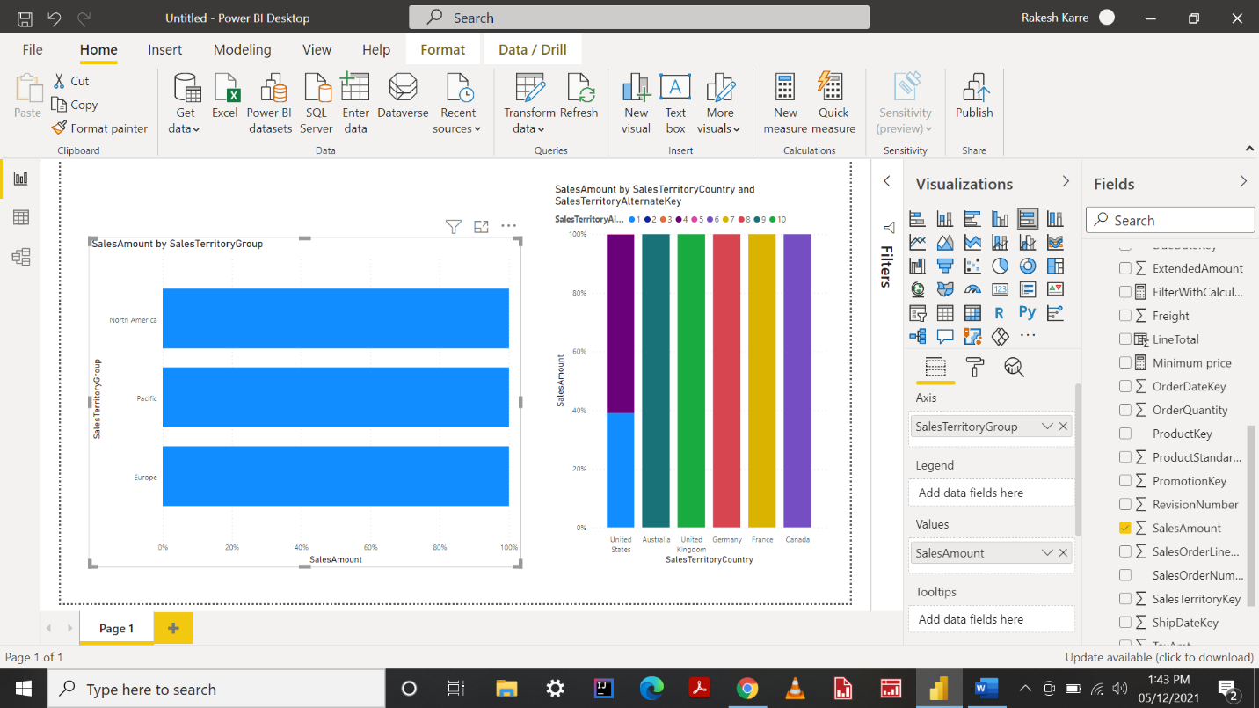

**Pie and donut chart** - A pie chart is a circular graph that shows individual categories as slices – or percentages – of the whole. Reference is shown below.

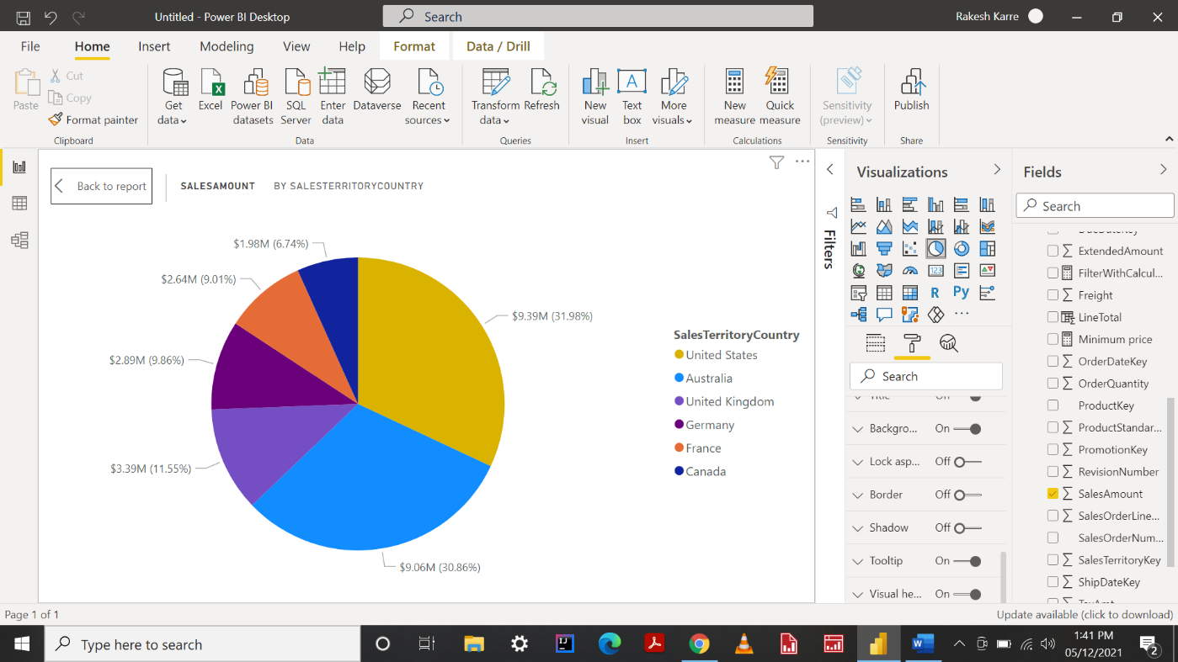

The donut chart is a variant of the pie chart, with a hole in its center, and it displays categories as arcs rather than slices. Both make part-to-whole relationships easy to grasp at a glance.

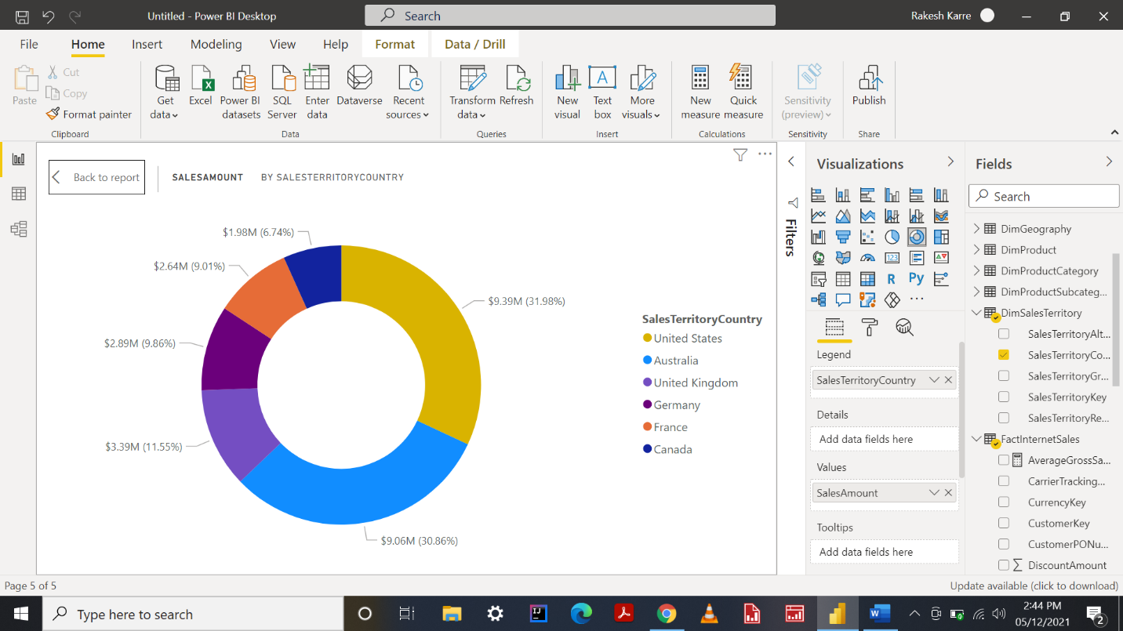

**Funnel chart**

Funnel charts are a type of chart, often used to represent stages in a sales process and show the amount of potential revenue for each stage.

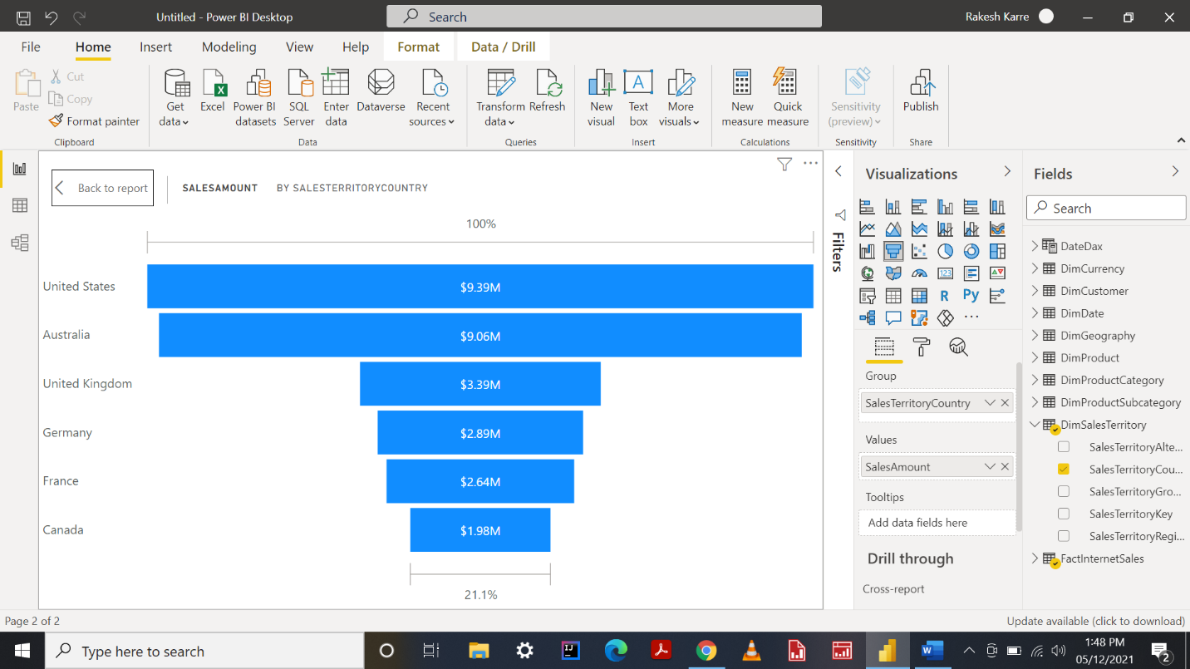

**Water Fall Chart**

They're useful for understanding how an initial value (like net income) is affected by a series of positive and negative changes. Reference is shown below.

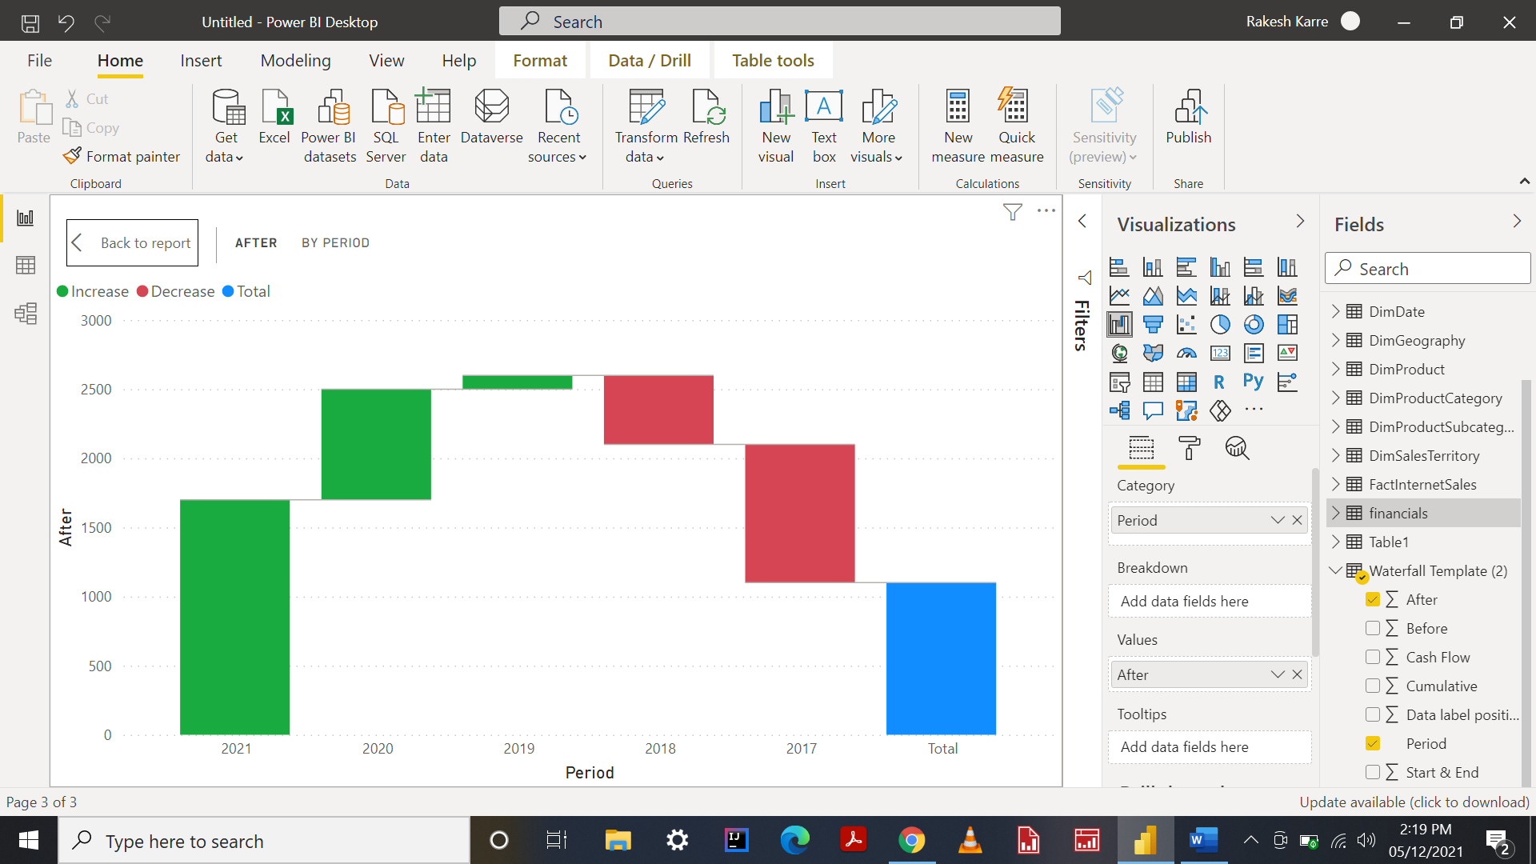

**Tree Map**

Tree Map display hierarchical data as a set of nested rectangles. Each level of the hierarchy is represented by a colored rectangle (branch) containing smaller rectangles.

The Tree maps in power bi are very useful to display the largest data in a small region.

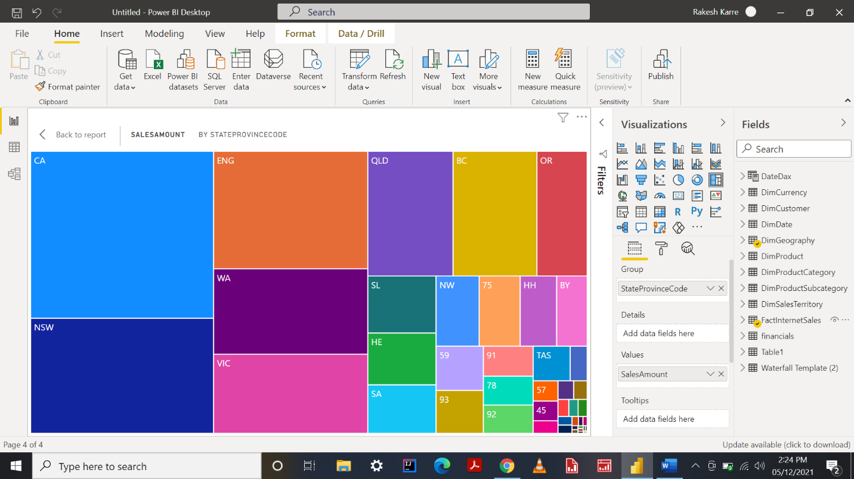

**Able to implement Key Performance Indicators**

**KPI**

KPIs are a key visualization type used to convey high level metrics to the end users. They provide an at-a-glance metric that allows business users to know whether they are on track or off-track.

That being said, one of the great things about having custom visuals is that they typically offer more enhanced visual options or settings that you cannot find in the default visual set in Power BI. KPIs have been one of those visuals that needed a bit more enhancement.

Reference of key performance indicators is shown in next page.

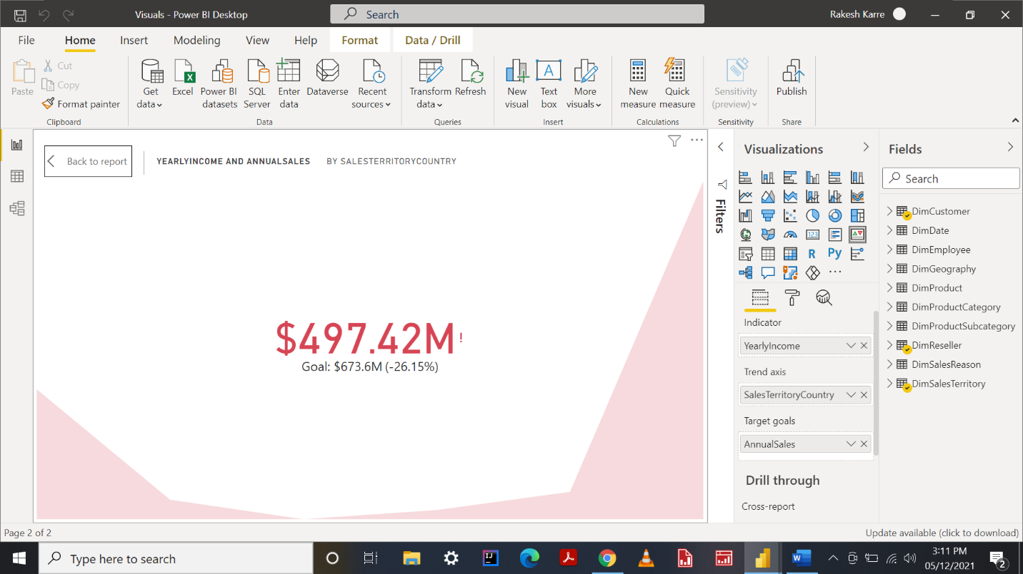

**Radial Gauge**

A radial gauge chart has a circular arc and shows a single value that measures progress toward a goal or a Key Performance Indicator (KPI)

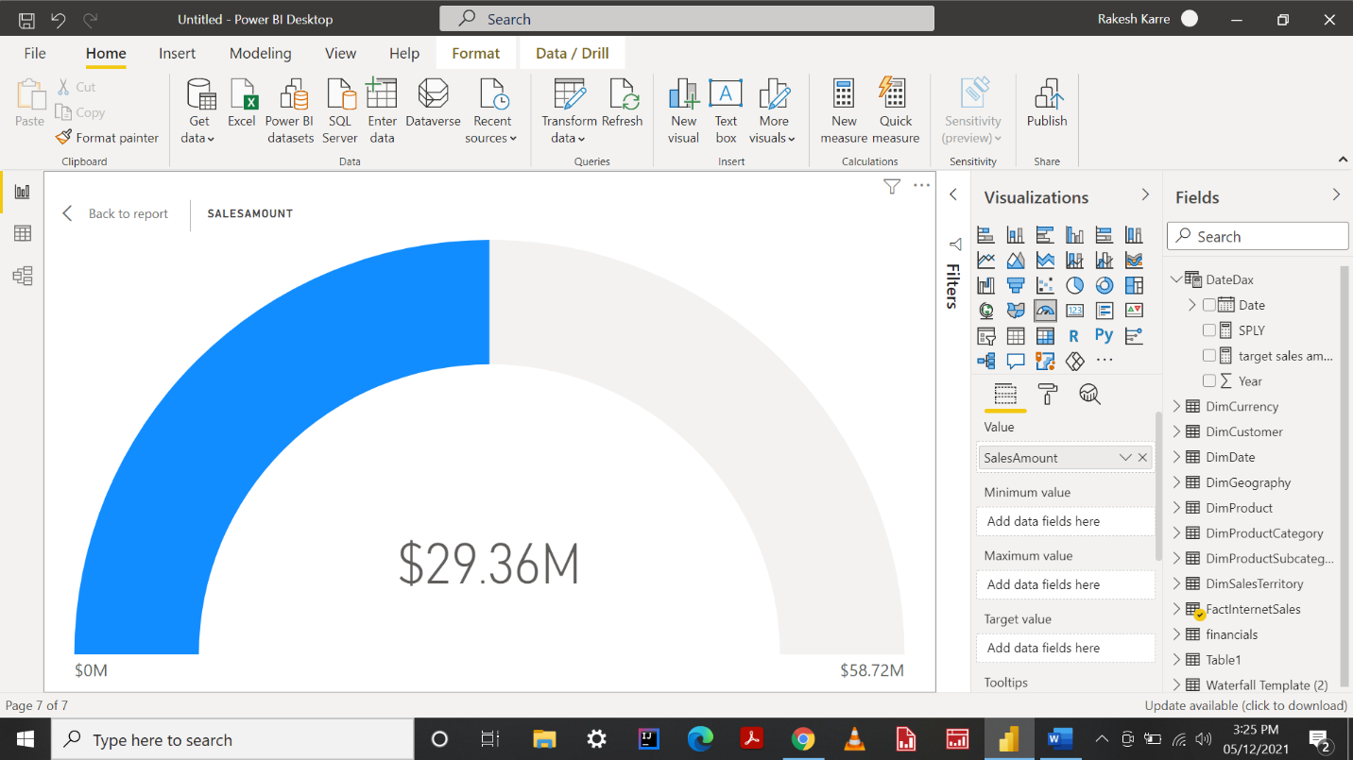

**Ability to Create Dashboards with Power BI to enhance reporting services**

**Able to create, populate workspace and create a dashboard.**

STEP 1: Click on Workspaces it will show you workspaces created by you. If you want to create a new workspace, click on create a workspace button.

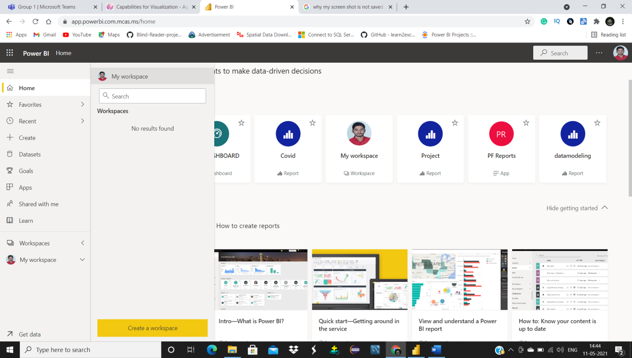

STEP2: Power BI service will ask you for name of the new workspace, provide the name and click

STEP3: You will see existing workspaces below the workspaces button. 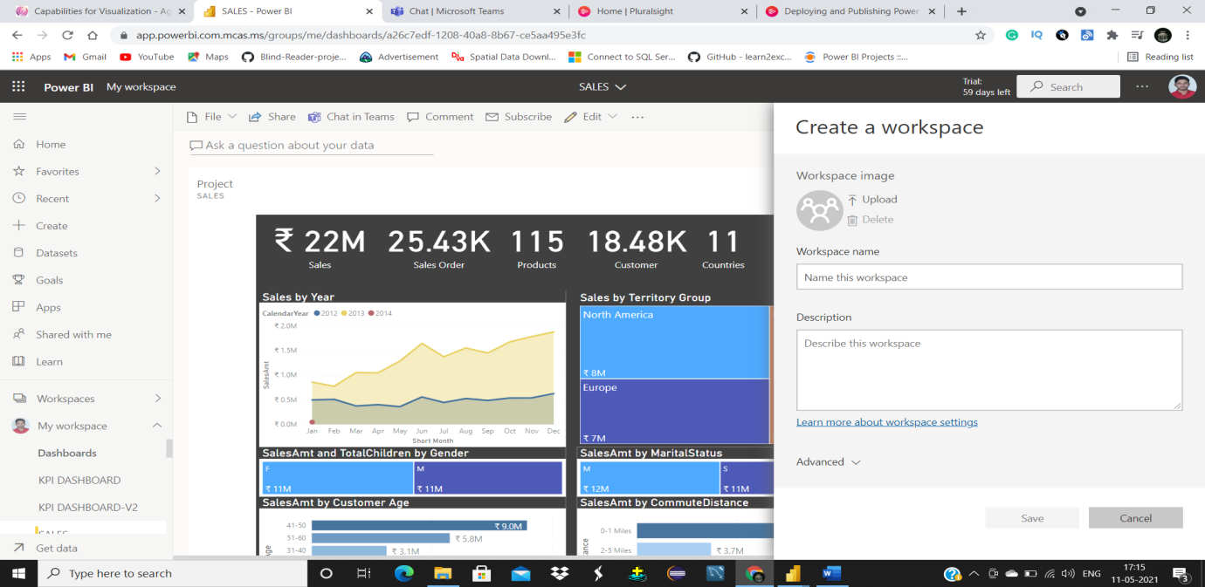

To expand particular workspace, click on workspace name, you will get all the reports, Dashboards and data sets present in that particular workspace.

STEP4: Click on dashboards to open existing dashboard and open the dashboard you want to work or create a new dashboard.

To pin a visual to Dashboard hover over the visual and then click on pin visual button.

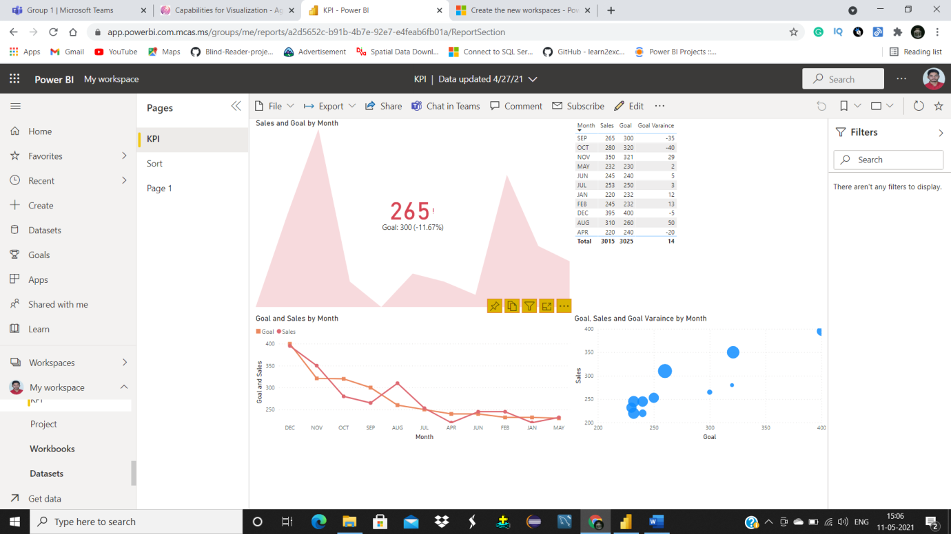

STEP5: You will get an option to choose an existing dashboard or to create a new dashboard. To create a new dashboard, choose new dashboard option and give name for that dashboard, Click on pin. A new dashboard will be created.

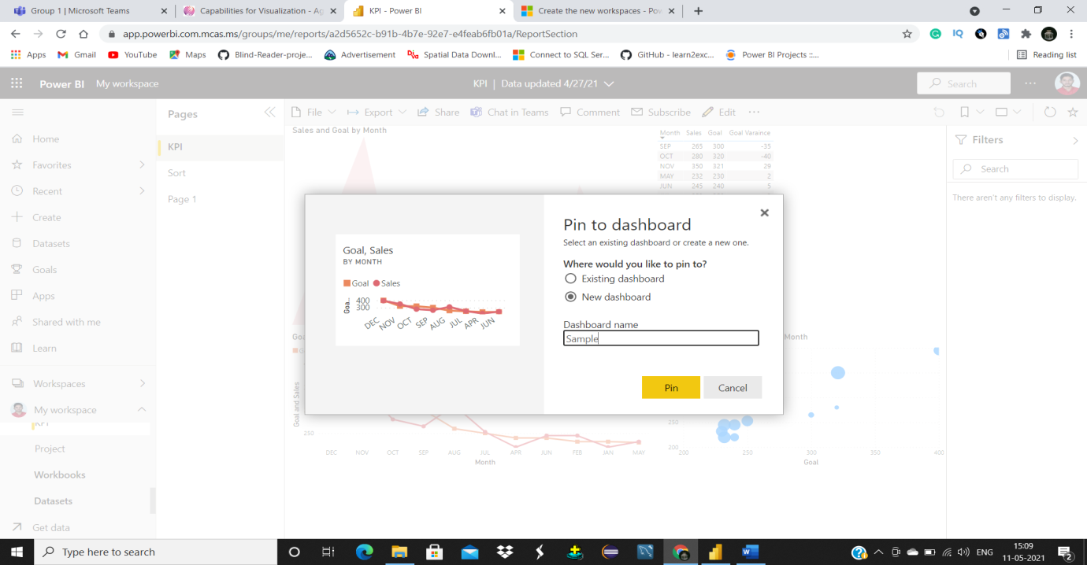

**Ability to customize a dashboard content using existing report**

STEP1: Open report from reports section in workspace you are working.

STEP2: Hover over the visual. You will see options like pin visual, click on that pin visual button.

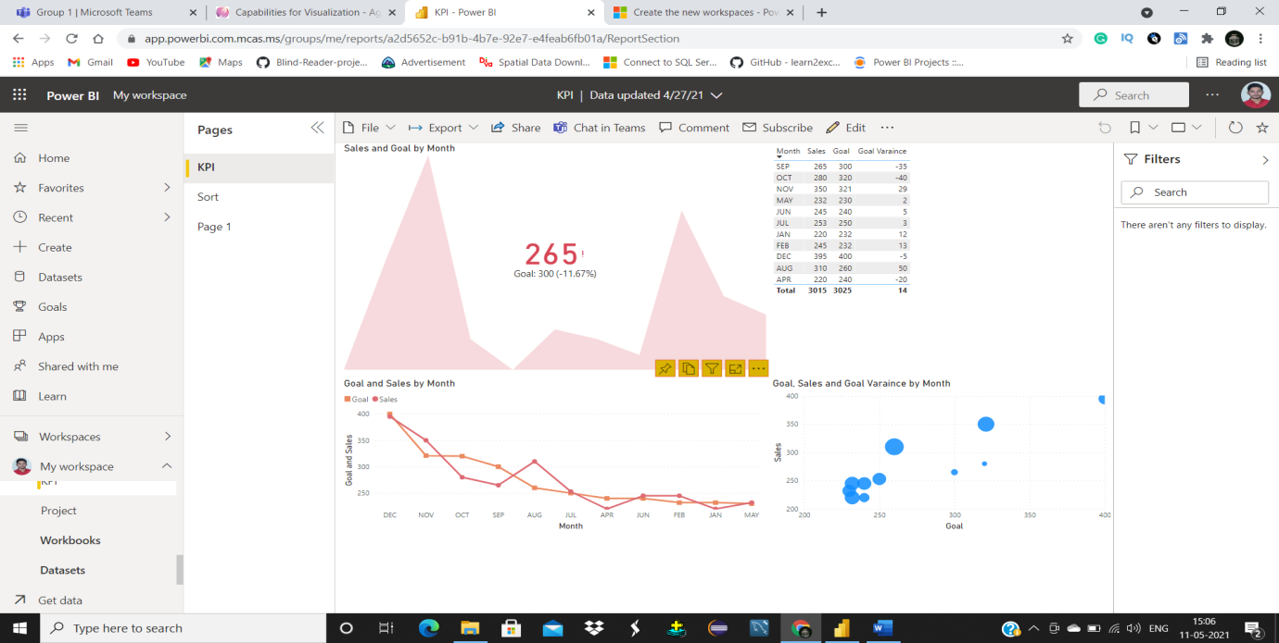

STEP3: You will be asked to choose an existing dashboard or create a new one. Choose the existing dashboard and select the dashboard on which you want to pin the visual by selecting the dashboard from the drop down.

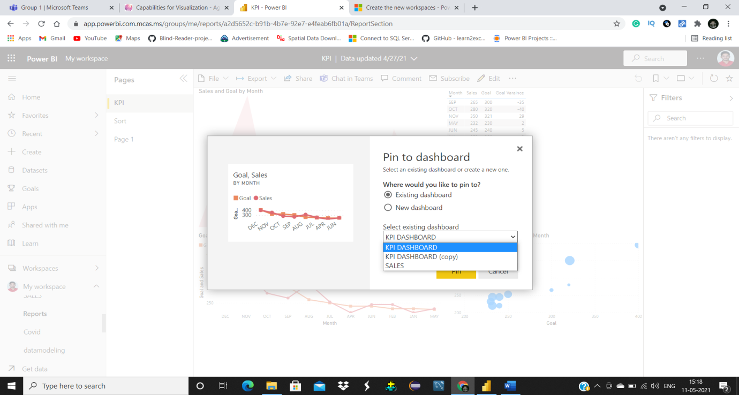

**Ability to configure tiles**

Visuals pinned to a dashboard are called as tiles. We can configure a tile according to our needs.

STEP1: Open dashboard. Hover over the tile then you will see three dots at top right corner. Click on that three dots.

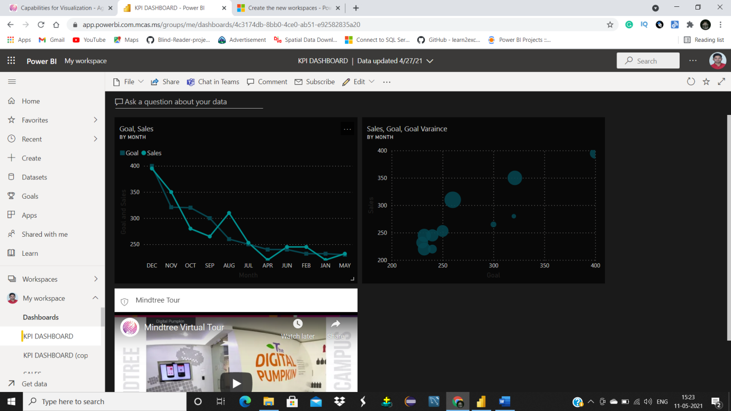

It will give options to make changes to tile and delete tile and you can also pin that tile to other dashboards.

STEP2: Select edit details option.

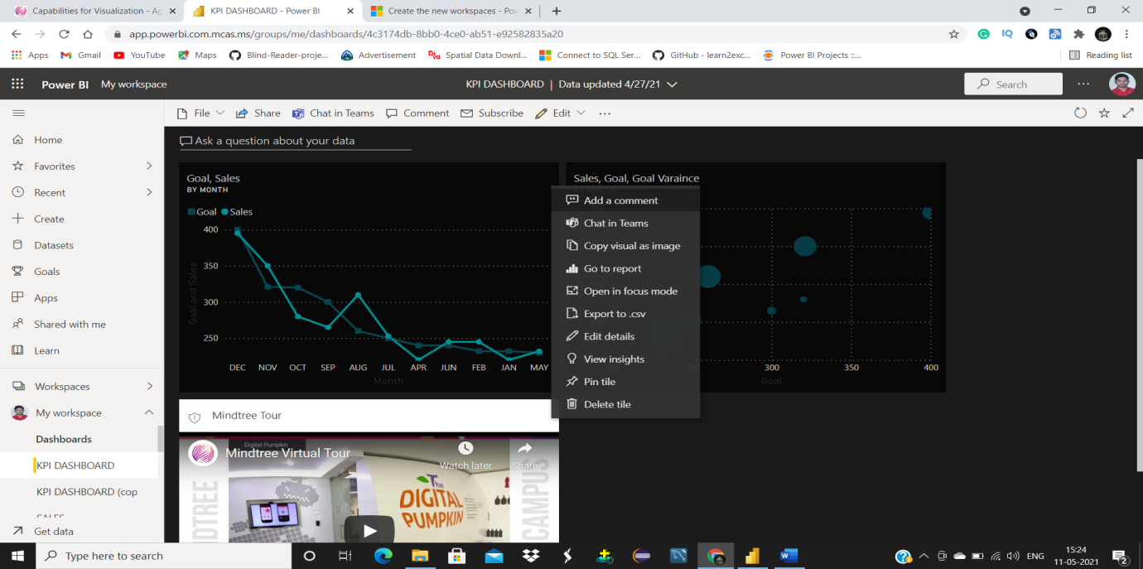

STEP3: Now you can edit tile details like title, subtitle and you can also add functionality to that tile, by adding a URL it can take to another webpage.

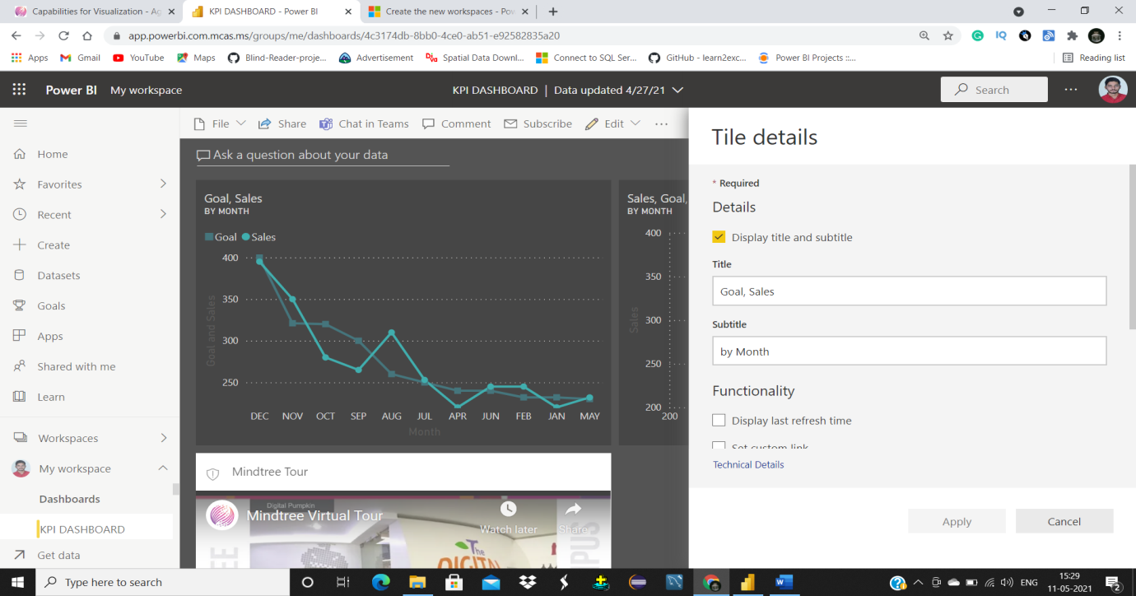

**Able to build mobile dashboard.**

Microsoft also developed a mobile app that can help users to check dashboards on the go. We can customize our dashboards according to mobile screen size.

STEP1: Click on edit button in the ribbon menu from that drop down select mobile view. 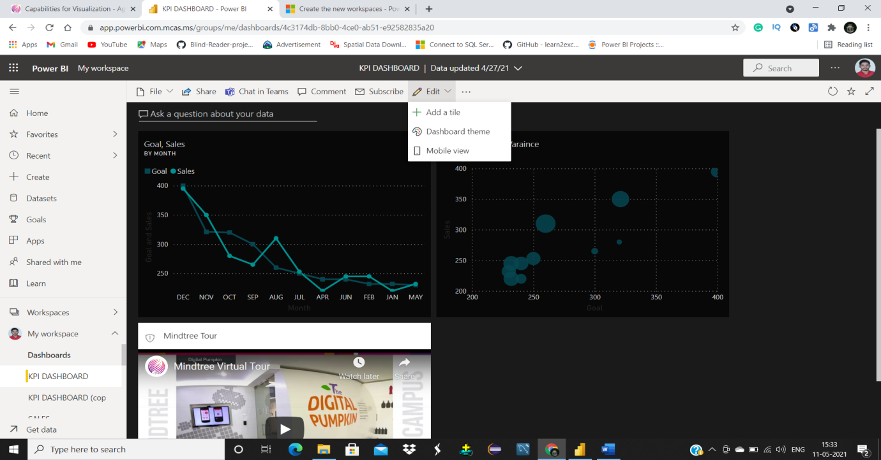

STEP2: You will see a mobile like screen from there you can change the tile position, size by dragging them.

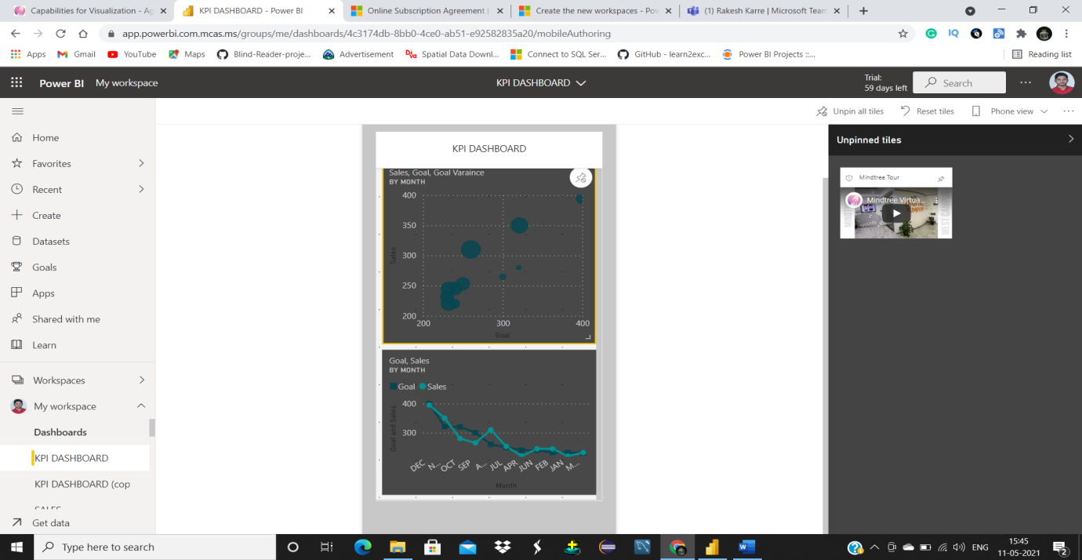

To hide a tile in mobile view hover over the tile and then click on unpin icon in the top right corner. All the unpinned tiles will be shown in unpinned tiles section.

**Able to add media tile options- Textbox Tile, the image tile, the video tile, web content tile.**

STEP1: To add tiles custom tiles like Textbox, images, video and web content click on edit button and then from drop down menu select add a tile option.

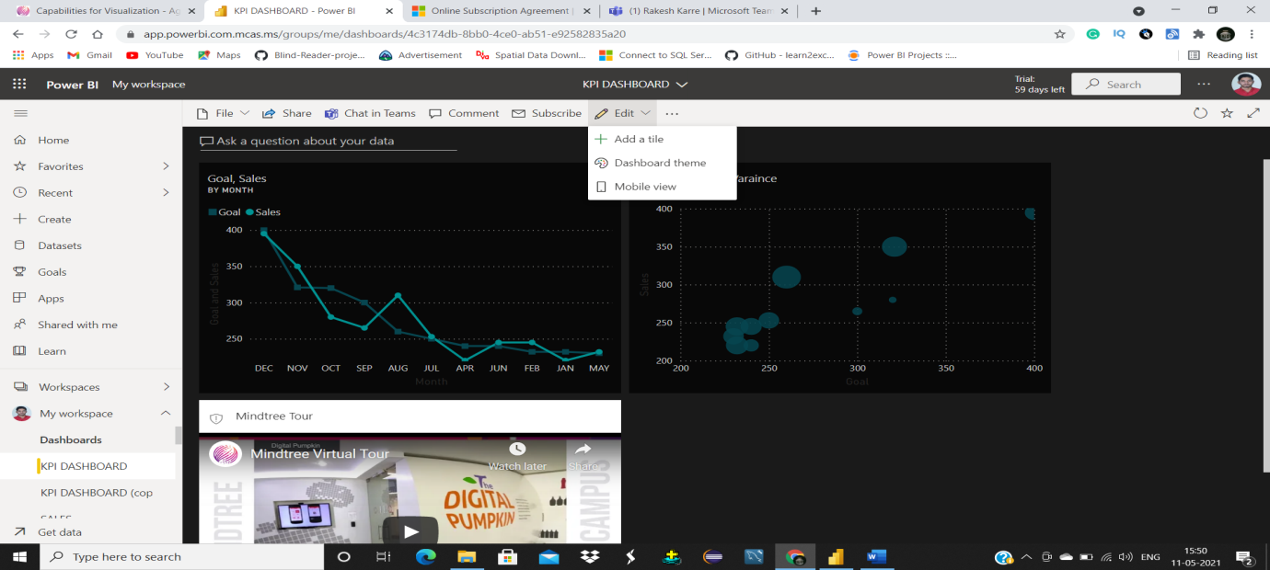

You will get a menu with all the options like textbox, image, video, and web content.

To add Text box: Choose text box from options and then click next.

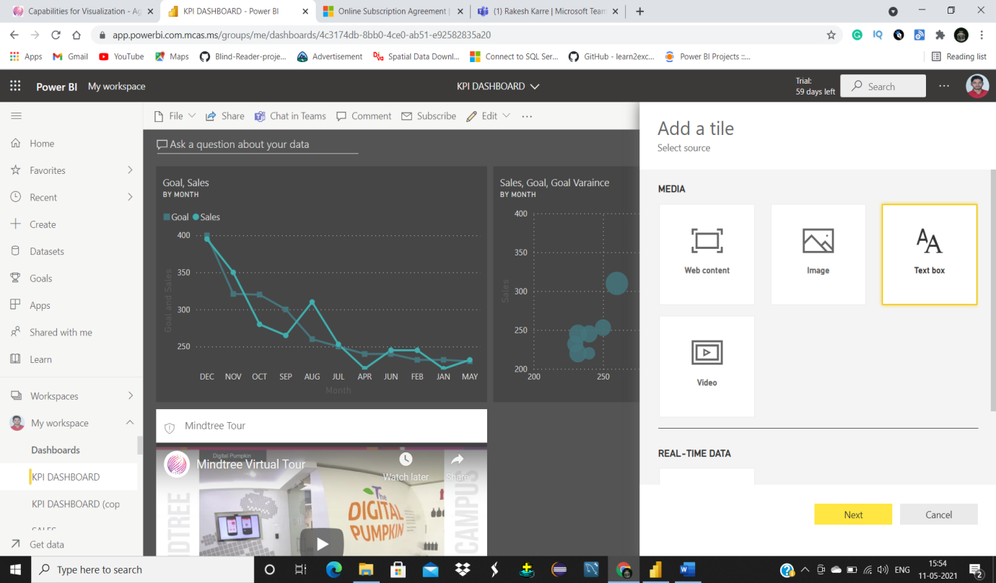

You will get configuration options for text from there you can add title, subtitle, text box content and you can also add functionality.

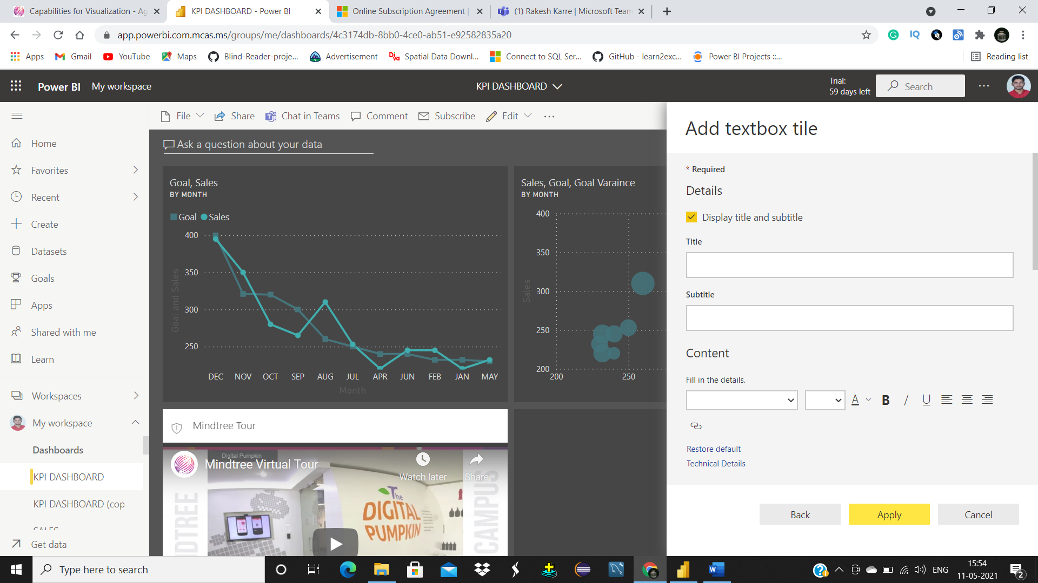

**To add an image:**

STEP1: Select image option from the options window and then click next.

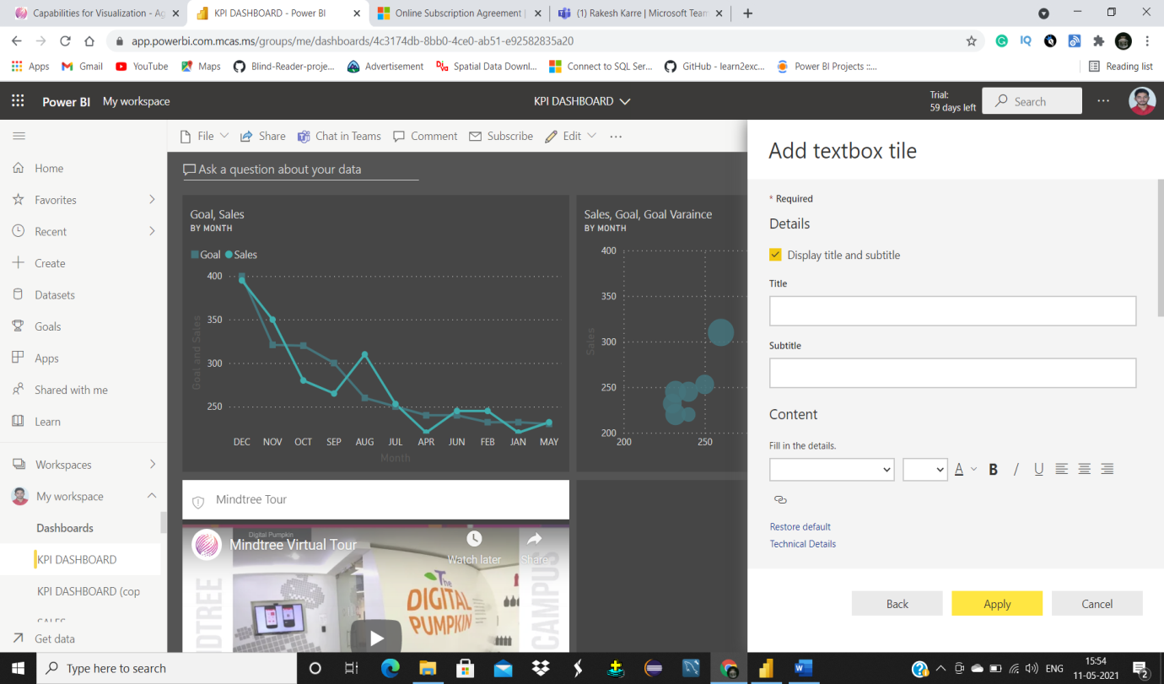

STEP2: Provide the URL for image, you cannot directly upload an image into power bi service. So, before inserting it upload it into cloud and then provide that URL in image URL section.

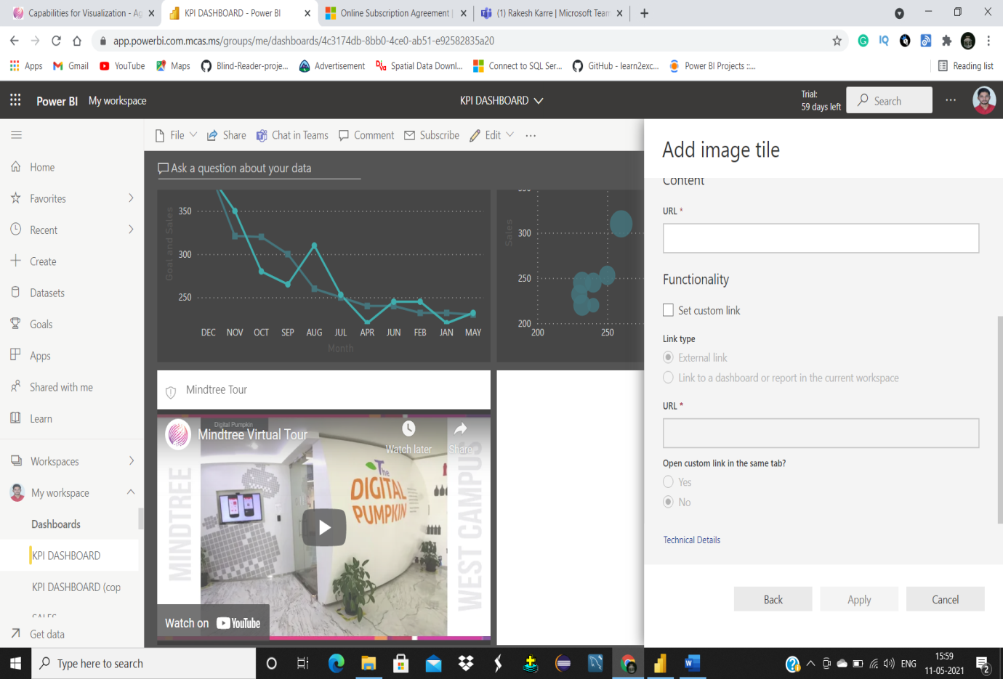

**To add a video tile:**

STEP1: Select video option from options and then press next button.

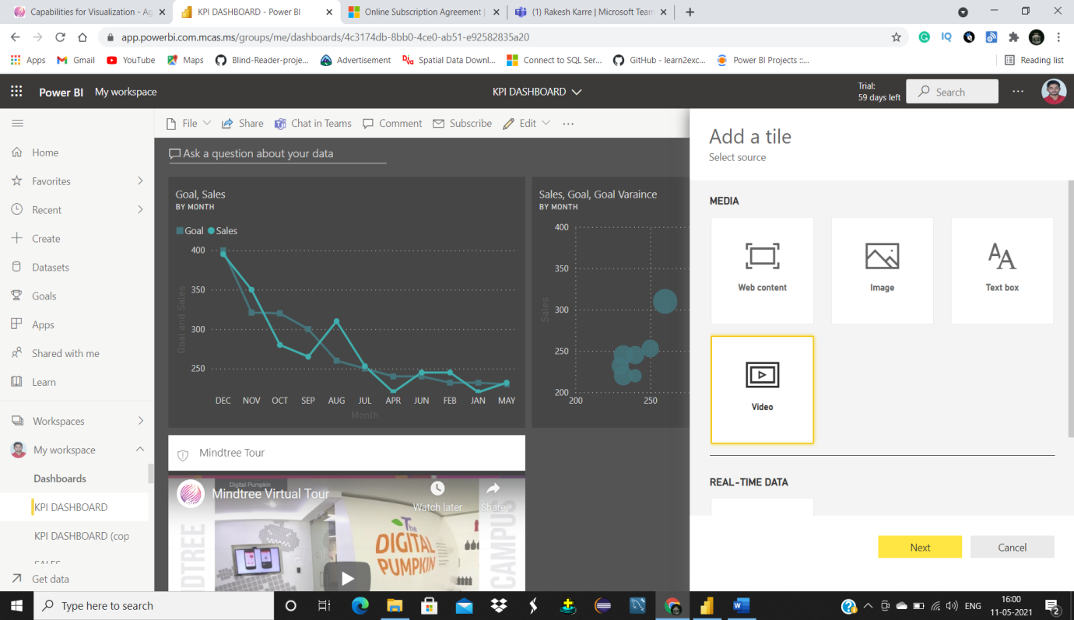

STEP2: Tile configuring dashboard will be opened. Power bi service can only take video URLs of YouTube video or Vimeo. Provide the URL of video either from YouTube or from Vimeo.

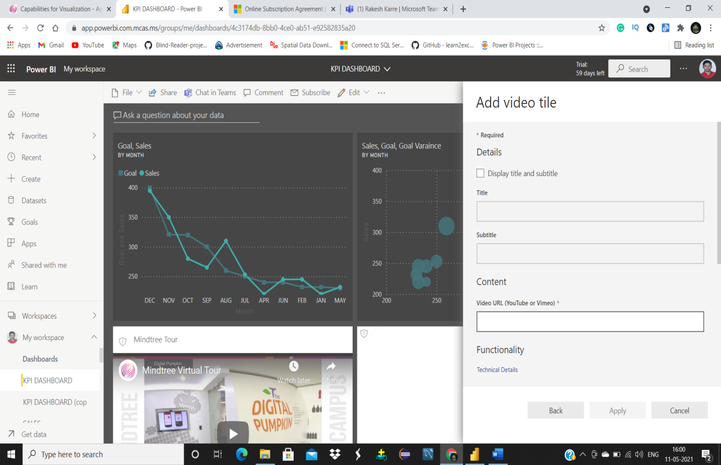

**To add Web content:**

STEP1: Select web content from options and then click on next button. You will get tile configuring dashboard.

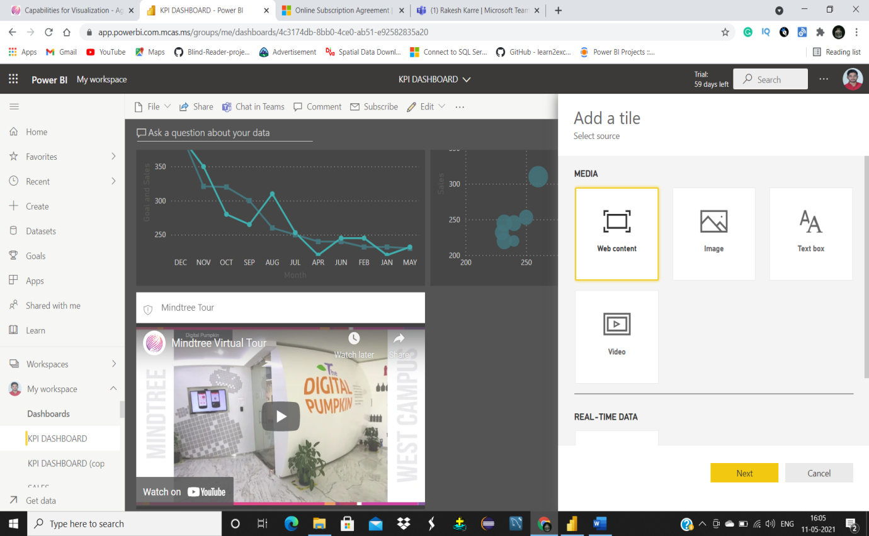

STEP2: Check or uncheck to show or hide title and subtitle of that tile. To display web content provide embed code.

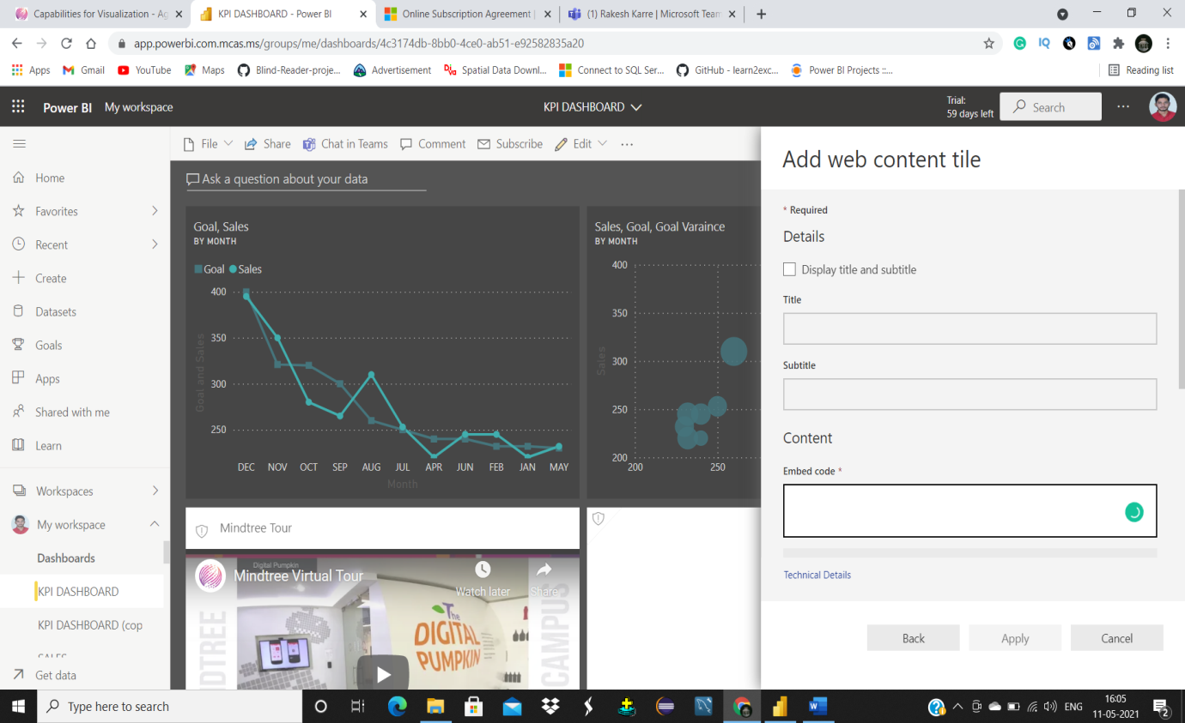

**Able to apply themes to dashboards, override visual settings and adding additional theme options**

STEP1: To change default theme click on edit button from dropdown click on dashboard theme.

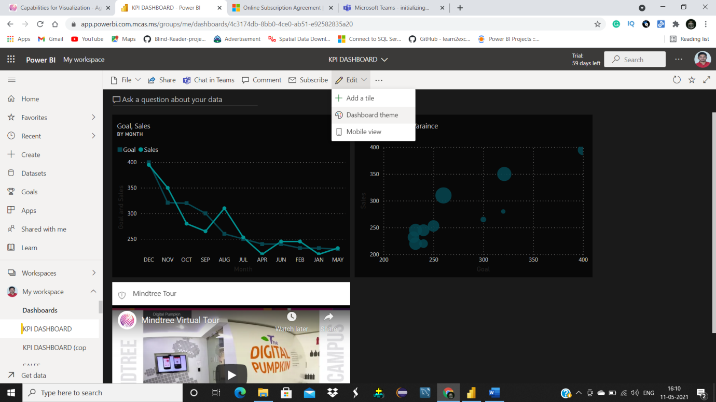

STEP2: There you will get different theme options like dark, light, color blind friendly and custom. To override the theme style, select custom from dropdown. After selecting custom, you will get options to change background color of the dashboard, Tile background, Tile font color and tile opacity.

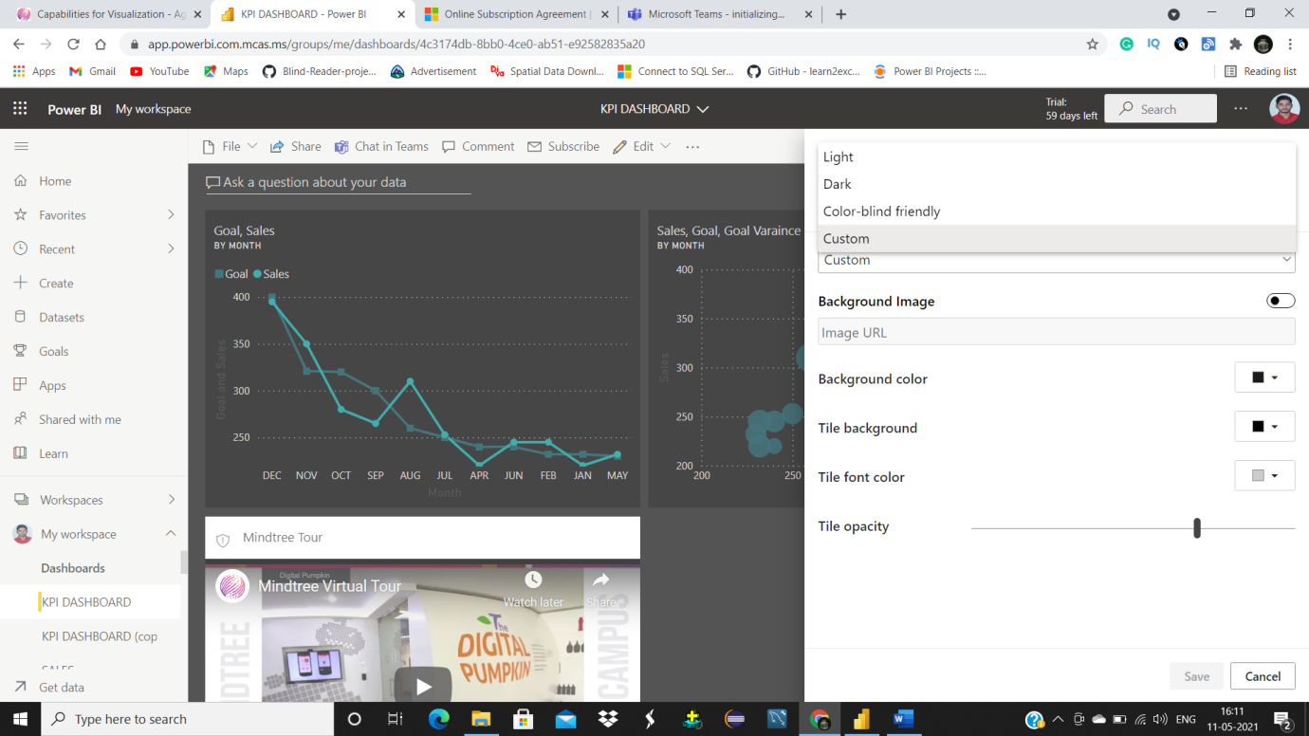

To change respective color, click on the color option and choose the color you want.

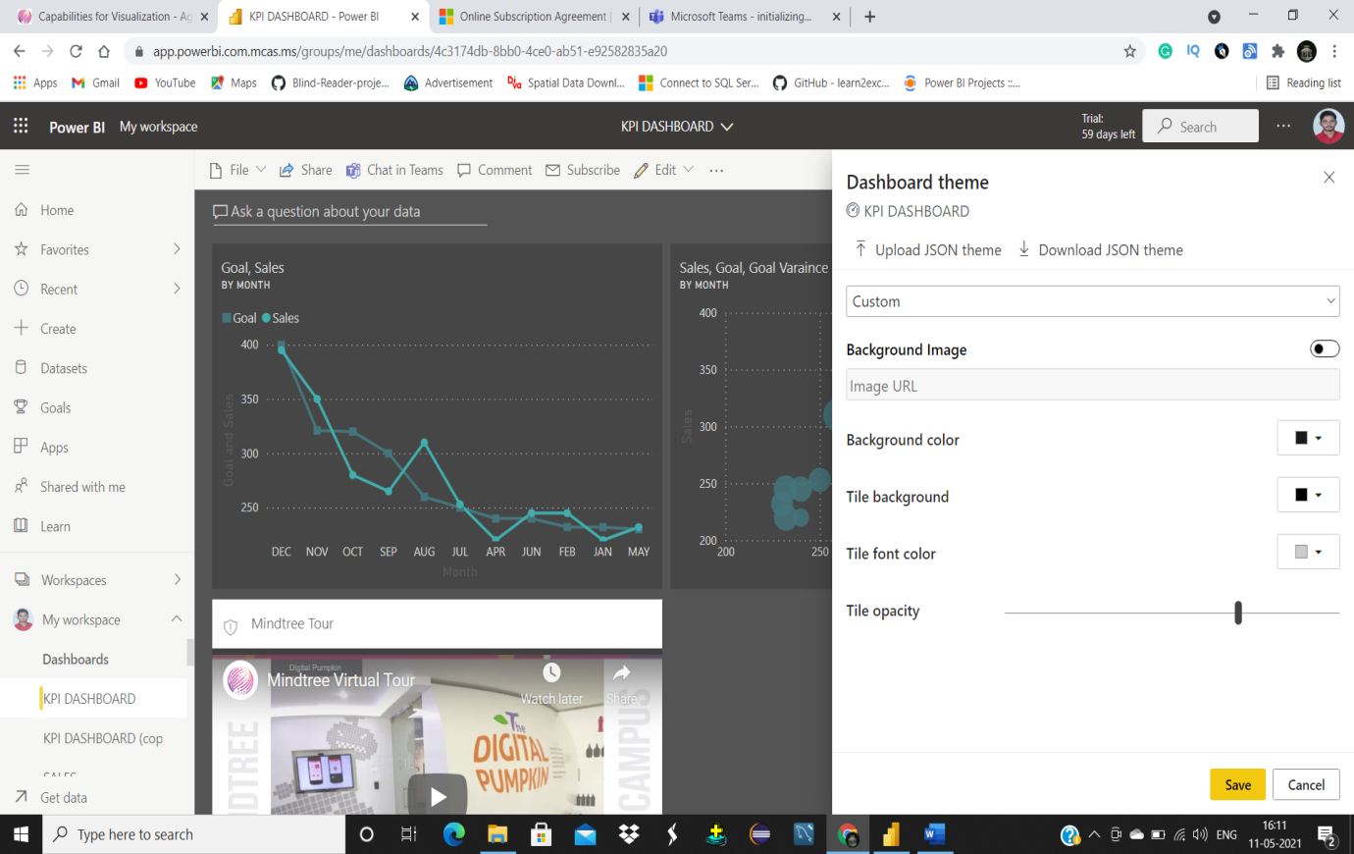

To Override Dashboard theme from JSON file click on Upload JSON theme select the file and then press open it will override the custom theme settings.

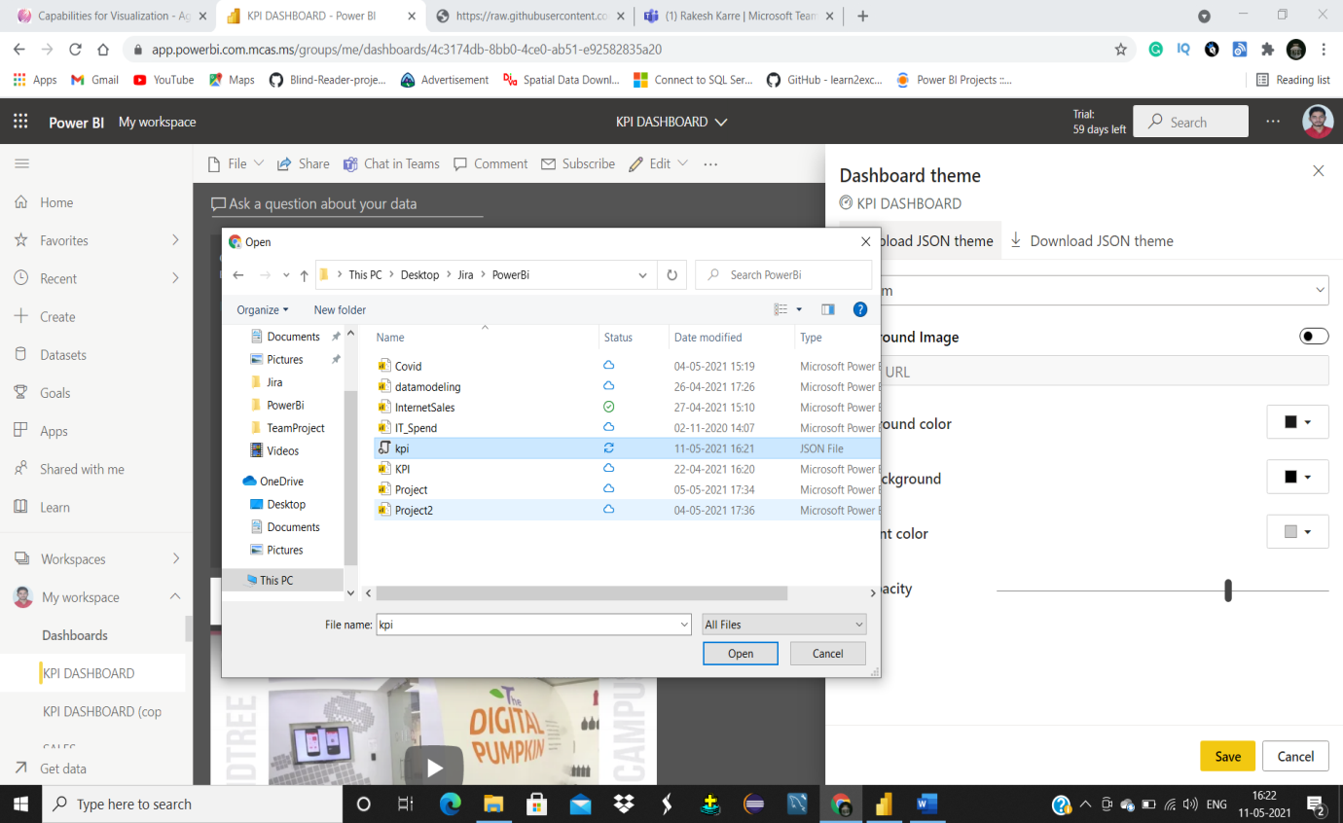

**Able to observe changes and handle changes with versioning.**

To observe changes, make copies of dashboard and give them versions.

STEP1: Click on file in dashboard menu and then click on save a copy option from the dropdown.

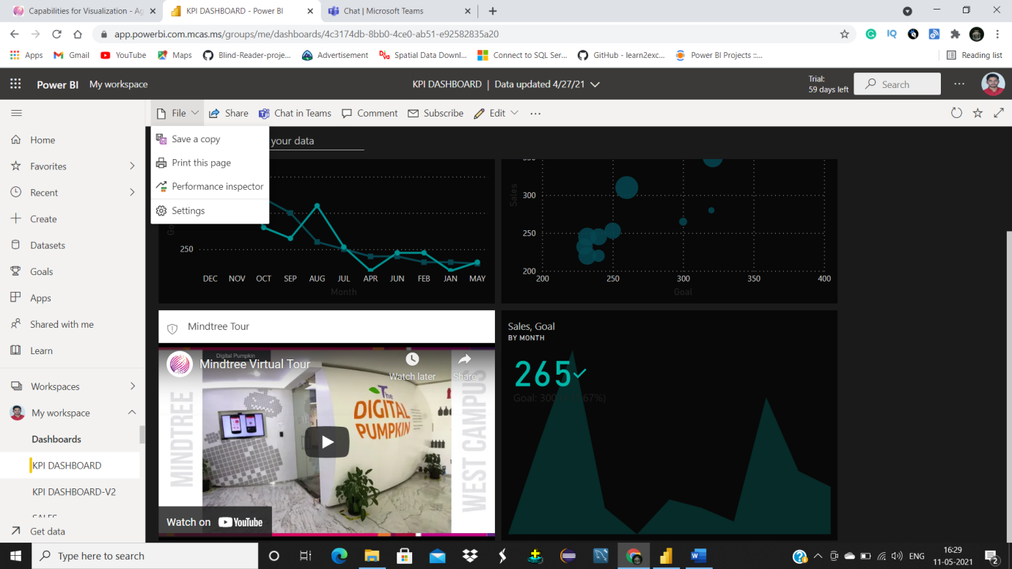

STEP2: It will ask you for name of the copied file give a name with version of that dashboard and then click on duplicate.

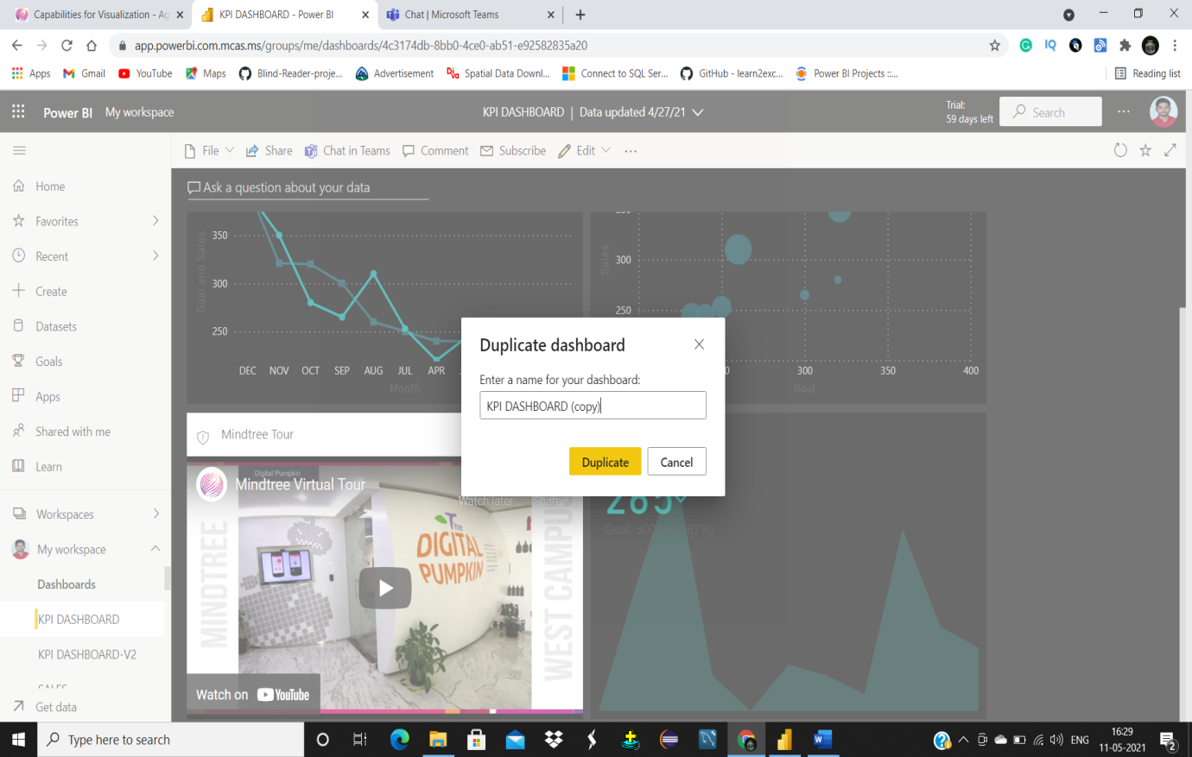

Now you can observe changes to original dashboard by referring to copied dashboards or versions.

**Able to add user permissions and tile cache**

STEP1: Open the workspace you want for which you want to add users. Click on access button in menu.

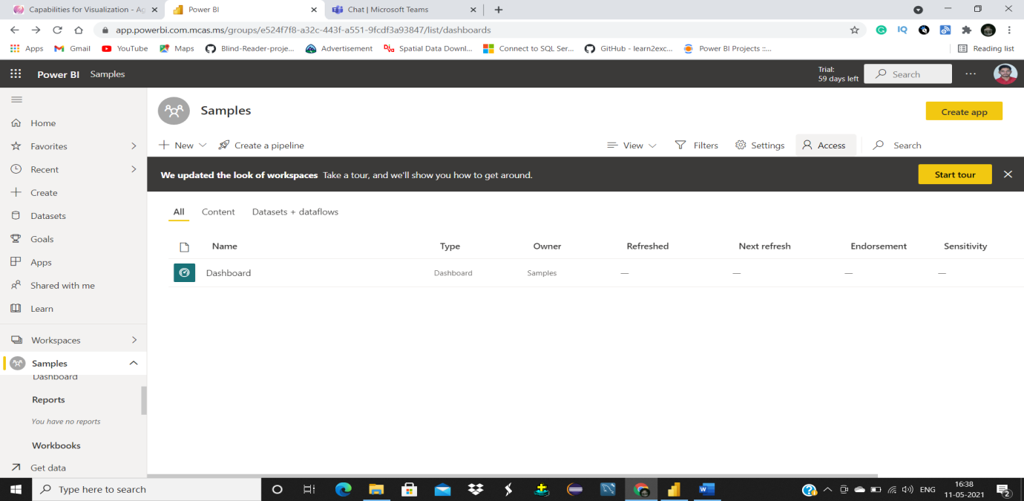

STEP3: It will ask you mail address of users, provide the mail address of the person to whom you want to share the workspace currently you are working in.

STEP3: After selecting the user select their role from drop down.

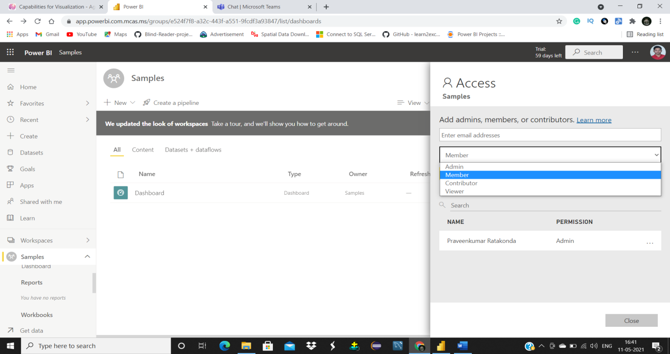

**Ability to Deploy and Publish Power BI Reports**

**Able to Publish Power BI Reports**

STEP1: Save the Report and then click on publish button in ribbon menu

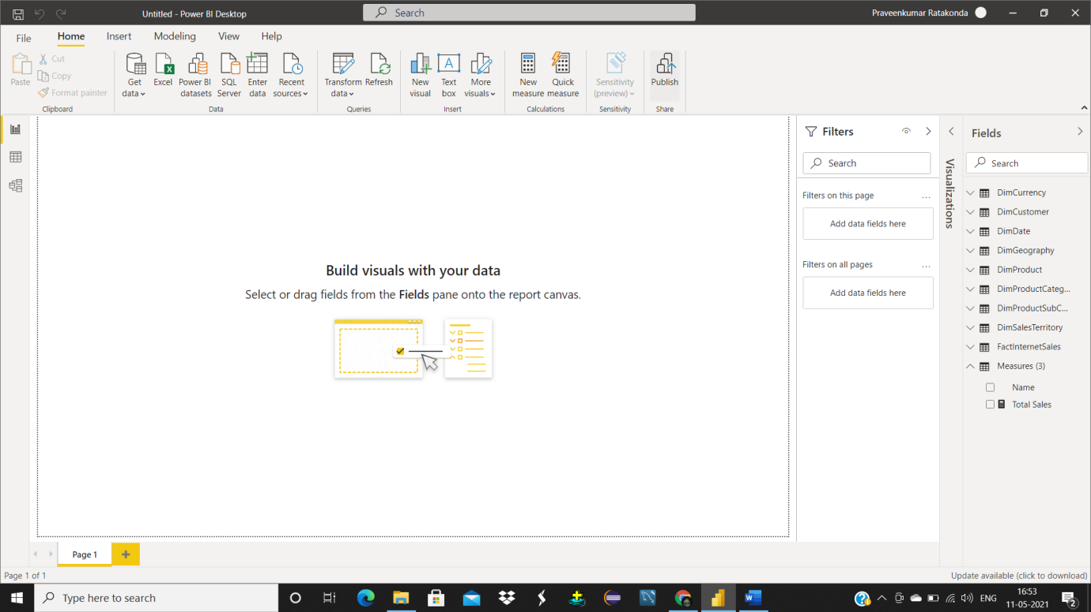

STEP2: Power Bi will show you workspaces select the destination workspace from the list and then click on select button. Report will be published to power bi service.

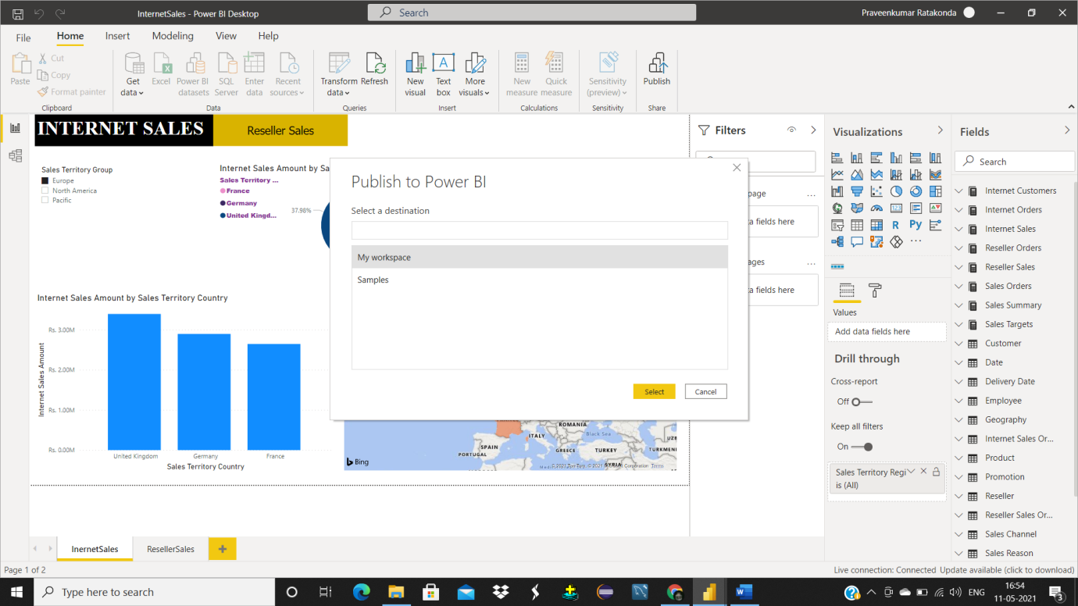

After publishing the report power bi will give the URL to access the report in the power bi service, you can use that link to navigate to the report you have published to service portal.

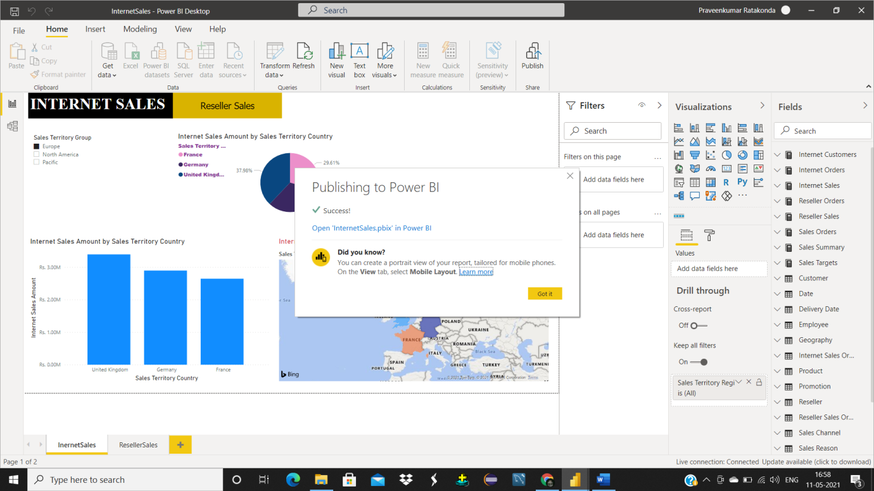

**Able to Share and secure reports**

STEP1: Click on share button. It will show you options like copy link, outlook and teams you can choose one among them and you can share directly to a person by giving his mail.

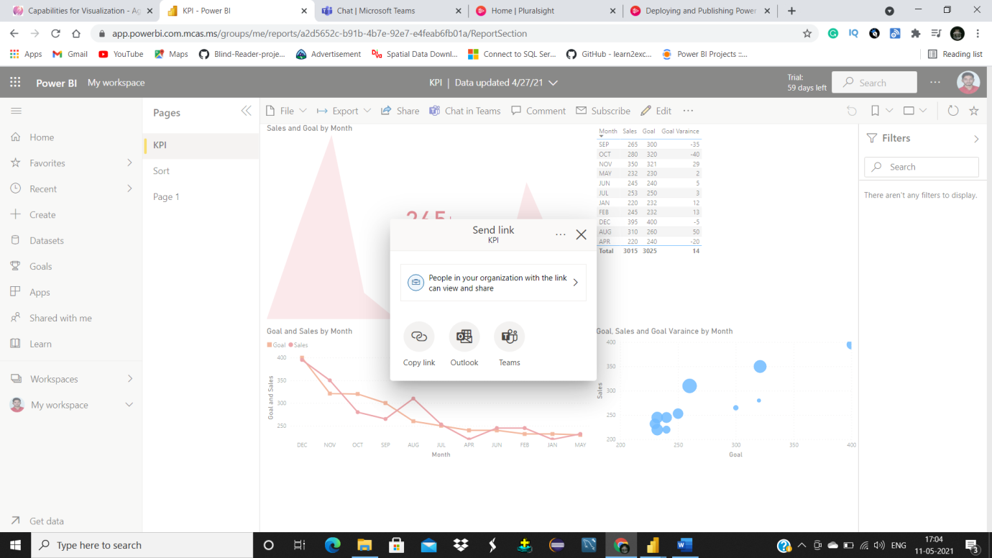

STEP2: To change permissions hover on sharing dashboard and then click on three dots at the top right corner. Give the permissions you want to give to user you are sharing the report with.

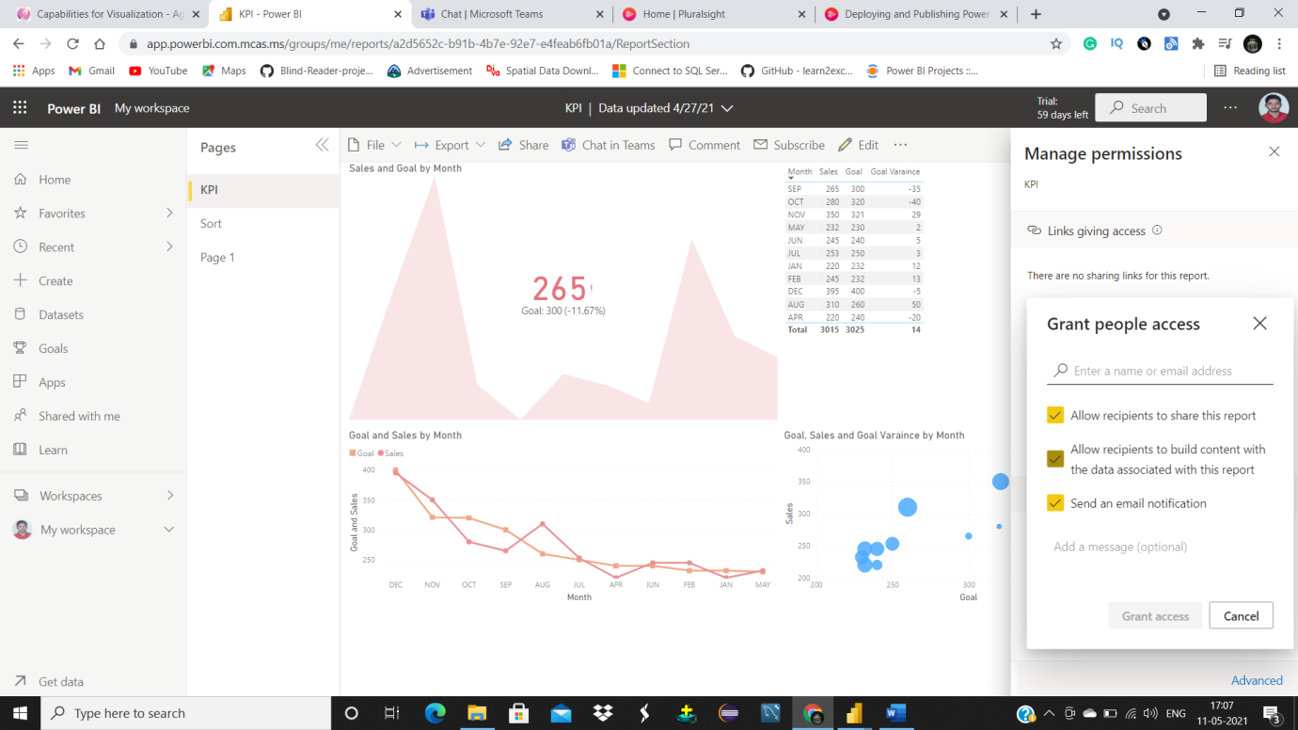

**Able to Share and secure dashboard**

STEP1: Click on share button in the menu. It will ask you the name of the person to whom you want to share the dashboard. Manage the permissions by clicking on three dots in the top right corner.

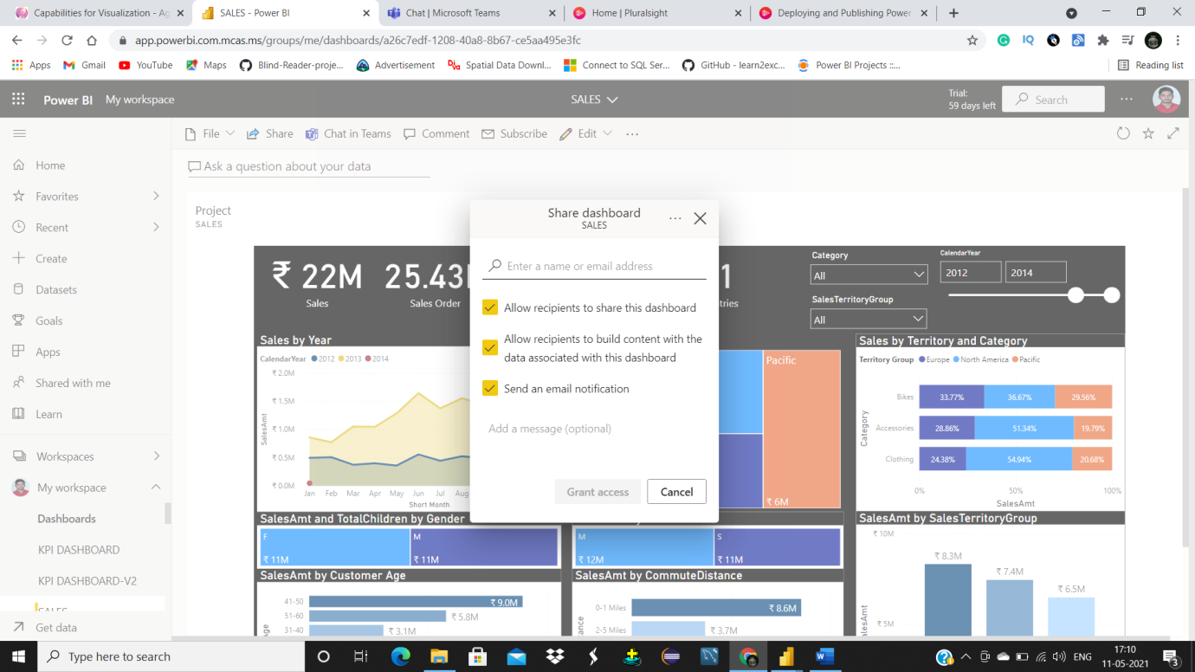

STEP2: If you want add a message and then click on grant access.

